APCRDA TDR Portal — Flow Diagrams

1. System Architecture Flow
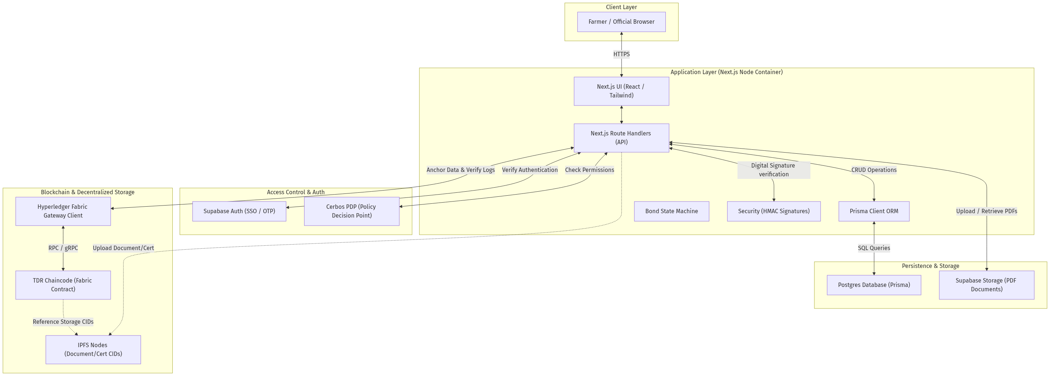

2. Infrastructure & Deployment Topology
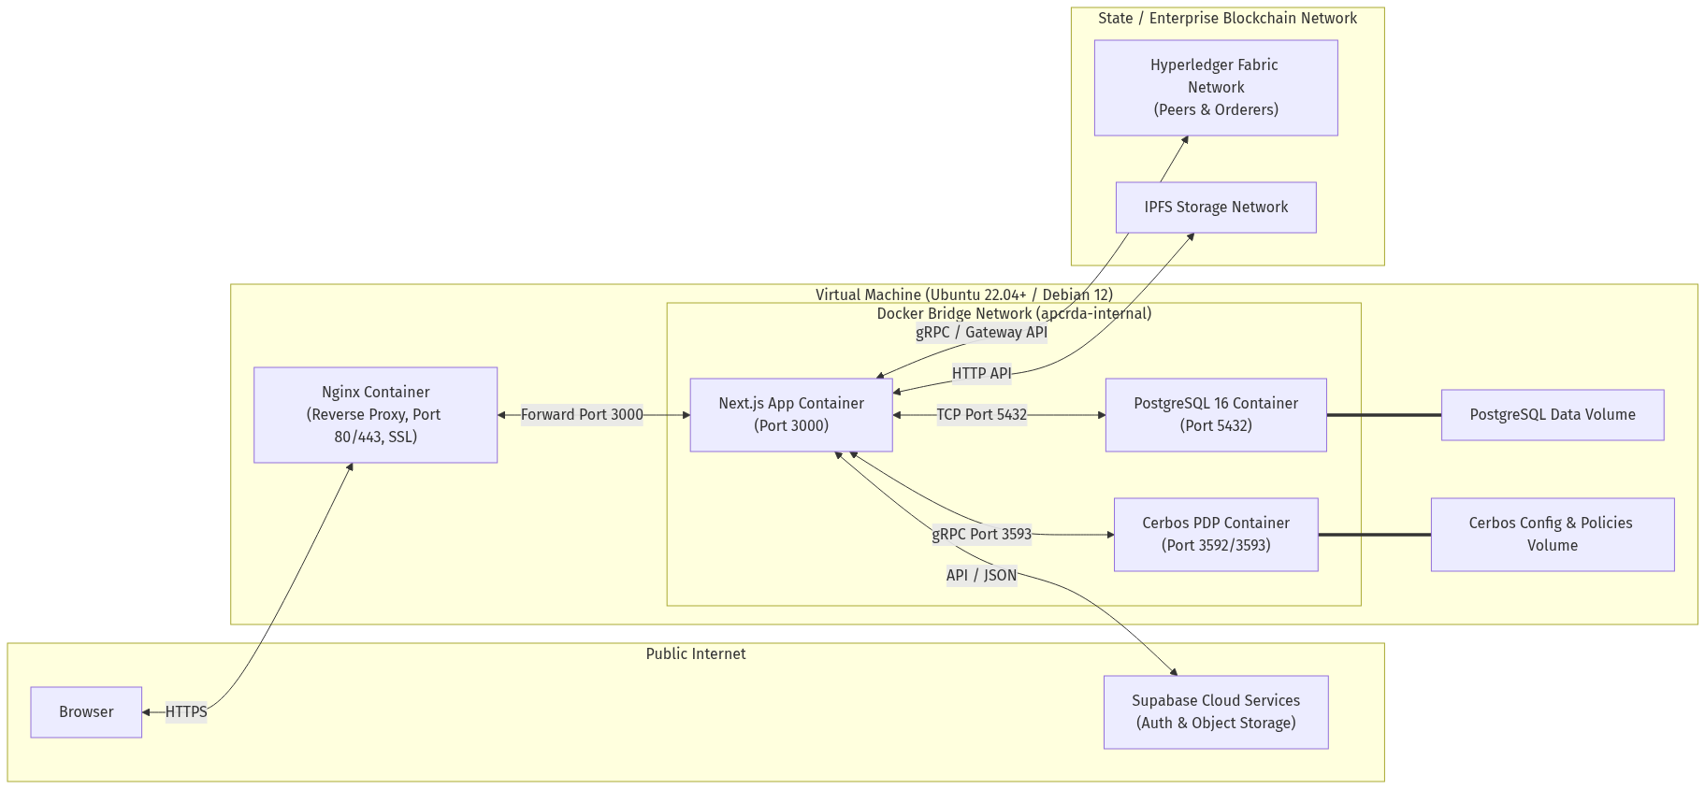

3. Approval Workflow State Machine
