APCRDA TDR Portal
System Specification, Architecture & Deployment Guide

1. System Architecture
The APCRDA Transferable Development Rights (TDR) portal leverages a highly secure Next.js architecture integrated with Cerbos for dynamic attribute-based access control, Supabase for user authentication, and Hyperledger Fabric blockchain for state auditable registry consensus.
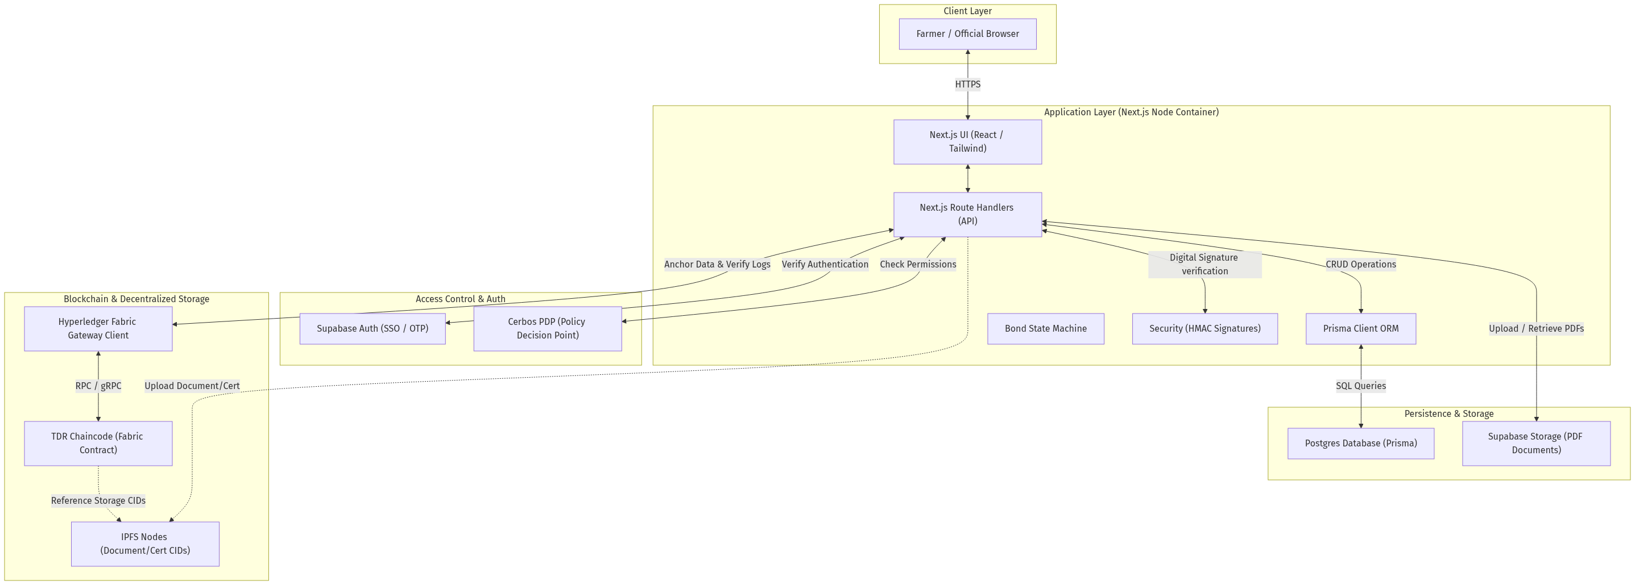

2. Infrastructure & Deployment Topology
To secure internal resources, Nginx serves as a reverse proxy performing SSL/TLS termination on ports 80/443. Core services (Next.js Application, PostgreSQL 16 DB, and Cerbos Policy Engine) are hosted on an internal Docker bridge network, restricting PostgreSQL database exposure to external traffic.
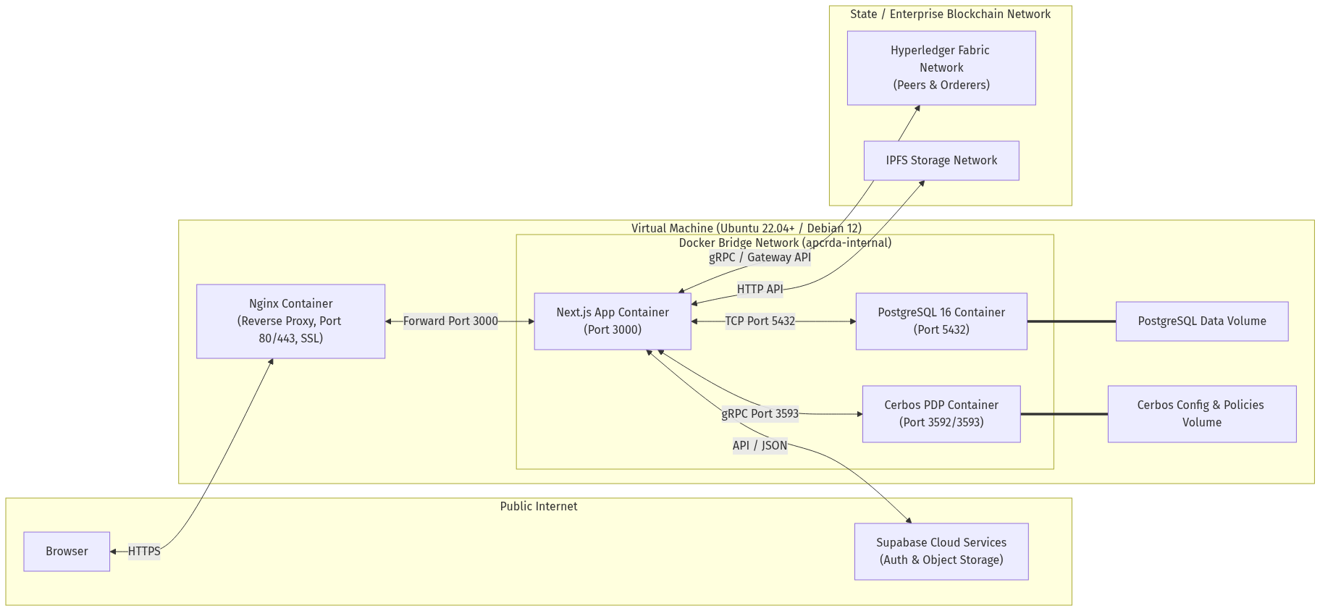

3. Approval Workflow State Machine
TDR applications are processed through a sequential 4-level official pipeline. The workflow enforces district-aware roles, cryptographic signature generation (HMAC), and registers immutable logs at each stage in the PostgreSQL database and Hyperledger Fabric ledger.
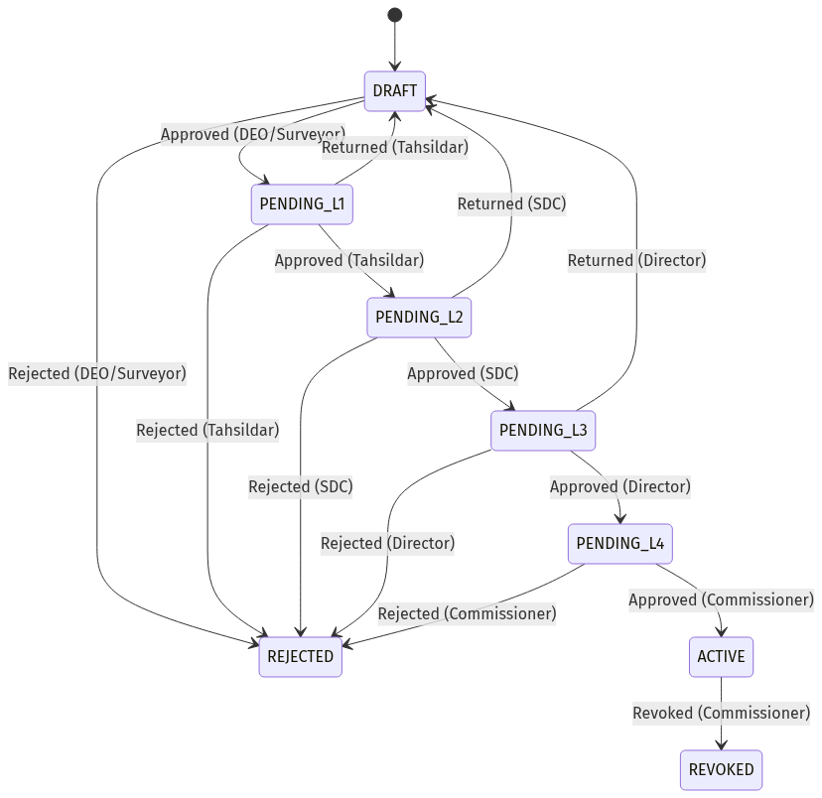

4. Database ERD Schema
The database is mapped via Prisma ORM to a relational PostgreSQL database. Relational schemas map relationships between TdrBonds, BondHolders, BondLandDetails, BondDocuments, ApprovalSteps, Officials, Farmers, and AuditLogs.
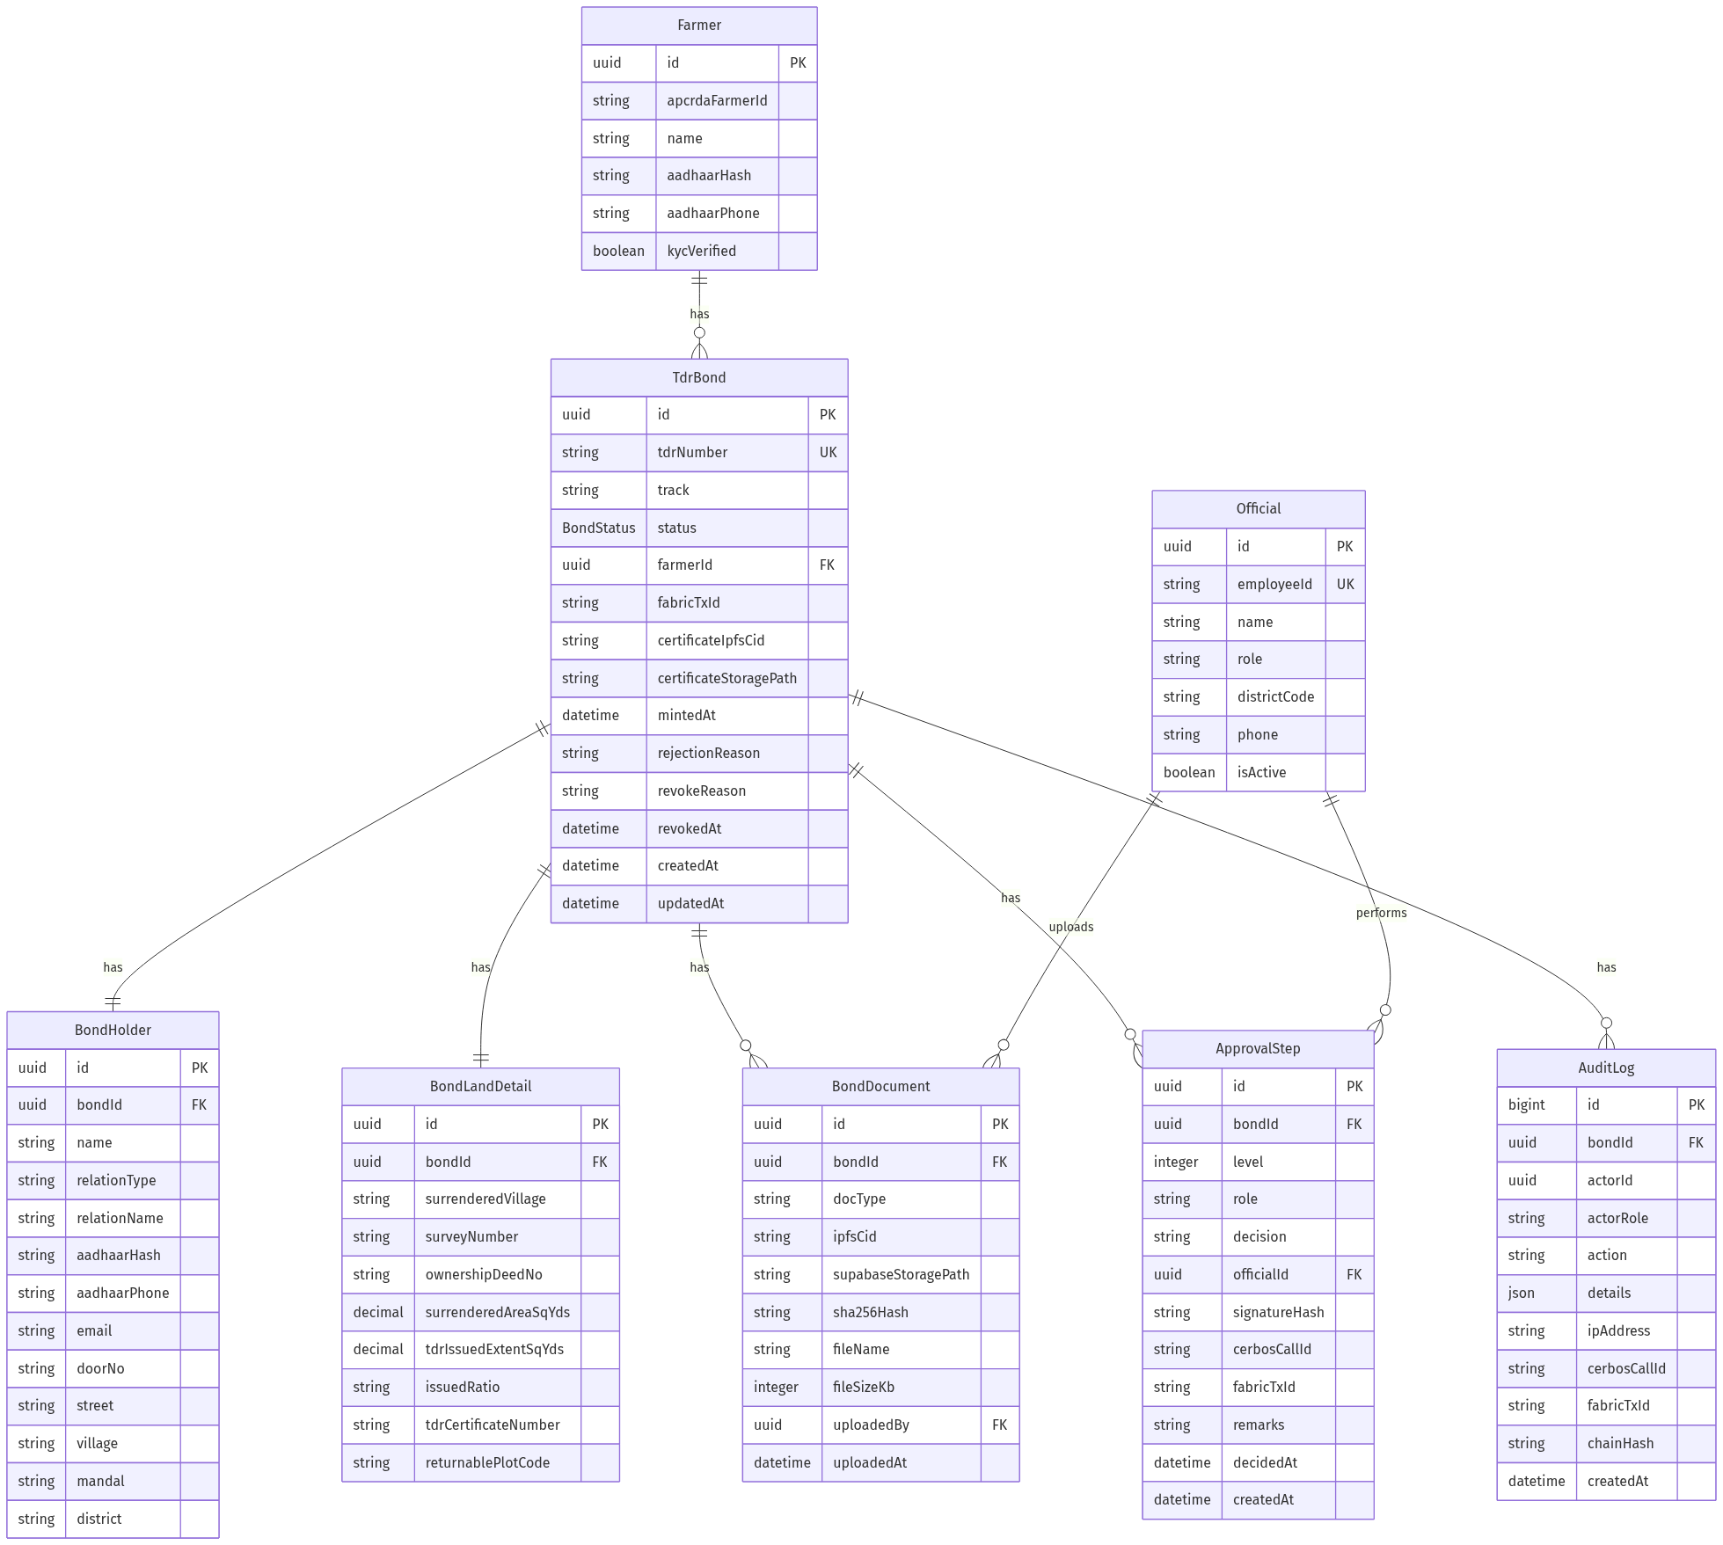

5. Host & Deployment System Requirements

A. Minimum Virtual Machine (VM) Specifications
- • Operating System: Ubuntu 22.04 LTS / Debian 12 recommended.
- • Processor: 2 Cores minimum (4 Cores recommended for production load).
- • Memory: 4 GB RAM minimum (8 GB recommended when running local Fabric container nodes).
- • Storage: 40 GB SSD (Expandable based on TDR application attachments and PDF file volumes).
- • Networks: Ports 80 (HTTP) and 443 (HTTPS) must be open in firewall security groups.

B. External Integrations
- • Supabase Cloud Services: An active project endpoint configured for User Auth (JWT API) and Object storage buckets for documents.
- • Hyperledger Fabric Network: Node SDK connectivity configuration to peer node and Raft consensus ordering cluster.
- • IPFS Gateway: A node provider integration (e.g. Pinata or local IPFS cluster) to pin TDR certificate storage PDFs.

C. Installation & Launch Steps
- 1. Clone repository to server: git clone https://github.com/sainath-666/TDR-Repo.git
- 2. Setup and modify the environment configurations: nano .env.production
- 3. Expose Nginx SSL/TLS key files to deploy/nginx/ssl/tdr.crt and tdr.key
- 4. Start compilation and launch containers: npm run deploy
- 5. Sync auth schemas and verify api: npm run auth:sync && curl http://localhost/api/health

