Bootstrap is a versatile toolkit that includes HTML, CSS, and JavaScript tools for creating and developing web pages and applications. It is a free and open-source project that was built by (and for) Twitter and is hosted on GitHub.
While working at Twitter, Mark Otto and Jacob Thornton created and announced Bootstrap in August 2011. The goal of the project was to make interface creation and maintenance as simple and uniform as possible. Bootstrap was a way to make several popular design patterns a standard in online design and development, not just a framework. The project was originally known as Twitter Blueprint, but it was eventually renamed Bootstrap and distributed as an open-source project. The project is still being maintained by the same folks, with the help of a big community of Github contributors.
Bootstrap gained tremendous popularity after its open-source release in 2011, and for good reason. Bootstrap is popular among web designers and developers because it is versatile and simple to use. Its key advantages are that it is responsive by design, that it supports a wide range of browsers, that it provides a consistent design by employing reusable components, and that it is simple to use and understand. It comes with built-in support for jQuery plugins and a programmatic JavaScript API for rich extensibility via JavaScript. Any IDE or editor, as well as any server-side technology and language, can be utilized with Bootstrap.

Bootstrap Interview Questions for Freshers

1. What are the advantages of Bootstrap?
The following are some advantages of Bootstrap:
- Bootstrap is simple to use and anyone with a basic understanding of HTML and CSS can get started.
- Features that adapt to phones, tablets, and desktops: Bootstrap's responsive CSS adapts to phones, tablets, and desktops.
- A mobile-first strategy: Mobile-first styles are built into the Bootstrap framework.
- Bootstrap 4 is compatible with all modern browsers, including Chrome, Firefox, Internet Explorer 10+, Edge, Safari, and Opera.

2. What is a Bootstrap Container, and how does it work?
A bootstrap container is a handy class that generates a central region on the page where we can put our site content. The bootstrap .container has the advantage of being responsive and containing all of our other HTML code. Containers are used to pad the content within them, and there are two types of containers:
- The .container class creates a fixed-width container that is responsive.
- The .container-fluid class creates a full-width container that spans the entire viewport width.
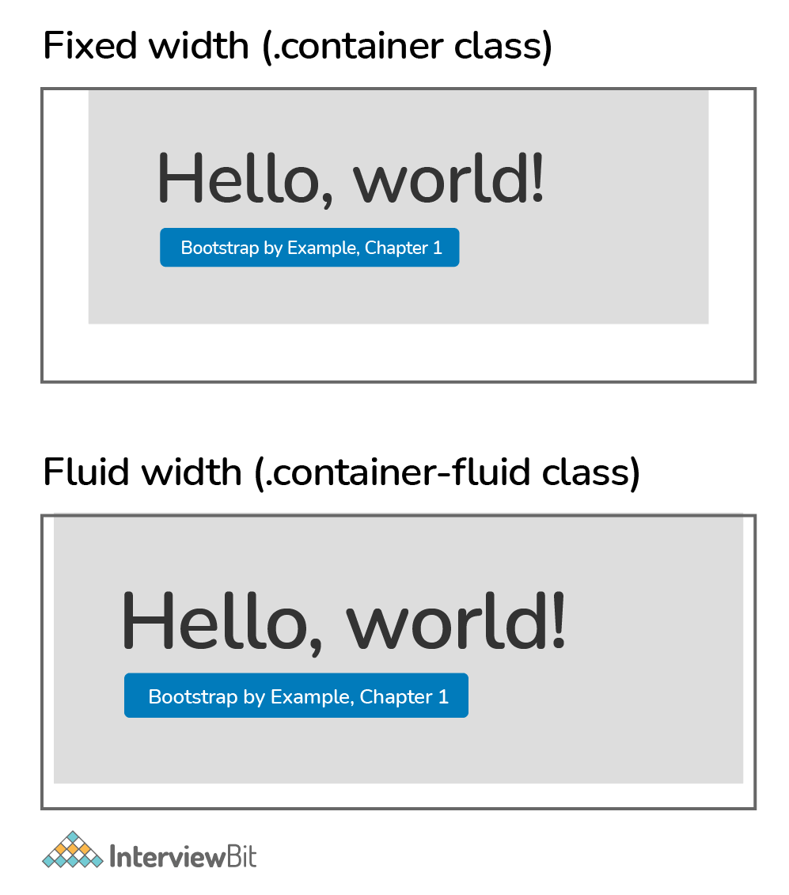

3. What are the default Bootstrap text settings?
The default font size in Bootstrap 4 is 16px, with a line-height of 1.5.
The default font family is "Helvetica Neue," which includes Helvetica, Arial, and other sans-serif fonts.
Margin-top: 0 and margin-bottom: 1rem are also set on all <p> elements (16px by default).

4. What do you know about the Bootstrap Grid System?
The Bootstrap Grid System is a mobile-first, responsive grid system that scales up to 12 columns as the device or viewport size grows. Predefined classes for quick layout options and powerful mix-ins for creating successful semantic layouts are included in the system.
There are five classes in the Bootstrap 4 grid system:
- .col- for extra small devices, whose screen width is less than 576px.
- .col-sm- small devices, whose screen width is equal to or greater than 576px.
- .col-md- medium devices, whose screen width is equal to or greater than 768px.
- .col-lg- large devices, whose screen width is equal to or greater than 992px.
- .col-xl- extra large devices, whose screen width is equal to or greater than 1200px.
The classes listed above can be combined to build layouts that are more dynamic and adaptable.
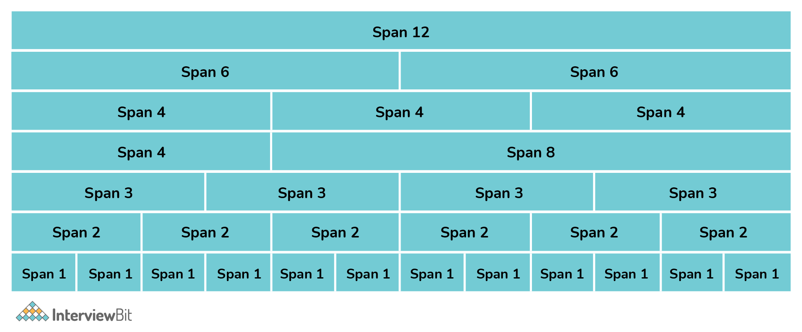

5. What is the difference between Bootstrap 4 and Bootstrap 5
PARAMETER | BOOTSTRAP 4 | BOOTSTRAP 5
Grid System | 5 tier grid system(xs, sm, md, lg, xl). | 6 tier grid system(xs, sm, md, lg, xl, xxl).
Color | It has limited colors. | Extra colors have been added with the looks.
Jquery | It has jQuery along with all the related plugins. | Jquery is removed and it has switched to vanilla JS with some working plugins.
Internet Explorer | Bootstrap 4 supports both IE 10 and 11. | Bootstrap 5 doesn’t support IE 10 and 11.
Form elements | Radio buttons and checkboxes look different in different OS and browsers. | The look of form elements does not change on different OS or browsers.
Utilities API | Utilities cannot be modified in Bootstrap 4. | Bootstrap 5 allows us to modify and also create our own utility.
Vertical Classes | Relative positioning of columns is allowed. | Relative positioning of columns is not allowed.
Bootstrap Icons | Bootstrap 4 doesn’t have its own SVG icons. | Bootstrap 5 has its own SVG icons.
Jumbotron | Bootstrap 4 supports the jumbotron. | Bootstrap 5 doesn’t support the jumbotron.
Card deck | The card deck class, used to create a set of cards with equal width and height, is available in bootstrap 4. | Card deck class has been removed in bootstrap 5.
Navbar | We have the inline-block attribute, and the default for the dropdown-menu-dark class is a white dropdown. | The inline-block property has been removed, and the dropdown-menu-dark class now uses a black dropdown as the default.
Static Site Generator | Jekyll software is used by Bootstrap 4. | Hugo software is used by Bootstrap 5.

