ONLINE CAR BOOKING

APPLICATION

ITMD 510

PROJECT PHASE – I

## Table of Contents

DESCRIPTION OF THE PROJECT 2

MAIN MENU FOR ONLINE CAR BOOKING APPLICATION 2

CLASS DESCRIPTION 2

UML DIAGRAM 3

DDL STATEMENTS 4

Table Creation 4

LIST OF DATABASE ENTITIES 6

ENTITY RELATIONSHIP DIAGRAM 6

s

# DESCRIPTION OF THE PROJECT

The project is about online car reservation system where cars can be booked for rental by the customers based on the availability of the cars. This application can be accessed by two types of users.

* Administrator
* Customer

Administrator will add, Update and Delete the car details and the accident history of the customer. The customers can book the cars, cancel the booking, make payment, view the booking and payment details.

# MAIN MENU FOR ONLINE CAR BOOKING APPLICATION

* *Administrator:*
  + Login
  + Add and delete the car details.
  + Add and update the accident history of the customer.
  + Logout
* *Customer:*
  + Login
  + Book available car for rental
  + Make payment for the rental car
  + View the availability of the cars for rental
  + View the payment made for the car rental
  + Logout

# CLASS DESCRIPTION

* The cardDetails acts as a superclass which has the sub class as Admin and Customers.

* CustomerOperations and AdminOperations acts as interface which is being implemented by Admin and Customers.

* There is a logical relationship between the customer and the booking details.

* Customer has the privileges to make booking, view the booking, make payments, view the payment confirmation, view car details and also can cancel the booking made.

* Admin has the privileges to add and update the car details and also add and update the accident history details.

# UML DIAGRAM

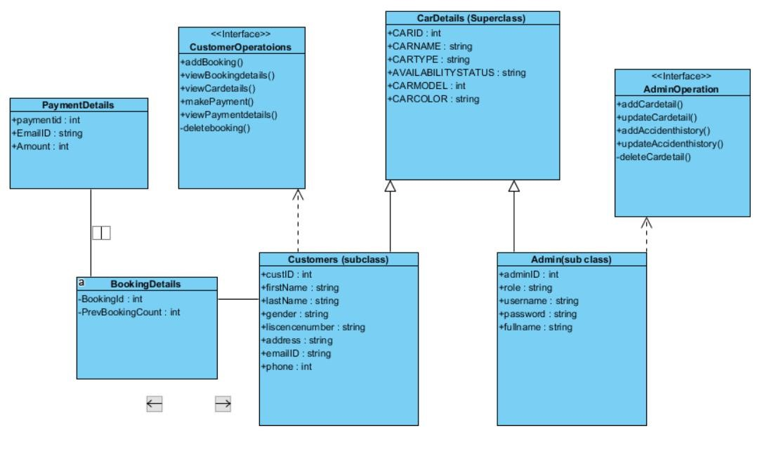





**ITM –Assignment**

**(EXTRA CREDIT)**

# DDL STATEMENTS

Below are the CRETAE TABLE queries that are used to create table.

# TABLE CREATION

**CUSTOMERS Table:**

CREATE TABLE customers (

Custid number NOT NULL PRIMARY KEY, Adminid varchar(20), firtname char(10), lastname char(10),

Gender Char(5),

Liscencenmbr varchar(20), Adress varchar(15), emailID varchar(15),

phone number,FOREIGN KEY (adminid) REFERENCES administ (Adminid));

**CarDetails Table:**

CREATE TABLE CarDetails (

CarId number NOT NULL PRIMARY KEY, custid number,

FOREIGN KEY (custid) REFERENCES customers (custid),

Adminid varchar(20),

FOREIGN KEY (Adminid) REFERENCES Administ (Adminid), carname char(10), cartype char(10), availabilitystatus Char(5), carModel number,

carcolor char(5));

**PAYMENT Table:**

CREATE TABLE paymentdetails ( PayId number NOT NULL PRIMARY KEY, carid number,emailID varchar(15),

Amount number, FOREIGN KEY (carid) REFERENCES cardetails (carid), custid number,FOREIGN KEY (custid) REFERENCES customers (custid) );

**ACCIDENTHISTORY Table:**

CREATE TABLE AccidentHistory (

AccID number NOT NULL PRIMARY KEY,

TicketType varchar(5),

Fineamount number, city char(10), Accidentdate date, NmbrOftickets number, custid number, AdminID varchar(20),

FOREIGN KEY (custid) REFERENCES customers (custid),

FOREIGN KEY (Adminid) REFERENCES Administ (Adminid));

**BOOKINGDETAIL Table:**

CREATE TABLE Bookingdetails (

BookingId number NOT NULL PRIMARY KEY, custid number, Prevbookingcount number,

carid number, FOREIGN KEY (custid) REFERENCES customers (custid),

FOREIGN KEY (carid) REFERENCES cardetails (carid));

**ADMINIST Table:**

CREATE TABLE Administ( Adminid varchar(10) primary key, custid number,role varchar(20), username varchar(20) not null,

password varchar(20),FullName varchar(20));

# LIST OF DATABASE ENTITIES

The list of table names that has been used to develop this project are,

• ORA_ADMINIST • ORA_CUSTOMERS • ORA_ACCIDENTHISTORY • ORA _CARDETAILS • ORA_PAYMENTDETAILS • ORA_BOOKINGDETAILS

# ENTITY RELATIONSHIP DIAGRAM

