
Sainatha Reddy
Emerging Ai/Data Engineer




Swiggy Food Delivery
End‑to‑End Data Engineering on Microsoft Fabric


Sainatha Reddy
Emerging Ai/Data Engineer
Swiggy Food Delivery – End‑to‑End Data Engineering on Microsoft Fabric
Lakehouse · PySpark Notebooks · Data Pipelines · Warehouse · Star Schema · Power BI Executive Summary
- Business analogy: Like a food delivery platform, we ingest orders (Bronze), clean them (Silver), package for analytics (Gold), move to a serving counter (Warehouse), and plate insights in a report (Power BI).
- Grain: one row = one order. Core measures: revenue, AOV, delivery minutes, ratings.
- Architecture: Lakehouse (Delta) → PySpark cleaning → Pipeline copy → Warehouse EDA → Star Schema → Power BI.

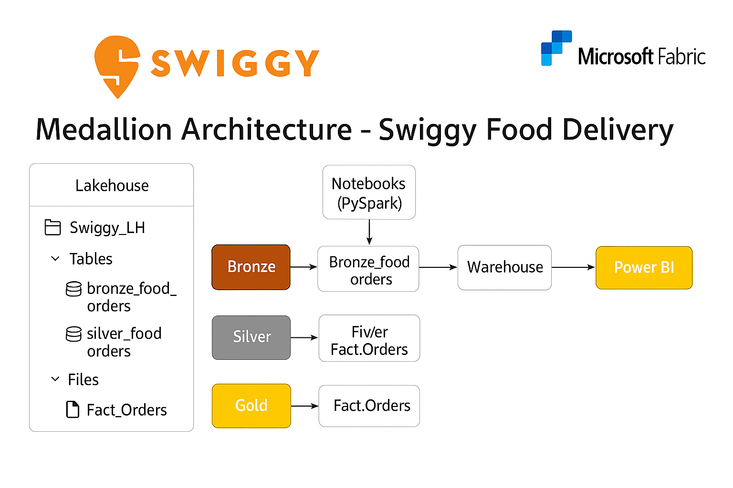

Sainatha Reddy
Emerging Ai/Data Engineer

Lakehouse – Swiggy_LH
- What it is: Fabric’s storage + SQL endpoint for Delta tables and files.
- How we created: New Lakehouse → upload CSV to Files/Bronze → create Bronze/Silver tables.
- Why it matters: Single place to land and govern data; Delta enables ACID & time travel.
- medallion layers; managed vs external data; Delta benefits; V‑Order/OPTIMIZE basics.
- Checks: row counts ≈ CSV; table schemas; permissions; SQL endpoint connectivity.

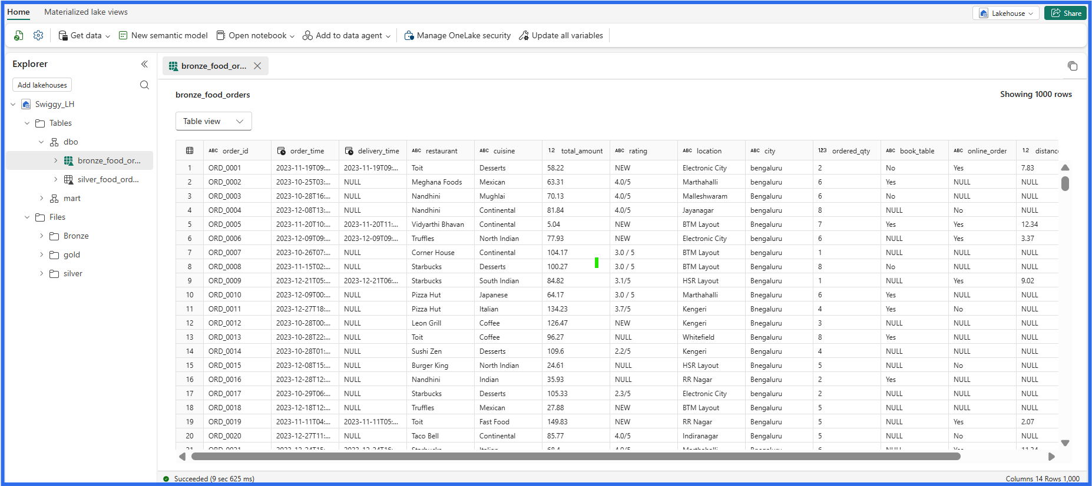


Sainatha Reddy
Emerging Ai/Data Engineer

Notebooks (PySpark) – Cleaning to Silver
What: Code to standardize strings, parse ratings (e.g., '4.5/5'→4.5), normalize flags, enforce integrity.

- How: Read CSV → trim/initcap/regex → cast amounts → set delivery fields to NULL for offline → derive delivery_minutes → write Delta Silver.
- Why: Silver = business‑truth layer; consistent types; rules documented & testable.
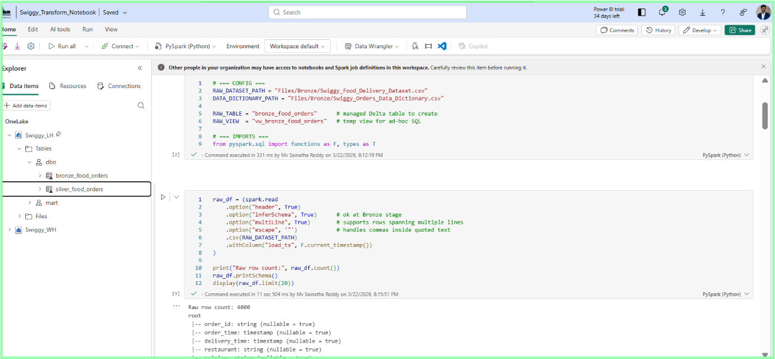
- Checks: no negative amounts; ratings in [0,5]; offline rows have no delivery_time/distance.

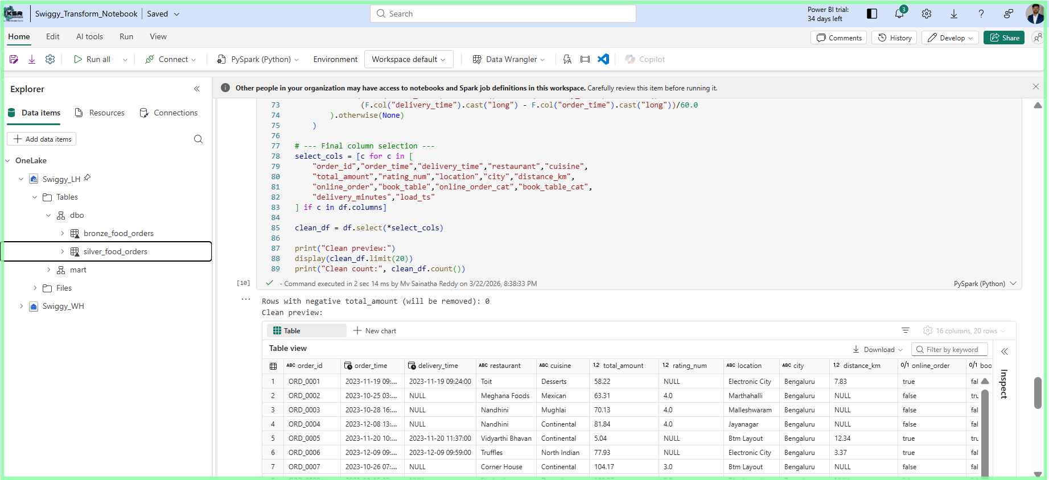

Data Pipeline – Lakehouse → Warehouse (Copy)
- What: Orchestrates Load using Lookup → ForEach → Script → Copy → Notifications (Email/Teams).
- How: Dynamic expressions for table names (Schema/TableName), optional Get Metadata → IF branch.
- Why: Repeatable movement to serving layer; CI‑friendly; parameterized.
- Interview hits: pipeline().parameters vs variables(); @item(); error handling & retry; run history.
- Expressions: Lakehouse table = @concat(Schema,'/',TableName); Warehouse table = @concat(Schema,'.',TableName).

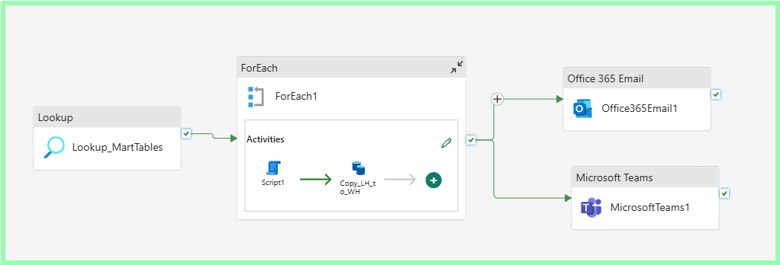
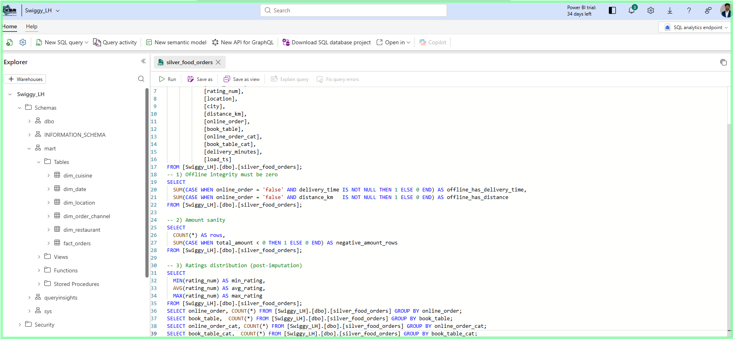

Sainatha Reddy
Emerging Ai/Data Engineer

Warehouse – Swiggy_WH (EDA & Serving)
- What: Fabric’s SQL engine (Polaris) to run T‑SQL and expose tables to BI/Apps.
- How: Copy Silver → Warehouse table (dbo.silver_food_orders); run EDA (20 questions).
- Why: Scalable SQL analytics; source for star schema and reports.
- Interview hits: bit vs text flags; window functions; TOP WITH TIES; correlation formula; query plan basics.
- Checks: counts match Silver; NULL/constraint sanity; permissions & endpoint.

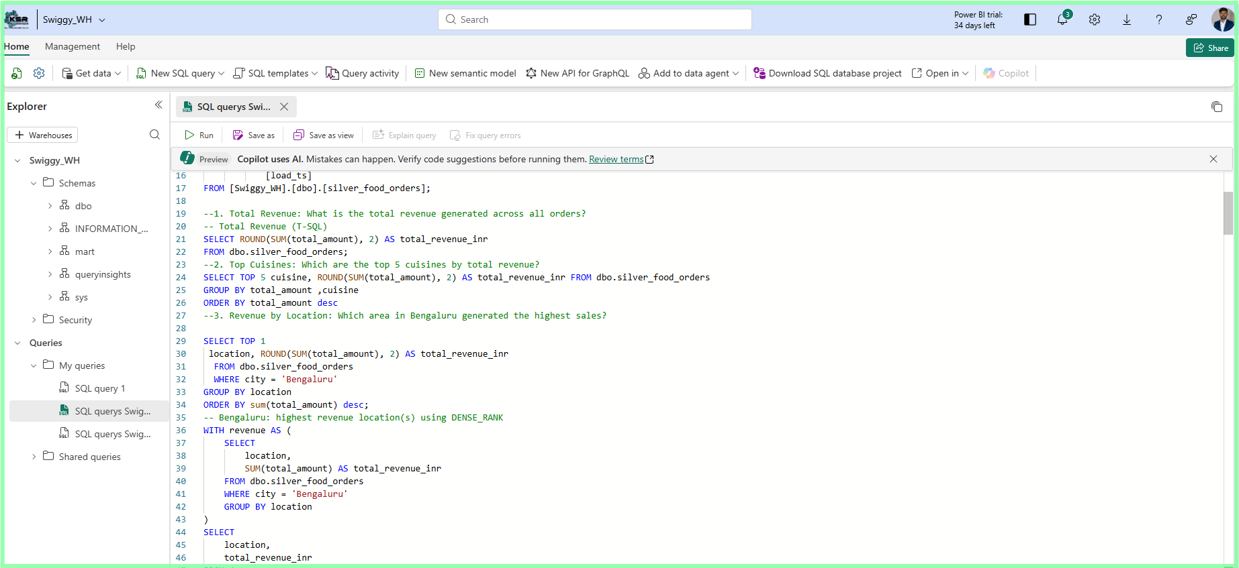
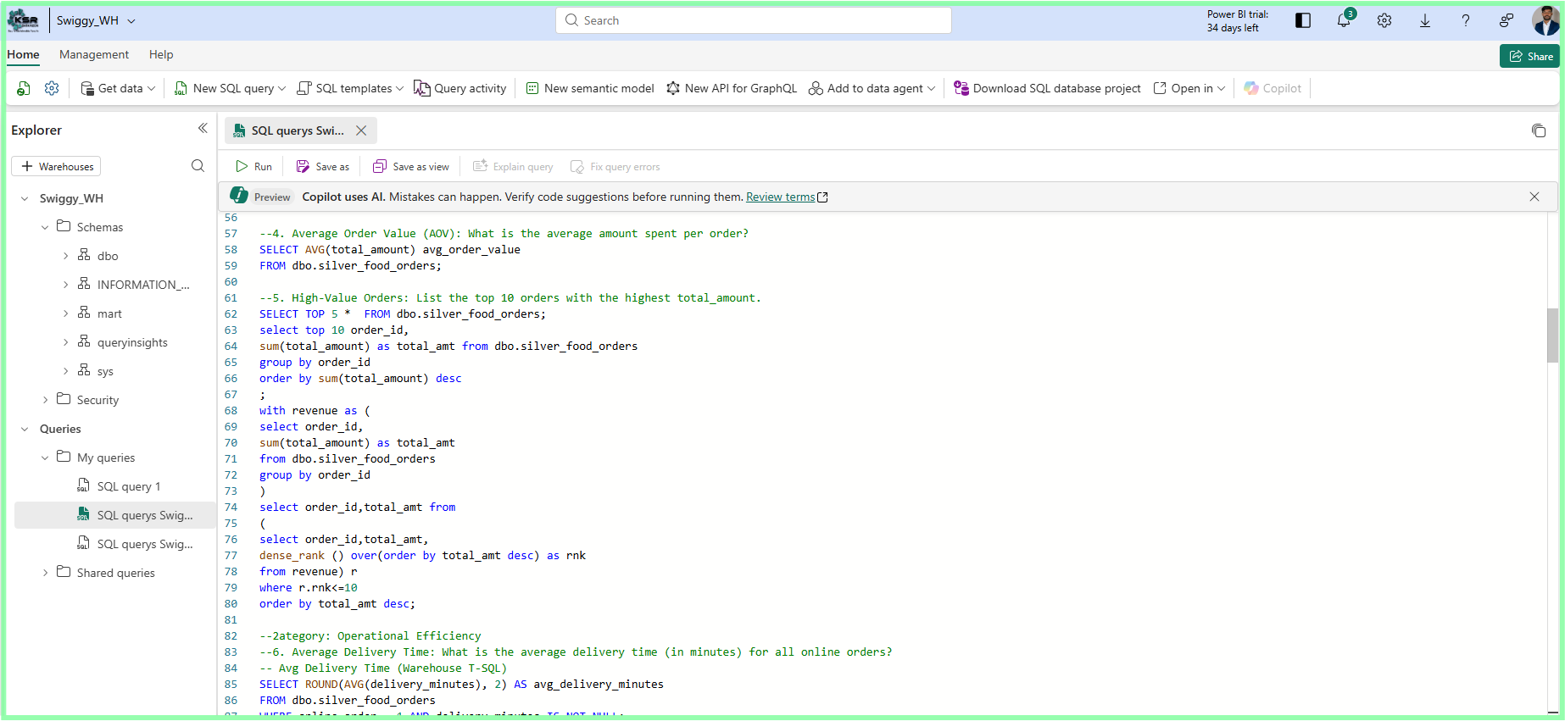

Sainatha Reddy
Emerging Ai/Data Engineer

Dimensional Modeling – Star Schema
- Fact_Orders (grain: 1 order): amounts, distance, delivery_minutes, rating_num + FK keys.
- Dimensions: Restaurant, Location, Time (date+hour), Order_Type (Online/Dine‑In/Walk‑In).
- Keys: deterministic hashes for stable surrogate keys; keep order_id as degenerate dim.
- Why: Simplifies DAX/SQL, improves performance, enables conformed dimensions.
- Interview hits: grain first; SCD strategy (Type‑1 here); degenerate dimensions; surrogate key rationale.

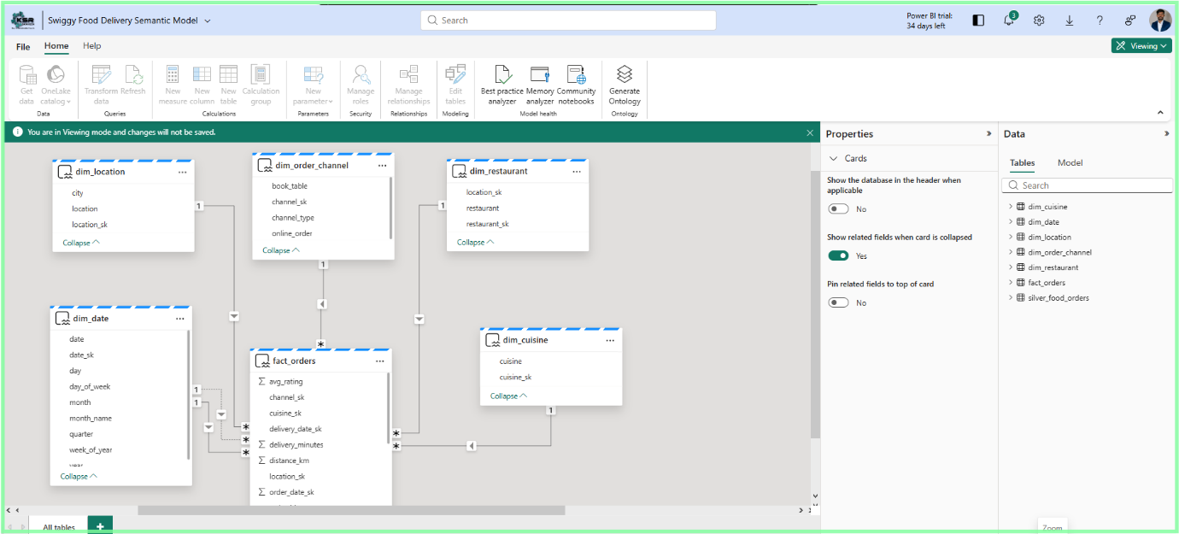

Power BI – Swiggy Delivery Summary
- What: Dashboard over Warehouse/Star with KPIs (Revenue, Orders, Delivery Minutes, Ratings).
- How: Import semantic model → measures → visuals (Top cuisines, Avg rating, Peak hours).
- Why: Last‑mile insights; shareable and monitored.
- Interview hits: Performance Analyzer (DAX vs render), display folders, hide FKs, measure naming.
- Checks: card values tie to Warehouse; filters behave; accessible colors.


Sainatha Reddy
Emerging Ai/Data Engineer

Model Hygiene – Best Practice Analyzer (Tabular Editor)
- What: Rule‑based scan for naming, DAX, metadata hygiene.
- How: Load Microsoft BPA rules → run → fix → re‑test with Performance Analyzer.
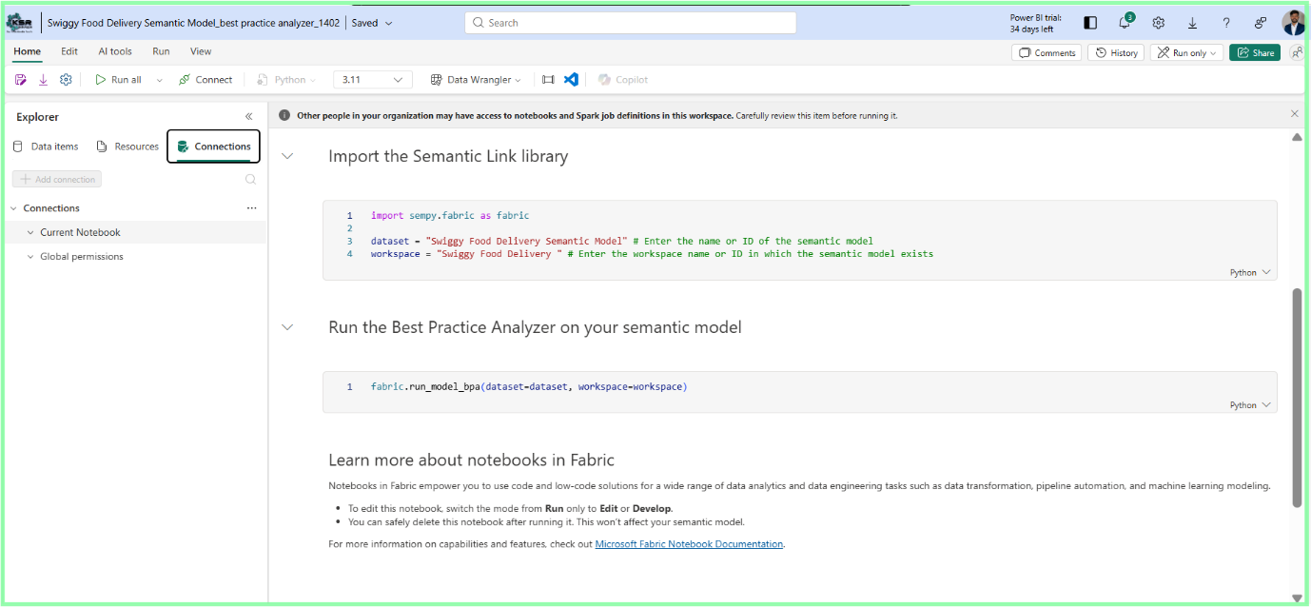
- Why: Faster models, fewer issues in prod
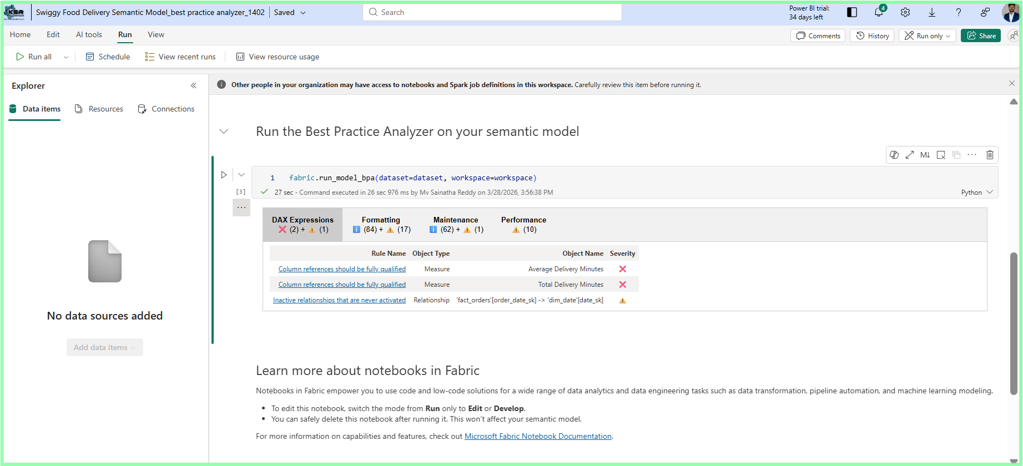

Quality Checks & Runbook
- DQ: row counts, ranges, integrity, reconciliation with visuals.
- Runbook: 1) Ingest to Bronze 2) Notebook → Silver 3) Pipeline → WH 4) EDA 5) Star 6) Report 7) BPA/Perf.

Interview Quick‑Recap (short answers)
- Medallion in one line: Bronze keeps raw truth; Silver enforces rules; Gold optimizes for analytics.
- Grain: one order per row → avoids double counting and makes AOV simple.
- Offline rule: no delivery_time/distance for offline orders → protects metrics.
- Peak hours: group by DATEPART(HOUR) not full timestamp; use WITH TIES/DENSE_RANK for ties.
- Booking effect: compare AVG(total_amount) between book_table=1 vs 0; show lift %.
- Delivery success: online_order=1 AND delivery_time IS NOT NULL over all online orders.
- Star schema: surrogate keys, degenerate order_id, Type‑1 dims here; SCD2 if slowly changing.
- Pipeline: parameterized table names and Get Metadata branching; ForEach for multiple tables.
- Power BI performance: use Performance Analyzer; hide FKs; measures only from fact; simple visuals.
- BPA: run Microsoft rules; fix naming, unused columns, format; re‑test performance.

Appendix – Screenshot Placeholders (add later)
- Lakehouse overview, Tables pane, SQL endpoint.
- Notebook cells (cleaning), Silver preview.
- Pipeline canvas & run history, parameter dialog.
- Warehouse query results, star schema DDL/run.
- Power BI summary page, Performance Analyzer panel.
- BPA results pane.
- Team‑specific: environment/capacity, lineage, governance notes.

