# ADF Pipeline Documentation: OnPremData2Cloud

## Introduction

This document provides a overview of the Azure Data Factory (ADF) pipeline titled 'OnPremData2Cloud'. The pipeline is designed to dynamically copy all tables from an on-premises MySQL database to Azure SQL Database. It uses a parameterized and scalable approach to detect and process all base tables in the source schema.

MySQL:

ADF:

## Pipeline Components and Flow

### 1. Lookup Activity – Get Table Names

Purpose: Dynamically fetches all table names from the MySQL schema 'amazon_db'.  
Query Used:

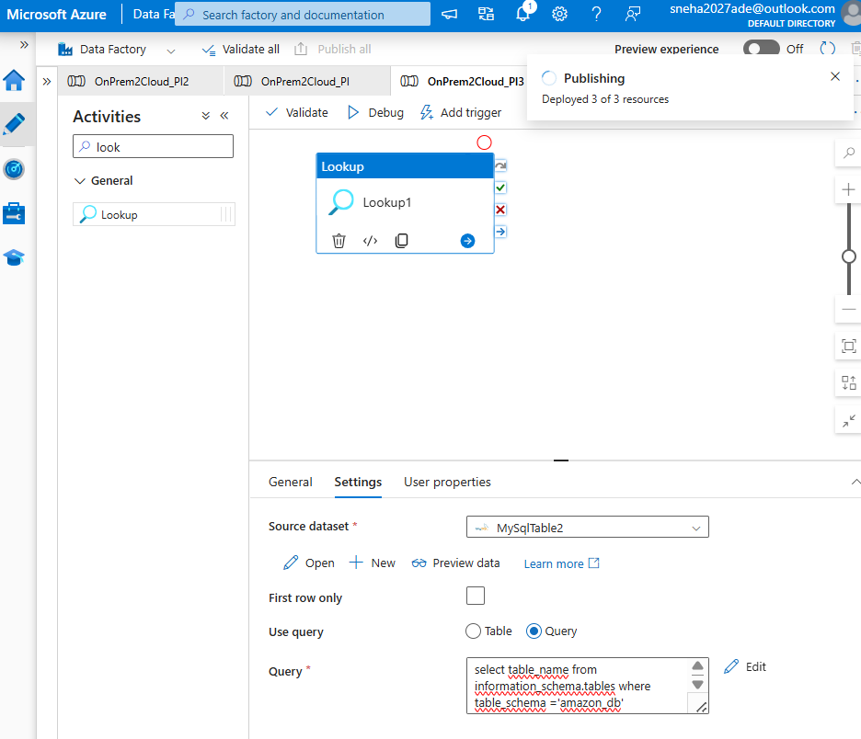  
SELECT table_name FROM information_schema.tables WHERE table_schema = 'amazon_db' AND table_type = 'BASE TABLE';  
Output: A JSON array of table names such as bike_data, car_data, customer_tb, employee, student_info.

### 2. ForEach Activity – Loop Over Tables

Purpose: Iterates over each table name returned by the Lookup activity.  
Input: The 'value' array from the Lookup output.  
Note: Only the 'TABLE_NAME' field is used inside the loop.

### 3. Copy Activity – Copy Table Data

Purpose: Copies data from each MySQL table to Azure SQL DB.  
Source:  
- Type: MySqlSource  
- Query: Dynamically generated using @concat('SELECT * FROM ', item().TABLE_NAME)

Sink:  
- Type: Azure SQL Database  
- Behavior: Auto-creates the destination table with inferred schema  
- Linked Service: Azure SQL DB connection  
Parameterization: The table name is passed dynamically using the item().TABLE_NAME expression.

Parameters for output data:

## Linked Services

- MySQL Linked Service: Connects to the on-premises MySQL database.

- Azure SQL Linked Service: Connects to the Azure SQL Database where data is loaded.

Publish all:

## Execution Summary

Tables Processed: 5  
- bike_data  
- car_data  
- customer_tb  
- employee  
- student_info  
Integration Runtime: integrationRuntime1  
Billing:  
- Self-hosted IR: 0.0167 hours  
- Azure IR: 0.0667 hours

## Troubleshooting Note

Issue Encountered:  
ErrorCode=UserErrorInvalidValueInPayload  
Message=Failed to convert the value in 'table' property to 'System.String'  
Cause: The ForEach activity was incorrectly configured to use the entire object instead of just the TABLE_NAME string.  
Fix: Ensure the ForEach activity uses @item().TABLE_NAME when passing the table name to the Copy activity.

## Key Learnings

- ADF can dynamically loop through tables using Lookup + ForEach.  
- Parameterized queries allow flexible and reusable pipelines.  
- Auto-creation of sink tables simplifies schema management.  
- Proper payload structure is critical to avoid runtime errors.

d

d

d

d