basic Java web application that manages a collection of books with the basic feature: list, insert, update, delete (or CURD operations - Create, Update, Read and Delete). The application looks something like this:

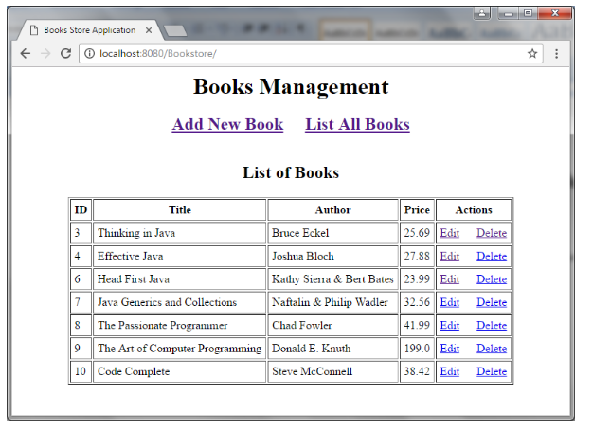
You will learn to how to build this application using the following technologies:
- Java Servlets and Java Server Pages (JSP)
- JSP Standard Tag Library (JSTL)
- Java Database Connectivity (JDBC)
- MySQL database
- Apache Tomcat Server

Creating MySQL Database
- For simplicity, we have only one table. Execute the following MySQL script to create a database named Bookstore and a table named Book:
CREATE DATABASE 'Bookstore';
USE Bookstore;

CREATE TABLE book(
book_id int(11) NOT NULL AUTO_INCREMENT,
title varchar(128) NOT NULL,
author varchar(45) NOT NULL,
price float NOT NULL,
PRIMARY KEY (book_id)
);

1) Writing Model Class
Next, create a Java class named Book.java to model a book entity in the database2
2) Coding DAO class
Next, we need to implement a Data Access Layer (DAO) class that provides CRUD (Create, Read, Update, and Delete) operations for the table book in database e(BookDAO).
The following methods are for CRUD operations:
- Create: insertBook(Book)- this inserts a new row into the table book.
- Read: listAllBooks() - this retrieves all rows; and getBook(id)- returns a specific row based on the primary key value (ID).
- Update: updateBook(Book)- this updates an existing row in the database.
- Delete: deleteBook(Book) - this removes an existing row in the database based on the primary key value (ID).

3) DBUTIL class

4) Writing Book Listing JSP Page
Next, create a JSP page for displaying all books from the database.( BookList.jsp)

5) Writing Book Form JSP Page
Next, we create a JSP page for creating a new book called BookForm.jsp.

6) Coding Controller Servlet Class
Now, the most difficult but interesting part is implement a Java Servlet that acts as a page controller to handle all requests from the client (BookController)

This page shows new form like this:
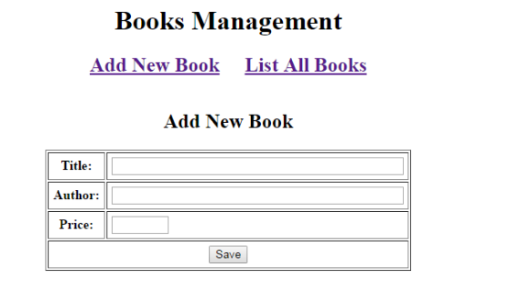
And on editing mode:
