1. CheckSum of OddDigi

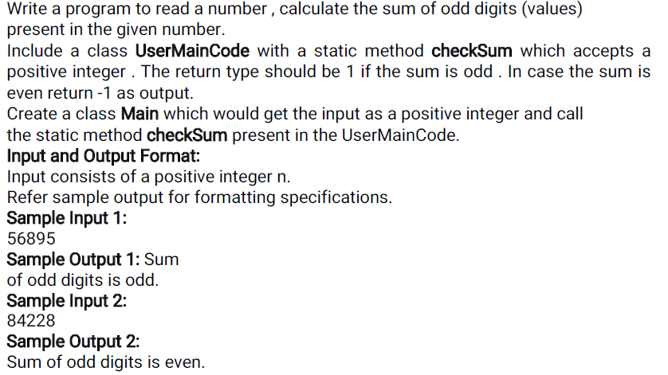
Main:
=====
Import java.util.*;
public class Main{
public static void main(String[] args)
{

}
}

USERMAINCODE:

public class UserMainCode {
public static int checkSum ( int n)
{

}

2. Number Validation:
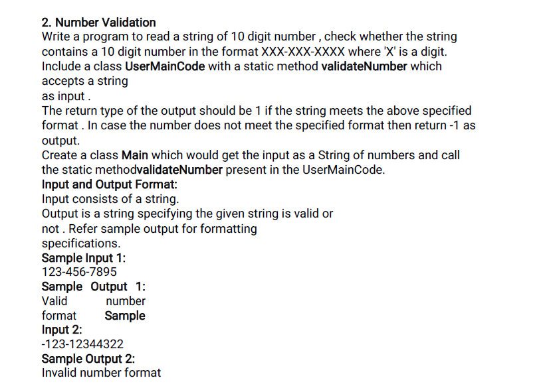

Main:
=====
Import java.util.*;
public class Main{
public static void main(String[] args)
{

}
}

USERMAINCODE:

public class UserMainCode {
public static int validateNumber (String number)
{

}

3. Sum of Squares of Even Digit

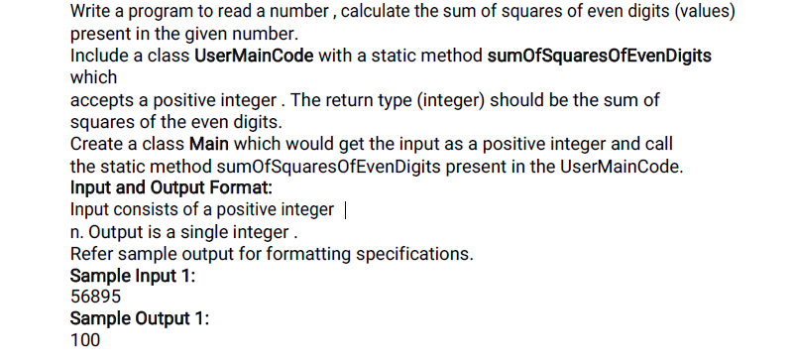

Main:
=====
Import java.util.*;
public class Main{
public static void main(String[] args)
{

}
}
USERMAINCODE:

public class UserMainCode {
public static int sumOfSquaresOfEvenDigits(int n) {

}

4. Fetching Middle Characters from String

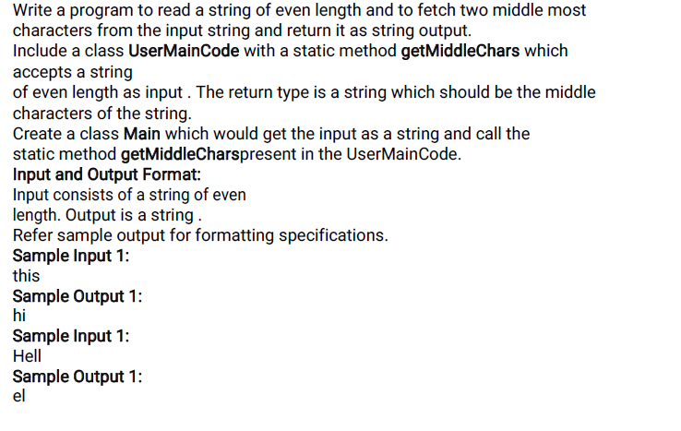

Main:
=====
Import java.util.*;
public class Main{
public static void main(String[] args)
{

}
}
USERMAINCODE:

public class UserMainCode {
public static String getMiddleChars(String st)
{
}

5. Check Characters in a String

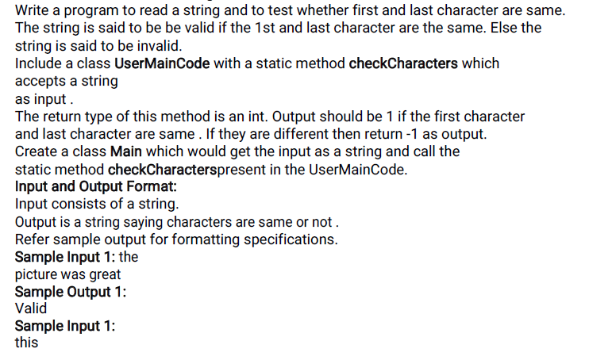


Main:
=====
Import java.util.*;
public class Main{
public static void main(String[] args)
{

}
}
USERMAINCODE:

public class UserMainCode {
public static int checkCharacters(String input)
{
}

