Lab : Strings, I/O Formatting and Parsing

Exercise 1: Write a Java program that reads a line of integers and then displays each integer and the sum of all integers.
Exercise 2: Write a Java program that reads a file and displays the file on the screen, with a line number before each line?
Exercise 3: Write a Java program that displays the number of characters, lines and words in a text?
Exercise 4: Write a Java program that reads on file name from the user, then displays information about whether the file exists, whether the file is readable, whether the file is writable, the type of file and the length of the file in bytes?
5)
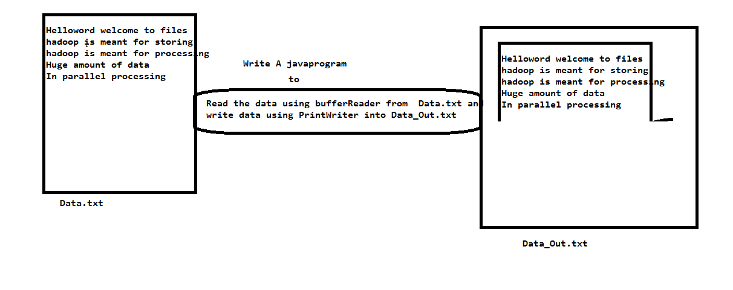

6. Forming New Word from a String
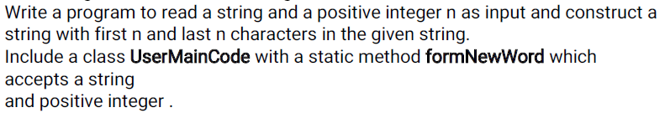
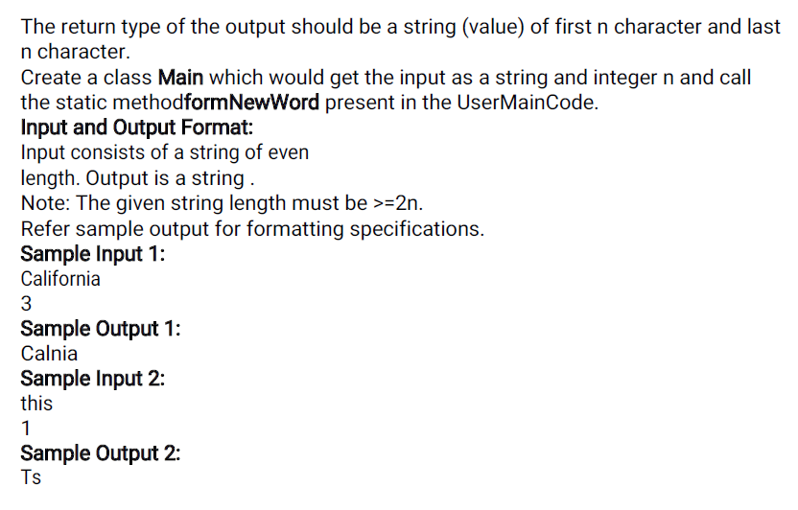
MAIN:
=====
Import java.util.*;
Public class Main {
Public static void main (String [] args)
{

}}
USERMAINCODE:
==============
public class UserMainCode {
public static String formNewWord (String s1, int n) {
}}

7. Reversing a Number
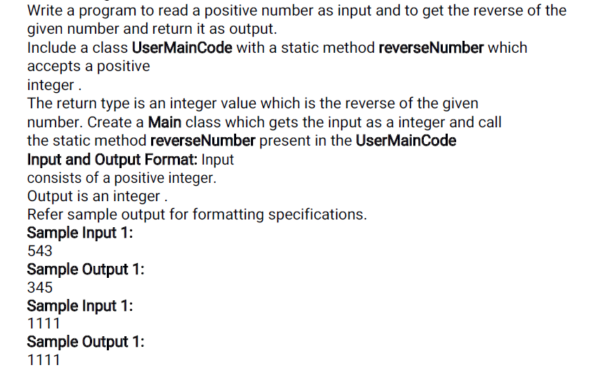

MAIN:
=====
Import java.util.*;
Public class Main {
Public static void main (String [] args)
{

}}
USERMAINCODE:
==============
public class UserMainCode {
public static int reverseNumber(int n){
}
}

