9. Validating Date Format
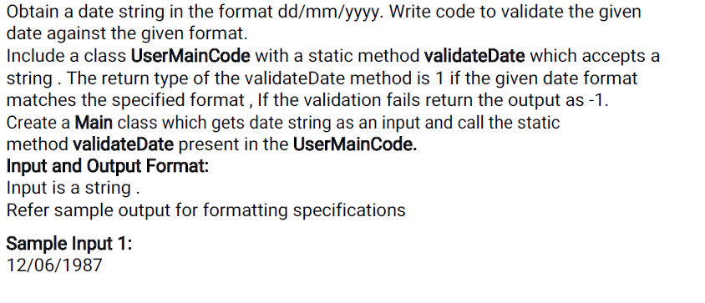
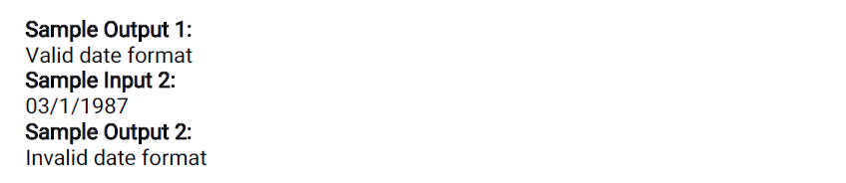
Main:
=====
Import java.util.*;
Public class Main {
Public static void main (String [] args)
{
}
UserMainCode:
============
import java.util.*;
import java.text.*;
public class UserMainCode{
public static int validateDate(String s1){

}}

10. Validate Time

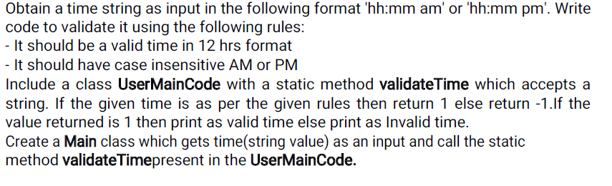
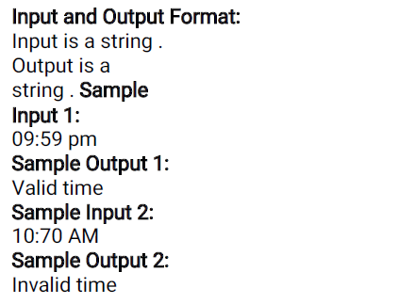

Main:
=====
Import java.util.*;
Public class Main {
Public static void main (String [] args)
{
}
UserMainCode:
============
import java.util.*;
import java.text.*;
public class UserMainCode{
public static int validateDate(String str){

}}

15. Difference between largest and smallest elements in an array

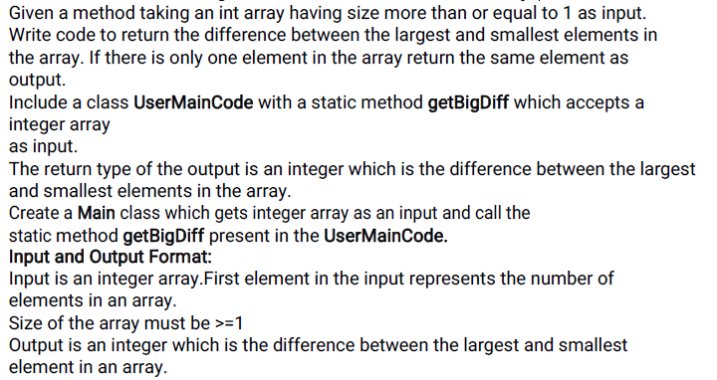
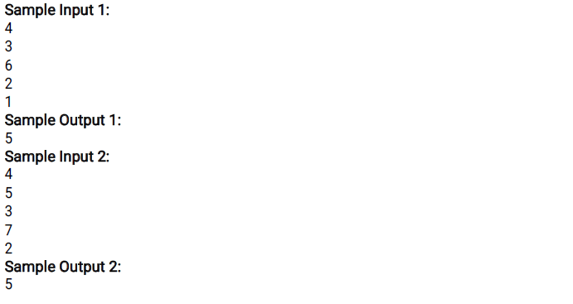

Main:
=====
Import java.util.*;
public class Main {
public static void main (String [] args)
{
}
UserMainCode:
============
import java.util.*;
import java.text.*;
public class UserMainCode{
public static int getBigDiff(int[] a, int n){

}}

16. Find the element position in a reversed string array

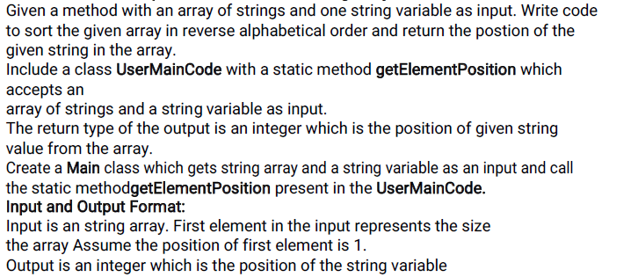
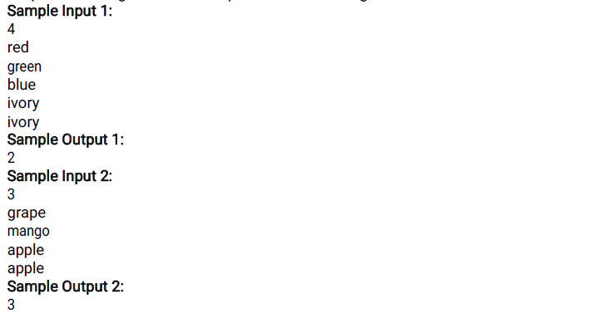

Main:
=====
Import java.util.*;
public class Main {
public static void main (String [] args)
{
}
UserMainCode:
============
import java.util.*;
import java.text.*;
public class UserMainCode{
public static void getElementPosition(String[] a, String b) {
}}

18. Calculate Electricity Bill
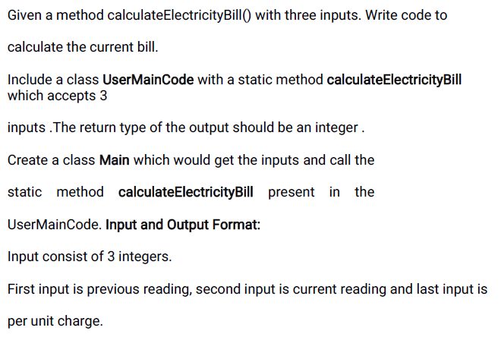
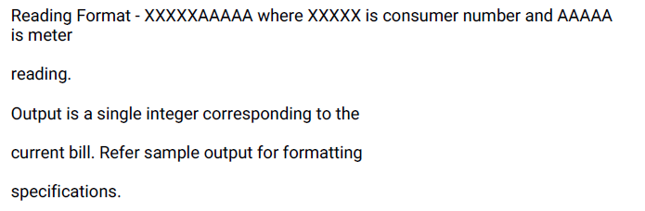
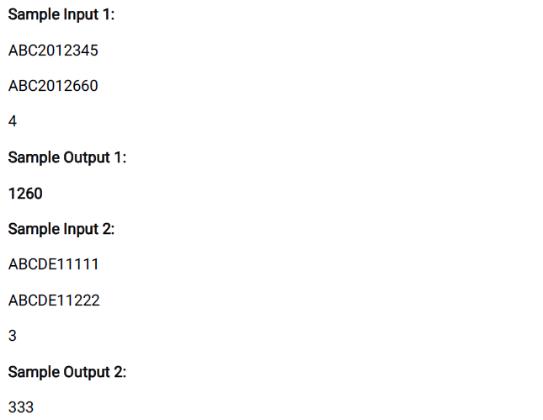

Main:
=====
Import java.util.*;
public class Main {
public static void main (String [] args)
{
}

UserMainCode:
============
import java.util.*;
import java.text.*;

public class UserMainCode{
public static int calculateElectricityBill(String input1,String input2,int input3) {

}}

