Questions

1.Product Bill Calculation
ZEE Shop wants to provide discount for the products purchased by their customers and generate bill. Help ZEE Shop to automate the above process with the help of java.
In the Product class include the given attributes and methods with the access specifiers as specified in the class diagram. The getter methods are used to retrieve the value.

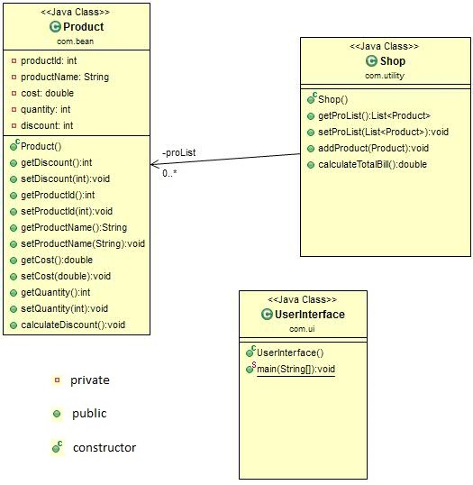

The calculateDiscount method should calculate discount based on the total price. The total price needs to be calculated for each product based cost and quantity. The discount should be set to the discount attribute.
totalPrice=unitPrice * quantity
Discount should be calculated based on the below conditions
TotalPrice | Discount Percentage
<500 | 0
>=500 && <=1000 | 10
>1000 | 20

The addProduct method of Shop class accepts Product object as argument and adds it to the productList. The product object passed should hold all the values including the discount percentage.
The calculateTotalBill method should return the total amount as double based on the cost , quantity and discount of each product in the list. If the list is empty the method should return -1.
[Total Amount= [cost* quantity –(cost*quantity*discount/100)]] of each product in the list and return the sum.
Note: The attribute/method/class name should be specified correctly as given in the class diagram.
Sample Input and Output:
Enter the number of products
3
Enter the product details
Enter the product id:
1
Enter the product name:
Furniture
Enter the cost:
500
Enter the quantity:
5
Enter the product details
Enter the product id:
2
Enter the product name:
Eraser
Enter the cost:
5
Enter the quantity:
2

Enter the product details
Enter the product id:
3
Enter the product name:
Bags
Enter the cost:
100
Enter the quantity:
5

Calculated Bill Amount:2460.0

2. Team Email Ids
The HR of a leading software company wants to categorize their employee official mail ids based on their team to communicate with employees.
Help them by writing a Java program to store the details of Employees as key-value pair with the team name as key and the list of official mail ids as values.

Consider the class given below:

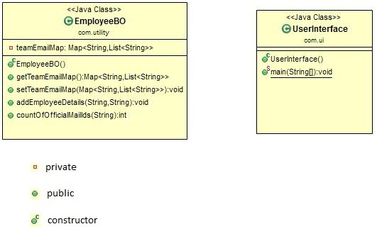

The public void addEmployeeDetails (String teamName,String officialMail) method should add teamName as key and add the officialMail in the list as values in Map. If the teamName(key) is already available in the map then add the officialMail into the list which is already available as value.

If the teamName(key) is not available in the map then add the teamName as key into the map and create a new list as value corresponding to the key and add the officialMail into that list.

The public int countOf OfficialMailIds(String teamName) method should return the number of official Mail ids available in the list corresponding to the teamName (key) passed as argument (String) to this method.

In the Map, if no key matches(case-insensitive) with the teamName which was passed as an argument, then the method has to return -1.

Note: teamName is case-insensitive. Use appropriate collection to maintain insertion order while adding elements into Map and List.

The signature of the above methods are given as part of code skeleton, do not change the method signature.

Sample keys and values of Vechicle Details:
Key(String) | Value (List<String>)
Corporate | [john@leadingsoft.com,joyson@leadingsoft.com]
HR | [jacob@leadingsoft.com]
Admin | [james@leadingsoft.com,cristy@leadingsoft.com]

In main class create a main method with the menu as described in sample Input and Output. When user selects the option 1. Add Employee Details, it should get the teamName (String) and OfficialMail (String) from the user and invoke the method addEmployeeDetails (String teamName,String OfficialMail).
When user selects the option 2. Number of Official Email, it should get the teamName (String) as input from the user and invoke the method countOfOfficialMailIds(String teamName) and display the count returned from the method.

When user selects the option 3. Exit, display the message "End" and terminate the program.

Sample Input and Output 1:
1. Add Employee Details
2. Number of Official Email
3. Exit
Enter your choice
1
Enter the Team Name
Corporate
Enter the official mail id
john@leadingsoft.com
1. Add Employee Details
2. Number of Official Email
3. Exit
Enter your choice
1
Enter the Team Name
HR
Enter the official mail id
jacob@leadingsoft.com
1. Add Employee Details
2. Number of Official Email
3. Exit
Enter your choice
1
Enter the Team Name
corporate // note teamName is case-Insensitive
Enter the official mail id
joyson@leadingsoft.com
1. Add Employee Details
2. Number of Official Email
3. Exit
Enter your choice
1
Enter the Team Name
Admin
Enter the official mail id
james@leadingsoft.com
1. Add Employee Details
2. Number of Official Email
3. Exit
Enter your choice
1
Enter the Team Name
Admin
Enter the official mail id
cristy@leadingsoft.com
1. Add Employee Details
2. Number of Official Email
3. Exit
Enter your choice
2
Enter the team Name to find number of official mail
corporate // note teamName is case-Insensitive
2
1. Add Employee Details
2. Number of Official Email
3. Exit
Enter your choice
3
End

Note:
Once completed the Case Study convert the Project into Zip folder and named As ID_NAME (ex:- 3233_Asish.zip) .
Upload the Case Study Zip into below URL
https://docs.google.com/forms/d/e/1FAIpQLSdhCJbx3NHjTXh7dmReaoZMcO5mjCmZ8Krb3HKWnD4b83lvLw/viewform?usp=sf_link

