What is Angular?
- Angular is a client side framework, which is used to create web applications. The framework provides skeleton of the project and specifies clear guidelines, where to write which type of code.
- Angular can be used in combination with any server side platform such as Java, NodeJS, Asp.Net, PHP, Python etc.
- Angular is developed using "TypeScript" language, which is a superset of JavaScript language.
- Angular is the most-used client side framework.
- Angular was developed by Google.
- Angular is free-to-use (commercially too).
- Angular is open-source. That means the source code of angular is available online for free of cost.
- Angular is cross-platform. That means it works in all the operating systems.
- Angular is cross-browser compatible. That means it works in all the browsers, except less than IE 9 (which is completely outdated).
- Angular is mainly used to create "data bindings". That means, we establish relation between a variable and html element; when the value of the variable is changed, the same will be automatically effected in the corresponding html element; and vice versa. So that the developer need not write any code for DOM manipulations (updating values of html tags, based on user requirements. for example, updating the list of categories when a new category added by the user). Thus the developer can fully concentrate on the application logic, instead of writing huge code for DOM manipulations. So we can achieve clean separation between "application logic" and "DOM manipulations".

- Angular mainly works based on "Components". The component is a class, which represents a specific section (part) of the web page.

Goals of Angular
- Separation of DOM manipulation from application logic.
- Separation of HTML logic from application logic.
- Make SPA (Single Page Application) development easier. SPA provides client-side navigation system; but can communicate with server only through AJAX; the web page never gets refreshed fully. Ex: Gmail.
- Separation of business logic from application logic.
- Enable Unit testing. The components can be unit tested individually.

Versions of Angular
- Angular 2 : Sep 14th 2016
- Angular 4 : Mar 23rd 2017 [Angular 3.0 was skipped due to misalignment of router package 3.3.0]
- Angular 5 : Nov 1st 2017
- Angular 6 : May 4th 2018

Angular (vs) jQuery
- jQuery is a “library”, which provides a set of pre-defined functions to perform DOM manipulations directly.
- Angular is a framework, which provides the complete application structure and set of concepts to organize the client side code completely, which enables the developers to work with “Data bindings” to avoid DOM manipulations directly.

Angular (vs) React
- React just acts as a "view layer", which provides necessary concepts to create data bindings in the view.
- Angular is a "complete client side framework", which provides the complete application structure and set of concepts to organize the client side code completely, which enables the developers to work with “Data bindings” to avoid DOM manipulations directly.
- Angular provides so many concepts such as services, directives, dependency injection, routing etc., which are not supported by React.
Features of Angular
- TypeScript based: Pre-defined code and User-defined code is developed based on TypeScript language.
- Faster performance: “Angular 2+” executes faster than “AngularJS 1”.
- Modular: Angular is divided into multiple small parts called “packages”. For example, "core", "common", "forms", "router" etc. The developer can use any of those modules based on the requirement.

Browser Compatibility of Angular 2+
Angular 2+ supports the following browsers:

Browser | Supported Version
Google Chrome | Any Version
Mozilla Firefox | Any Version
MS Internet Explorer | 9+
MS Edge | 13+
Safari | 7+
Android Browser | 4.1+

FUNDAMENTALS OF ANGUALR

Building Blocks of Angular
Angular is composed with the following “building blocks”:

1. Component: Application state + Application logic

2. Metadata: Details about the component / module etc.

3. Template: Design logic (HTML)

4. Data Binding: Connection between HTML element and Component property

5. Module: Group of components, directives and pipes.

6. Service: Re-usable code / business logic.

7. Dependency Injection: Injecting (loading) Service objects into Components.

8. Directive: Manipulating DOM elements

9. Pipe: Transforming values before displaying

Angular Architecture
• Angular 2+ framework is built based on this architecture.

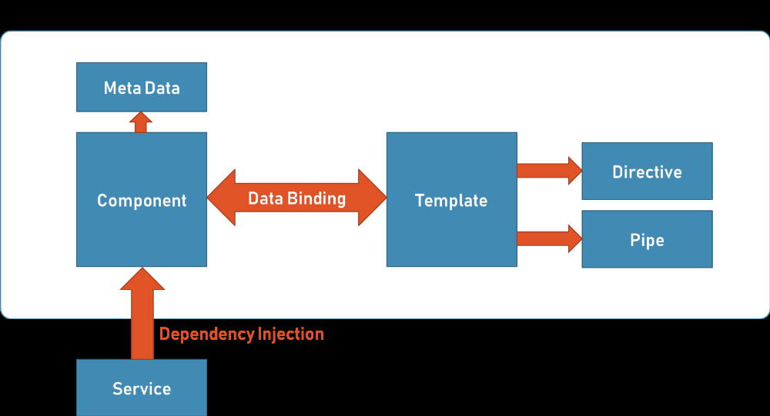

Types of compilation in Angular
• Angular framework supports two types of compilation.
Just-In-Time Compilation
- Templates (.html files) and angular compiler files will be loaded into the browser and then the templates will be compiled automatically at the time of execution, when the component is invoked.

- The template will be compiled only for the first time, when it invoked, after loading the application files into the browser.

- Disadvantage: Performance is slower, because every time when you run the application, the templates will be loaded into browser and compiled in the browser; it takes some time to compile.

- Advantage: The developer need not compile it manually at command prompt, for each modification of code.

- This is recommended during the development.
- Bootstrapping (loading app module into the browser) is done by “@angular/platform-browser-dynamic” package.

Ahead-Of-Time Compilation
- The developer gives “ngc” command in the Command Prompt; then the “ngc” compiler compiles the templates into javascript code; the compiled javascript code will be loaded into the browser and it directly executes. There is no need of loading “templates (.html files)” and “angular compiler scripts” into the browser.

- Advantage: Performance is faster, because the templates are already compiled.

- Disadvantage: The developer need to compile it manually at command prompt, for each modification of code.

- This is recommended in the production server only.
- Bootstrapping is done by “@angular/platform-browser” package.

Steps to develop angular application:
--------------------------------------------------
1) Installed the Node.js
2) Installed the TypeScript
Ex: npm install –g typescript

3) Installed the Angular using Cli

npm install –g @angular/cli

it will download all the angular packages(core, common , http..)
4) Create a one folder (workspace) On desktop named as angularprojects

5) Create an angular project (skeleton of project)

Cd angularprojects
angularprojects> ng new myapp note:- myapp is a projectName

6) Change the directory from angularprojects to myapp project
Cd myapp

myapp> ng serve or ng serve --o or ng serve –open

Note:- --o or –open automatically browser will opened on http://locahost:4200

Data Bindings:
------------------
The ‘data binding’ is the relation between “component” and the “template”.

When the value of component is changes, the “template” will be changed automatically. When the value of template is changed, the component will be
Changed automatically

Data Binding are four types:
1) Interpolation Binding
2) Property binding
3) Event Binding
4) Two-way Binding

Interpolation Binding
-----------------------------
Syntax: {{propertyName}}

It display the value of the property in the template.

When the value of the property is changed, the same value will be automatically updated in the template

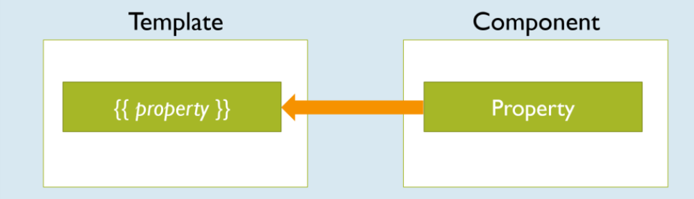

Property Binding:
------------------------
Syntax: <tag [attribute] =”propertyName”></tag>
“Property Binding” is used to send data from component to template and assign the same into an attribute of the tag.

When the value of the property is changed, the same value will be automatically
Updated in the template
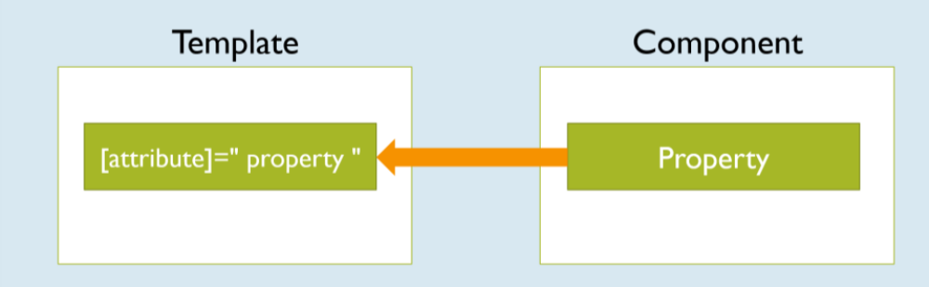

Event Binding:
------------------
Syntax: <tag (event) =”method ()”> </tag>
It is used to pass event notifications from template to component.

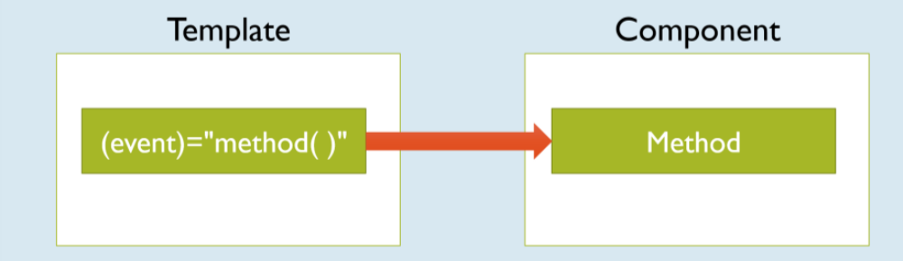

Two-Way Data Binding:
-------------------------------
Syntax:
<tag [(ngModel)] =”propertName”></tag

Two way data binding is a combination of both property binding and event binding

When you change the value of the property in component, the same will be automatically updated in the template (html)

When you change the value of html element (template), the same will be automatically updated in the property in component.

The “ngModel” is pre-defined directive, which is used to create two- way data binding.

Two-Way data binding is applicable only for <input> and <select> tags

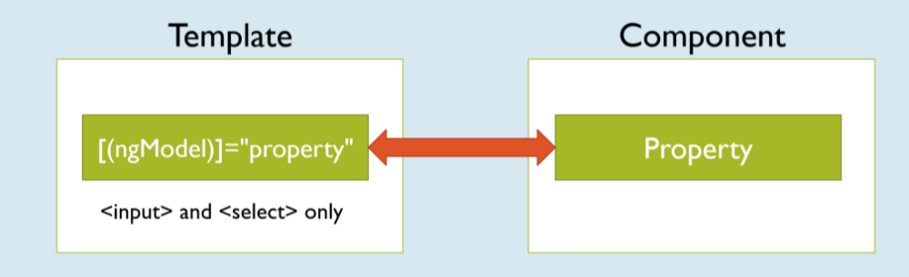
Note:
-------
FormsModule must be imported in order to use two-way data binding.

In app.module.ts we have imports array in this array we can specify FormsModule.

Ex:

import { FormsModule } from '@angular/forms';

imports: [
BrowserModule,
AppRoutingModule,
FormsModule
],

Built-In Directives
===============
Style
• It is used to set the CSS property value dynamically at run time.
• When the value of component property is changed, the value of css property will be automatically gets changed.

Syntax:
<tag [style.cssproperty] =”component property Name”>
</tag>
ngClass
• It is used to set the css class name dynamically at run time.
• When the value of component property is changed, the css class will be automatically changed.
• Use this directive to set styles with multiple properties, conditionally at runtime.
Syntax:
<tag [ngClass] =”component property”>
</tag>

ngIf
• The “ngIf” displays the element if the condition is “true”; otherwise the element will be deleted from DOM.
Syntax:
<tag *ngIf=”condition”>
</tag>
• The “ngIf” must be prefixed with “*”, to mark that it accepts “micro syntax”, which is not just an “expression”, it accepts its own syntax.
• Use “ngIf” if you want to display some content based on the condition. The content appears when the condition is true, it disappears when the condition is false.

ngIf and else
• The “ngIf and else” displays one element if it is “true”; otherwise it displays another element.
Syntax:
<tag *ngIf=”condition; then template1; else template2”>
</tag>
<ng-template #template1>
…
</ng-template>
<ng-template #template2>
…
</ng-template>
• The “ng-template” is a container, inside which you can place any no. of tags.
• Use “ngIf and else”, if you want to display one content for the “true” case, another content for the “false” case.

ngSwitch
• The “ngSwitch” checks the value of a variable, whether it matches with any one of the “cases” and displays the element when it matches with anyone.
• Use “ngSwitch” if you want to display some content for every possible value in a variable.
Syntax:
<tag [ngSwitch] =”property”>
<tag *ngSwitchCase=” ‘value‘ ”></tag>
<tag *ngSwitchCase=” ‘value‘ ”></tag>
<tag *ngSwitchCase=” ‘value‘ ”></tag>
…
<tag *ngSwitchDefault></tag>
</tag>

ngFor
• It is used to repeat the tag once for each element in the array. It generates (repeats) the give content once for one element of the array. For example, you are reading friends names from an array and displaying the same as a bulleted list.
• We have to prefix “*” before”ngFor”, as it is the micro syntax. The “micro syntax” means, it’s not just a value; we can write some complex code in it.
arrayname = [ value1, value2, … ];
• Ex: Displaying products list in the online shopping website.
• Use “ngFor” to display list of records. Ex: List of banks, list of salesman and their sales etc.
Syntax:
<tag *ngFor=”let variable of arrayname”>
</tag>

ngFor with Object Array
• First you will store a set of objects inside an array. Read those objects one-by-one by using “ngFor” and display the data in table format.
Example: Reading and displaying product names and prices.
• Create Object Array:
arrayreferencevariable : classname[] =[
new classname(),
new classname(),
…
];
• ngFor with Object Array:
<tag *ngFor="let variable or arrayreferencevariable">
variable.property1
variable.property2
…
</tag>

Syntax: to create a model or pojo class :- ng generate class classname or
ng g class classname

ngFor with Add, Remove
• We can allow the user to add new records (objects) to existing array. The user can also delete existing records.
• We use “push” function to add new object to array.
• We use “splice” function to remove existing object from the array.
Steps:
• Adding element to array:
arrayvariable.push(value);
• Removing element from array:
arrayvariable.splice(index, count);

ngFor with Searching and Sorting
• We can search for some content in the array.
• We can allow the user to sort the data based on a specific property.
• We use “filter” function to search content. The filter function receives a callback function, which gets executed once for each item in the array, in the sequence. If the callback function returns “true”, the item will be kept; if it returns “false”, the item will be skipped; thus it collects all the items that has “true”, forms an array with those elements and returns the new array.
• We use “sort” function to sort data. The sort function receives a callback function, which gets called for each pair of items in the list. We should return an integer (either negative, 0, or positive). If negative number is returned, the item1 comes first. If the “0” is returned, no changes will be done; original order of items will be kept as it is. If positive number is returned, item2 comes first, item1 is next.
Steps:
• Searching:
arryname.filter((item) => { return true or false; } );
• Sorting:
arrayname.sort(
(item1, item2) =>
{
if (item1 is less than item2)
return -1;
else if (item1 > item2)
return 1;
else
return 0;
}
)

