Spring Boot 2 - Angular CURD

**SCREENS**

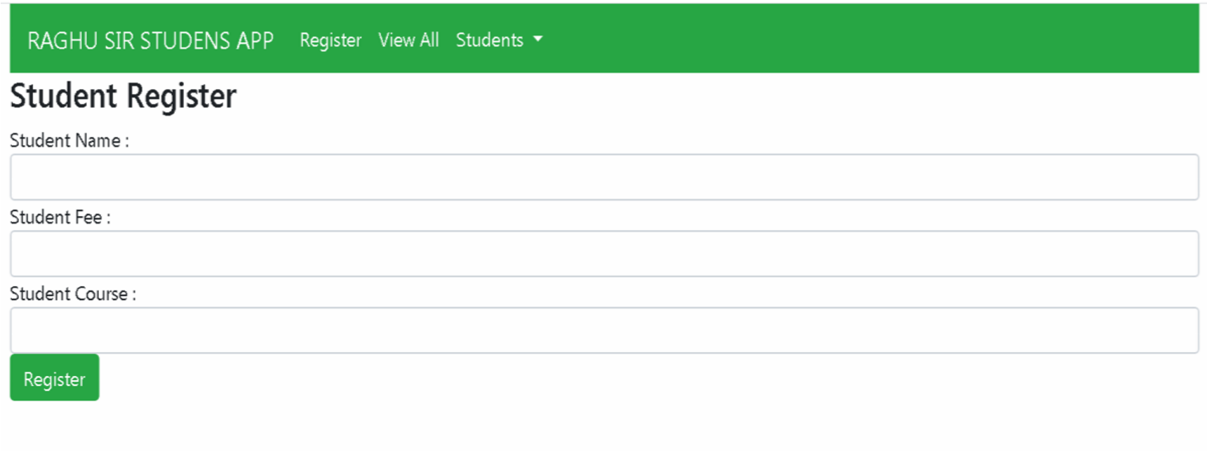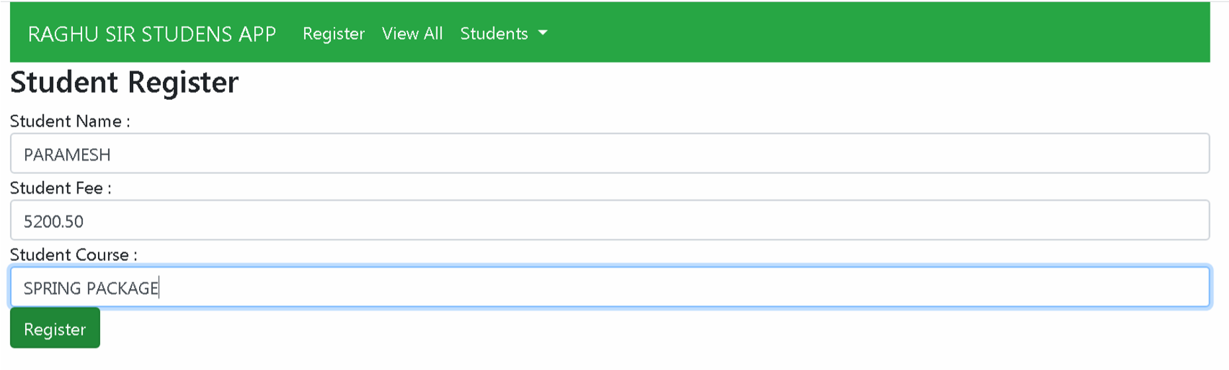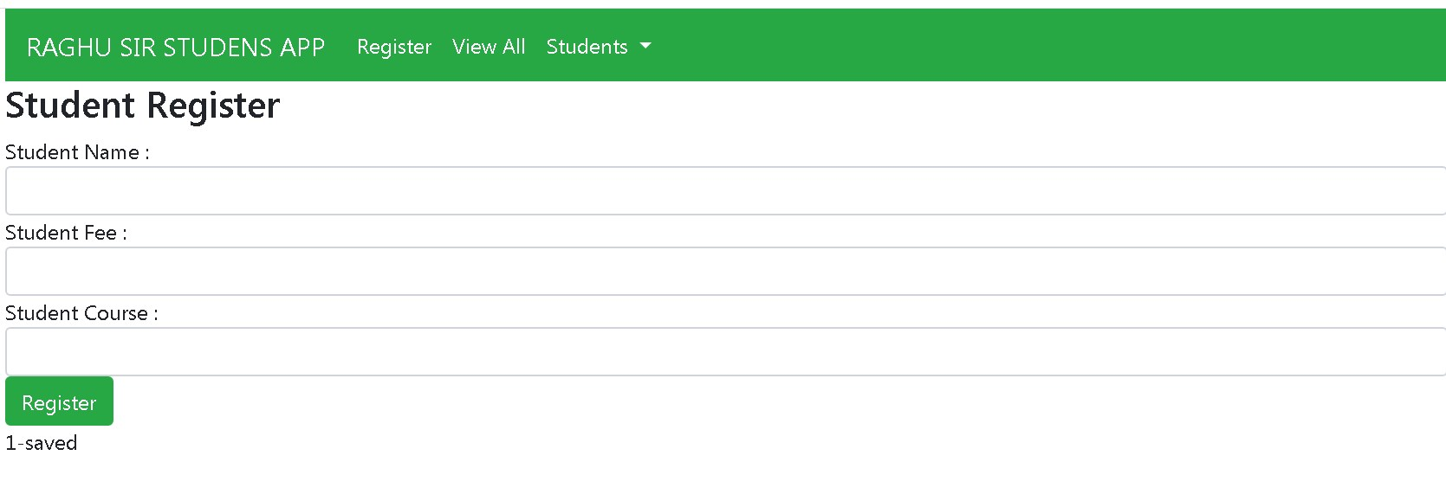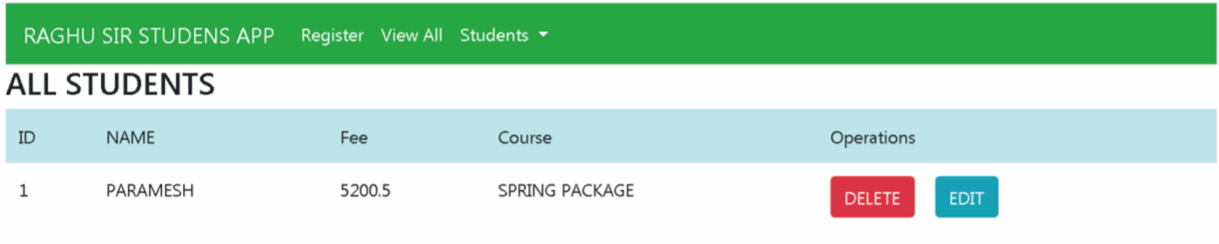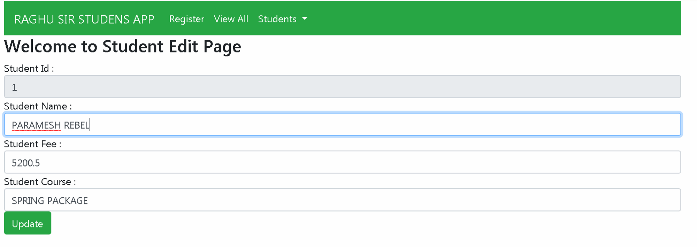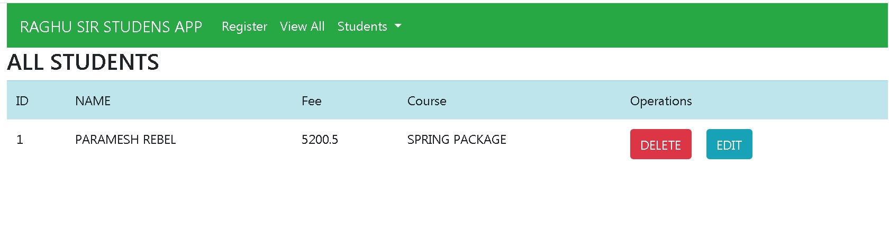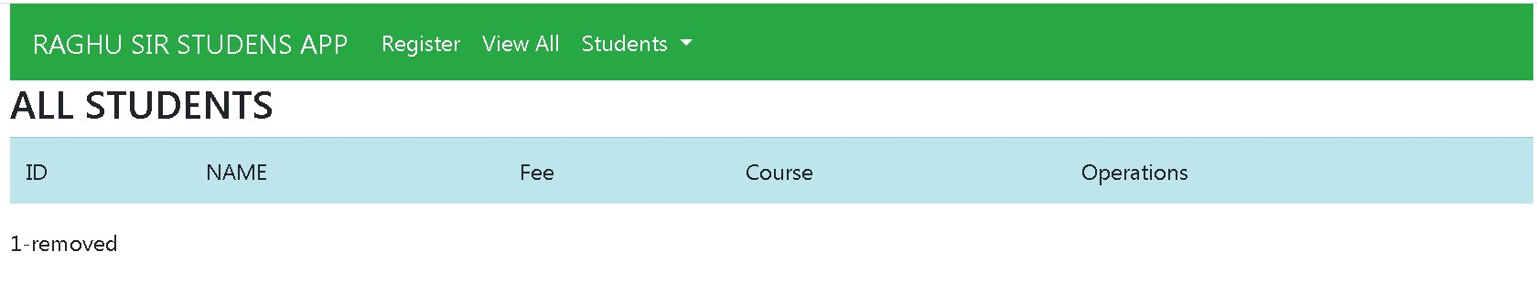

**Step#1 Create one Spring Starter Project in STS with Dependencies : Spring Web, Lombok, Data JPA, MySQL Driver, DevTools** pom.xml

<dependency>

<groupId>org.springframework.boot</groupId>

<artifactId>spring-boot-starter-data-jpa</artifactId>

</dependency>

<dependency>

<groupId>org.springframework.boot</groupId>

<artifactId>spring-boot-starter-web</artifactId>

</dependency>

<dependency>

<groupId>org.springframework.boot</groupId>

<artifactId>spring-boot-devtools</artifactId>

<scope>runtime</scope>

<optional>true</optional>

</dependency>

<dependency>

<groupId>org.projectlombok</groupId>

<artifactId>lombok</artifactId>

<optional>true</optional>

</dependency>

<dependency>

<groupId>mysql</groupId>

<artifactId>mysql-connector-java</artifactId>

</dependency>

**Step#2 Specify application.properties for DB Connection, JPA and server.**

server.port=9898

spring.datasource.driver-class-name =com.mysql.cj.jdbc.Driver spring.datasource.url=jdbc:mysql://localhost:3306/boot spring.datasource.username=root

spring.datasource.password=root

spring.jpa.properties.hibernate.dialect=org.hibernate.dialect.MySQL8D ialect

spring.jpa.show-sql=true

spring.jpa.hibernate.ddl-auto=update

server.servlet.context-path=/springboot-crud-rest

**Step#3 Create one Model class with JPA Mapping and Lombok Annotations**

**package** com.demo.model;

@Entity

**public** **class** Student {

@Id

@GeneratedValue **private** Integer stdId;

@Column

**private** String stdName;

**@Column**

**private** Double stdFee; @Column

**private** String stdCourse;

//default constructor

//parameterized constructor

//getters and setter

//tostring

}

**and also for Message Return**

**package** com.demo.model;

**import** lombok.AllArgsConstructor;

**import** lombok.Data;

**import** lombok.NoArgsConstructor;

**public** **class** Message {

**private** String type; **private** String message;

**//construtors**

**//getters and setters**

}

**Step#4 Define Repository Interface**

**package** com.demo.repo;

**import** org.springframework.data.jpa.repository.JpaRepository;

**import** com.demo.model.Student;

**public** **interface** StudentRepository **extends** JpaRepository<Student,Integer>

{

}

**Step#5 Define Service Interface for all basic Operations**

**package** com.demo.service;

**import** java.util.List;

**import** java.util.Optional;

**import** com.demo.model.Student;

**public** **interface** IStudentService {

**public** Integer saveStudent(Student s);

**public** List<Student> getAllStudents();

**public** Optional<Student> getOneStudent(Integer id); **public** **boolean** isExist(Integer id);

**public** **void** deleteStudent(Integer id);

}

**Step#6 Create ServiceImpl class for service interface**

**package** com.demo.service.impl;

**import** java.util.List;

**import** java.util.Optional;

**import** org.springframework.beans.factory.annotation.Autowired; **import** org.springframework.stereotype.Service;

**import** com.demo.model.Student;

**import** com.demo.repo.StudentRepository; **import** com.demo.service.IStudentService;

@Service

**public** **class** StudentServiceImpl **implements** IStudentService

{

@Autowired

**private** StudentRepository repo; //HAS-A

@Override

**public** Integer saveStudent(Student s) {

**return** repo.save(s).getStdId();

}

@Override

**public** List<Student> getAllStudents() { **return** repo.findAll();

}

@Override

**public** Optional<Student> getOneStudent(Integer id) {

**return** repo.findById(id);

}

@Override

**public** **void** deleteStudent(Integer id) { repo.deleteById(id);

}

@Override

**public** **boolean** isExist(Integer id) { **return** repo.existsById(id);

}

}

**Cross-Origin Resource Sharing** ([CORS](https://developer.mozilla.org/en-US/docs/Glossary/CORS)) is an [HTTP](https://developer.mozilla.org/en-US/docs/Glossary/HTTP)-header based mechanism that allows a server to indicate any [origins](https://developer.mozilla.org/en-US/docs/Glossary/Origin) (domain, scheme, or port) other than its own from which a browser should permit loading resources. CORS also relies on a mechanism by which browsers make a "preflight" request to the server hosting the cross-origin resource, in order to check that the server will permit the actual request. In that preflight, the browser sends headers that indicate the HTTP method and headers that will be used in the actual request.

This @CrossOrigin annotation **enables cross-origin resource sharing only for** this specific method. By default, its allows all origins, all headers, and the HTTP methods specified in the @RequestMapping annotation. Also, a maxAge of 30 minutes is used.

**Step#7 Define RestController with Operations**

**package** com.demo.controller.rest;

**import** java.util.List;

**import** java.util.Optional;

**import** org.springframework.beans.factory.annotation.Autowired; **import** org.springframework.http.HttpStatus;

**import** org.springframework.http.ResponseEntity;

**import** org.springframework.web.bind.annotation.CrossOrigin; **import** org.springframework.web.bind.annotation.DeleteMapping; **import** org.springframework.web.bind.annotation.GetMapping; **import** org.springframework.web.bind.annotation.PathVariable; **import** org.springframework.web.bind.annotation.PostMapping; **import** org.springframework.web.bind.annotation.PutMapping; **import** org.springframework.web.bind.annotation.RequestBody; **import** org.springframework.web.bind.annotation.RequestMapping; **import** org.springframework.web.bind.annotation.RestController;

**import** com.demo.model.Message;

**import** com.demo.model.Student;

**import** com.demo.service.IStudentService;

@RestController

@CrossOrigin(origins = "*") //to interact with /*angular/react/php/*/

@RequestMapping("/rest/student")

**public** **class** StudentRestController {

@Autowired

**private** IStudentService service;

/**

* 1. This method takes Student object
* as input from JSON/XML using * **@RequestBody** and returns * ResponseEntity<T>.
* call service.saveStudent(ob) */

@PostMapping("/save")

**public** ResponseEntity<Message> saveStudent(

@RequestBody Student student)

{

ResponseEntity<Message> resp=**null**;

**try** {

Integer id=service.saveStudent(student); resp=**new** ResponseEntity<Message>(**new**

Message("SUCCESS",id+"-saved"),HttpStatus.***OK***);

} **catch** (Exception e) { resp=**new** ResponseEntity<Message>(**new**

Message("FAIL","Unable to Save"),HttpStatus.***OK***);

e.printStackTrace();

}

**return** resp;

}

/***

* 2. This method reads data from DB
* using findAll() and returns
* List<Student> if data exist
* or String (not exist)
* as ResponseEntity using annotation
* **@ResponseBody**

*/

@GetMapping("/all") **public** ResponseEntity<?> getAllStudents(){ ResponseEntity<?> resp=**null**;

**try** {

List<Student> list=service.getAllStudents();

**if**(list!=**null** && !list.isEmpty())

resp=**new**

ResponseEntity<List<Student>>(list,HttpStatus.***OK***);

**else**

resp=**new** ResponseEntity<String>("No Data

Found",HttpStatus.***OK***);

} **catch** (Exception e) {

resp=**new** ResponseEntity<String>("Unable to fetch

Data",HttpStatus.***INTERNAL_SERVER_ERROR***);

|  |  |  |
| --- | --- | --- |
|  |  | e.printStackTrace(); |
|  |  | } |
|  |  |  |
|  |  | **return** resp; |

}

/**

* 3. Read PathVariable id (as input)
* use service layer to find one object
* based on Id. Return Student if exist
* else String (error message) as
* ResponseEntity<?>

*/

@GetMapping("/one/{id}") **public** ResponseEntity<?> getOneStudent(

@PathVariable Integer id)

{

ResponseEntity<?> resp=**null**;

**try** {

Optional<Student> opt=service.getOneStudent(id);

**if**(opt.isPresent())

resp=**new**

ResponseEntity<Student>(opt.get(),HttpStatus.***OK***);

**else**

resp=**new** ResponseEntity<String>("No Data

Found",HttpStatus.***BAD_REQUEST***);

} **catch** (Exception e) {

resp=**new** ResponseEntity<String>("Unable to Fetch

Data",HttpStatus.***INTERNAL_SERVER_ERROR***);

|  |  |  |
| --- | --- | --- |
|  |  | e.printStackTrace(); |
|  |  | } |
|  |  | **return** resp; |

}

/**

* 4. Read pathVariable id
* check row exist or not
* if exist call service delete
* else return String error msg

*/

@DeleteMapping("/remove/{id}")

**public** ResponseEntity<Message> deleteStudent(

@PathVariable Integer id)

{

System.***out***.println("welcome"); ResponseEntity<Message> resp=**null**;

**try** {

**boolean** exist=service.isExist(id);

**if**(exist) { service.deleteStudent(id); resp=**new** ResponseEntity<Message>(**new**

Message("SUCCESSS",id+"-removed"),HttpStatus.***OK***);

}**else** {

resp=**new** ResponseEntity<Message>(**new**

Message("FAIL",id+"-Not Exist"),HttpStatus.***BAD_REQUEST***);

}

} **catch** (Exception e) {

resp=**new** ResponseEntity<Message>(**new**

Message("FAIL","Unable to Delete"),HttpStatus.***INTERNAL_SERVER_ERROR***);

|  |  |  |
| --- | --- | --- |
|  |  | e.printStackTrace(); |
|  |  | } |
|  |  |  |
|  |  | **return** resp; |

}

/**

* 5. Read Input as JSON/XML using
* **@RequestBody** , check id exist or not
* if exist call service save method
* Return ResponseeEntity

*/

@PutMapping("/update") **public** ResponseEntity<Message> updateStudent(

@RequestBody Student student) { ResponseEntity<Message> resp=**null**;

**try** {

**boolean** exist=service.isExist(student.getStdId());

**if**(exist) {

service.saveStudent(student);

resp=**new** ResponseEntity<Message>(**new**

Message("OK",student.getStdId()+"-Updated"),HttpStatus.***OK***);

}**else** {

resp=**new** ResponseEntity<Message>(**new**

Message("OK",student.getStdId()+"-Not Exist"),HttpStatus.***BAD_REQUEST***);

}

} **catch** (Exception e) {

resp=**new** ResponseEntity<Message>(**new**

Message("OK","Unable to Update"),HttpStatus.***INTERNAL_SERVER_ERROR***);

e.printStackTrace();

}

**return** resp;

}

}

Angular Setup and code

**## Download and Install Node JS:**  https://nodejs.org/en/download/

> Click on OS Option(Ex: Windows)

> It will be downloaded as setup

> Double click on setup file > next > Next > Finsih

**## Check installtion of Node using cmd prompt**

C:\Users\raju> node -v

V20.16.3

C:\Users\raju> npm -v

**## Install Angular (wait for : 10 mins to 1 hr after cmd)**

Open cmd prompt and type command like

> npm install -g @angular/cli@14

**## Check angular installtion using cmd**

> ng version

**## Download Visual Studio Code Software and install**

Goto : https://code.visualstudio.com/download

Click on OS Option (Ex: Windows)

> Double click on setup file > next > next > Finish

**## Open VS Code Editor**

> File > open folder > create new folder (ex: myangapps) > Open

> press ctrl+` (before to 1 Key)

**Step#8 Open Visual Studio Code Editor and Goto terminal 'ctrl+`'**

**Step#9 Create one new Angular Project**  cmd: ng new student-app-new

with routing option : yes

with CSS option : press Enter

**Step#10 Switch to student app folder**  cmd: cd student-app-new

**Step#11 Generate Models, Service and Components cmds:** ng g class student

ng g class message

ng g s student

or ng generate service student

ng g c student-all

or ng generate component student-all

ng g c student-create

ng g c student-edit

**Step#12 Enable HTTP and Forms in Angular Project [app.module.ts]**

import { BrowserModule } from '@angular/platform-browser'; import { NgModule } from '@angular/core';

import { HttpClientModule } from '@angular/common/http' import { FormsModule } from '@angular/forms'

import { AppRoutingModule } from './app-routing.module'; import { AppComponent } from './app.component'; import { StudentAllComponent } from './student-all/studentall.component';

import { StudentCreateComponent } from './student-create/studentcreate.component';

import { StudentEditComponent } from './student-edit/studentedit.component';

@NgModule({ declarations: [ AppComponent,

StudentAllComponent,

StudentCreateComponent,

StudentEditComponent

], imports: [ BrowserModule,

AppRoutingModule,

], providers: [], bootstrap: [AppComponent]

HttpClientModule

,

FormsModule

,

})

export class AppModule { }

**Step#13 Add Properties in Student, Message Model classes**

export class Student {

stdId : number; stdName : string; stdFee : number; stdCourse: string;

}

export class Message {

type : string;

message: string;

}

**Step#14 Define Service Layer Code with all HTTP Operations**

**[student.service.ts]**

import { Injectable } from '@angular/core';

import { HttpClient } from '@angular/common/http'; import { Student } from './student';

import { Observable } from 'rxjs';

import { Message } from './message';

@Injectable({ providedIn: 'root' })

export class StudentService {

private baseUrl : string = 'http://localhost:9898/springboot-crudrest/rest/student';

constructor(private http:HttpClient) { }

getAllStudents():Observable<Student[]>{

return this.http.get<Student[]>(`${this.baseUrl}/all`);

}

deleteOneStudent(id:number):Observable<Message>{

return this.http.delete<Message>(`${this.baseUrl}/remove/${id}`);

}

createStudent(student:Student):Observable<Message>{

return this.http.post<Message>(`${this.baseUrl}/save`,student);

}

getOneStudent(id:number):Observable<Student>{

return this.http.get<Student>(`${this.baseUrl}/one/${id}`);

}

updateStudent(student:Student):Observable<Message>{

return this.http.put<Message>(`${this.baseUrl}/update`,student);

}

}

**Step#14 Provide Router link for each module**

**[app-routing.module.ts]**

import { NgModule } from '@angular/core';

import { Routes, RouterModule } from '@angular/router'; import { StudentAllComponent } from './student-all/studentall.component';

import { StudentCreateComponent } from './student-create/studentcreate.component';

import { StudentEditComponent } from './student-edit/studentedit.component';

const routes: Routes = [

{path:'all',component:StudentAllComponent},

{path:'add',component:StudentCreateComponent},

{path:'edit/:id',component:StudentEditComponent},

{path:'',redirectTo:'all',pathMatch:'full'},

];

@NgModule({

imports: [RouterModule.forRoot(routes)], exports: [RouterModule]

})

export class AppRoutingModule { }

**Note:- Learn How to use bootstrap Css classes in angular**

**Step#15 Define Menu bar and routerLink [app.component.html]**

<nav class="navbar navbar-expand-lg navbar-light bg-success">

<a class="navbar-brand textwhite" href="#">STUDENTS APP</a>

<button class="navbar-toggler" type="button" datatoggle="collapse" data-target="#navbarNavDropdown" ariacontrols="navbarNavDropdown" aria-expanded="false" arialabel="Toggle navigation">

<span class="navbar-toggler-icon"></span>

</button>

<div class="collapse navbar-collapse" id="navbarNavDropdown">

<ul class="navbar-nav">

<li class="nav-item active"> <a class="nav-link text-

white" href="#" routerLink="add">Register </a>

</li>

<li class="nav-item"> <a class="nav-link text-

white" href="#" routerLink="all">View All</a>

</li>

<li class="nav-item dropdown">

<a class="nav-link dropdown-toggle textwhite" href="#" id="navbarDropdownMenuLink" role="button" datatoggle="dropdown" aria-haspopup="true" aria-expanded="false"> Students

</a>

<div class="dropdown-menu" arialabelledby="navbarDropdownMenuLink"> <a class="dropdown-

item" href="#" routerLink="add">Register</a>

<a class="dropdown-

item" href="#" routerLink="all">View All</a>

</div>

</li>

</ul>

</div>

</nav>

<router-outlet></router-outlet>

**Step#17 Edit index.html page**

<!doctype html>

<html lang="en">

<head>

<meta charset="utf-8">

<title>StudentAppNew</title>

<base href="/">

<meta name="viewport" content="width=device-width, initial-scale=1">

<link rel="icon" type="image/x-icon" href="favicon.ico">

<!-- CSS only -->

<link rel="stylesheet" href="https://stackpath.bootstrapcdn.com/bootst rap/4.5.0/css/bootstrap.min.css" integrity="sha384-

9aIt2nRpC12Uk9gS9baDl411NQApFmC26EwAOH8WgZl5MYYxFfc+NcPb1dKGj7Sk" crossorigin="anonymous">

<!-- JS, Popper.js, and jQuery -->

<script src="https://code.jquery.com/jquery3.5.1.slim.min.js" integrity="sha384-

DfXdz2htPH0lsSSs5nCTpuj/zy4C+OGpamoFVy38MVBnE+IbbVYUew+OrCXaRkfj" cros sorigin="anonymous"></script>

<script src="https://cdn.jsdelivr.net/npm/popper.js@1.16.0/dist/umd/po pper.min.js" integrity="sha384-

Q6E9RHvbIyZFJoft+2mJbHaEWldlvI9IOYy5n3zV9zzTtmI3UksdQRVvoxMfooAo" cros sorigin="anonymous"></script>

<script src="https://stackpath.bootstrapcdn.com/bootstrap/4.5.0/js/boo tstrap.min.js" integrity="sha384OgVRvuATP1z7JjHLkuOU7Xw704+h835Lr+6QL9UvYjZE3Ipu6Tp75j7Bh/kR0JKI" crossorigin="anonymous"></script>

</head>

<body>

<div class="container">

<app-root></app-root>

</div>

</body>

</html>

**Step#18 Display all Students [students-all.component.ts]**

import { Component, OnInit } from

'@angular/core';

import { StudentService } from '../student.service'; import { Router } from '@angular/router';

import { Student } from '../student';

import { Message } from '../message';

@Component({

selector: 'app-student-all',

templateUrl: './student-all.component.html', styleUrls: ['./student-all.component.css']

})

export class StudentAllComponent implements OnInit {

students : Student[];

message : Message = new Message();

constructor(private service:StudentService, private router:Router) {

}

ngOnInit(): void { this.getAllStudents();

}

getAllStudents(){

this.service.getAllStudents().subscribe(data=>{this.students=data}

, error=>{ this.students=[]

}); }

deleteStudent(id:number){

this.service.deleteOneStudent(id).subscribe(

data=>{ this.message=data, this.getAllStudents();

},

error=>{console.log(error)}

);

}

editStudent(id:number){

this.router.navigate(['edit',id]);

}

}

**[student-all.component.html]**

<h3>ALL STUDENTS</h3>

<table class="table ">

<tr class="table-info">

<td>ID</td>

<td>NAME</td>

<td>Fee</td>

<td>Course</td>

<td>Operations</td>

</tr>

<tr *ngFor="let s of students ">

<td>{{s.stdId}}</td>

<td>{{s.stdName}}</td>

<td>{{s.stdFee}}</td>

<td>{{s.stdCourse}}</td>

<td>

<button class="btn btn-

danger" (click)="deleteStudent(s.stdId)">DELETE</button>

&nbsp;&nbsp; <button class="btn btn-

info" (click)="editStudent(s.stdId)">EDIT</button>

</td>

</tr>

</table>

{{message.message}}

**Step#19 Create Student Register [student-create.component.ts]**

import { Component, OnInit } from '@angular/core'; import { StudentService } from '../student.service'; import { Router } from '@angular/router'; import { Student } from '../student'; import { Message } from '../message';

@Component({

selector: 'app-student-create',

templateUrl: './student-create.component.html', styleUrls: ['./student-create.component.css']

})

export class StudentCreateComponent implements OnInit {

student : Student = new Student(); message : Message = new Message();

constructor(private service:StudentService,private router:Router) { }

ngOnInit(): void {

}

createStudent(){

this.service.createStudent(this.student).subscribe(data=>{ this.message=data;

});

this.student=new Student();

}

}

**[student-create.component.html]**

<h3>Student Register</h3>

<form (ngSubmit)="createStudent()">

Student Name : <input type="text" class="formcontrol" [(ngModel)]="student.stdName" name="stdName"/>

Student Fee : <input type="text" class="formcontrol" [(ngModel)]="student.stdFee" name="stdFee"/>

Student Course : <input type="text" class="formcontrol" [(ngModel)]="student.stdCourse" name="stdCourse"/>

<input type="submit" value="Register" class="btn btn-success"/>

</form>

{{message.message}}

**Step#20 Crate Student Edit Page and update code**

**[student-edit.component.ts]**

import { Component, OnInit } from '@angular/core'; import { StudentService } from '../student.service'; import { ActivatedRoute, Router } from '@angular/router'; import { Student } from '../student';

@Component({

selector: 'app-student-edit',

templateUrl: './student-edit.component.html', styleUrls: ['./student-edit.component.css']

})

export class StudentEditComponent implements OnInit {

student : Student ; id : number;

constructor(private service:StudentService,private activeRouter:Acti vatedRoute, private router:Router) { }

ngOnInit(): void { this.student =new Student();

this.id=this.activeRouter.snapshot.params['id']; this.service.getOneStudent(this.id).subscribe( data=>{

this.student=data;

}

); }

updateStudent(){

this.service.updateStudent(this.student).subscribe(data=>{ console.log(data),

this

.

router

.

navigate

([

'/all'

])

;

})

;

}

}

**[student-edit.component.html]**

<h3>Welcome to Student Edit Page</h3>

<form (ngSubmit)="updateStudent()"> Student Id : <input type="text" class="form-

control" [(ngModel)]="student.stdId" name="stdId" readonly/>

Student Name : <input type="text" class="formcontrol" [(ngModel)]="student.stdName" name="stdName"/>

Student Fee : <input type="text" class="formcontrol" [(ngModel)]="student.stdFee" name="stdFee"/>

Student Course : <input type="text" class="form-

control" [(ngModel)]="student.stdCourse" name="stdCourse"/>

<input type="submit" value="Update" class="btn btn-success"/>

</form>

**Step#21 Start Angular Application**

> ng serve --open

**Step#22 Go to browser and Enter URL: http://localhost:4200**