[**Hotel-Room-Booking**](https://github.com/jbgoldman1104/Hotel-Room-Booking-Django/tree/main)

1)

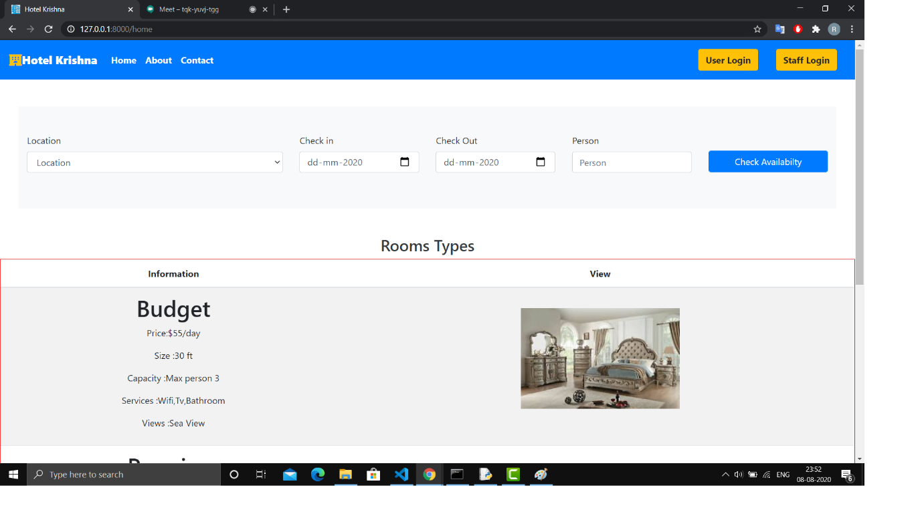

2)

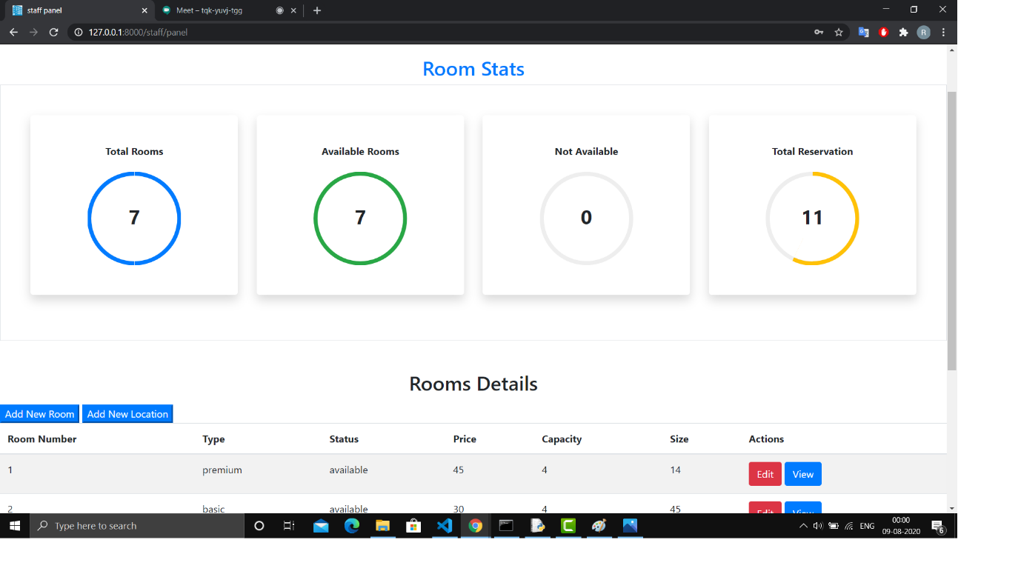

3) 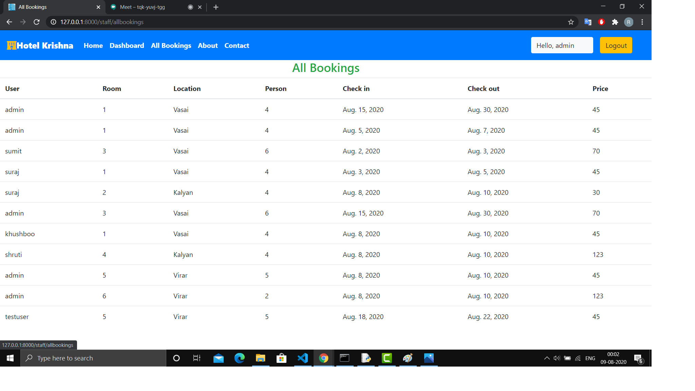

3)

