HTML
Lab Book

- HTML Basics
Goals | - Understand the process of creating an HTML page and viewing it in a browser window.  - Learn to apply physical or logical character effects.  - Learn to manage document spacing
Time | 45 minutes

1.1: Create HTML Page
Create a web page to display the text ‘This is the first html page created’.
Solution:
Step 1: Click the Start button. On the Programs menu, navigate to the Accessories submenu. Click Notepad.
Step 2: Write the below HTML program in Notepad.
<!DOCTYPE html>
<html>
<head>
<title>This is the first html page</title>
</head>
<body>
This is the first html page created
</body>
</html>

Step 3: Save the file with extension .html. Save it in the lab1 directory as firstpage.html.
Step 4: From Internet Explorer, on the File menu, click Open. Open dialog box appears. Click Browse to select the file you have just saved. Refer to the figure that follows.
Step 5: Once you have selected the file, click OK in the Open dialog box. Output appears as shown in the figure that follows.
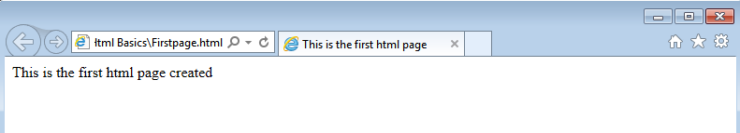
Figure 1: First.html in a browser

1.2 Example: MyFirstPage.html

<!DOCTYPE html>
<html>
<head>
<title>My First Page</title>
<meta [http-equiv] [contents=n]>
<meta http-equiv=refresh content=60>
<!---will refresh the current document after every 60 seconds.-->
<meta http-equiv=refresh content=”20;url=c:/html/html34.htm”>
<--will load secified file after 20 seconds. →
<base href=“c:/mydir/html/”>
<!-- you to use shortcuts in your URLs if you must reference several files from the same location.-->
</head>
<body> Hello World!! </body>
</html>

Example 1: MyFirstPage.html

Output of the above HTML code is:

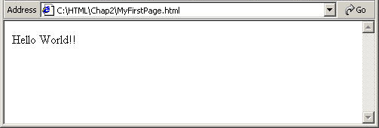
Figure 2: MyFirstPage.html Output

1.3 Example: Headers.html

<!DOCTYPE html>
<html>
<head><title>This is the first html page</title>
<body>This is the first html page created
<h1>This is level 1 heading</h1>
<h2>This is level 2 heading</h2>
<h3>This is level 3 heading</h3>
</body>
</head></html>

Example 2: Headers.html
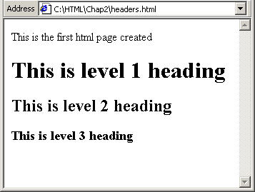
Figure 3: Headers.html Output

1.4 Example: Address.html

<html>
<head>
<title>Address Example</title>
</head>
<body>
<font size="2">Your address:</font><br>
Abc Xyz<br>
<address>b/102 royal palms,</address>
<address>off. s. v. road,</address>
<address>Andheri-West,</address><address>Mumbai.</address>
</body>
</html>

Example 3: Address.html

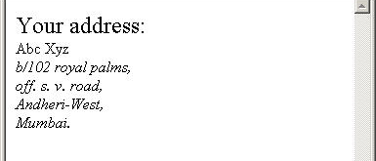
Figure 4: Address.html Output

1.5 Example: PreFormattedText.html

<!DOCTYPE html>
<html>
<head><title>
PREFORMATTED TEXT EXAMPLE
</title></head>
<body>
<h3>GROSS SALE WITH PREFORMATTING</h3>
<hr>
<pre>
<b>GROSS SALES</b>
SALESMAN SALES RANKING
TIM $10,000 2<BR>
TOM $ 5,000 5<BR>
TAMMY $20,000 1<BR>
Each line has a carriage return after it.
</pre>
<h3>GROSS SALE WITHOUT PREFORMATTING</h3>
<p><hr>
<b>GROSS SALE<b>
SALESMAN SALES RANKING
TIM $10,000 2<BR>
TOM $ 5,000 5<BR>
TAMMY $20,000 1<BR>
</body>

Example 4: PreFormattedText.html

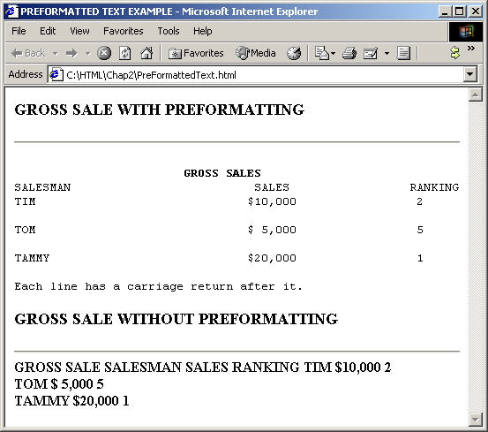
Figure 5: PreFormattedText.html Output
Problem 1: Resume Creation <<To Do>>
Problem Statement:
Create your resume page as per the format shown in the figure that follows.

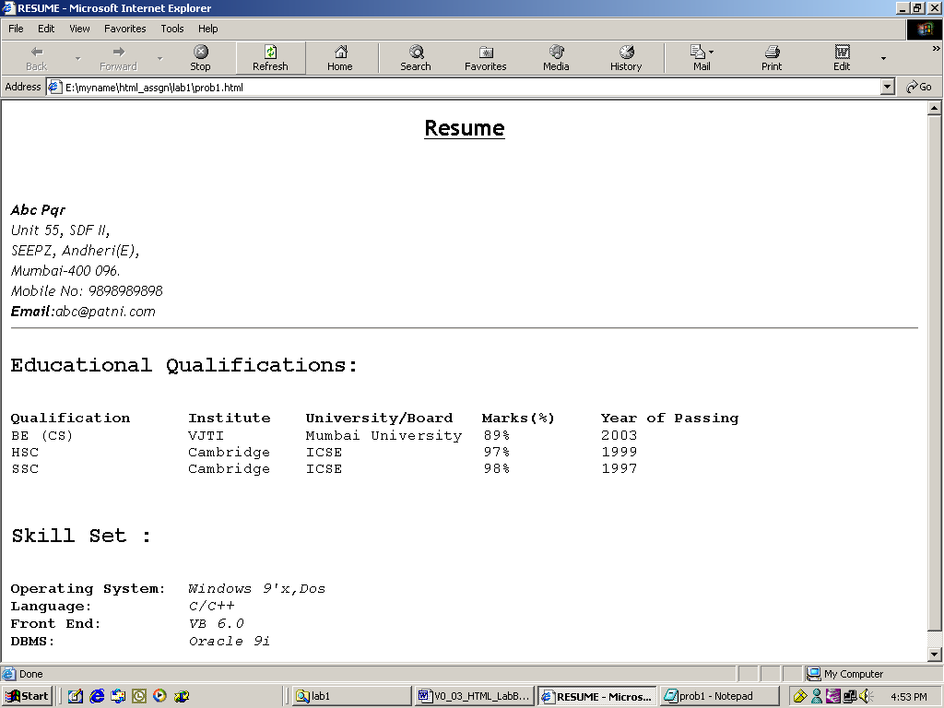
Figure 6: Resume Page

Solution:
- Open Editor. Type the code and save the file.
- Use Heading 2 for the headings “Educational Qualifications” and “Skill Set”.
- Use font size 3 for data pertaining to educational qualifications and skill set.
- Display details against categories under Skill Set in italics.
- Start the Internet Explorer. On the File menu, click Open. File open dialog box appears. Click the Browse button and select prob2.html file.
- Check if the output is as per the requirement.
- Creating Tables
Goals | At the end of this lab session you will understand:  - Attributes of a Table  - Table Headers  - Table Data  - Table Formatting  - Control Table Borders  - Grouping of Columns
Time | 90 minutes

Problem 1: Fun with Food
Problem Statement:
Create a web page, which uses a table with columns Fruit, Color and Cost per pound as shown in the figure that follows.
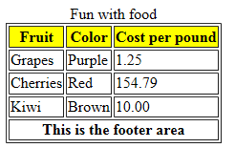
Figure 7: Fruits Table

Problem 2: Table Heading << To Do>>
Problem Statement: Create a html page. When this page is opened in a browser, it should appear as shown in the following figure
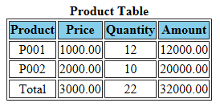
Figure 8: Product table
Note: Table heading - Background color is: navy and font color is: white.

Problem 3: Calendar <<To Do>>
Problem Statement:
Design a web page to display a calendar for a month using html table.

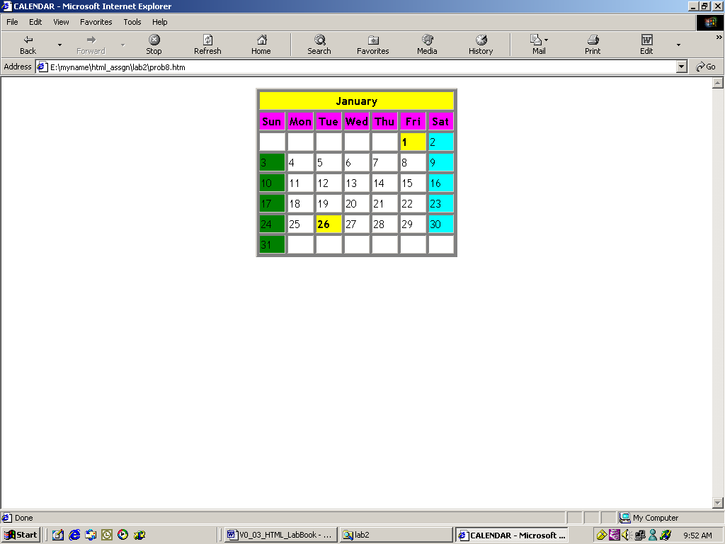
Figure 9: Calendar

Note: Background colors to be used: For all the Sundays: green, for all the Saturdays: aqua, for 1, 26 Jan: yellow

- Working with Lists
Goals | At the end of this lab session you will be able to use following types of lists:  - Numbered List  - Bulleted List  - Directory List  - Glossary List
Time | 30 minutes

Problem 1: Types of Lists
Problem Statement:
Design a web page as shown below

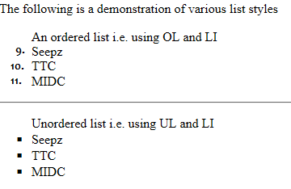
Figure 10: List

Problem 2: Subjects <<To Do>>
Create a web page to display a list as shown in the figure that follows.
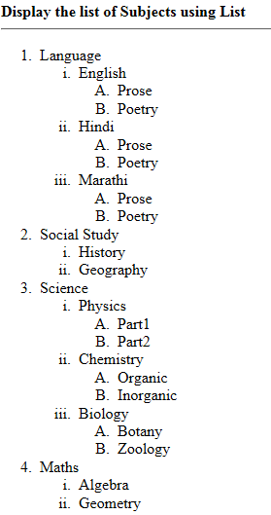
Figure 11: Subject list
- Working with Links
Goals | At the end of this lab session you will be able to:  - Create links to web documents.  - Create links to email.  - Create hyperlinks for lists and table data.  - Provide target for hyperlink.
Time | 30 minutes

Problem 1: Welcome to Big Company
Problem Statement:
Design a simple home page for a company with a heading and 3 links – About, Products, Contact as given in the figure below.
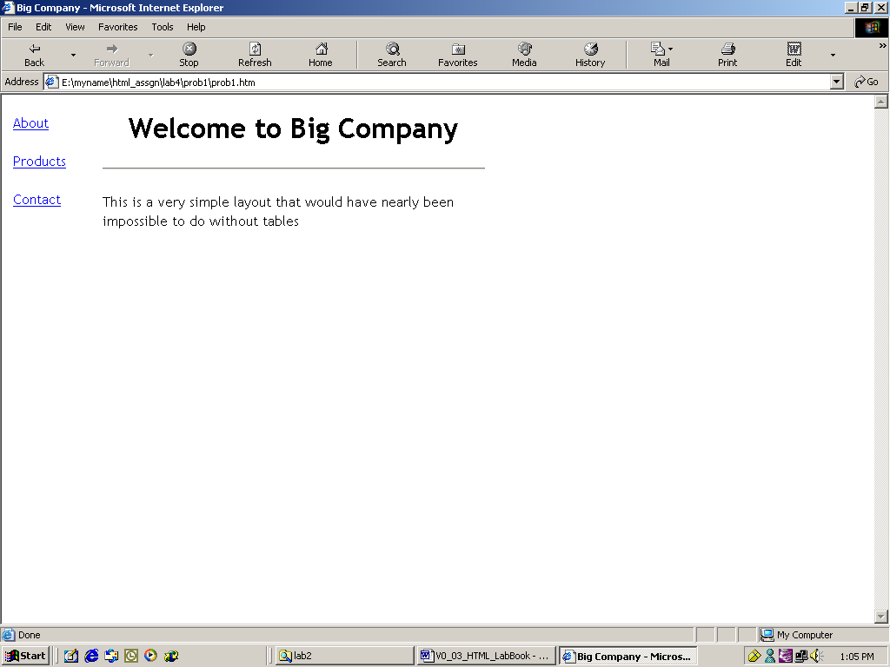
Figure 12: Big Company home page

When you click the “About” hyperlink, following page should be displayed.


Figure 13: About
When you click the Back button on the browser toolbar, they should be redirected to the page prob1.html. Click the “Products” hyperlink to reach the following page:


Figure 14: Products
When you click the Back button on the browser toolbar, they are redirected to page prob1.html. Click the “Contact” hyperlink. It opens Outlook Express and the e-mail address given in the To field, which is lnd.in@capgemini.com in the following illustration, is displayed in the New message window. This email address is specified in the mailto attribute.
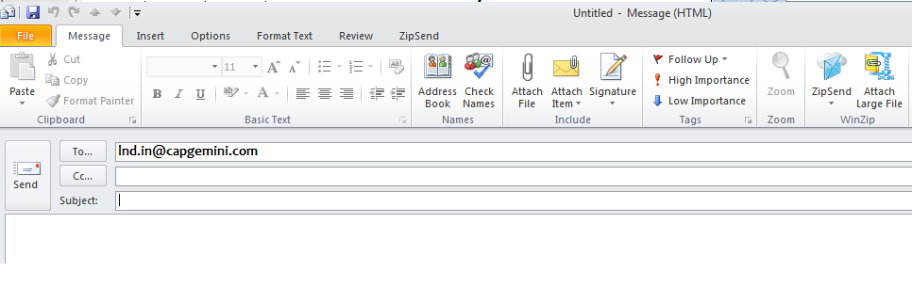
Figure 15: Contact

- Image Handling
Goals | At the end of this lab session you will be able to:  - Understand the use of inline images.  - Attributes of an inline image.  - Text and image aligning.  - Use of an image as a hyperlink.
Time | 30 minutes

Problem 1: Images with Clickable Areas <<To do>>
Problem Statement:
Create a web page with some images as shown in following figure: (download images from web )
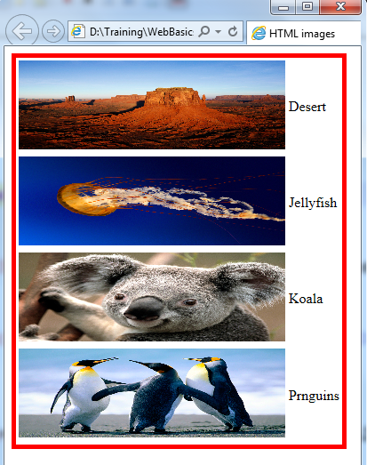
Figure 16 : Images

- HTML Forms for User Input
Goals | At the end of this lab session you will be able to:  - Understand the role of forms in web pages.  - Understand various HTML elements used in forms.  - Develop HTML forms in web pages.
Time | 45 minutes

Problem 1: Form
Problem Statement:
Design a web page prob1.html in the directory lab7. When prob1.html is opened in the browser, the page is displayed as shown in the figure that follows.
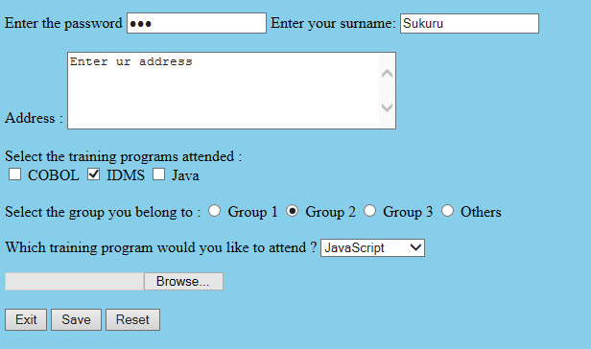
Figure 174: Forms

Problem 2: Employee Details <<To Do>>
Problem Statement:
Design a web page prob2.html to accept the following employee details:
- Employee Name (Max 20 characters).
- Employee Code (Max 4 characters).
- Department (Use radio buttons).
- Date of Join (Use the format dd/mm/yyyy).
- Address.
- Training programs attended (Use check boxes).
- Training programs need to attend (Use select box).
- Send the information at xyz@gmail.com

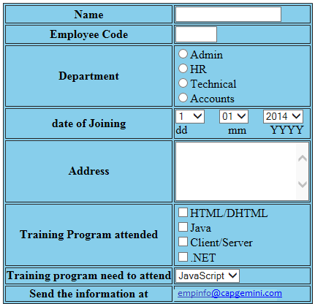
Figure 185: Employee Details

- New Form Elements
Goals | At the end of this lab session, you will be able to:  - Develop web pages using HTML5 enhanced form elements
Time | 120 minutes

Problem 1: Form
Problem Statement:
Design a web page prob1.html in the directory lab8. When prob1.html is opened in the browser, the page is displayed as shown in the below figure
for New Form Elements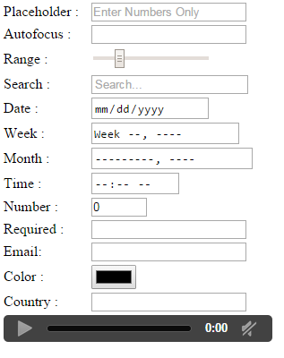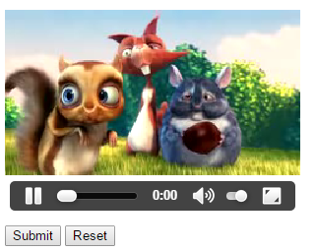
Figure 196: New Form Elements

Problem 2: Candidate Details <<To Do>>
Problem Statement:
Design a web page StudentInfoForm.html to accept the following student details:
- Name (Accept only characters , Max 15 characters )
- Password (Max 15 characters)
- Phone number(Accept 10 digits)
- Gender (Make use of radio button)
- Date of Birth (Make use of date field and date of birth should not be greater than current date)
- Email (Accept valid Email)
- Highest Qualification (Make use of datalist to populate data like B.Tech, M.Tech, MBA, MCA, MSc, MA, BSC..)
- Courses interested in (Make use of check box)
- Comments to mention regarding Degree / External Certificates (Make use of textarea)
- Uploading Degree / External certificates (Make use of file input type)
- Use Placeholders to describe the type of input.
- All fields marked (*) are mandatory

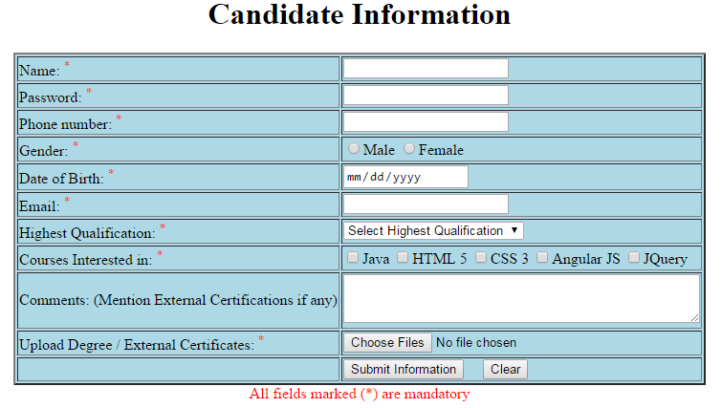
Figure 207: Candidate Details

Drive Link to Upload (empId_yourname_htmllab)

https://docs.google.com/forms/d/e/1FAIpQLSc9yUSJesSmYW74rkyiDsLwzzxUh05Cgm30j7BnJ-9SbAIAQQ/viewform?usp=sf_link

