Lab Book
Lab 1: Working with Arrays

Goals | Work with Array Object
Time | 10 minutes

4 .1: Using Array to display values
Create a prob1.html web page containing script. In this script, declare an array of 6 employee names and display it in the browser as shown below:

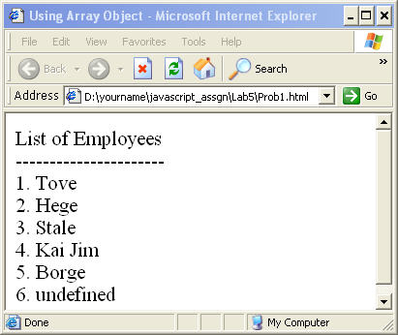
Figure 1: Using Array to display values
Solution:
Step 1: Write the Code, and save it as Prob1.html.

Step 2: Open prob1.html page in the browser, and verify that you get the same output as required.

Lab 2: Working with Form Object

Goals | - Understand and use Form Object.
Time | 90 minutes

8.1: Form Validation
Create a prob1.html web page, as shown below, and calculate Payment Information based on Loan Information. Validate Loan information textfields for numbers. The Payment Information textfields should be uneditable. The other constraints are as follows:
- Amount of Loan should not be more than 15 lakhs.
- Repayment period should be between 7 yrs to 15 yrs.
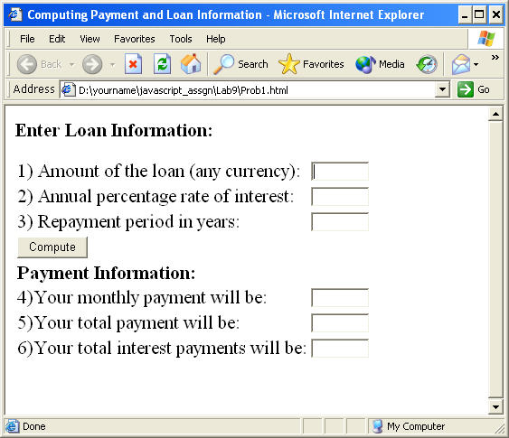
Figure 2: Validating Form elements

If the repayment period is not between 7 and 15, then an error message should be displayed next to this control.
Similar kind of error message should be displayed if the amount of loan exceeds 15 lakh.
In the function calculatePayment()
/*
TODO:
calculate the monthly payment, total payment, total interest payment on click of the button with label "compute"
*/
Example 1: Lab 8: Prob1.html
Open prob1.html page in the browser, and verify that you get the same output as required.

8.2 Validate Field
Create a prob2.html page as shown in the below figure.
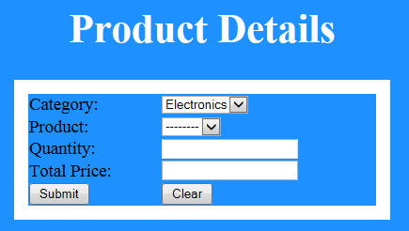
Figure 20: Lab 8.2 Product Details
Data should be prepopulated in category list box (Electronics, Grocery). Based on selection of category, product list need to be populated automatically with values as given in the below table. Also Total price need to be calculated for the entered quantity as per the data in the below table. Total price field should be non-editable field.

Category | Product | Price per quantity in Rupees
Electronics | Television | 20000
Electronics | Laptop | 30000
Electronics | Phone | 10000
Grocery | Soap | 40
Grocery | Powder | 90

While clicking on submit button, if all the text fields contains valid values then display the filled details in a popup window.

Lab3: Regular Expressions in JavaScript

Goals | - Understand Regular Expression object  - Use Regular Expression object for validating
Time | 90 minutes

9.1: Regular Expression
Create a prob1.html page which has two text fields – one for the Regular Expression search pattern and the other for the string in which the pattern has to be checked.
The form has two buttons one “Test Match” and the other “Show Match”.
Test Match will test the regular expression against the string. Show Match will show the matching part of the string.
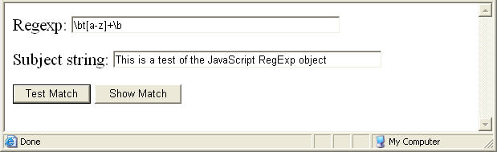
Figure 3: Regular Expression Pattern

Type the regular expression in the first textbox and the string in the second text box. Click the “Test Match” button.
If the text in the second text box matches the Regular Expression in the first text box, then it should display a message as shown below.
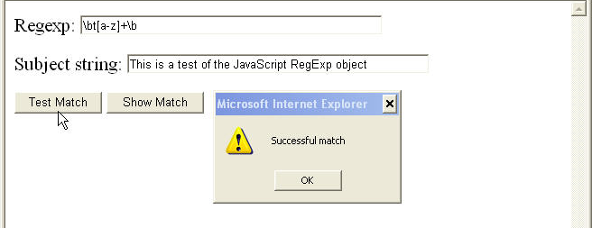
Figure 4: Validating Regular Expression Pattern
If you click the “Show Match” button, then it should display the match as shown in the figure given below:

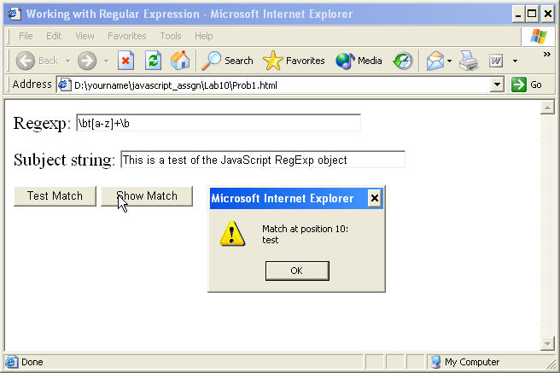
Figure 5: Displaying text matching Regular Expression Pattern
Solution:
Step 1: Write the Code and save it as Prob1.html.
Some Tips

In the function demoMatchClick()
/*
TODO:
define a variable re which is the regular expression object, to which the regular expression pattern is passed as an argument. define a variable str which holds the string from subject field match the "str" with "re" using the match method of the string object and display appropriate messages
*/

In the function demoShowMatchClick()
/*
TODO:
Store the regular expression pattern in a variable "re" and invoke exec method of regular expression object which takes the matching string as argument and returns the index of the matching string found
*/
Example 2: Prob1.html
Step 2: Open prob1.html page in the browser, and verify that you get the same output as required.

9.2: Form Validation using Regular Expression
Create a prob3.html page as shown in the below figure. Use CSS for designing page The page should be submitted on clicking the Submit button when all the form fields are properly validated.
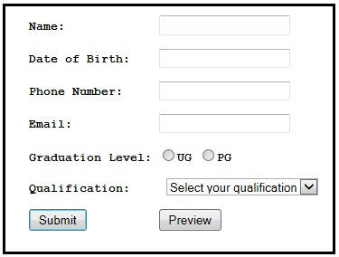
Figure 6: Form Validation using Regular Expression
- None of the fields should be empty ( Use HTML 5 attributes )
- Name field should be between 3 to 10 characters ( Use HTML 5 attributes )
- Date of Birth format can be either (DD/MM/YY or DD/MM/YYYY) ( Use HTML 5 date control )
- Phone Number should be in xxx-xxxx-xxxx format ( Use HTML 5 attributes )
- Email ID should be valid. ( Use HTML 5 attributes )
- Based on graduation level selected, qualification need to be populated automatically. For an example, if graduation level selected is UG, then qualification should be B.Sc, B.A, B.Com, etc... If graduation level selected is PG, then qualification should be M.A, M.Tech, MCA, MBA, etc… ( Call function on onChange event )
- Calculate age of the person and display all the details in a new popup window when “Preview” button is clicked. Details should be printed in the specified format as given below:
Name:
Age:
Phone Number:
Email:
Graduation Level:
Qualification:
Display the appropriate error message when the condition fails.

- All statements within corresponding opening and closing brace must be indented. Indentations must be in odd columns.

Column no
123456789…………………………………………………………………………
if (condition) {
...
} else {
if (condition) {
...
} else {
...
}
}

- Also the code should not extend past the 80th column so that it is required to scroll to the right or left to edit a particular line. In the case of strings which do not fit on one line, it is recommended that temporary variables be used with the string concatenation operator (+=) to construct strings of longer lengths. The following example illustrates this:

Column no
123456789…………………………………………………………………80
strMessage = “Demonstrating the use of … “;
strMessage += “prepared on 15-07-1999”;

