Bean Validation API
This API simplifies the validation of input field. It provides annotation based constraints such as @NotNull and @Email which can be used on bean attributes to specify validation criteria. Some of the annotations provided by this API are given below.
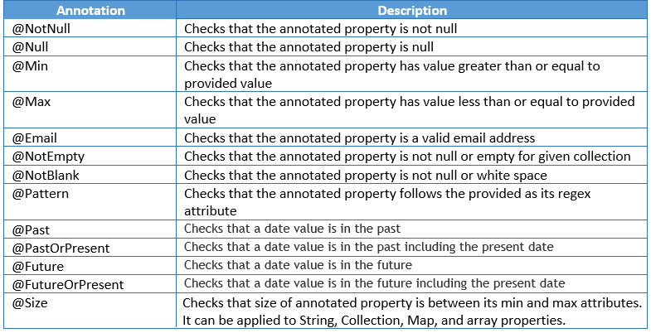
All these annotations have message attribute which is the message that will be displayed when the validation fails.
To use Bean Validation API, you have to add following spring-boot-starter-validation dependency in pom.xml:
<dependency>
<groupId>org.springframework.boot</groupId>
<artifactId>spring-boot-starter-validation</artifactId>
</dependency>

Add @Valid for the @RequestBody

@ExceptionHandler(MethodArgumentNotValidException.class)
public ResponseEntity<ErrorInfo> exceptionHandler(MethodArgumentNotValidException exception) {
ErrorInfo errorInfo = new ErrorInfo();
errorInfo.setErrorCode(HttpStatus.BAD_REQUEST.value());
errorInfo.setTimestamp(LocalDateTime.now());

String errorMsg = exception.getBindingResult().getAllErrors().stream().map(x -> x.getDefaultMessage())
.collect(Collectors.joining(", "));
errorInfo.setErrorMessage(errorMsg);

return new ResponseEntity<>(errorInfo, HttpStatus.BAD_REQUEST);
}

PathVariable:
So far, you have learnt how to validate the data sent in request body. But what to do if path variable or request parameter is invalid. For example, if you want to restrict the value of customerId in path variable between 1 and 100. This requires validation of path variable or request parameter. You can also do this validation using Bean Validation API. Lets see how to do this.
For this, annotate the controller class with @Validated annotation to tell Spring to validate path variables and request parameters. Then annotate the parameters of the handler methods which needs to be validated with constraint annotations.
@ExceptionHandler(ConstraintViolationException.class)
public ResponseEntity<ErrorInfo> pathExceptionHandler(ConstraintViolationException exception) {
ErrorInfo errorInfo = new ErrorInfo();
errorInfo.setErrorCode(HttpStatus.BAD_REQUEST.value());
String errorMsg = exception.getConstraintViolations().stream().map(x -> x.getMessage())
.collect(Collectors.joining(", "));
errorInfo.setErrorMessage(errorMsg);
errorInfo.setTimestamp(LocalDateTime.now());
return new ResponseEntity<>(errorInfo, HttpStatus.BAD_REQUEST);
}

