Introduction to Redux

STATE MANAGEMENT:
• state management makes the state of application tangible in the form of a data structure
• it makes ‘invisible’ state clearly visible for us and work with.
• state management libraries provides the tools for creating data structures, and updating when new actions occur.
• with a state management system, to find out what the state of our application is and we check our state data structure.
• without a state management system, how do we know what the state of our application is? We look at the DOM. We can check DOM elements to see if they have certain classes (‘active’, ‘error’), or to check whether certain elements exist.

WHAT IS REDUX?
• Redux is a predictable state container for JavaScript applications. It helps to you write applications, run in different environments and easy to test.
• And simply we called as Redux is a state management tool
• It is lightweight, so we don’t have to worry about it making your application’s asset size bigger.
• Redux, the state of your application is kept in a store, and each component can access any state that it needs from this store.

Redux works mainly three principles:

➢ Application state is stored in a single object. Redux stores state in a single JavaScript object to make it easier to map out and pass data throughout the entire application. Centralizing state in a single object also make the process of testing and debugging faster.

➢ Application state is immutable. In redux, states cannot be modified. The only way to change the state is to provide an action. Actions are immutable JavaScript objects that describes the state changes. Actions are executed in an order to prevent race conditions.

➢ Reducers specify how the action transform the state. Reducers are JavaScript functions that create a new state with the given current state and action. They centralize data mutations and can act on all or part of the state. Reducers can also be combined and reused.

TERMINOLOGY OF REDUX:

➢ working of redux is simple. There is a central store that holds the entire state of the application.

➢ each component can access the stored state without having to send down props from one component to another

➢ Components in redux
Actions
Store
Reducers
Dispatch
Subscribe
State
getstate()

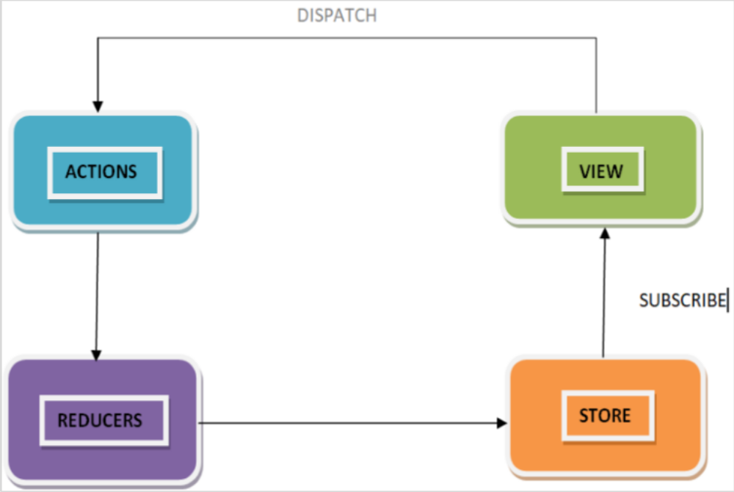

ACTIONS IN REDUX:

➢ Simply we call that actions are events.

➢ They are the only way we can send data from application to Redux store. The data can be from user interactions, API calls, or even form
submissions.

➢ Actions are sent using the store.dispatch() method.
➢ Actions are plain JavaScript objects, and they must have a type property to indicate the type of action to be carried out.
➢ They must also have a payload that contains the information that should be worked on the action.

STORE IN REDUX:
➢ The store holds the application state. There is only one store in any Redux application.

➢ redux has one global store

➢ we can access the state stored, update the state, and register or unregister listeners via helper methods.

➢ The central idea of a Redux app is to separate the state of the app from the app itself.
➢ The state of the app is stored in a store. Hence the state of the app which is in the store.

➢ The state stored in the store is a simple JS object with slices. As the state thus hierarchically contains other structures it also called a state tree

➢ Actions performed on the state always return a new state, hence state is very easy and predictable

➢ create redux store:
Redux comes with one predefined function that creates store, i.e. createstore
Syntax:
import { createStore } from 'redux';
const store = createStore();

REDUCERS IN REDUX:
➢ Reducers are a pure function in Redux, these Pure functions are predictable.
➢ Reducers are the only way to change states in Redux.
➢ It is the only place where you can write logic and calculations.
➢ reducers main job is to take “current state” and an ” action “ and return the ”new state”
➢ Reducer function will accept the previous state of app and action being dispatched, calculate the next state and returns the new object.
➢ Redux reducers work just like the function is pass to Array, the main thing is they reduce is actions.
➢ They reduce a set of actions (over time) into a single state.
➢ The difference is that with Array’s reduce it happens all at once, and with Redux, it happens over the lifetime of our running app.
➢ The following few things should never be performed inside the reducer:
- Mutation of functions arguments
- API calls & routing logic
- Calling non-pure function
The following is the syntax of a reducer:
(state, action) => newState
getstate in redux:
➢ Returns the current state tree of your application. It is equal to the last value returned by the store's reducer.
➢ and getstate() returns current state tree of your application.
➢ It helps you retrieve the current state of your Redux store.
➢ The syntax for getState is as follows:
store.getState()

DISPATCH in REACT:
• It allows to dispatch an action to change a state in your application.
• Dispatch() is the only way to trigger a state change.
• The store's reducing function will be called with the current getstate() result and the given action synchronously.
• It return value will be considered the next state.
• It will be returned from getstate()from now on, and the change listeners will immediately be notified.
• Simply dispatch is the one request to the store to perform a specific actions.
• dispatch() is the function that belongs to the store, which means the store not only holds the state of the app it also operates as a dispatcher that dispatches commands.
• The syntax for dispatch is as follows:
store.dispatch ({key : 'deposit'})

DISPATCH WORKING:
• we created store has a built-in function called dispatch
• then Call it with an action and Redux will call our reducer with that action and then replace the state with whatever your reducer returned.

SUBSCRIBE IN REACT:
• It helps to register a callback that Redux store will call when an action has been dispatched.
• As soon as the Redux state has been updated, the view will re-render automatically.
• Adds a change listener. It will be called any time an action is dispatched, and some part of the state tree may potentially have changed. You may then call getstate()to read the current state tree inside the callback.
• The subscriptions are snapshotted just before every dispatch()call. If you subscribe or unsubscribe while the isteners are being invoked, this will not have any effect on the dispatch() that is currently in progress. However, the next dispatch() call, whether nested or not, will use a more recent snapshot of the subscription list.
• To unsubscribe the change listener, invoke the function returned by subscribe.

ARCHITECTURE/FLOW OF REDUX:

➢ Redux follows the unidirectional data flow. It means that application data will follow in one-way binding data flow.
➢ As the application grows & becomes complex, it is hard to reproduce issues and add new features if you have no control over the state of your application. -
➢ Redux reduces the complexity of the code, by enforcing the restriction on how and when state update can happen.

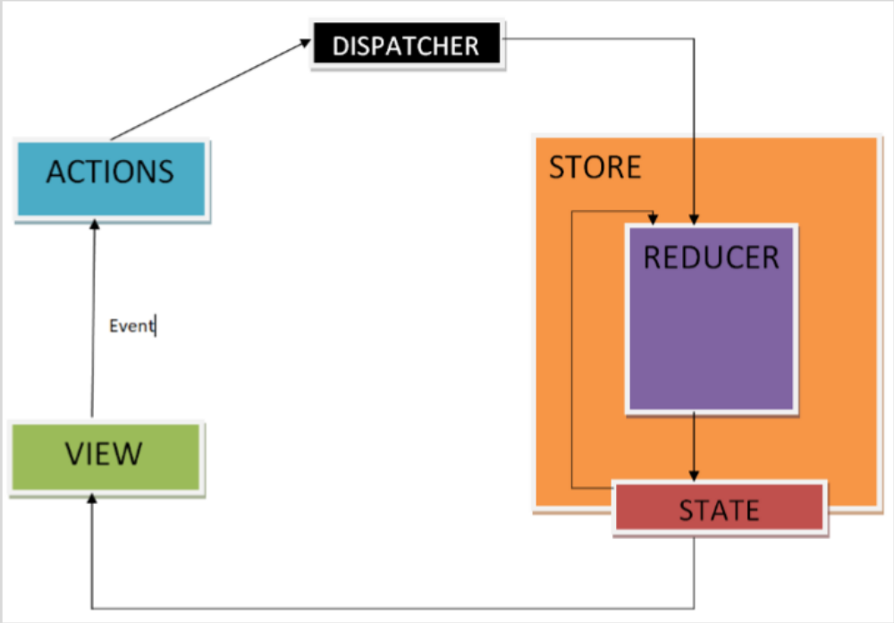

• An action is dispatched when a user interacts with the application.
• The root reducer function is called with the current state and the dispatched action. The root reducer may divide the task among smaller reducer functions, which ultimately returns a new state.
• The store notifies the view by executing their callback functions.
• The view can retrieve updated state and re-render again

REDUX – INSTALLATION:
• Before installing Redux, we have to install Nodejs .
• Below are the instructions that will help you install it. You can skip these steps if you already have Nodejs installed in your device.
• Website: https://nodejs.org/
• You can check successful installation by opening the command prompt and type “ node –v ”
• This will show you the latest version of Node in your system.
• To install redux, follow the following steps:
➢ Run the following command in your command prompt to install Redux.
npm install redux --save
(or)
yarn add redux –save
➢ To use Redux with react application, we need to install an additional dependency as follows:
npm install react-redux –save

Example:

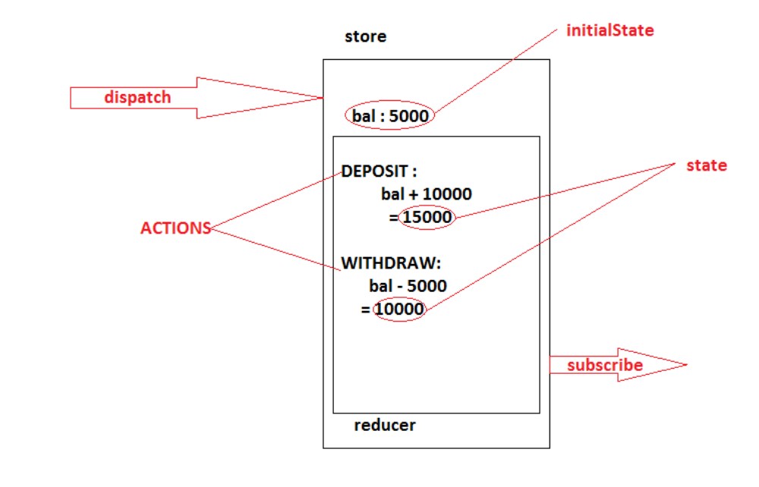

1) create the directory
ReduxEx
2) switch to ReduxEx
> cd ReduxEx
3) download the redux
> yarn add redux --save
4) create the redux architecture application
Directory Structure
********************************************************
ReduxEx
Demo.js
*******************************************************
Demo.js
const { createStore }= require("redux");
const initialState = {
bal : 5000
};
const reducer = (state=initialState,actions)=>{
const newState = {...state};
switch(actions.type){
case "DEPOSIT":
newState.bal+=actions.value;
break;
case "WITHDRAW":
newState.bal-=actions.value;
break;
}
return newState;

};
const store = createStore(reducer);
store.subscribe(()=>{
console.log(store.getState());
});
store.dispatch({type:"DEPOSIT",value:5000});
store.dispatch({type:"DEPOSIT",value:5000});
store.dispatch({type:"DEPOSIT",value:5000});
store.dispatch({type:"WITHDRAW",value:1000});
store.dispatch({type:"DEPOSIT",value:5000});
store.dispatch({type:"WITHDRAW",value:10000});
Execute the above application by using following command : node demo.js

