**Chapter 3**

**SYSTEM OVERVIEW**

As we know that in this project we showing five different application to avoid or eliminate traffic congestion minimise traffic fatalities and also to pave way for ambulance when in dire situations also to send messages to vehicles within its few meters of vicinity.

**Road Side Unit**

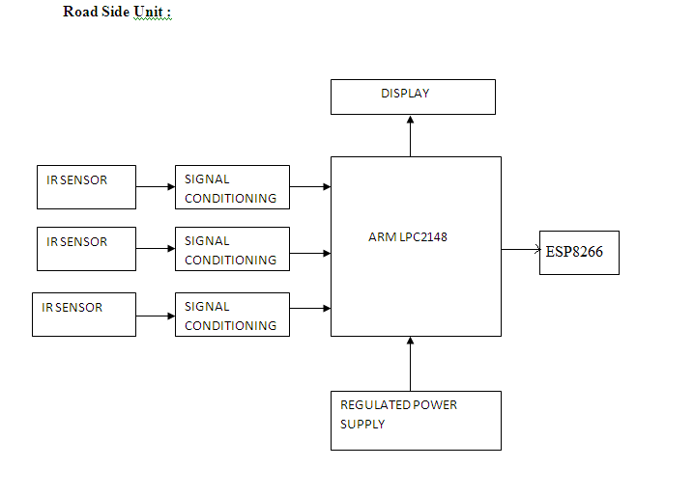

Fig 3.1 Road Side Unit

**On-board Unit (Vehicle)**

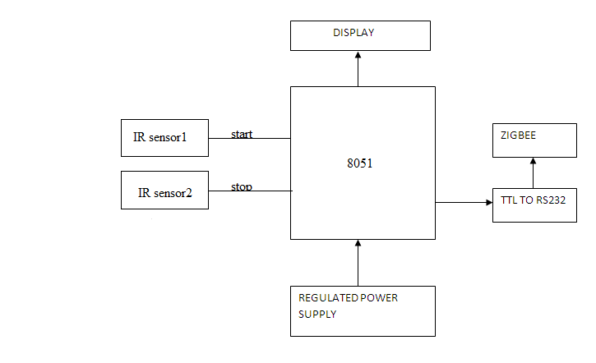

Fig 3.2 Vehicle On-board Unit

**3.1 CONGESTION AVOIDANCE**

When vehicles are travelling near junction on different roads at different speed one cannot foresee whether another vehicle is coming or not so one has to either slow down to be on safer side or to go with same speed unfortunately if there is another vehicle then there is high chances of accident.to overcome this we have placed a hub near junction.

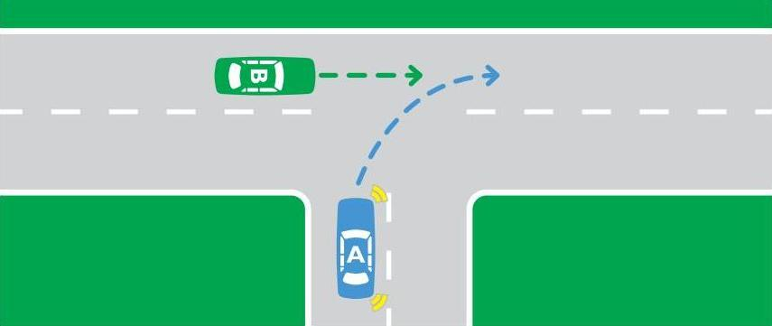

Fig 3.3 Congestion Avoidance

We can calculate speed of each vehicle on each road using two IR sensors , one sensor detect starting point of the vehicle other detects end point of vehicle since both sensors are placed at pre determined distance using timer in microcontroller as time reference one can calculate speed of the vehicle By knowing the speed of vehicle at different roads one can send warning message stating the other vehicle speed is high so that driver can continue with same speed or slow down to avoid accident.

1. Speed of road 1 vehicle is sent to hub.

2. Speed of road 2 vehicle is sent to hub.

3. Hub judges speed and sends message to slower vehicle.

4. On slower vehicle “Vehicle at other road is faster” message is displayed.

If there is high traffic at any junction then Hub sends message to all the vehicles in its vicinity so that they can choose different route thus avoiding traffic congestion and saving the time of the passengers.

**3.2 HILL STATION MESSAGE**

In hill station first of all roads are very much curved and are too steep even if one foresees the danger one cannot control vehicle due to time constraint too control vehicle .so using V2V communication we can avoid accidents.

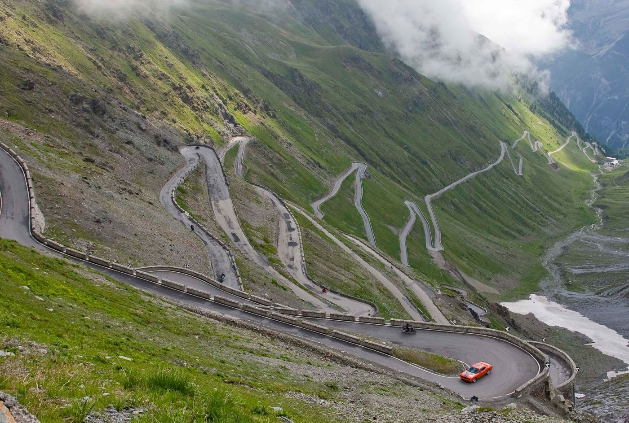

Fig 3.4 Hill Station Caution Message

1. Vehicle 1 can send message stating its arrival.

2. Vehicle 2 (if present) can send message stating its arrival also.

3. Both vehicles can speed down and pass over without accident.

This methodology helps in smooth transportation in hilly terrain area. This saves the life of many passengers.

**3.3 DATA TO CLOUD**

How mobiles can be detected in which area they are located in and that information stored in HLR and VLR. Same concept can be applied for vehicles also as soon as a vehicle enters the coverage area of hub its presence is noted and sent to cloud not only its presence many other details can be stored.

ROAD1 ROAD3

ROAD2

Fig 3.5 Upload Data Online

1. Data from road 1, 2, 3 can be sent to hub.

2. Data from hub can be sent to vehicles on road 1 ,2 ,3.

3. Vehicles on road 1, 2, 3 can send messages to one another.

**3.4 ACCIDENT DETECTION**

Even after taking lot of precaution accident can happen due to negligence of driver if at all it happens near junction then problematic vehicle sends message to hub stating it is in trouble.

Then hub can act wisely and send messages to other vehicles to choose different route till accident sight is cleared and it can also request for nearest ambulance service.

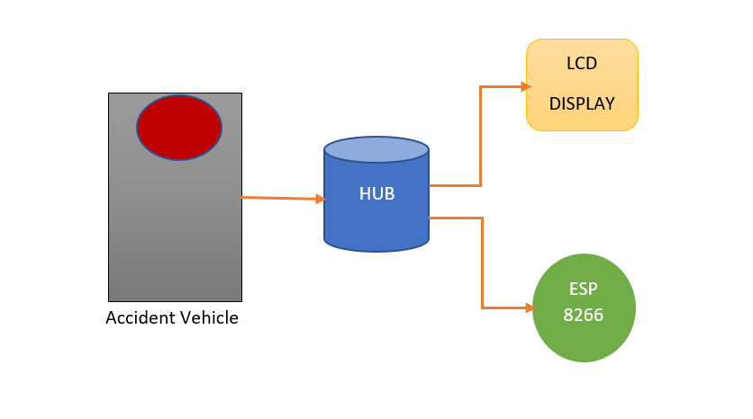

Fig 3.6 Accident Detection Block Diagram

This avoids congestion that could have caused if other without awareness had got accumulated and it also saves passenger if they are in dire need medical services.

1. Accident near hub.

2. Accident detection by hub.

3. Hub sends message for other vehicle to choose different path.

**3.5 AMBULANCE PRIORITY**

The frequency of traffic collisions in India is [amongst the highest in the world](https://en.wikipedia.org/wiki/List_of_countries_by_traffic-related_death_rate). A [National Crime Records Bureau](https://en.wikipedia.org/wiki/National_Crime_Records_Bureau) (NCRB) report revealed that every year, more than 135,000 traffic collision-related deaths occur in India. On occasions like when ambulance is arriving without considering the speed of vehicles at different roads we have to priorities for ambulance to cross the junction.

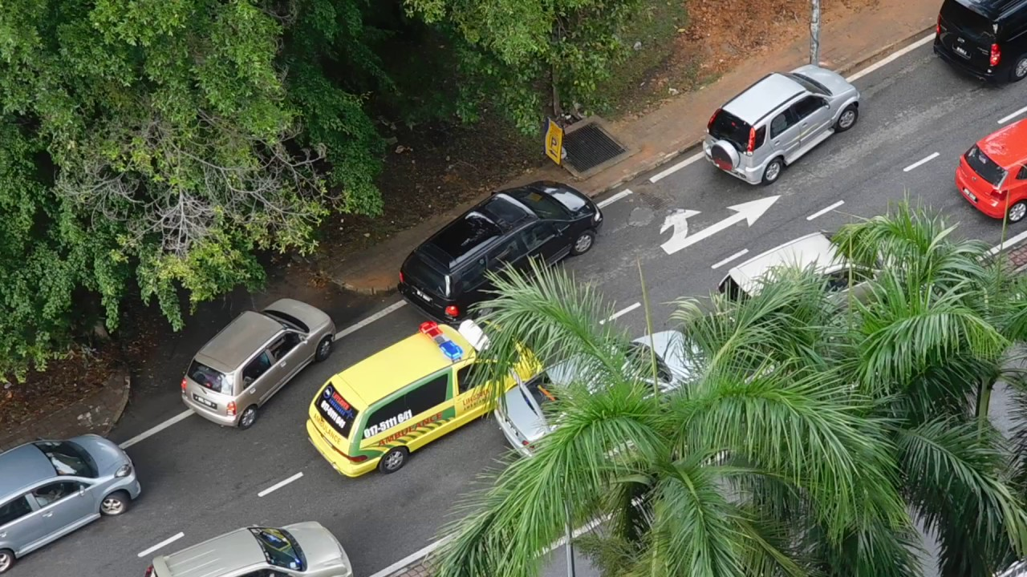

Fig 3.7 Ambulance Priority

1. Speed of vehicles on different roads sent to hub

2. Ambulance arrival is detected by hub

3. Hub priorities the ambulance and send messages

4. Other vehicles get message “ambulance arriving”

5. Other vehicles can pave way for ambulance to cross.

By providing priority to ambulance road is cleared for the ambulance and ambulance can pass the road without any hustle . This would save the accident victim.

**3.6 VEHICLE TO VEHICLE COMMUNICATION**

Vehicle-to-vehicle (V2V) is an automobile technology designed to allow automobiles to "talk" to each other. V2V communications form a [wireless ad hoc network](https://en.wikipedia.org/wiki/Wireless_ad_hoc_network) on the roads. Such networks are also referred to as vehicular ad hoc networks, [VANETs](https://en.wikipedia.org/wiki/VANET). The systems will use a region of the 5.9 GHz band set aside by the United States Congress, the unlicensed frequency also used by [WiFi](https://en.wikipedia.org/wiki/WiFi" \o "WiFi). The US V2V standard, commonly known as WAVE ("Wireless Access for Vehicular Environments"), builds upon the lower-level [IEEE 802.11p](https://en.wikipedia.org/wiki/IEEE_802.11p) standard.

For any Vehicle to Vehicle/V2V Communication system, there are two important factors-

1. The communicating vehicle(s)
2. The roadside infrastructure with which the communication takes place

The actual communication takes place with the help of ‘Dedicated Short Range Communication (DSRC)’ wireless communication devices. As per the regulation in the United States, these devices work in the 5.9GHz band with a bandwidth of 75MHz which it separately assigned for the vehicular communication only. The approximate range of these devices is 1000m. DSRC devices communicate not only with the other vehicles but also with the road infrastructure. It includes road signals or informative nodes installed by the roadside.

[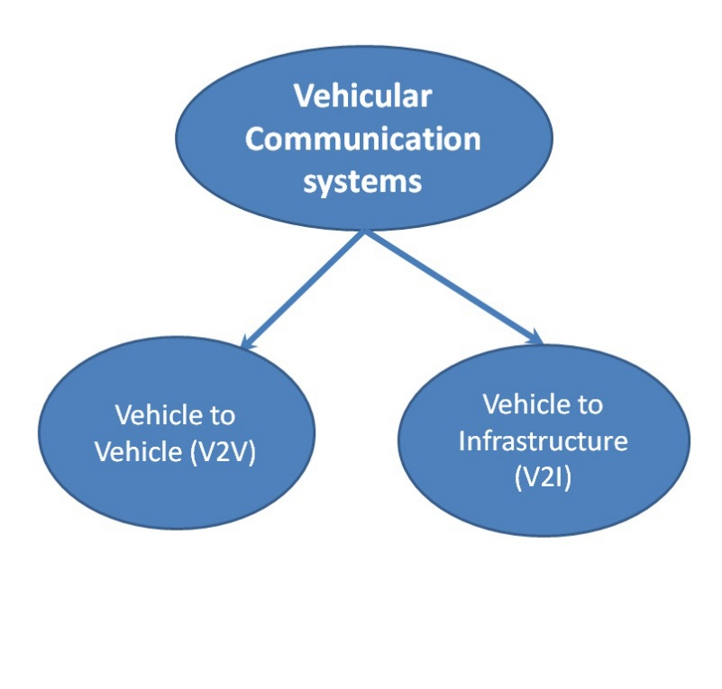](http://carbiketech.com/wp-content/uploads/2015/12/Vehicular-communication-types.jpg)

Fig 3.8 Vehicular Communication System

**3.6.1 THE FUTURE OF V2V SYSTEMS**

At present, development of the first generation of V2V systems is underway. The limitation of its functioning is only giving a warning to the driver. However, these systems are unable to take any corrective action on the input given by the driver.

Furthermore, the second generation of Vehicle to Vehicle systems would be able to take control of the vehicle in danger and provide the corrective action. Hence, these systems would ultimately merge with the autonomous driving technology.

**3.6.2 ADVANTAGES OF V2V**

1. Improved road safety
2. Reduced traffic congestions
3. Helps in streamlining of the flow of vehicles on road

**3.6.3 LIMITATIONS OF V2V**

1. The threat of hacking: Being IT-dependent system, they are vulnerable to attacks of hacking or cracking. In such a situation, the hacker can alter the information displayed in the vehicle. Thereby, causing a disaster.
2. Additional cost: The estimated cost of installing the V2V communication system in the vehicle is high. It could be in the range of 2,000 USD to 20,000 USD depending upon the vehicle model and complexity of the system.
3. The frequency band set aside for this system can’t support a large number of vehicles simultaneously.