**Chapter 6**

**SOFTWARE IMPLEMENTATION**

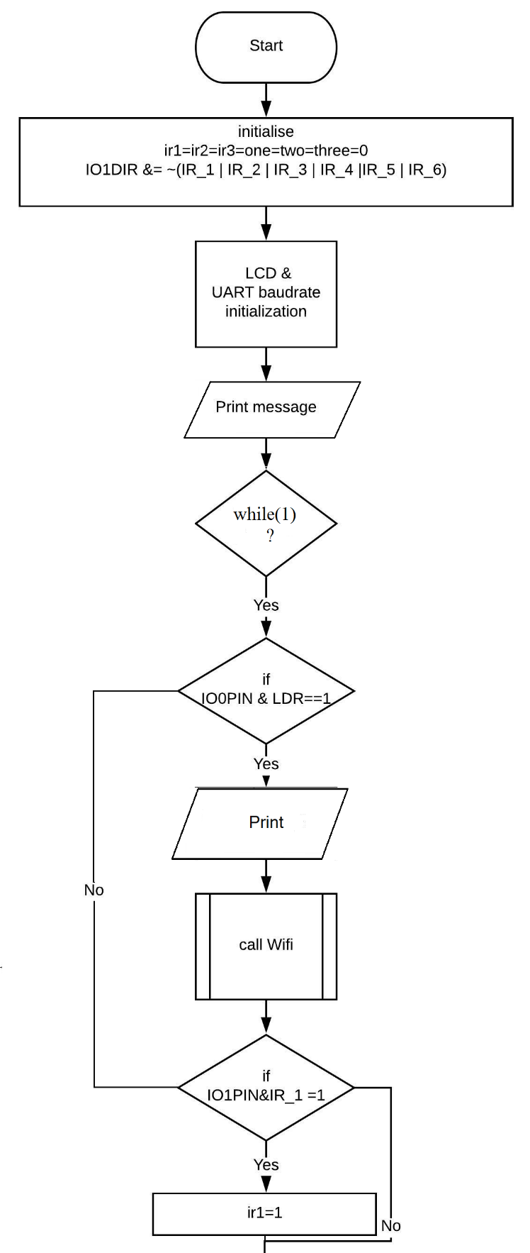**6.1 FLOWCHART OF THE ARM HUB**

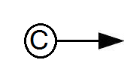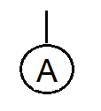

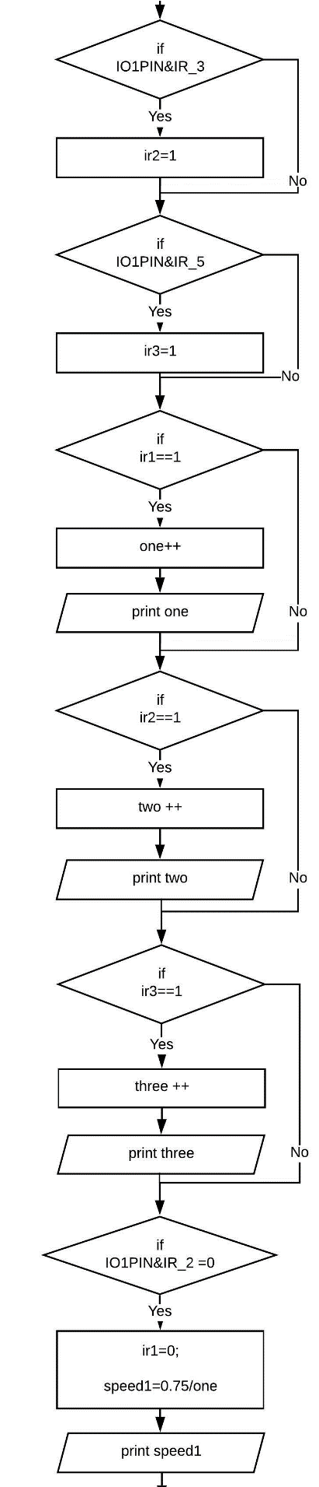



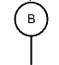

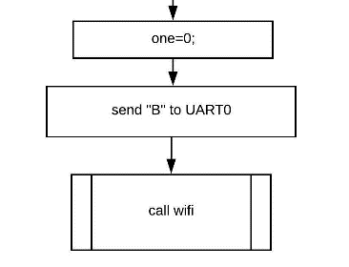

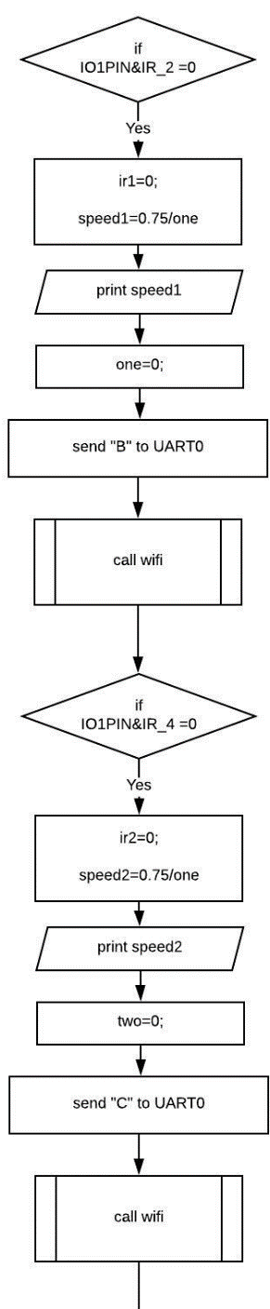





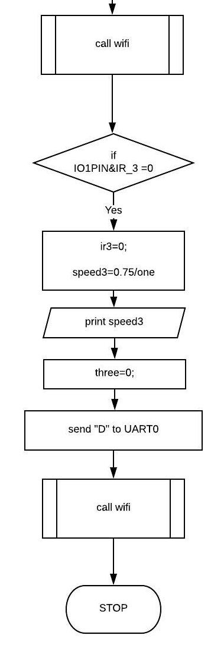

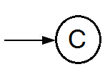

**6.2 FLOWCHART FOR 8051 INTERFACING WITH ZIGBEE**

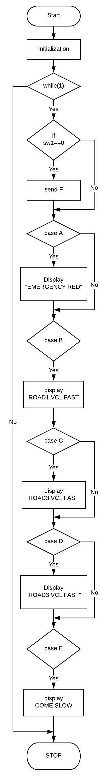

**6.2.1 FLOWCHART FOR UART INTERRUPT**

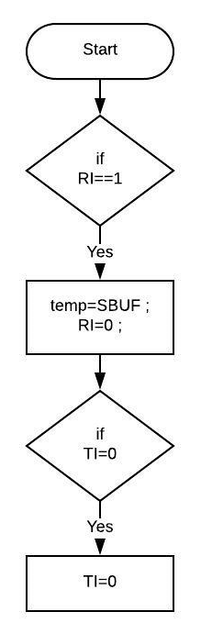

In order to complete the function of the developed system, we write a program. The program has been written in basic C language. The software tool used here is Keil µVision.

After the compilation of the program the output HEX file downloaded into the ROM of the AT89C51 microcontroller. This program performs initial configurations for the AT89C51 and ARM7 microcontroller. ARM7 is ready to transmit the data. 8051 is ready to communicate with other vehicles (i.e ready to transmit and receive). Based on the data received particular message is displayed on the LCD.