

Experiment No.2
Identify suitable Agent Architecture and type for the problem.
Date of Performance:
Date of Submission:

Aim: Identify suitable Agent Architecture and type for the problem.
Objective: To study the structure , characteristics of intelligent agent and identify the type of any rational agent.

Theory:

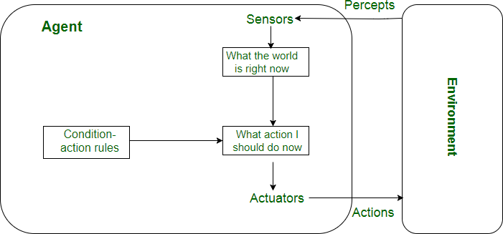

Simple Reflex agent:
- The Simple reflex agents are the simplest agents. These agents take decisions on the basis of the current percepts and ignore the rest of the percept history.
- These agents only succeed in the fully observable environment.
- The Simple reflex agent does not consider any part of percepts history during their decision and action process.
- The Simple reflex agent works on Condition-action rule, which means it maps the current state to action. Such as a Room Cleaner agent, it works only if there is dirt in the room.

. Model-based reflex agent

- The Model-based agent can work in a partially observable environment, and track the situation.
- A model-based agent has two important factors:
  - Model: It is knowledge about "how things happen in the world," so it is called a Model-based agent.
  - Internal State: It is a representation of the current state based on percept history.
- These agents have the model, "which is knowledge of the world" and based on the model they perform actions.
- Updating the agent state requires information about:
. How the world evolves
a. How the agent's action affects the world.

Goal-based agents
- The knowledge of the current state environment is not always sufficient to decide for an agent to what to do.
- The agent needs to know its goal which describes desirable situations.
- Goal-based agents expand the capabilities of the model-based agent by having the "goal" information.
- They choose an action, so that they can achieve the goal.
- These agents may have to consider a long sequence of possible actions before deciding whether the goal is achieved or not. Such considerations of different scenario are called searching and planning, which makes an agent proactive.

Utility-based agents
- These agents are similar to the goal-based agent but provide an extra component of utility measurement which makes them different by providing a measure of success at a given state.
- Utility-based agent act based not only goals but also the best way to achieve the goal.
- The Utility-based agent is useful when there are multiple possible alternatives, and an agent has to choose in order to perform the best action.
- The utility function maps each state to a real number to check how efficiently each action achieves the goals.

Learning Agents
- A learning agent in AI is the type of agent which can learn from its past experiences, or it has learning capabilities.
- It starts to act with basic knowledge and then able to act and adapt automatically through learning.
- A learning agent has mainly four conceptual components, which are:
. Learning element: It is responsible for making improvements by learning from environment
- Critic: Learning element takes feedback from critic which describes that how well the agent is doing with respect to a fixed performance standard.
- Performance element: It is responsible for selecting external action

- Problem generator: This component is responsible for suggesting actions that will lead to new and informative experiences.
- Hence, learning agents are able to learn, analyze performance, and look for new ways to improve the performance.

Conclusion:

.
SOPHIA ROBOT.

Sophia is simultaneously a human-crafted science fiction character depicting the future of AI and robotics, and a platform for advanced robotics and AI research.She is the world’s first robot citizen and the first robot Innovation Ambassador for the United Nations Development Programme. Sophia is now a household name, with appearances on the Tonight Show and Good Morning Britain, in addition to speaking at hundreds of conferences around the world.

Type of Agent: Learning Agent
Sophia is designed to interact with humans and learn from these interactions over time.
Learning Capability: Sophia utilizes machine learning algorithms to improve its understanding of human behavior, language, and preferences. It can learn from conversations and interactions with people, adapting its responses and behavior based on these interactions.
Adaptability: The robot can adapt its responses and actions based on the feedback it receives. This adaptability is a key characteristic of learning agents, where the agent's behavior evolves over time through learning mechanisms.
Knowledge Acquisition: Sophia continuously gathers data from its environment (including conversations, internet sources, etc.) to improve its knowledge base and decision-making processes.

PEAS
Performance: Sophia’s performance can be measured by the accuracy and appropriateness of its responses, the quality of interactions it facilitates, and the tasks it successfully completes.
Environment: Sophia operates in dynamic environments that include human interactions, various physical settings (like conferences or public events), and online information sources.
Actuators: The robot interacts through speech (text-to-speech synthesis), facial expressions (animatronic features), and body movements. It can also access and display information on screens.
Sensors: Sophia uses cameras and microphones to perceive the environment, speech recognition to understand human input, and possibly other sensors for environmental awareness.

Architecture
Perception: Sensors (cameras, microphones) to perceive the environment and understand human input.
Learning Module: Uses machine learning algorithms (possibly reinforcement learning, deep learning for natural language processing) to improve its responses and interactions.
Reasoning/Decision Making: Processes information to generate appropriate responses and actions based on its learning and the current context.
Action: Actuators (speech synthesis, facial expressions, movements) to interact with humans and the environment.

Working
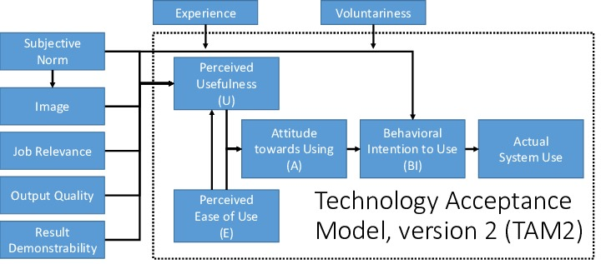

Sophia's working involves the following steps:
Perception: Receives input from the environment through sensors, including visual and auditory information.
Learning: Utilizes machine learning to analyze and learn from the input data, such as understanding speech patterns, recognizing faces, and learning social cues.
Reasoning: Based on its knowledge base and current input, Sophia decides on appropriate responses and actions.
Action: Executes actions through its actuators, responding verbally or non-verbally to interact with humans effectively.
Feedback: Receives feedback from interactions and adjusts its behavior and responses accordingly, continuing the learning cycle.

CONCLUSION:
As it is adaptable to it's mistakes and learns from it, the ability to grow remains endless. Thus the potential to improve based on it's past experiences, getting information from the sensor both visually and via speech. In the future, it's going to be am extremely important aspect in the growth of the age of AI

