WISEBUY: AN AI POWERED TECHNOLOGY SHOPPING ASSISTANT

A PROJECT REPORT

Submitted by

K.Divya Sainath Reddy [RA2512005010045]

Under the Guidance of

Dr. SANTHIYA P
(Assistant Professor, Department of Computing Technologies)

in partial fulfilment of the requirements for the course

21CSE746P - AI INTEGRATED FULL STACK APPLICATION DEVELOPMENT WITH DEVOPS

MASTER OF TECHNOLOGY
in
COMPUTER SCIENCE ENGINEERING



DEPARTMENT OF COMPUTING TECHNOLOGIES
COLLEGE OF ENGINEERING AND TECHNOLOGY
SRM INSTITUTE OF SCIENCE AND TECHNOLOGY
KATTANKULATHUR - 603 203

NOVEMBER 2026
Department of Computing Technologies
SRM Institute of Science & Technology

Own Work Declaration Form

This sheet must be filled in, signed, dated with student registration number, and included with all assignments submitted for evaluation.
Field | Details
Degree / Course | M.Tech / 21CSE746P - AI Integrated Full Stack Application Development with DevOps
Student Name | K.Divya Sainath Reddy
Registration Number | RA2512005010045
Title of Work | WiseBuy: An AI Powered Technology Shopping Assistant

I hereby certify that this assessment complies with the University rules and regulations relating to academic misconduct and plagiarism. I confirm that all work contained in this report is my own except where indicated through citation and acknowledgement, and that I have:
- Clearly referenced and listed all sources as appropriate.
- Referenced and put in inverted commas all quoted text from books, documentation, or other sources.
- Given the sources of all pictures, diagrams, data, and code that are not my own.
- Not made use of the report or essay of any other student either past or present.
- Acknowledged any help received from others.
- Complied with any other plagiarism criteria specified by the course handbook or University website.

DECLARATION: I am aware of and understand the University policy on academic misconduct and plagiarism. I certify that this assessment is my own work, except where indicated by referencing, and that I have followed good academic practices.
Student Signature | Student Name | Registration Number | Date
 | K.Divya Sainath Reddy | RA2512005010045
SRM INSTITUTE OF SCIENCE AND TECHNOLOGY
KATTANKULATHUR - 603 203

BONAFIDE CERTIFICATE

Certified that 21CSE746P - AI Integrated Full Stack Application Development with DevOps – Project report titled "WiseBuy: An AI Powered Technology Shopping Assistant" is the bonafide work of K.Divya Sainath Reddy [RA2512005010045], who carried out the project work under my supervision. Certified further, that to the best of my knowledge the work reported herein does not form any other project report or dissertation on the basis of which a degree or award was conferred on an earlier occasion on this or any other candidate.

SIGNATURE | SIGNATURE
Dr. SANTHIYA P  ASSISTANT PROFESSOR  DEPARTMENT OF COMPUTING TECHNOLOGIES | Dr. G. NIRANJANA  PROFESSOR & HOD  DEPARTMENT OF COMPUTING TECHNOLOGIES

ACKNOWLEDGEMENT
I express my humble gratitude to Dr. C. Muthamizhchelvan, Vice-Chancellor, SRM Institute of Science and Technology, for the facilities extended for the project work and his continued support.
I extend my sincere thanks to Dr. Leenus Jesu Martin M, Dean-CET, SRM Institute of Science and Technology, for his invaluable support.
I wish to thank Dr. Revathi Venkataraman, Professor and Chairperson, School of Computing, SRM Institute of Science and Technology, for her support throughout the project work.
I encompass my sincere thanks to Dr. M. Pushpalatha, Professor and Associate Chairperson - CS, School of Computing, and Dr. C. Lakshmi, Professor and Associate Chairperson - AI, School of Computing, SRM Institute of Science and Technology, for their invaluable support.
I am incredibly grateful to our Head of the Department, Dr. G. Niranjana, Professor, Department of Computing Technologies, SRM Institute of Science and Technology, for her suggestions and encouragement at all the stages of the project work.
My inexpressible respect and thanks to my subject faculty and guide, Dr. Santhiya P, Assistant Professor, Department of Computing Technologies, SRM Institute of Science and Technology, for providing me with an opportunity to pursue my project under her mentorship. She provided me with the freedom and support to explore the research topics of interest, and her guidance at every review shaped both the system and this report.
I also wish to thank the members of the project review panel, Department of Computing Technologies, SRM Institute of Science and Technology, for their valuable feedback and insightful review of my work.
I sincerely thank all the staff members of the Department of Computing Technologies, School of Computing, SRM Institute of Science and Technology, for their help during my project. Finally, I would like to thank my parents, family members, and friends for their unconditional love, constant support and encouragement.
K.Divya Sainath Reddy

ABSTRACT
Selecting an electronic device requires more than comparing a price and a specification sheet. A student may ask for a laptop for coding, a creator may prioritise video editing, and a traveller may need comfortable headphones with noise cancellation. These needs are difficult to express as technical filters, while prices and configurations differ across online retailers. This project presents WiseBuy, an AI powered technology shopping assistant that converts a natural-language shopping request into a small, explainable shortlist supported by eligible Indian retailer listings.
The application uses a React frontend, a Node.js and Express REST API, MongoDB with Mongoose, and a Groq language-model service. The system extracts category, budget, intended use and requirements, then asks Groq to suggest up to three suitable product models. Each model is searched individually through configured shopping providers. The application checks model identity, whole-device status, seller eligibility, currency and budget before displaying an offer. Displayed prices come from shopping results rather than language-model estimates. A deterministic parser supports requirement extraction when the AI response cannot be used.
WiseBuy supports smartphones, laptops, headphones, smartwatches, tablets and monitors. Product comparison, observed price history, review-video discovery, contextual follow-up chat, user authentication, favourites and search history support the purchase decision. Verification completed for this report recorded 248 passing backend tests, four passing frontend chat-context tests and a successful production frontend build. Docker Compose and a Render Blueprint provide deployment configurations. The report presents the architecture, AI workflow, data handling, implementation, verification results and limitations of provider-dependent recommendations.
Keywords: WiseBuy, Conversational Recommendation, Technology Shopping, Large Language Models, Groq, React, Express, MongoDB, Product Matching, Price Comparison, Docker, DevOps.

TABLE OF CONTENTS
ABSTRACT v
TABLE OF CONTENTS vi
LIST OF FIGURES viii
LIST OF TABLES viii
ABBREVIATIONS ix

1 INTRODUCTION 1
1.1 Introduction 1
1.2 Problem Statement 1
1.3 Motivation 1
1.4 Objectives 2
1.5 Course Outcome and SDG Alignment 2
1.6 Scope of the Report 3
1.7 Contributions 3

2 LITERATURE SURVEY 4
2.1 Overview 4
2.2 Recommendation Systems and User Intent 4
2.3 Natural Language and Large Language Models 4
2.4 Language Models for Product Recommendation 5
2.5 Product Retrieval and Evidence Grounding 5
2.6 Research Gap and Project Objectives 5

3 PROPOSED METHODOLOGY 6
3.1 Methodology Overview 6
3.2 System Architecture 6
3.3 Application Request and Data Flow 7
3.4 Application Components 7
3.5 Data Model and Storage 7
3.6 Security and Reliability Boundaries 8
3.7 Recommendation and Verification Pipeline 8
3.8 Product Data and Source Provenance 9
3.9 Data Preprocessing 9
3.10 Selection and Comparison Logic 10
3.11 AI Inference and Failure Handling 10
3.12 Explanations and Product Research 10
3.13 Mathematical Model Summary 11

4 FULL-STACK IMPLEMENTATION AND DEPLOYMENT 12
4.1 Design Principle 12
4.2 Product and Provider Models 12
4.3 Recommendation and Product Lifecycle 12
4.4 Database and Data Persistence 12
4.5 API Design 13
4.6 Frontend Shopping Interface and Catalog 13
4.7 Natural Language Recommendation 14
4.8 Product Comparison and Price History 14
4.9 Review Discovery and Contextual Chat 14
4.10 Authentication and User Experience 15
4.11 Docker and Delivery Configuration 15
4.12 Deployment on Render 16
4.13 Testing Methodology 16

5 EXPERIMENTAL SETUP 17
5.1 Development and Runtime Environment 17
5.2 Product Categories and Shopping Constraints 17
5.3 Data and Test Preparation 17
5.4 Evaluation Criteria 18
5.5 Recommendation and Application Test Protocol 18

6 RESULTS AND DISCUSSION 19
6.1 Automated Verification Results 19
6.2 Product Matching and Offer Validation 19
6.3 Requirement and Ranking Behaviour 21
6.4 Worked Shopping Example 21
6.5 Application and API Testing 21
6.6 Deployment Configuration and DevOps 22
6.7 Comparison, History and Advisor Behaviour 23
6.8 Discussion and Limitations 24
6.9 Threats to Validity 24
6.10 Result Summary 25

7 CONCLUSION AND FUTURE ENHANCEMENTS 26
7.1 Conclusion 26
7.2 Future Enhancements 26
7.3 Final Remarks 26

REFERENCES 27
APPENDIX A - REQUIREMENT AND PRODUCT DATA FIELDS 28
APPENDIX B - REPOSITORY LAYOUT 29
APPENDIX C - APPLICATION INTERFACE AND DEPLOYMENT VIEWS 30
APPENDIX D - SELECTED SOURCE CODE 34

LIST OF FIGURES
3.1 System architecture of WiseBuy 6
3.2 Recommendation and verification workflow 9
4.1 Shopping session and product lifecycle 14
6.1 Automated tests and catalog coverage 20
C.1 WiseBuy landing page 30
C.2 Product catalog and filters 31
C.3 Conversational recommendation results 31
C.4 Product details and seller offers 32
C.5 Side-by-side product comparison 32
C.6 Docker and Render configuration 33

LIST OF TABLES
1.1 Course alignment for 21CSE746P 2
3.1 Application components and responsibilities 7
3.2 MongoDB collections and stored information 8
4.1 Main REST endpoints of the WiseBuy API 13
4.2 Requirement fields and recommendation service settings 15
5.1 Supported categories and illustrative seed-catalog coverage 17
6.1 Verification outcomes recorded for WiseBuy 19
6.2 Representative product and offer validation scenarios 20
6.3 Requirement handling and ranking rules 21
6.4 Automated application tests and checks 22
6.5 Deployment and container configuration 23
6.6 Limitations and planned improvements 24
A.1 Requirement and product data fields 28
B.1 Repository layout 29

ABBREVIATIONS
Abbreviation | Expansion
AI | Artificial Intelligence
API | Application Programming Interface
CI | Continuous Integration
CD | Continuous Delivery or Deployment
CORS | Cross-Origin Resource Sharing
CPU | Central Processing Unit
CRUD | Create, Read, Update and Delete
CSS | Cascading Style Sheets
DB | Database
GPU | Graphics Processing Unit
HTML | HyperText Markup Language
HTTP | Hypertext Transfer Protocol
HTTPS | Hypertext Transfer Protocol Secure
INR | Indian Rupee
JSON | JavaScript Object Notation
JWT | JSON Web Token
LLM | Large Language Model
ODM | Object Document Mapper
RAM | Random Access Memory
REST | Representational State Transfer
SDG | Sustainable Development Goal
SDK | Software Development Kit
SPA | Single-Page Application
TTL | Time to Live
UI | User Interface
URL | Uniform Resource Locator
UX | User Experience
JS | JavaScript
YAML | YAML Ain’t Markup Language

CHAPTER 1
INTRODUCTION

1.1 Introduction
Online electronics shopping presents many products, overlapping specifications and changing seller offers. A buyer often understands the intended activity better than the hardware required for it. Requests such as a laptop for college programming or headphones for daily travel describe a goal, but they do not directly specify a processor tier, memory capacity or feature combination. Conventional category filters require the buyer to translate that goal into technical choices before searching.
WiseBuy is a full-stack web application that connects this stated intent with product discovery. The shopper describes a requirement in ordinary language, and the application produces a shortlist of matching devices with eligible retailer offers. The system combines React, Express, MongoDB, a Groq language-model service and shopping-provider adapters. Supporting pages allow users to inspect specifications, compare products, view recorded prices, discover review videos and ask follow-up questions about the selected shortlist [1].

1.2 Problem Statement
The problem addressed by WiseBuy is the difficulty of moving from a personal shopping need to a small, relevant and verifiable set of electronic devices. Keyword searches can return accessories, unsuitable configurations or models outside the stated budget. A general chatbot can suggest products without establishing current seller availability or price. WiseBuy therefore separates model suggestion from offer verification and requires a listing to pass explicit eligibility checks before it becomes a displayed recommendation.

1.3 Motivation
The motivation is to reduce the effort involved in researching a technology purchase. Shoppers currently move between search engines, retailer pages, comparison sites and review videos. Combining these activities in one interface can make the decision easier to follow. Natural-language interaction lets a shopper explain priorities such as portability, gaming, camera quality or battery life without first learning a detailed specification vocabulary.
The project also explores a practical boundary for generative AI in shopping. A language model can interpret a request and propose relevant model names, while application code verifies retrieved offers and explains the available fields. This division makes the origin of prices explicit and avoids treating generated text as evidence of a current retail offer. Missing information remains a limitation of the available listing rather than a reason to invent a specification.

1.4 Objectives
- Develop a responsive conversational interface that accepts a shopper’s complete request and preserves its budget, category, intended use and explicit constraints.
- Integrate a hosted language model for requirement interpretation and product-model shortlisting, with schema validation and a deterministic requirement parser.
- Retrieve shopping listings for exact shortlisted models and reject ineligible sellers, non-INR offers, accessories, wrong models and offers outside the budget.
- Provide explanations, side-by-side comparison, observed price history, review-video discovery and contextual follow-up advice for the selected products.
- Implement authenticated accounts, saved products, search history, automated checks and repeatable deployment configurations using MongoDB, Docker and Render.

1.5 Course Outcome and SDG Alignment
Table 1.1 relates the WiseBuy implementation to the course themes of application development, data handling, AI integration and DevOps. The project uses JavaScript across the application stack and integrates a hosted pretrained model. It demonstrates modular software development and AI service integration; training a Python machine-learning estimator is outside the implemented scope.
Table 1.1: Course alignment for 21CSE746P
Course theme | WiseBuy implementation
Modular application development | JavaScript services, provider classes, shared utilities and error handling.
Data handling and frontend | Listing normalization, schema validation and a responsive React interface.
Full-stack database integration | Express API, Mongoose schemas and persistent MongoDB records.
AI integration | Hosted Groq inference for requirements, model suggestions and contextual advice.
DevOps practices | Docker images, Compose health checks, local tests and Render Blueprint.

WiseBuy relates to SDG 9, Industry, Innovation and Infrastructure, through the development of an integrated software service. Its support for informed product selection also has a potential connection to SDG 12, Responsible Consumption and Production. The project does not measure reduced consumption, financial savings or environmental impact, so these connections describe intended relevance rather than demonstrated sustainability outcomes. The alignment refers to the published Sustainable Development Goals [16].

1.6 Scope of the Report
This report covers the WiseBuy frontend, REST API, MongoDB models, language-model integration, requirement parser, recommendation engine, shopping-provider fallback, product validation, comparison, price history, video discovery, authentication and saved-user workflows. It also covers the test suite and the Docker Compose and Render deployment configurations. Payment processing, order fulfilment, retailer inventory ownership and training a foundation model are outside the scope. No public deployment uptime or real-user recommendation-quality benchmark is claimed.

1.7 Contributions
- A conversational shopping workflow that turns a free-text request into structured requirements and a small model shortlist across six technology categories.
- An offer-validation pipeline that preserves model identity and budget boundaries while rejecting accessory and replacement-part listings.
- A connected purchase-research experience with product comparison, retailer links, price observations, review-video discovery and shortlist-aware chat.
- A modular React, Express and MongoDB implementation with authentication, persistent user activity, passing automated checks and container and cloud deployment definitions.

CHAPTER 2
LITERATURE SURVEY

2.1 Overview
The background for WiseBuy includes recommendation systems, natural-language preference elicitation, language-model assisted recommendation and the grounding of product information in retrieved evidence. Traditional search depends on a shopper knowing the correct keywords or filters. A conversational assistant can collect a goal and constraints, but it must still connect these preferences to identifiable products and reliable offer data.

2.2 Recommendation Systems and User Intent
Recommendation systems help users choose from a large item space by relating user preferences to item characteristics or interaction patterns. The survey by Wu et al. reviews how large language models can support recommendation tasks through their language understanding and representation capabilities [3]. WiseBuy uses the stated request rather than a history of ratings: its input is an intended use, a budget and any explicit feature or brand restrictions.
This project follows a task-oriented approach to preference collection. A shopper may state coding, photography or travel as the primary use case. The system extracts these needs and maps them to a structured request. When a category cannot be determined, it asks a targeted clarification and can move to a guided flow. This design supports a new user without requiring previous purchases or a large personal interaction history.

2.3 Natural Language and Large Language Models
The Transformer architecture established attention-based sequence modelling as a foundation for modern language systems [2]. In WiseBuy, a hosted language model interprets shopping text and proposes model names; the project does not train a Transformer. Prompt instructions distinguish requirement extraction from product discovery, and structured responses are checked locally before the application uses them. This reduces reliance on unvalidated prose, although schema validity alone cannot establish that a model suggestion is suitable.

2.4 Language Models for Product Recommendation
Language-model recommendation research considers ways to use text understanding for item selection and explanation [3]. WiseBuy applies this idea in a constrained workflow: Groq suggests up to three canonical device models, and shopping providers then search those names. The default research path requests browser-assisted model discovery when a supported model is configured [4]. The shortlist remains a set of search targets until retrieved offers pass the application’s checks.

2.5 Product Retrieval and Evidence Grounding
A model suggestion, a shopping listing and a seller offer represent different kinds of information. WiseBuy retains that distinction. SerpApi and RapidAPI adapters supply listing data; the backend normalises fields, validates product identity and applies budget and retailer rules. Current recommendation discovery accepts Amazon India and Flipkart offers. The broader product-offer utility also recognises Croma. These application checks improve traceability, but a successful lookup is not a guarantee of checkout price or stock availability [1], [10].

2.6 Research Gap and Project Objectives
The application-level gap is the absence of a single workflow that combines free-text intent, a small researched shortlist, exact-model retrieval, budget verification and follow-up product research. WiseBuy addresses that gap through a layered system. Evaluation focuses on the implemented parsing, matching, filtering and fallback behaviour. A future user study and a human-labelled recommendation dataset are needed to establish how well the system improves purchase decisions.

CHAPTER 3
PROPOSED METHODOLOGY

3.1 Methodology Overview
The workflow begins with a shopping message in the React interface. The frontend requests requirement analysis from the Express API. The AI service extracts the category, budget, use cases, requirements and priorities, while a deterministic parser is available if extraction fails. The recommendation service asks Groq for suitable model names and searches each model through the product-provider chain. Eligible results are grouped by configuration, selected, stored and returned to the chat interface.

3.2 System Architecture
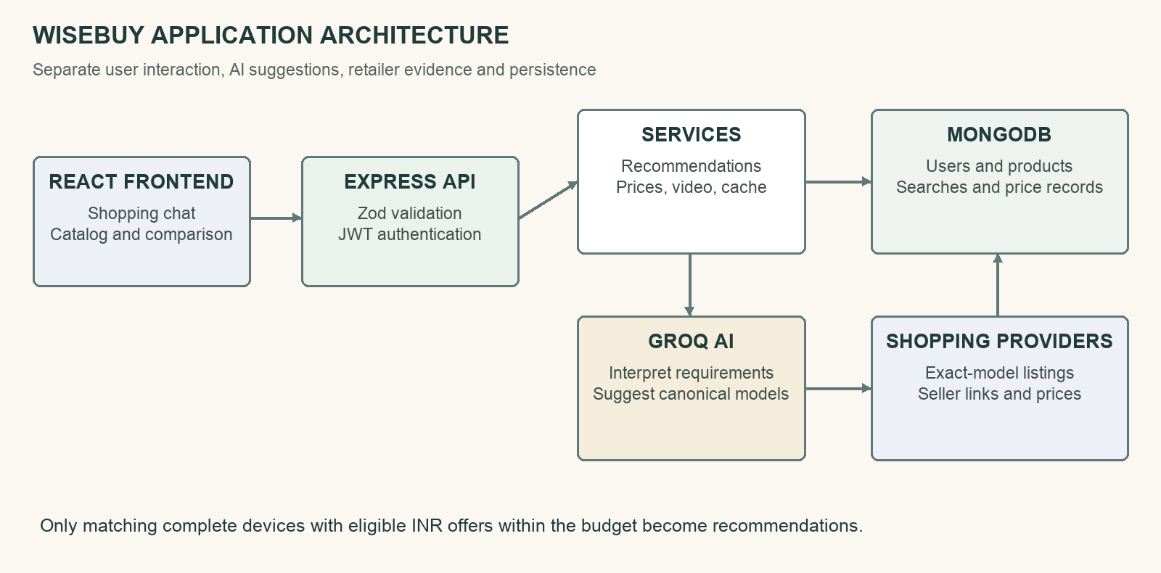
Fig. 3.1 System architecture of WiseBuy: React interface, Express services, MongoDB and external providers
Fig. 3.1 separates the browser, API, application services, storage and external integrations. React renders the shopping conversation and supporting pages [5]. Express routes delegate to controllers and services [6]. Mongoose models store users, products, recommendations, searches and observed prices in MongoDB [7], [8]. The Groq service interprets requirements and suggests models; the product-provider layer supplies listing evidence. Price history and video review lookups are requested separately when the shopper opens a product.

3.3 Application Request and Data Flow
A recommendation request carries the original query alongside structured requirements. The backend validates the request, checks the category and budget range, obtains the model shortlist and performs up to three model lookups concurrently. The provider chain advances when a source fails or returns no eligible result for that same model. After filtering, one available configuration is selected per matched model. The response preserves the shortlist order and may contain fewer than three products when some models have no qualifying offer.

3.4 Application Components
Table 3.1: Application components and responsibilities
Component | Technology | Responsibility
Browser interface | React, Router, Zustand | Shopping chat, catalog, product details, comparison and saved activity.
REST API | Node.js, Express, Zod | Validation, routing, authentication and shared error handling.
AI service | Groq SDK | Requirement extraction, model shortlisting and contextual chat.
Recommendation engine | JavaScript services | Eligible configuration selection, explanations and persistence.
Shopping integration | SerpApi and RapidAPI adapters | Exact-model retrieval, provider fallback and normalized responses.
Storage | MongoDB, Mongoose | Users, products, recommendations, search and price history.
Deployment | Docker, Nginx, Render | Repeatable containers and production web-service definition.

3.5 Data Model and Storage
Five Mongoose models form the persistence layer: User, Product, Recommendation, SearchHistory and PriceHistory. A product contains its provider title, category, model, seller offers, specifications and provenance. A recommendation records the original request, structured preferences, shortlisted models and selected picks. Search history links an authenticated user to a previous query and recommendation. Price observations retain their source and timestamp. User documents store password hashes and favourite-product references.
Table 3.2: MongoDB collections and stored information
Collection | Main information | Purpose
users | Identity, email, password hash, favourite references | Authentication and saved products.
products | Model, listing title, category, offers, specifications, source | Catalog and verified selected products.
recommendations | Original query, preferences, shortlisted models, picks | Saved recommendation snapshot.
searchhistories | User, query, recommendation, time, count | Replay authenticated shopping activity.
pricehistories | Product, platform, price, timestamp, source | Observed and demonstration price history.

3.6 Security and Reliability Boundaries
Authentication uses signed access tokens and an httpOnly refresh cookie, with bcrypt password hashing. Protected routes identify the user before serving favourites or history. Request bodies are validated with Zod; application middleware also configures security headers, CORS, rate limiting and central error handling. Provider timeouts and quota checks limit stalled or exhausted integrations. MongoDB is the persistent datastore; the application does not implement an in-memory replacement for saved user data. Zod and the JWT standard document the validation and token concepts used here [14], [15].

3.7 Recommendation and Verification Pipeline
WiseBuy separates intent interpretation, model suggestion and offer verification. Groq first proposes a small model shortlist. For each suggestion, the server searches the canonical manufacturer and model name, preserving requested family restrictions. Retrieved listings must describe complete devices, match the model and category, and contain an available eligible INR offer within the stated range. Fig. 3.2 shows this sequence and the point at which a suggestion becomes a verified recommendation.
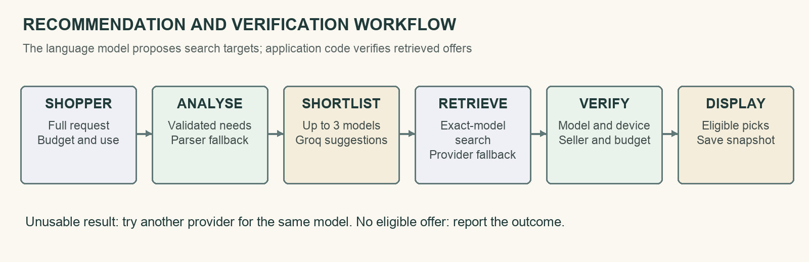
Fig. 3.2 Recommendation workflow from shopping request to eligible product shortlist

3.8 Product Data and Source Provenance
The project has two distinct product-data paths. A seed file defines 55 illustrative catalog products across six categories for browsing and demonstrations. Live recommendations use shopping-provider results for Groq-selected models. A provider result can contain a title, image, price, seller and link, but it may not provide a complete specification sheet. The stored source and listing title support later validation. Seeded prices and generated demonstration history are not evidence of current retailer prices.
Recommendation = model suggestion + matching listing + eligible offer
The recommendation flow searches a fixed shortlisted model through fallback providers instead of broadening to an unrelated model when a source fails. A response containing only accessories, wrong variants, disallowed sellers or out-of-budget offers is treated as unusable for that model. This can increase provider calls, but it keeps the search aligned with the shopper’s request. If no model has an eligible offer, the API reports the outcome rather than filling the result with unrelated products.
Eligible offer = model match ∩ whole device ∩ approved seller ∩ INR ∩ budget ∩ available

3.9 Data Preprocessing
The backend normalises provider responses into a shared product shape. Price strings are parsed into numeric INR values, and identifiable RAM, storage, CPU and GPU information can be extracted from listing titles. Configuration-aware grouping prevents offers for different RAM or storage variants from being merged. Duplicate detection combines equivalent product offers, and whole-product checks reject cases, repair parts and replacement components. Missing listing facts remain unavailable rather than becoming inferred manufacturer specifications.

3.10 Selection and Comparison Logic
The live shortlist is ordered by Groq’s model suggestions. Within a model’s matching listings, deterministic logic selects an eligible configuration using the structured requirements and available product fields. The code also includes specification, intent, rating, price and value scoring helpers. These helpers do not turn Groq suggestions into a validated percentage probability of suitability. The interface identifies the ranking source rather than presenting the shortlist as a trained classifier’s accuracy score.
The separate comparison page evaluates two to four selected products using known numeric fields. It highlights the best available value in each row and counts row wins for a simple overall verdict. Lower price is preferred in the price row; larger values are preferred in the other implemented numeric rows. Missing values do not win a comparison row.
Wins(p) = Σ over rows r of I(product p has a best known value in row r)
The product with the most row wins is selected by the comparison helper, with a lower-price tie break. This is an arithmetic comparison of available fields, not a benchmark of real-world device performance. Numeric RAM and processor tiers across different platforms should therefore be interpreted with care.

3.11 AI Inference and Failure Handling
Requirement extraction validates AI output and can fall back to deterministic parsing. Model shortlisting and contextual chat still require Groq. The shopping chain tries alternative providers for the same model. Individual failures can produce a partial shortlist; a complete failure returns an error. Identical pending requests and recent results share caches to avoid redundant calls.

3.12 Explanations and Product Research
Explanations reference verified product fields and the requested budget. Product pages add seller comparison, observed price history and review discovery. Follow-up chat is bound to a product or saved recommendation, keeping later questions focused on the current selection.
Display(p) = true only when at least one eligible offer exists for product p
Price history distinguishes demonstration data from recorded observations and requires two points for a trend. Review discovery uses configured search services or a YouTube search-link fallback. These supporting lookups run on demand, separately from recommendation discovery.

3.13 Mathematical Model Summary
Let q be a shopping message, R(q) its validated requirements and M the ordered shortlist of at most three models. Provider search produces listings L(m) for each model m. Eligibility checks retain E(m), the complete-device listings with matching identity and eligible in-budget INR offers. The system chooses at most one configuration per non-empty E(m), preserves model order and saves the picks. This separates model suggestions from retailer price evidence.

CHAPTER 4
FULL-STACK IMPLEMENTATION AND DEPLOYMENT

4.1 Design Principle
The frontend, HTTP handling, business rules, persistence and external providers have separate responsibilities. React components call a shared API client rather than accessing MongoDB or provider credentials directly. Express routes validate requests and invoke controllers, while services implement requirement analysis, recommendation, product search, price history and review discovery. Provider adapters convert external formats into a common internal representation. This organisation keeps third-party response handling away from the interface.

4.2 Product and Provider Models
Mongoose schemas define the product and user data contracts. Product records include original listing titles, model identity, category, seller offers, specification maps and provenance. The ProductProvider abstraction and concrete adapters give the search layer a common interface over different shopping APIs. Configuration and validation stay in the backend. JavaScript provider classes allow another source to be integrated without changing the frontend contract.

4.3 Recommendation and Product Lifecycle
A shopping session moves from message entry to requirement extraction, shortlisting, listing verification and saved results. Selected live products are persisted with qualifying offers and can be opened in the detail view. Authenticated users can save favourites and replay prior searches. A new session or category change starts a new search context. Fig. 4.1 summarises how a request becomes a recommendation and then supports comparison or further product research.

4.4 Database and Data Persistence
MongoDB is accessed through Mongoose models with schema validation and indexes. Product records support text, category, brand and price queries; search history is indexed by user and creation time. Price history is indexed by product and timestamp. The database configuration is supplied through MONGO_URI. Docker Compose keeps database files in a named volume so container recreation does not discard saved records. A hosted deployment requires a configured MongoDB service and appropriate database access settings.
Table 4.1: Main REST endpoints of the WiseBuy API
Method and endpoint | Purpose
GET /api/health | Application health response.
POST /api/auth/signup and /login | Create an account or start a session.
POST /api/auth/refresh and /logout | Refresh or clear the session cookie.
POST /api/ai/analyze-requirement | Convert shopping text into validated requirements.
GET /api/products | Browse, filter and sort the catalog.
GET /api/products/:id | Retrieve product details.
GET /api/products/:id/related | Retrieve related products.
GET /api/products/:id/prices | Retrieve seller price comparison.
GET /api/products/:id/history | Retrieve price observations and summary.
POST /api/products/compare | Compare two to four products.
POST /api/recommendations | Generate and save eligible recommendations.
GET /api/recommendations/:id | Retrieve a saved recommendation.
GET /api/youtube/search | Discover review videos or a search fallback.
GET/POST /api/history | Retrieve or log authenticated searches.
GET/POST/DELETE /api/users/favorites | Manage saved products.
POST /api/chat | Ask about one product or recommendation.

4.5 API Design
The Express application groups routes under authentication, AI analysis, products, recommendations, users, chat, history and YouTube search. Request schemas validate the supported body shapes. Controllers use shared error handling and return JSON responses. The client API layer attaches the access token and coordinates a refresh request after an eligible unauthorised response. Favourites and history require a signed-in user, while the main shopping and browsing functions support guest use.

4.6 Frontend Shopping Interface and Catalog
The React application uses React Router for navigation and Zustand stores for authentication, saved products, comparison selections and the guided intake flow. The landing page passes a shopping request to the chat experience. Catalog filters support category, search, sort and price range. Product cards lead to detail pages and comparison controls. Vite builds the browser bundle; styling, icons and motion libraries support the responsive interface [5], [9].

4.7 Natural Language Recommendation
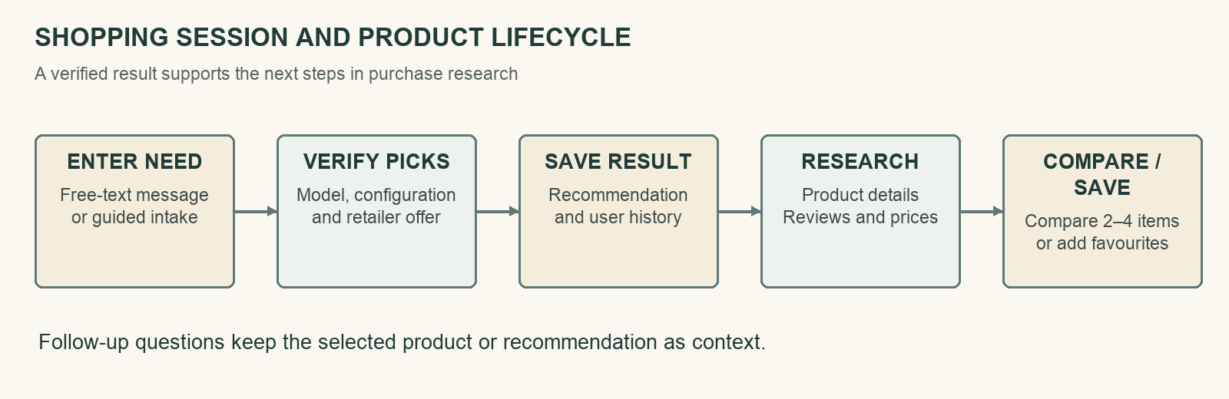
Fig. 4.1 Shopping session and product lifecycle
The chat page retains the shopper’s full request, obtains structured analysis and posts the validated requirements to the recommendation endpoint. It displays eligible products inline with a budget summary, explanations and links. Ambiguous category requests can trigger one clarification, followed by the guided intake flow if ambiguity persists. Search input supports up to 4,000 characters; oversized messages are rejected explicitly rather than silently shortened. Table 4.2 lists the main request fields and service settings.

4.8 Product Comparison and Price History
The comparison page accepts two to four selected products and constructs a specification matrix with row winners and an arithmetic overall verdict. Product detail pages compare available retailer offers and request price history on demand. Observations retain their timestamp and source, and a single observation is shown as a recorded point rather than a price trend. Saved recommendation offers describe the search snapshot and should not be interpreted as a promise of a future checkout price.

4.9 Review Discovery and Contextual Chat
The review service searches for product review videos using the configured RapidAPI or YouTube integration and provides a search-link fallback when retrieval is unavailable. Contextual chat accepts exactly one target, either a product identifier or a recommendation identifier. The backend supplies the relevant product or shortlist context to Groq. The client limits recent conversation messages and omits failed replies, helping the next request remain focused on the displayed selection.
Table 4.2: Requirement fields and recommendation service settings
Field or setting | Type | Role | Behaviour
category | Enum | Requirement | One of six supported device categories.
budget | Min/max INR | Constraint | Explicit lower and upper offer bounds.
useCases | Text array | Preference | Coding, gaming, travel or other stated activity.
requirements | Structured object | Constraint | RAM, storage, GPU and other parsed needs.
priorities | Numeric weights | Preference | CPU, GPU, memory, display, battery and portability.
keywords | Text array | Context | Extra terms from the shopper’s request.
Original query | Text | Context | Full message retained up to the accepted limit.
Shortlist size | Up to 3 | Discovery | Canonical model names suggested by Groq.
Retailers | Allowlist | Validation | Amazon India and Flipkart in recommendation discovery.
Offer currency | INR | Validation | Non-INR offers rejected.
Search cache | 5 minutes | Efficiency | Shares recent and identical pending requests.
Comparison count | 2–4 products | Interface | Numeric row comparison with known fields.

4.10 Authentication and User Experience
Sign-up and login create a user session with a JWT access token and an httpOnly refresh cookie. Passwords are stored as bcrypt hashes, and the public user representation excludes the hash. Favourites and search history are associated with the authenticated user. Guest shoppers can still search and compare products. Clear loading, empty-result and provider-error states help users understand whether a query failed, no eligible offer exists, or a dependent service is unavailable.

4.11 Docker and Delivery Configuration
The backend Dockerfile uses node:24-alpine, installs production dependencies and runs the Express server as the node user on port 5050. The frontend uses a multi-stage build: Node builds the Vite application and Nginx serves the generated files. Docker Compose defines MongoDB 7, the backend and the frontend, with health checks and dependency ordering. Nginx forwards API requests to the backend, and a named MongoDB volume retains application data [11].
The repository contains Docker and Render configuration files, but no GitHub Actions workflow was present in the inspected project. Automated checks can be run locally and could be connected to a future continuous-integration job. The report therefore distinguishes the implemented packaging and cloud build commands from a deployment pipeline that has not been configured in this repository.
Environment variables provide the database URI, token secrets, AI configuration and shopping credentials. Live recommendations require the live-search mode and configured model and shopping providers. Credentials remain in the service environment rather than being embedded in the frontend bundle. The container health checks query the application response, while database health checks control local startup ordering. A health response alone does not establish external provider availability.

4.12 Deployment on Render
The root render.yaml defines a Node web service with a frontend build command, production start command and /api/health check. The backend serves the compiled frontend from the same origin in production. The Blueprint generates JWT secrets and expects the MongoDB URI to be supplied by the service owner. Groq and shopping credentials are also required for live functionality. Render’s Blueprint documentation describes this repository-based service configuration [12].
Deployment verification in this report covers the repository configuration and successful frontend production build. Public hosting availability, service deployment history, external quotas and uptime require separate checks in the deployment environment and are not reported as measured results.

4.13 Testing Methodology
Verification combines automated backend tests, frontend chat-context tests, a production frontend build and review of the main interface flows. Backend tests mock provider responses so parsing, matching, budgets, fallback and persistence-related behaviour can be checked without spending live provider quota. Negative cases include accessory listings, wrong model suffixes, invalid seller links, missing prices and oversized prompts. User-interface illustrations use controlled catalog data; they are not evidence of current retail availability. The automated checks use the Node.js test runner [13].

CHAPTER 5
EXPERIMENTAL SETUP

5.1 Development and Runtime Environment
The application backend uses Node.js, Express 5, Mongoose, Groq SDK, Zod, bcrypt and JSON Web Token libraries. The frontend uses React 19, React Router, Zustand, Axios and Vite. The container definitions use Node 24, Nginx and MongoDB 7. Report verification ran with the available Node 24.22.1 runtime. The project’s dependency manifests and lockfiles define the installed package environment; hosted language models and shopping services remain external dependencies.

5.2 Product Categories and Shopping Constraints
WiseBuy supports six categories. A request can include a budget range, intended use, minimum RAM or storage, a dedicated-GPU need, keywords and priorities across CPU, GPU, RAM, storage, display, battery and portability. Requirements are represented in one common schema for chat and guided intake. The category determines which device identities and accessory terms are relevant. Table 5.1 lists the categories and the number of illustrative products in the seed catalog.
Table 5.1: Supported categories and illustrative seed-catalog coverage
Category | Seed records | Example intent | Validation focus
Smartphone | 18 | Photography, everyday use | Model generation and complete handset.
Laptop | 22 | Coding, gaming, creation | Model suffix and RAM/storage variant.
Headphones | 5 | Travel, audio, noise cancellation | Complete headphones or earbuds, not parts.
Smartwatch | 4 | Fitness and daily use | Watch model and eligible device listing.
Tablet | 3 | Study and portable productivity | Generation and tablet configuration.
Monitor | 3 | Work, display quality, gaming | Monitor identity and size/configuration.

5.3 Data and Test Preparation
The seed file contains 55 catalog products: 18 smartphones, 22 laptops, five headphones, four smartwatches, three tablets and three monitors. These records support demonstrations and browsing, and are separate from live recommendation offers. Automated tests construct controlled model and provider responses to exercise specific conditions. No train/test split is applied because the project does not fit a local supervised model. Live recommendation quality requires a separately labelled evaluation set.

5.4 Evaluation Criteria
Verification measures whether the implemented rules and interfaces behave as expected. The recorded checks are the number of passing and failing backend tests, passing frontend context tests and production build completion. Functional criteria include correct requirement extraction, preservation of full query text, exact-model identity, whole-device eligibility, budget adherence, provider fallback, known specification handling and context retention. Passing tests do not measure shopper satisfaction, recommendation precision or live retailer coverage.

5.5 Recommendation and Application Test Protocol
The backend suite was executed over all test files under backend/src/__tests__. The four frontend context tests were run separately, followed by the Vite production build. External responses were controlled by test mocks; live Groq or shopping calls were not used as a benchmark. The protocol records successful and unsuccessful checks without interpreting test duration as end-to-end response time. Catalog illustrations use seeded data and explicit example requests to explain the interface.

CHAPTER 6
RESULTS AND DISCUSSION
The results describe the implemented WiseBuy workflow and verification completed for this report. All 248 backend tests and four frontend chat-context tests passed, and the production frontend build completed. The seed catalog contains 55 products across six categories. The remaining sections discuss product validation, requirement handling, supporting features, deployment configuration and the practical limits of the evaluation.

6.1 Automated Verification Results
The backend test run completed with 248 passes and no failures, cancellations or skipped tests. The frontend context run completed with four passes and no failures. The production build generated the frontend assets successfully. Table 6.1 records these outcomes. The tests cover defined behaviour using controlled inputs; they do not establish the quality or availability of every live shopping response.
Table 6.1: Verification outcomes recorded for WiseBuy
Check | Executed | Passed | Failed | Result
Backend automated tests | 248 | 248 | 0 | Passed
Frontend context tests | 4 | 4 | 0 | Passed
Production frontend build | 1 | 1 | 0 | Completed

These results support confidence in the tested parsing, product matching, offer filtering, caching and context-handling paths. The build verifies that the frontend can be compiled for production. A browser interaction or a passing unit test cannot establish that external credentials, retailer stock or provider quota will remain valid. Operational checks should therefore be repeated in the target deployment environment.

6.2 Product Matching and Offer Validation
The test cases include wrong model names, accessories, replacement screens, charging cases, laptop keyboard parts, variant mismatches and seller-link edge cases. Other cases confirm that genuine device bundles remain eligible. The model-matching rules preserve distinguishing generations and suffixes, while configuration checks avoid merging unlike RAM or storage variants. Table 6.2 summarises representative conditions rather than reporting a labelled-marketplace accuracy statistic.
Table 6.2: Representative product and offer validation scenarios
Scenario | Expected handling | Covered behaviour
Accessory or repair part | Reject | Cases, screens, keyboards, ear pads and charging cases.
Wrong model or generation | Reject | Distinct model suffixes and product families.
Different configuration | Keep separate | RAM/storage identity and seller grouping.
Offer beyond budget | Reject | Explicit minimum and maximum boundaries.
Invalid seller or currency | Reject | Retailer URL, INR and availability checks.
Valid device bundle | Allow when eligible | Whole-device bundles remain acceptable.
Provider failure or unusable results | Try same model elsewhere | Fallback without switching to unrelated products.
No eligible model offer | Return clear result or error | No synthetic live-price substitution.

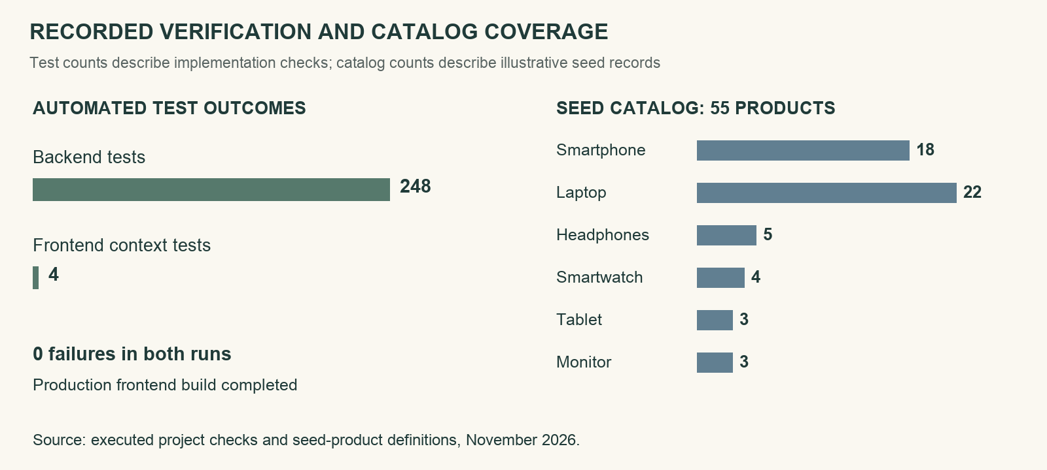
Fig. 6.1 Automated test outcomes and illustrative catalog coverage

6.3 Requirement and Ranking Behaviour
Table 6.3: Requirement handling and ranking rules
Input or rule | Implemented handling | Interpretation
Complete query | Retained within 4,000 characters | Full context reaches shortlisting.
Budget boundaries | Validated and enforced | Preference tier does not override hard range.
Model order | Preserved after verification | Order originates from Groq suggestions.
Missing specifications | Remain unavailable | No invented manufacturer facts.
Comparison verdict | Row wins and price tie break | Arithmetic summary of supplied fields.

The implementation retains the complete shopping message as the primary shortlisting input and treats extracted fields as supporting context. Explicit brand families and budget limits remain constraints. Groq’s model order is preserved after offer validation, while within-model selection uses available configuration information. The separate comparison verdict counts row winners. These two forms of ordering serve different stages of the purchase-research workflow.

6.4 Worked Shopping Example
For the message “I need a laptop for coding and college work under 80k”, the required category is laptop and the maximum budget is INR 80,000. The intended use includes coding and study. Groq proposes up to three models, and each is searched individually. A listing is displayed only if it matches a suggested complete device and has an eligible in-budget offer. The particular models and prices depend on the live response; this example defines the workflow rather than fixing a current quote.

6.5 Application and API Testing
The backend suite covers deterministic parsing, requirement intent, full-prompt handling, shortlisting, provider fallback, exact-model matching, normalization, deduplication, whole-product validation, saved listings, price history, caching and contextual chat. The frontend tests check message retention and conversation bounds. Table 6.4 groups the tested behaviours. The report records the executed totals without claiming comprehensive browser automation or full production security testing.
Table 6.4: Automated application tests and checks
Test group | Representative checks | Verification type | Outcome
Requirement parsing | Category, INR budget, full prompt and intent | Backend unit/service | Passed
Model identity | Exact model, suffix and configuration checks | Backend regression | Passed
Product eligibility | Whole device, accessories and saved-listing validation | Backend regression | Passed
Provider behaviour | Same-model fallback and pending-request caching | Mocked services | Passed
Price data | INR parsing, history and observed sources | Backend unit/service | Passed
Contextual chat | Target validation and provider error handling | Backend service | Passed
Frontend context | Message retention, limits and history bounds | 4 helper tests | 4 passed
Production assets | Vite compilation and generated files | Build check | Completed

The tests use mocked external services so they can reproduce failures and unusual listings without provider charges. This is useful for budget violations, missing prices or a provider returning only accessories. It does not validate the provider’s own data accuracy. MongoDB persistence and external service credentials still need operational verification in the deployment environment.
The successful frontend build produced the application bundle. Its build output included a warning about a JavaScript chunk exceeding the default size threshold. This warning did not stop the build. Future code splitting could reduce initial download work, but no measured page-speed improvement is claimed here. The four frontend tests cover context helpers rather than all rendered components.

6.6 Deployment Configuration and DevOps
The repository defines two deployment paths: Docker Compose for a local frontend, backend and MongoDB stack, and a Render Blueprint for a combined web service. Container health checks and a MongoDB volume support repeatable startup and persistence. The Render build and start commands are present in the repository. A public WiseBuy URL, continuous deployment history and uptime measurements are not part of the verified results.
Table 6.5: Deployment and container configuration
Layer | Configuration | Value or role | Verification
Backend image | node:24-alpine | Express on 5050; non-root user | Dockerfile present.
Frontend image | Node build and Nginx | Static frontend and API proxy | Dockerfile present.
Database | mongo:7 | Named data volume | Compose service present.
Local entry | Frontend port | 127.0.0.1:5173 by default | Compose configuration.
Cloud service | Render Blueprint | Build, start and health commands | render.yaml present.
Continuous integration | No workflow configured | Local checks available | Future integration.

The local frontend container publishes port 5173 and forwards API requests through Nginx. The backend runs internally on port 5050 and connects to MongoDB over the Compose network. The named database volume persists data across restarts. The service health checks are useful startup indicators, but do not replace monitoring for external API failures or quota exhaustion.
The Render configuration builds the frontend and serves it through the Express process in production. Sensitive configuration is supplied through environment settings. The repository does not contain a GitHub Actions job, so automatic test execution on each push and verified cloud rollout are future delivery improvements. Their absence is separate from the presence of working local checks and container definitions.
The deployment design keeps the model and shopping API credentials on the server. Browser requests go through the application API, which controls validation, provider selection and persistence. This allows the same interface to work with configured external services while keeping the source of product evidence explicit.

6.7 Comparison, History and Advisor Behaviour
The comparison view operates on two to four selected products. It highlights the best known value in each supported numeric row and chooses an overall result by row wins and a price tie break. This offers a repeatable summary of supplied fields, but it cannot replace a real workload benchmark. Values absent from the listing are not treated as established advantages.
Price history displays observed or provider-supplied points with their origin. A product with fewer than two observations does not receive an invented trend. Search history and favourites preserve selected activity for signed-in users. Review discovery provides retrieved videos where possible and a search-link fallback otherwise. The seeded catalog and demonstration history remain distinguishable from live recommendation offers.
The contextual advisor receives either the selected product or the saved recommendation as its target. Subsequent questions therefore refer to the current selection. A new session or category choice starts another search. Provider timeouts, configuration errors and usage limits return explicit error messages. Follow-up language-model text still needs user judgement because contextual information does not eliminate the possibility of an inaccurate generated statement.

6.8 Discussion and Limitations
WiseBuy demonstrates a complete application path from a free-text need to a stored shortlist with retailer evidence. Its strengths are the separation of model suggestion from price data, strict budget and product checks, provider fallback, reusable services and reproducible tests. Its main limitations are dependence on external services, incomplete listing specifications, time-sensitive prices and the absence of a human-rated recommendation benchmark. Table 6.6 relates these limitations to practical improvements.
Table 6.6: Limitations and planned improvements

Limitation | Effect | Planned improvement
External API dependence | Quota or outages can interrupt discovery. | Quota monitoring and provider-health metrics.
Incomplete listing data | Some specifications cannot be compared. | Manufacturer-backed specification enrichment.
Changing retail offers | Saved prices may become stale. | Offer timestamps and explicit refresh controls.
Heuristic model matching | New aliases may be missed. | Independent labelled matching dataset.
Simple numeric comparison | Cross-platform performance can be misleading. | Category-aware comparison and benchmark data.
Limited frontend tests | Rendered flows lack a complete automated suite. | Accessibility and end-to-end browser tests.
No relevance benchmark | Tests do not measure shopper benefit. | Human-rated requests and user evaluation.
No CI workflow | Checks are not automatically run on each push. | Verified build, test and deployment pipeline.

6.9 Threats to Validity
The main evaluation limitation is that mocked provider responses do not represent every live marketplace condition. Existing tests emphasise known failure patterns and may miss new title formats, model aliases or seller redirects. Passing a fixed suite therefore cannot be interpreted as a real-world precision estimate. There is also no shopper study comparing decision time or satisfaction with conventional search. Any future evaluation should use an independent, dated and human-labelled set of requests and listings, with category-specific results and documented provider settings.

6.10 Result Summary
The verified outcomes are 248 passing backend tests, four passing frontend context tests and a successful production frontend build. The project provides six-category shopping support, a 55-product demonstration catalog, model-first live discovery, offer validation, comparison, observed price history, review discovery and authenticated saved-user workflows. Docker Compose and Render configuration are implemented. Live recommendation relevance, user satisfaction and public hosting uptime remain separate evaluation tasks.

CHAPTER 7
CONCLUSION AND FUTURE ENHANCEMENTS

7.1 Conclusion
WiseBuy was developed to help shoppers express a technology need in ordinary language and investigate a small set of suitable devices. The application connects a React interface, Express services, MongoDB persistence, Groq model inference and shopping-provider adapters. It validates retrieved offers before displaying them and supports the next research steps through comparison, price history, review discovery and contextual advice.
The project demonstrates AI integration within a complete software workflow. Requirement extraction has a deterministic fallback, while model shortlisting depends on the hosted AI service. Displayed prices come from eligible shopping results. Verification recorded 248 passing backend tests, four passing frontend context tests and a successful frontend build. These outcomes establish the tested implementation behaviour, while recommendation quality and deployment reliability require further observation under real operating conditions.

7.2 Future Enhancements
Future work can add an independent recommendation dataset with human relevance ratings, category-specific matching metrics and a user study of decision time and satisfaction. Technical improvements include richer manufacturer specifications, better model-alias coverage, stronger configuration matching, explicit offer timestamps, broader retailer coverage and quota-aware operational monitoring. Application work can add accessibility testing, multilingual requests, saved-search alerts and a larger browser test suite. Delivery improvements include code splitting, an automated continuous-integration workflow and a verified deployment health-check stage.

7.3 Final Remarks
The main contribution of WiseBuy is a traceable connection between a shopper’s intent, AI-selected model names and eligible retailer offers. Each stage has a separate responsibility and a defined failure path. This makes the application a useful foundation for technology-shopping assistance and provides a clear direction for future improvements in data quality, evaluation and reliability.

REFERENCES
[1] WiseBuy project repository, application source, README, dependency manifests, automated tests, Dockerfiles, docker-compose.yml and render.yaml, November 2026.
[2] A. Vaswani et al., “Attention Is All You Need,” Advances in Neural Information Processing Systems, vol. 30, 2017. Available: https://arxiv.org/abs/1706.03762
[3] L. Wu et al., “A Survey on Large Language Models for Recommendation,” arXiv:2305.19860, 2023, revised 2024. Available: https://arxiv.org/abs/2305.19860
[4] Groq, “Browser Search” and API documentation. Available: https://console.groq.com/docs/tool-use/built-in-tools/browser-search
[5] React, “Quick Start.” Available: https://react.dev/learn
[6] OpenJS Foundation, “Express Documentation.” Available: https://expressjs.com/
[7] MongoDB, “MongoDB Documentation.” Available: https://www.mongodb.com/docs/
[8] Mongoose, “Mongoose Documentation.” Available: https://mongoosejs.com/docs/
[9] Vite, “Vite Guide.” Available: https://vite.dev/guide/
[10] SerpApi, “Google Shopping API.” Available: https://serpapi.com/shopping-api
[11] Docker, “Docker Compose Documentation.” Available: https://docs.docker.com/compose/
[12] Render, “Blueprint YAML Reference.” Available: https://render.com/docs/blueprint-spec
[13] Node.js, “Test Runner.” Available: https://nodejs.org/api/test.html
[14] Zod, “Zod Documentation.” Available: https://zod.dev/
[15] IETF, “JSON Web Token (JWT),” RFC 7519, 2015. Available: https://www.rfc-editor.org/rfc/rfc7519
[16] United Nations, “Sustainable Development Goals 9 and 12.” Available: https://sdgs.un.org/goals

APPENDIX A
REQUIREMENT AND PRODUCT DATA FIELDS
The requirement schema represents the shopper’s category, budget, use cases, hard requirements, priorities and keywords. Product records represent retrieved evidence and retain provenance. Table A.1 lists the main fields used by the application. These fields support inference, validation and display; they are not columns of a locally trained regression dataset.
Table A.1: Requirement and product data fields
Field | Meaning and use
category | Supported product category.
budget.min / budget.max | Explicit lower and upper INR bounds.
useCases | Activities stated by the shopper.
requirements | Structured minimums and required features.
priorities | Relative dimensions used by selection helpers.
keywords | Additional contextual terms.
originalQuery | Unmodified accepted shopping message.
shortlistedModels | Ordered canonical names and brands.
listingTitle | Original provider title retained for validation.
sellers | Platform, price, currency, URL and availability.
bestPrice | Lowest eligible price available for display.
specs | Human-readable specification map.
normalizedSpecs | Known numeric comparison fields.
source / sourceProductId | Provider provenance and product identity.
picks | Selected products, rank, offer snapshot and explanation.
timestamp | Observation time for a recorded price.

APPENDIX B
REPOSITORY LAYOUT
The repository separates frontend pages and components, API routes and controllers, business services, provider adapters, database models, validation utilities and automated tests. Deployment definitions reside at the root and in the application folders. Table B.1 lists the principal paths used in the implementation.
Table B.1: Repository layout
Path | Contents
frontend/src/pages/ | Chat, catalog, detail, comparison, login and saved views.
frontend/src/components/ | Reusable chat, product, layout and intake components.
frontend/src/store/ | Zustand stores for session, favourites, comparison and intake.
frontend/src/lib/ | API client, formatters and conversation-context helpers.
backend/src/app.js and server.js | Express assembly and process startup.
backend/src/routes/ and controllers/ | HTTP route contracts and request handlers.
backend/src/services/ | AI, recommendation, product search, price, cache and video logic.
backend/src/services/providers/ | Shopping-provider abstraction and concrete adapters.
backend/src/models/ | User, Product, Recommendation, SearchHistory and PriceHistory.
backend/src/utils/ and validators/ | Parsing, matching, normalization, comparison and Zod schemas.
backend/src/seed/ and __tests__/ | Illustrative catalog and automated backend tests.
docker-compose.yml and render.yaml | Local containers and production service definition.

APPENDIX C
APPLICATION INTERFACE AND DEPLOYMENT VIEWS
The following figures show the project frontend with WiseBuy display branding and controlled illustrative catalog data. They explain the implemented interface and interaction flow. Example product prices and seeded specifications shown in these figures are demonstration values, not current retailer quotations. The deployment figure describes the repository configuration rather than an observed public hosting session.

Fig. C.1 WiseBuy landing page and natural-language shopping entry
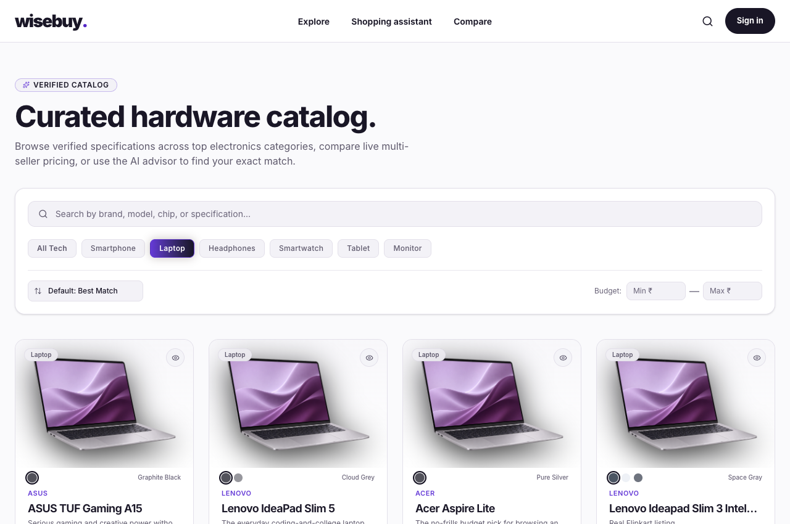
Fig. C.2 Product catalog with category, search and price filters
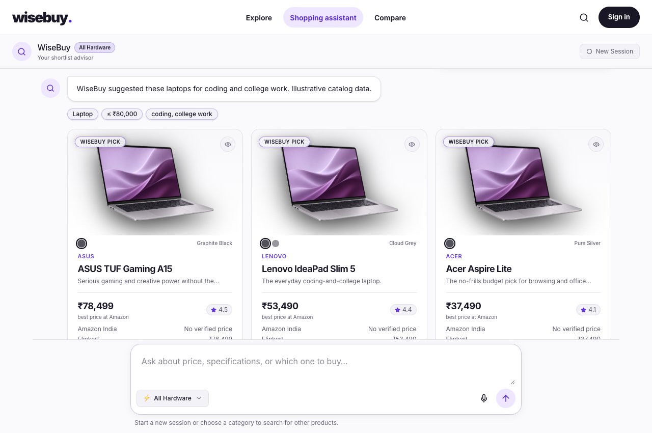
Fig. C.3 Conversational recommendation results using illustrative catalog data
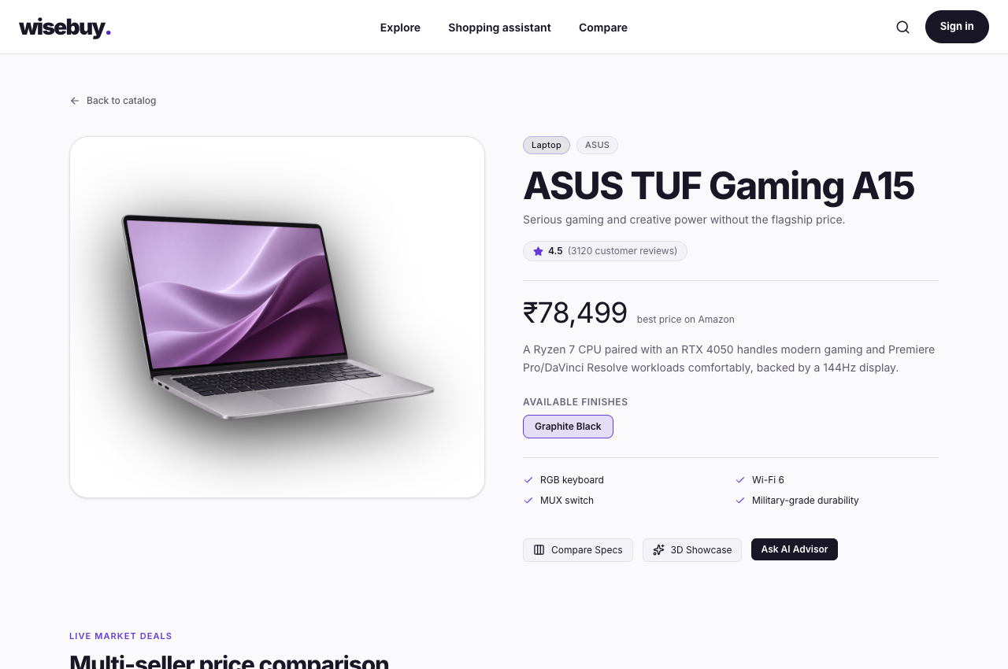
Fig. C.4 Product detail page with specifications and seller-offer controls
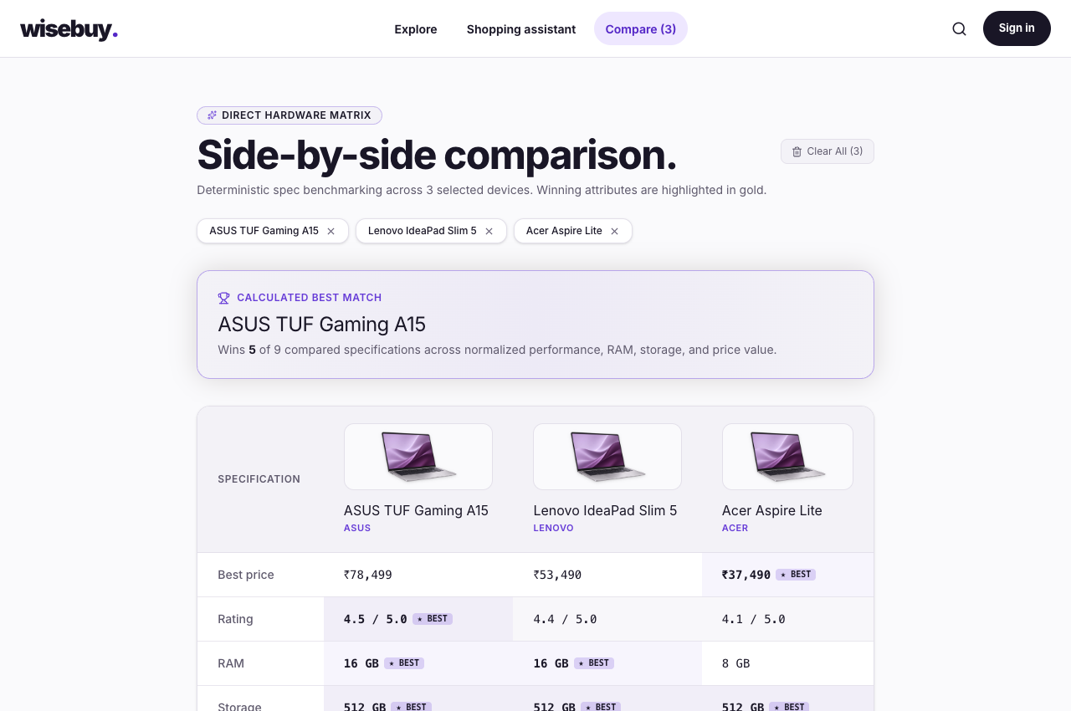
Fig. C.5 Side-by-side comparison of selected products using illustrative data
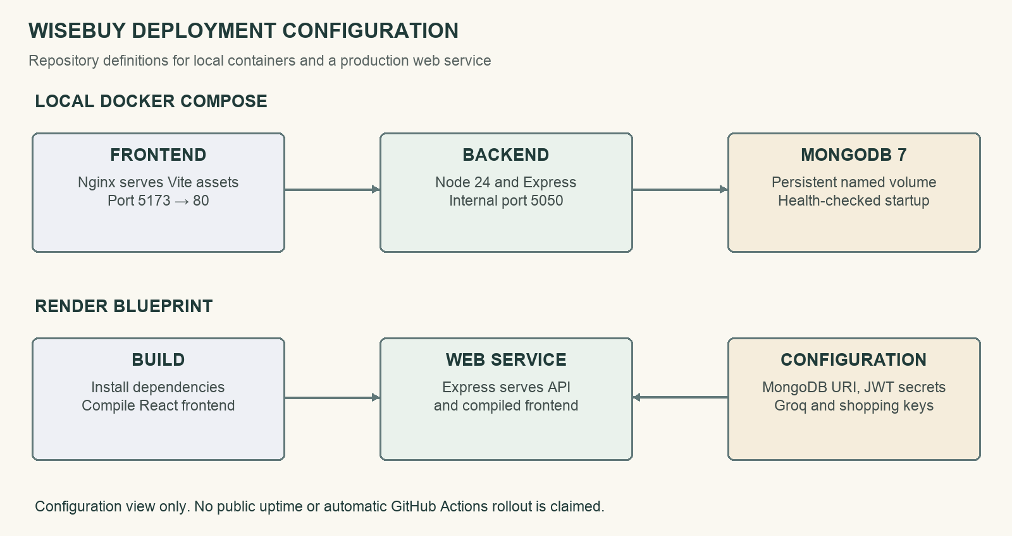
Fig. C.6 Docker Compose and Render deployment configuration

APPENDIX D
SELECTED SOURCE CODE
The following selected implementations show the requirement, offer-validation, comparison and caching ideas used in WiseBuy. The excerpts are self-contained functions or clearly identified schema definitions from the project. They illustrate the implemented logic without exposing application secrets. The complete application repository remains the reference for surrounding imports and integration [1].
D.1 RAM and storage normalization
export function parseRAM(input) {
if (input == null) return null;
if (typeof input === "number") return input;
const match = String(input).match(/(\d+(?:\.\d+)?)\s*[-]?\s*(gb|gigabyte)/i);
return match ? Number(match[1]) : null;
}

/**
* "512GB SSD" | "0.5TB" | "512 GB storage" | "1TB" -> GB as a number
*/
export function parseStorage(input) {
if (input == null) return null;
if (typeof input === "number") return input;
const str = String(input);

const tbMatch = str.match(/(\d+(?:\.\d+)?)\s*[-]?\s*tb/i);
if (tbMatch) return Number(tbMatch[1]) * 1024;

const gbMatch = str.match(/(\d+(?:\.\d+)?)\s*[-]?\s*gb/i);
if (gbMatch) return Number(gbMatch[1]);

return null;
}
D.2 Eligible Indian retailer offers
export function indianOffers(offers = []) {
const byRetailer = new Map();
for (const offer of offers) {
if (offer.currency !== "INR" || offer.availability === false || !Number.isFinite(offer.price) || offer.price <= 0) continue;
const verified = resolveIndianOffer(offer);
if (!verified || offer.price >= (byRetailer.get(verified.platform)?.price ?? Infinity)) continue;
byRetailer.set(verified.platform, { ...(offer.toObject?.() ?? offer), ...verified });
}
return [...byRetailer.values()].sort((a, b) => a.price - b.price);
}
D.3 Numeric product comparison
export function buildComparison(products) {
const rows = ROWS.map((row) => {
const values = products.map((p) => row.get(p) ?? null);
const known = values.filter((v) => v != null);
let bestValue = null;
if (known.length > 0) {
bestValue = row.direction === "higher" ? Math.max(...known) : Math.min(...known);
}
return {
key: row.key,
label: row.label,
format: row.format,
values: products.map((p, i) => ({
productId: p._id,
value: values[i],
isBest: values[i] != null && bestValue != null && values[i] === bestValue && known.length > 1,
})),
};
});

return { productIds: products.map((p) => p._id), rows };
}
D.4 Shared pending requests and TTL cache
const store = new Map();
const pending = new Map();

export function get(key) {
const entry = store.get(key);
if (!entry) return undefined;
if (entry.expiresAt < Date.now()) {
store.delete(key);
return undefined;
}
return entry.value;
}

export function set(key, value, ttlMs) {
store.set(key, { value, expiresAt: Date.now() + ttlMs });
}

/**
* Returns the cached value for `key` if present and fresh; otherwise calls
* `fn()`, caches the result for `ttlMs`, and returns it. Concurrent requests
* for the same key share the pending call rather than consume another API call.
*/
export async function wrap(key, ttlMs, fn) {
const cached = get(key);
if (cached !== undefined) {
console.log(`[CACHE] Served from cache: ${key}`);
return cached;
}
const existing = pending.get(key);
if (existing) return existing;

const request = Promise.resolve().then(fn).then((value) => {
// A clear() or a replacement request invalidates this call's cache write.
if (pending.get(key) === request) set(key, value, ttlMs);
return value;
}).finally(() => {
if (pending.get(key) === request) pending.delete(key);
});
pending.set(key, request);
return request;
}

export function clear() {
store.clear();
pending.clear();
}

