HCLTech - CLOUD DATA ENGINEER
NAME : SAINATH REDDY
USN : 23BTRCL213

SECTION A

Q1. Database Design and Advanced Queries

a.
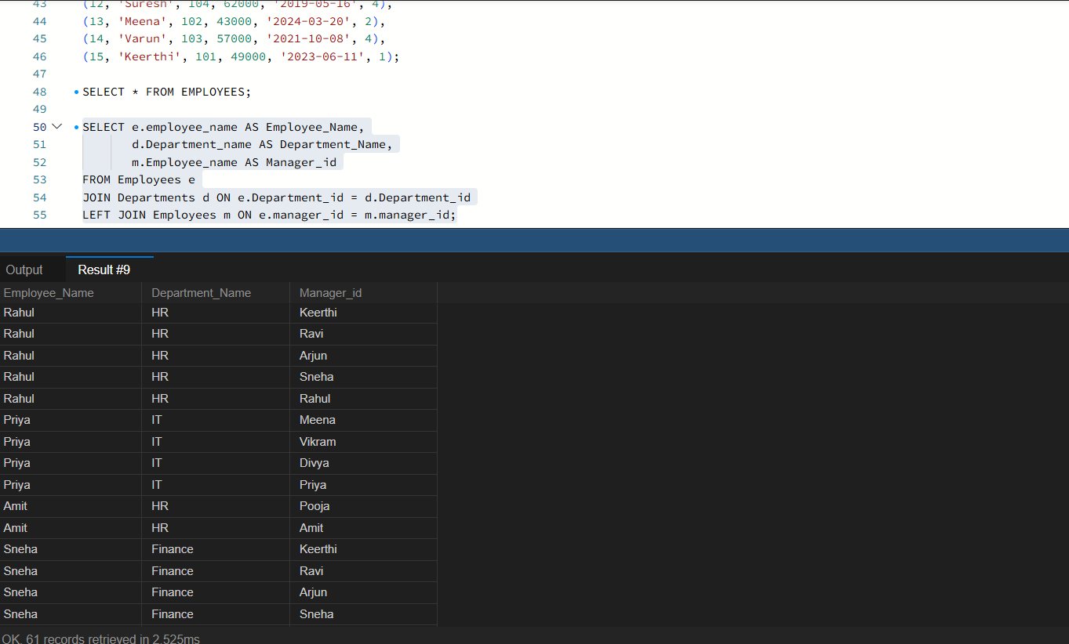

b.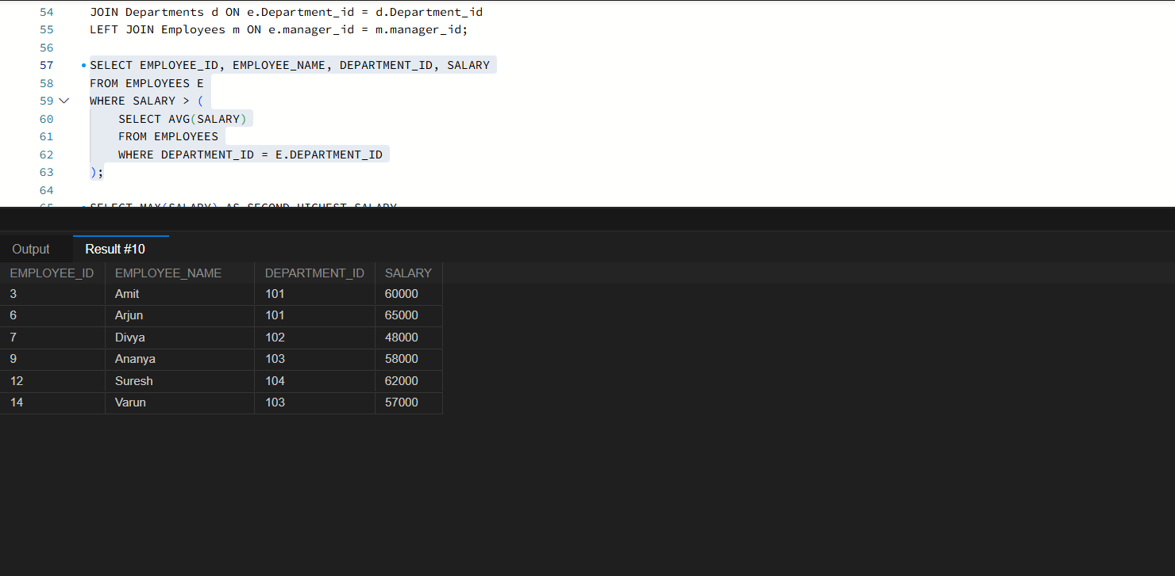

C.
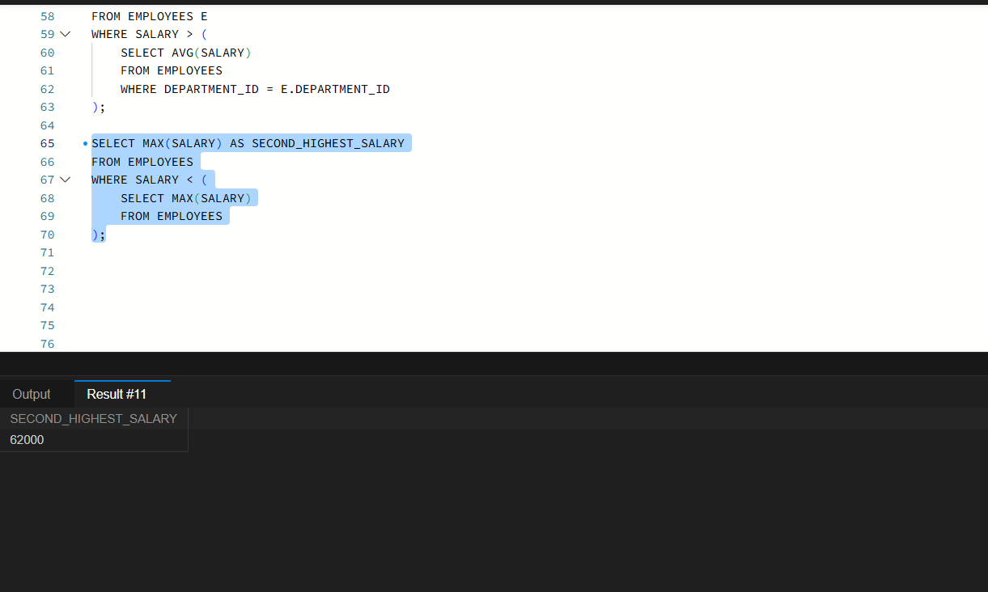

D. 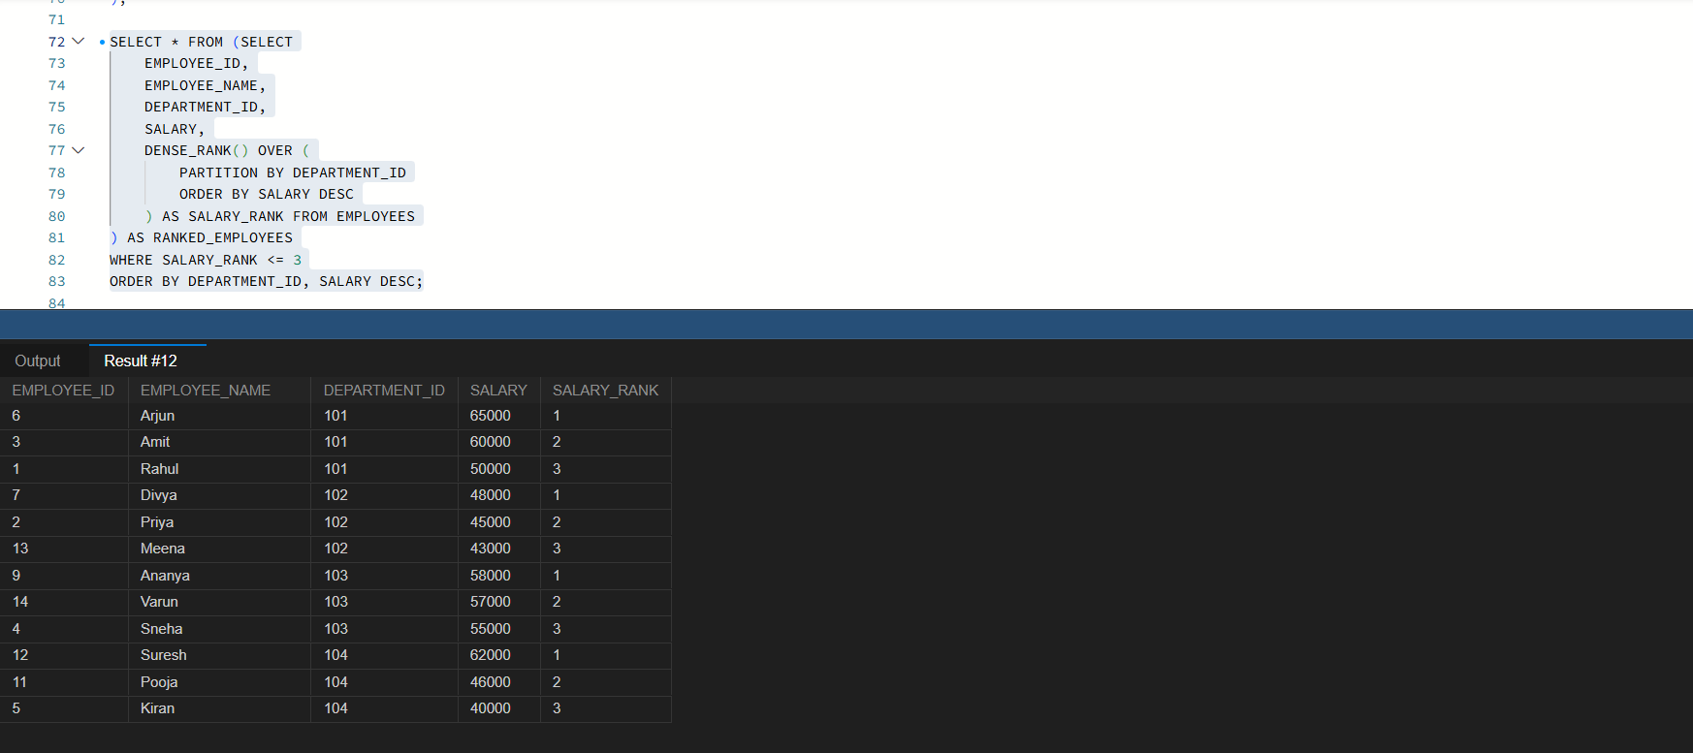

2.Sales Analytics and Query Optimization

A.
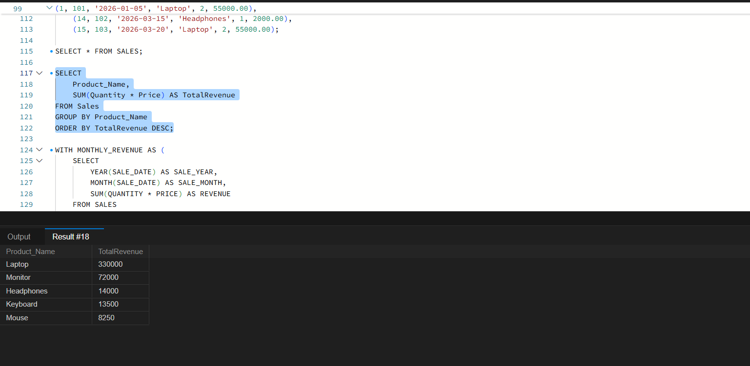

B. 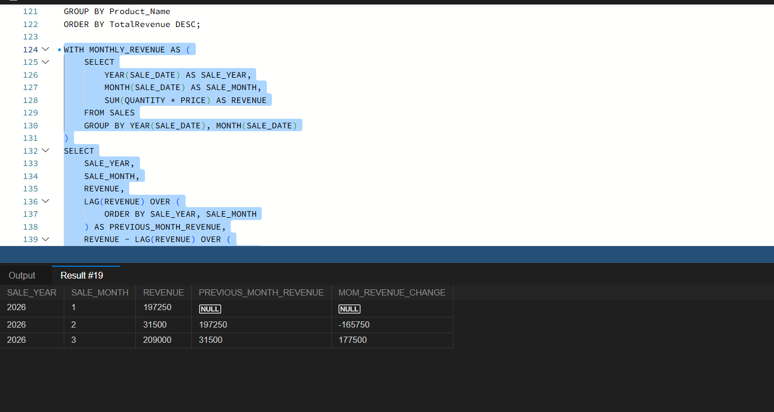

C.
Rewrite the following query to improve the potential for index usage and explain why your version may perform better.

SELECT * FROM Employees WHERE YEAR(JoiningDate) = 2025; Assume JoiningDate may be indexed.

Ans :
SELECT * FROM Employees
WHERE JoiningDate >= '2025-01-01'
AND JoiningDate < '2026-01-01';

3.
A.Explain how an execution plan helps identify expensive operations in a query.
Ans :
By creating a table operations contains details of an price of an operation and by using the aggregate function called (max) we can identify the expensive operation.
B.
Recommend an appropriate index strategy for queries filtering employees by DepartmentID and Salary. Explain your reasoning.
Ans :
By creating an composite index for salary and department id it will help database find employees in a particular department and filter them by salary quickly.

C.
Write a query to identify duplicate customer email addresses and display only addresses occurring more than once.
Ans :
SELECT EMAIL FROM CUSTOMERS
GROUP BY EMAIL HAVING COUNT(*)>1;

SECTION B

4.
Assume /var/log/application.log contains millions of log entries in the following format: 2026-10-28 10:15:23 ERROR payment-service Transaction failed
A . Find all lines containing ERROR.
Ans :
grep "ERROR" /var/log/application.log

B. Display the 20 most recent error entries in the file
Ans :
grep "ERROR" /var/log/application.log
tail -n 20
C. Count the total number of error entries.
Ans :
grep -c "ERROR" /var/log/application.log

D. Extract error entries for a specified date into a separate file.
Ans :
grep "2026-10-28 .*ERROR" /var/log/application.log > /var/log/errors-2026-10-28.log

5. Permissions and System Troubleshooting
A.
Create a group named finance and a report file, assuming you have the required privileges.

Ans: sudo group add finance
Sudo touch /path/to/report.txt
B.
Set permissions so the owner can read and write, the finance group can read, and other users have no access.

Ans : sudo chown “user “:finance path/to/report.txt
sudo chmod /path/to/report.txt
C.
Identify the processes consuming the most CPU.
Ans : top
D.
Display memory usage and filesystem disk utilization.
Ans : free -h
E.
Find files larger than 100 MB under a specified application directory.
Ans : find path/to/report.txt -type f -size -100m

6. Bash Scripting
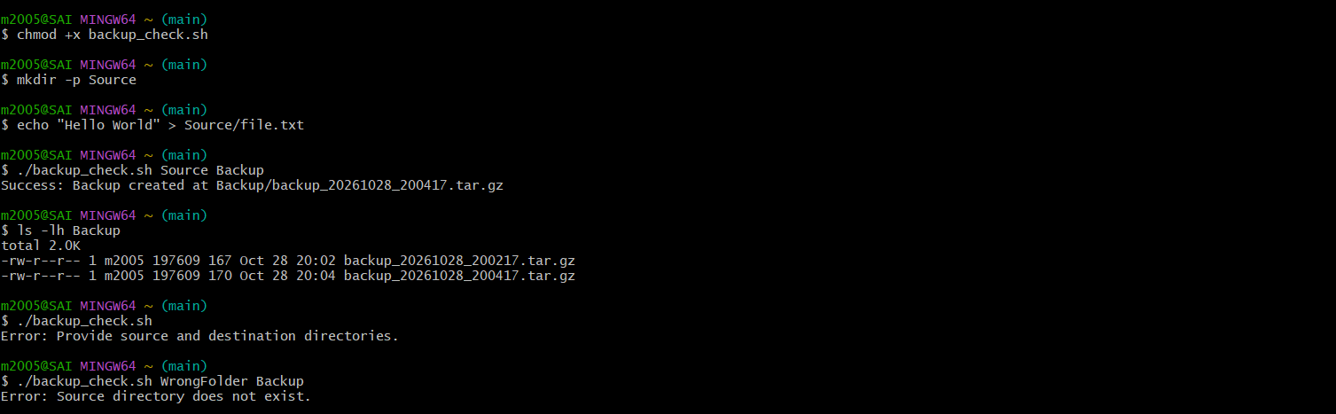

SECTION C

7. PySpark DataFrame Operations

A.Display the schema and first five records.
ANS : 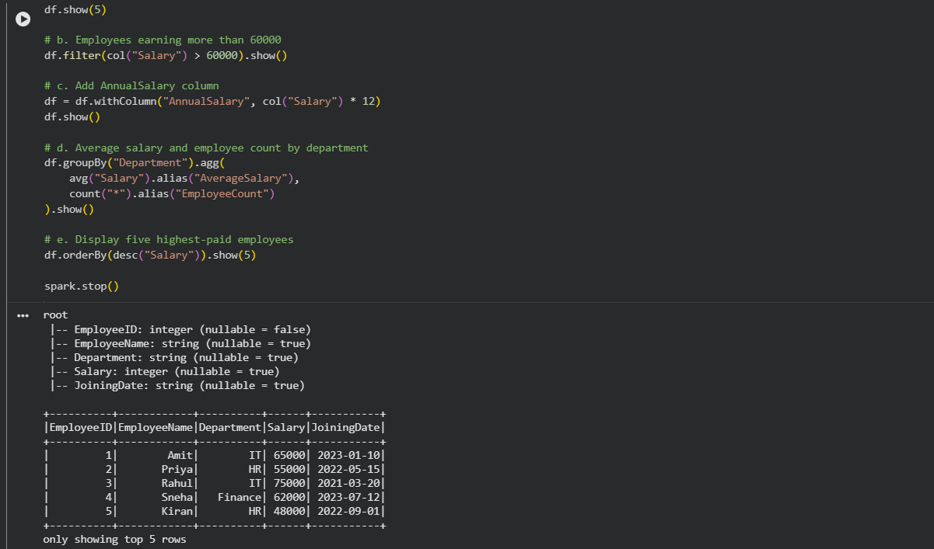
B.
Filter employees whose monthly salary is greater than ₹60,000.
Ans :
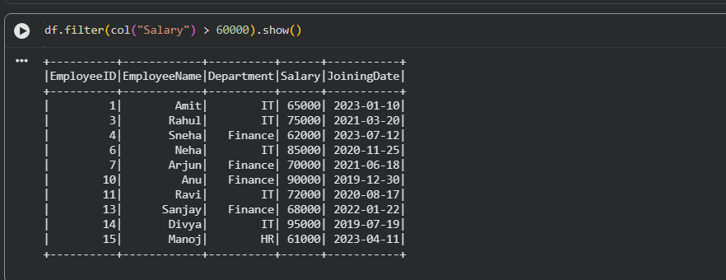

C.
Add an AnnualSalary column calculated from the monthly salary
Ans :
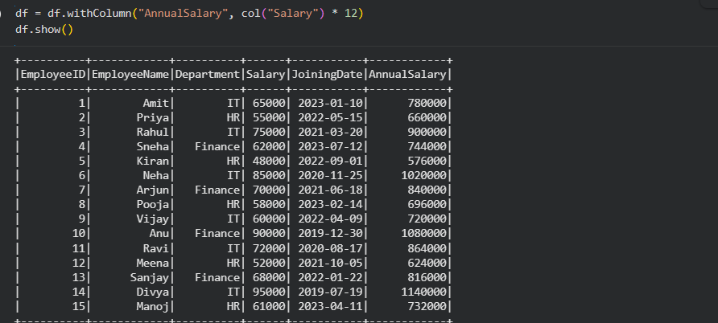

D. Group employees by department and calculate the average salary and employee count.
Ans :
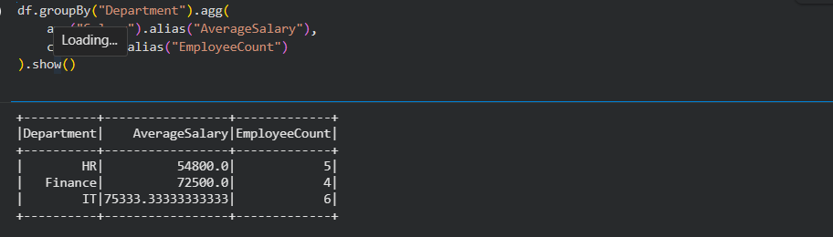

E.
Display the five highest-paid employees.
Ans : 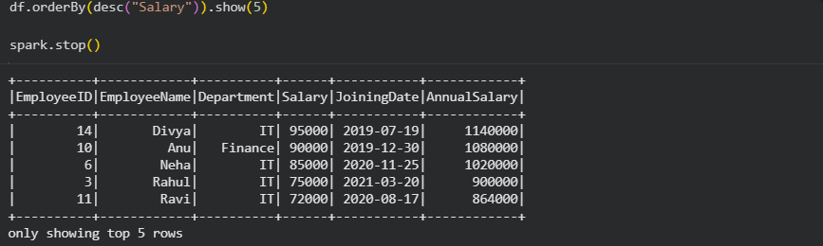
Question 8: Data Cleaning and Aggregation
a. Read the CSV file using an appropriate schema and header configuration.
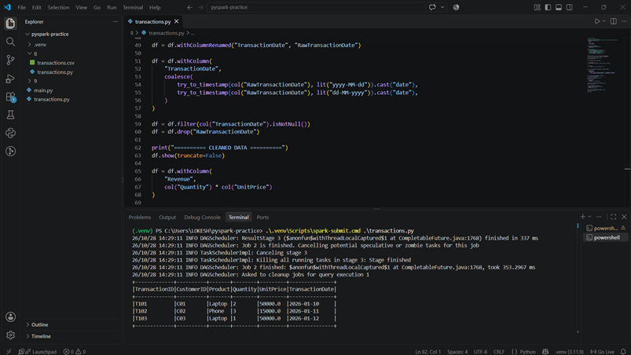
​b. Identify and remove duplicate transactions using a suitable business key.
c. Handle missing values in required fields and explain your chosen approach.
d. Convert TransactionDate into a date type and handle invalid dates.

e. Calculate revenue using Quantity × UnitPrice.
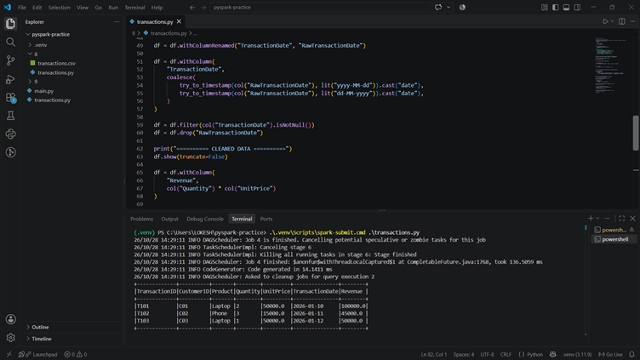
​f. Calculate total revenue by product and display the results in descending order.
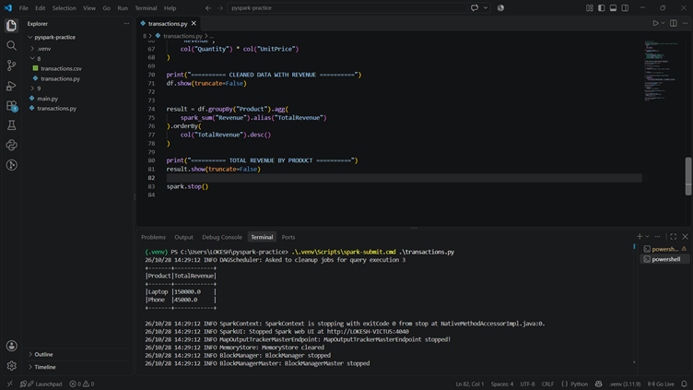

9.A. Load both datasets into DataFrames.
Ans:

SECTION D

Q10.A.
Create an S3 bucket with Block Public Access enabled and upload a sample file.
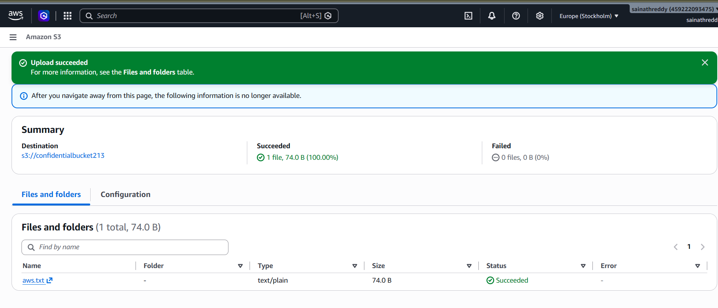
B.
Design an IAM policy that grants read access to objects in the designated bucket without granting access to unrelated buckets.
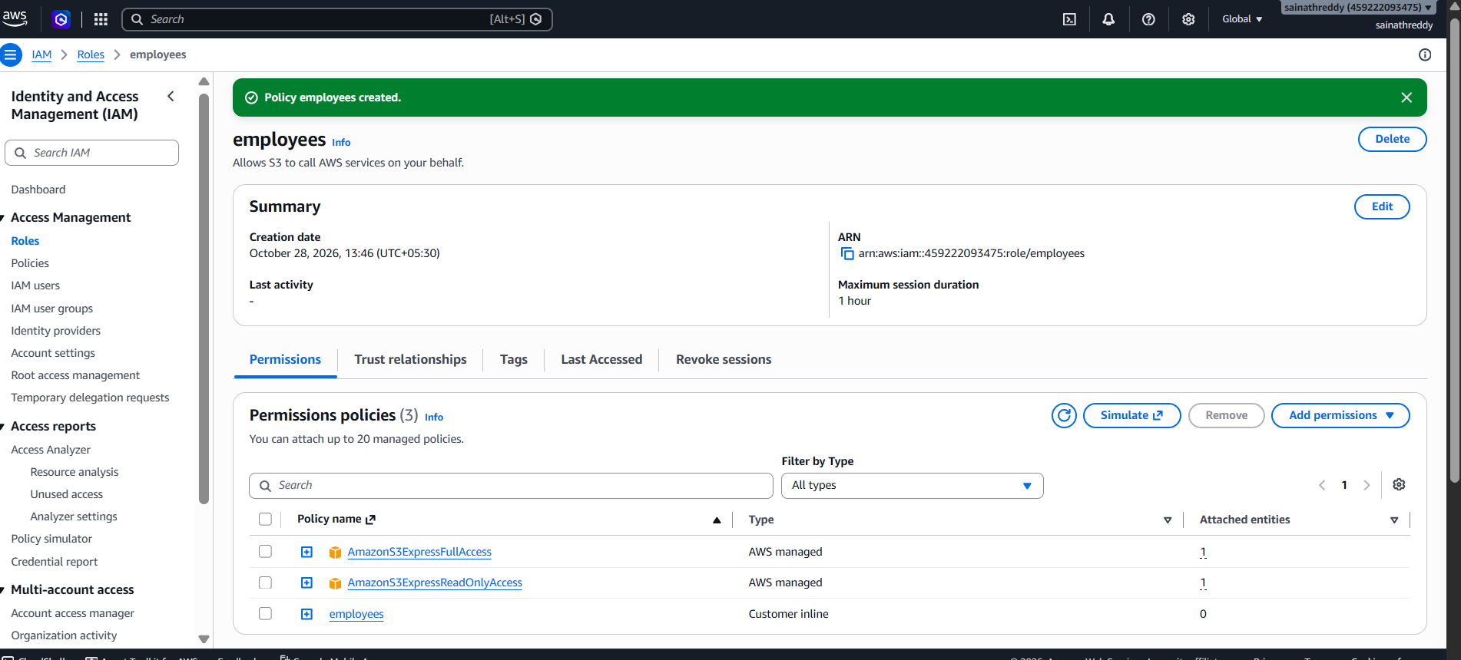

C.
Explain how you would verify that an unauthorized user cannot read the file.
Ans :
First login to the aws console as an unauthorized hr user and try downloading the sample file from the s3 bucket and the file opens successfully and try to download the sample file from s3 bucket and then it will show that the access denied.

D.
Explain how encryption at rest protects the stored data.
Ans :
Encryption at rest helps to protect confidential data from unauthorized access if the stored data is exposed.

Q11.A
Check the EC2 instance state and status checks.
Ans :
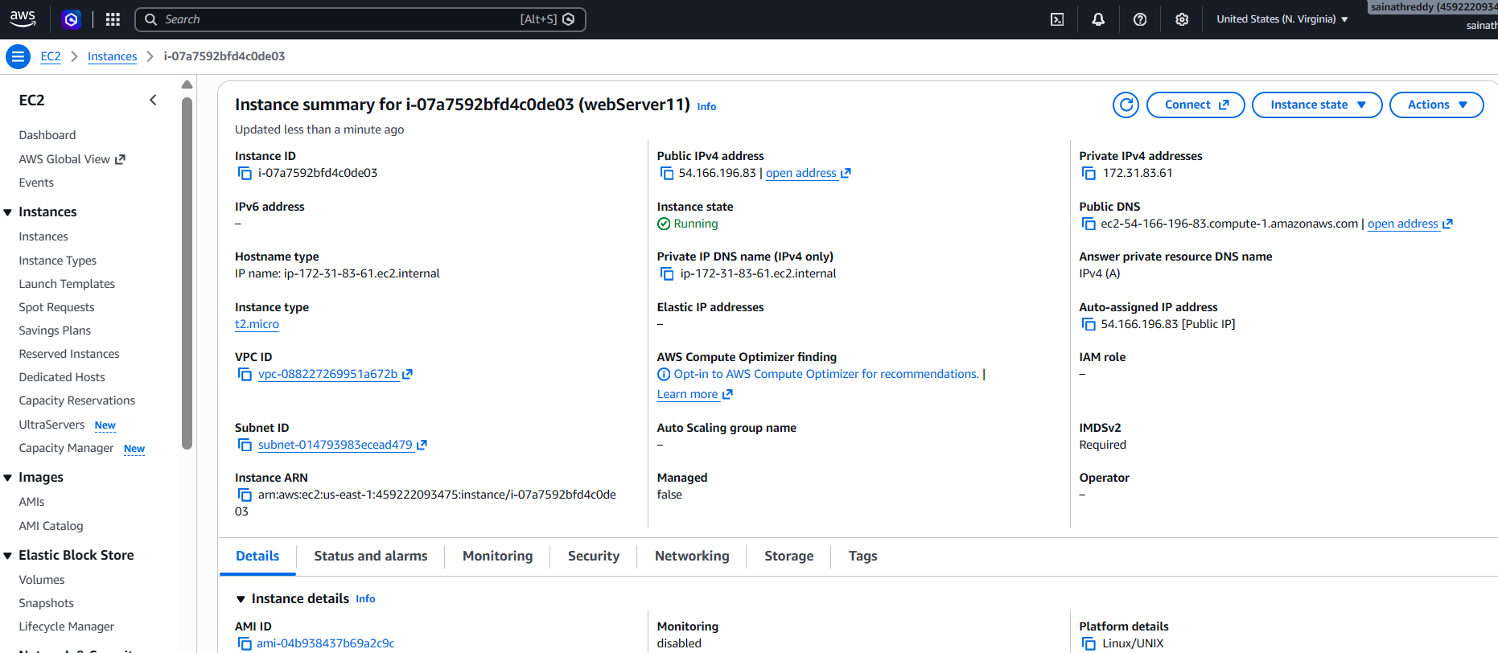
B.
Explain how security groups and route tables can affect application connectivity.
Ans :
Security groups acts as an virtual firewalls fro ec2 instance inbound rules control incoming traffic and outbound control outgoing traffic. Route tables determine where network traffic is directed within a vpc.
C.
Explain how to configure a CloudWatch alarm when CPU utilization exceeds 85% for a defined evaluation period.
Ans :
Security groups control the traffic coming into and going out of a network while route tables determine where that traffic needs to go . If these settings are not configure properly applications may face connectivity issues.

D.Identify one method for investigating the root cause of high CPU utilization.
Ans : Check Amazon CloudWatch metrics to find sudden increases in CPU usage. Then, review the application logs and running processes to identify which process or task is using too much CPU.

12.A.
Identify a suitable service for executing the processing code.
Ans :
Use AWS Lambda to execute the code that validates and processes the uploaded CSV files.
B.
Explain how an S3 upload can trigger processing.
Ans :
Configure an S3 Event Notification to trigger the Lambda function automatically whenever a new CSV file is uploaded to the input bucket.

C. Explain the IAM permissions needed to read the input file and write the results.
Ans :
Assign an IAM execution role to Lambda with permissions to read input files (s3:GetObject) and write processed results to the output bucket (s3:PutObject).

D.
Explain how errors and processing logs can be captured.
Ans :
Use Amazon CloudWatch Logs to capture Lambda execution logs, errors, and debugging information. Configure CloudWatch alarms to notify administrators of failures.

E. Explain how to prevent duplicate processing or recursive triggering.

Ans :
Use idempotency checks to prevent duplicate processing, and configure the S3 trigger only for the input bucket or a specific prefix (e.g., input/). Store results in a separate output bucket or prefix to prevent recursive triggering.

SECTION E

13. State Machine Design

A. Validate the input file.
Ans : 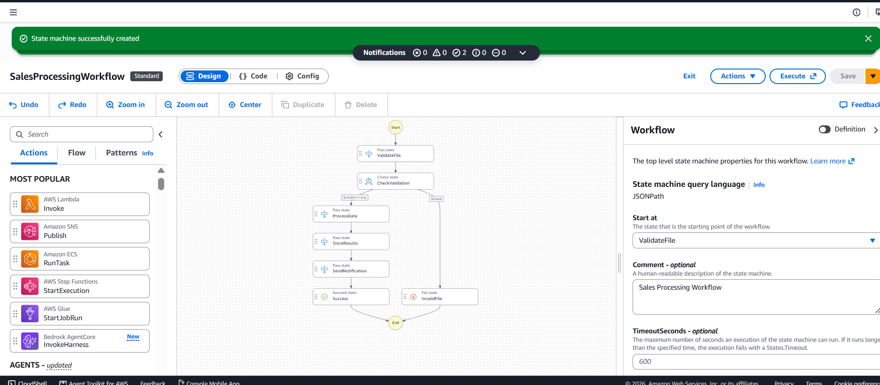
B .
Explain how a Choice state can route invalid files to a failure path and valid files to processing.
Ans :
A choice state checks whether the input file is valid or invalid. If the file is valid, the workflow proceeds to the processing state. If the file is invalid, the workflow is routed to a failure state, and processing is stopped. This prevents invalid files from being processed.

C. Explain how Retry and Catch can handle transient failures and permanent errors.
Ans : Retry automatically attempts a failed task again when a temporary error occurs, such as a network timeout or service unavailability. Catch handles errors when a task fails and redirects the workflow to an appropriate error-handling or failure state
D.
Explain how the state machine can invoke Lambda functions or other supported AWS services
Ans : The state machine uses task states to invoke AWS Lambda functions for file validation and data transformation. It can also integrate with other AWS services, such as Amazon S3 to store processed results and Amazon SNS to send completion notifications.

E. Explain how execution history helps troubleshoot a failed workflow.
Ans : Execution history records each state executed in the workflow, including its inputs, outputs, execution status, and error messages. It helps identify which state failed, understand the cause of the failure, and troubleshoot the problem to ensure the workflow runs successfully.

14 . A . Write an ASL JSON definition containing the three sequential tasks. Use placeholders for resource ARNs where necessary.
Ans : 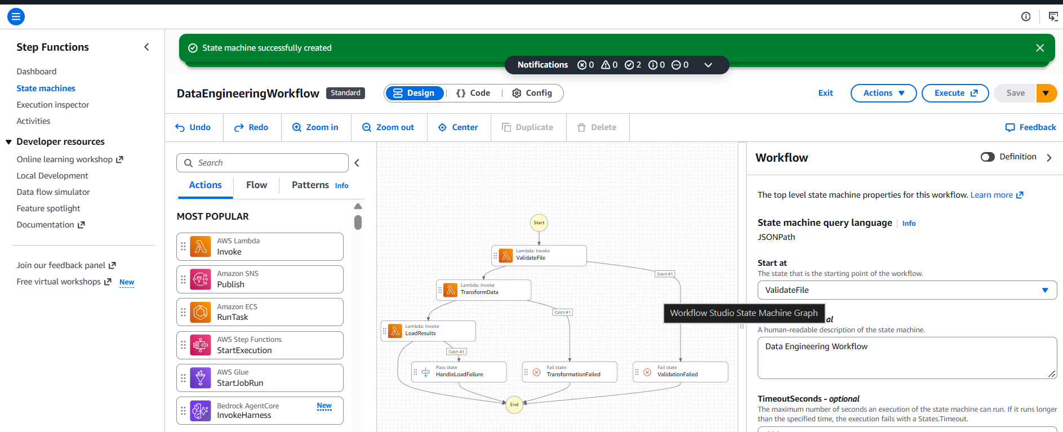
B. . Configure a retry policy for the transformation task with an appropriate error category, retry interval, and maximum attempts
Ans : 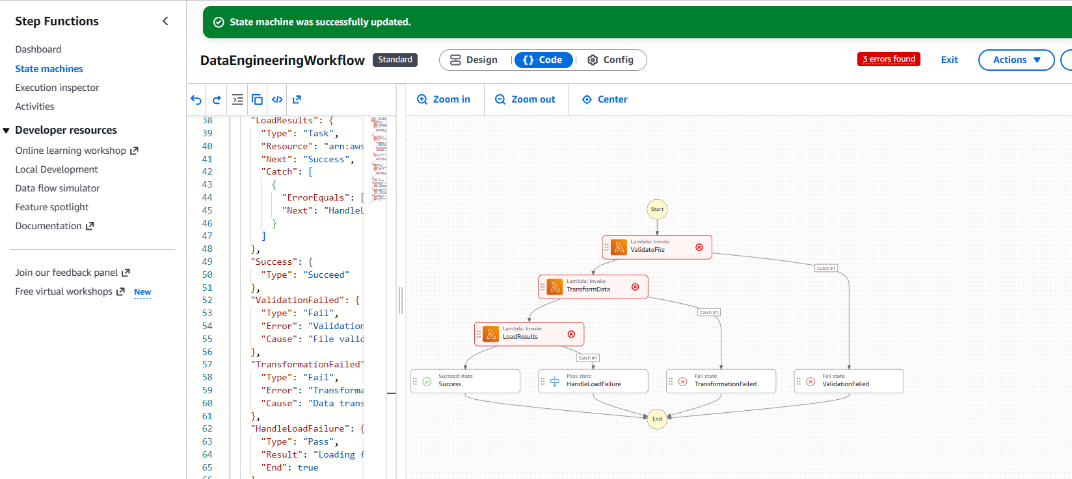

C . Configure a Catch transition for the loading task that routes to an error-handling state.
Ans :
A Catch transition handles errors that occur during the LoadResults task. If loading fails, the workflow redirects execution to an error-handling state, where the failure can be handled or recorded. This prevents the workflow from ending without managing the error appropriately.

D . Explain how data from one task is passed to the next task
Ans :
The output of one task is passed as the input to the next task in AWS Step Functions by default. This allows each task to process the data received from the previous task.

E . Explain how you would test successful and failed executions
Ans :
Test successful execution by providing valid input and verifying that all tasks complete successfully. Test failed execution by providing invalid input or simulating task errors, then check whether retries and error-handling states work correctly.

SECTION F
15 . Azure Data Lake Storage and Security

A . Configure or describe a storage account with hierarchical namespace enabled for Azure Data Lake Storage Gen2.
Ans : 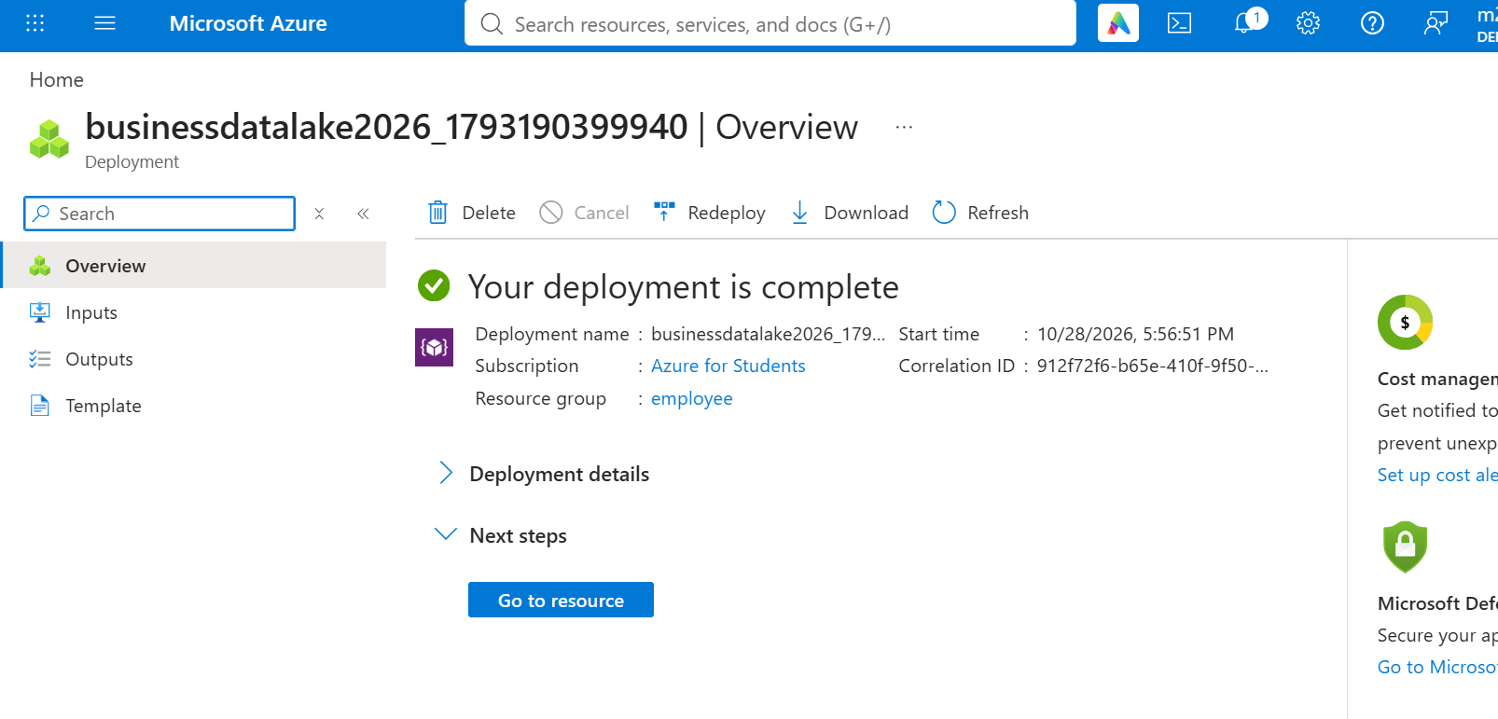
B. Create a filesystem or container and upload a sample dataset
Ans : 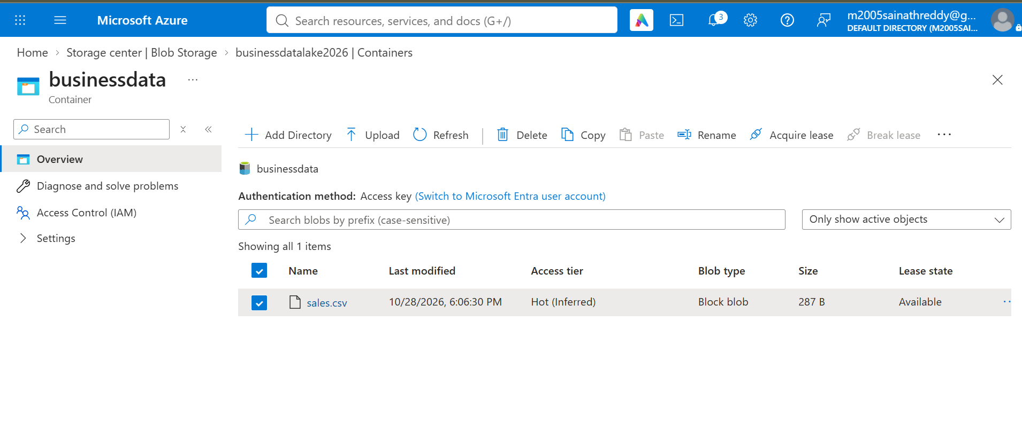
C. Explain how Microsoft Entra ID and Azure role-based access control can manage access to the data.
Ans :
Microsoft Entra ID verifies users' identities, while Azure RBAC assigns permissions to control who can access, read, or modify the data. Administrators assign roles such as Storage Blob Data Reader or Storage Blob Data Contributor to users or groups, ensuring that only authorized people can access confidential data.

D . Explain how you would verify that unauthorized users cannot access the dataset.
Ans :
I would test access using an unauthorized user account and verify that access is denied. I would also check Azure RBAC permissions, ensure public access is disabled, and review Azure Monitor logs to confirm that unauthorized access attempts are blocked.

16 .Azure VM Troubleshooting
A .Verify the VM's provisioning and power states
Ans : 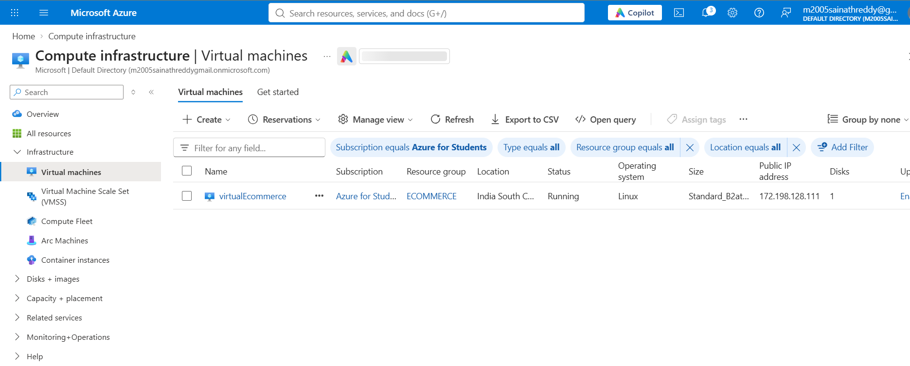
B. Explain how Network Security Group rules can prevent connectivity

Ans :
Network Security Group (NSG) rules control inbound and outbound traffic to an Azure virtual machine. If a required port is blocked by a Deny rule or no applicable Allow rule exists, administrators cannot connect to the VM. For example, blocking SSH port 22 prevents SSH access to a Linux VM.
C . Explain how subnet and routing configuration affect connectivity.

Ans :
Subnet configuration determines which network the Azure VM belongs to. Incorrect subnet settings or routing tables can prevent traffic from reaching the VM. Missing or incorrect routes may block communication between networks or prevent access to the internet, causing connectivity problems.
D. Recommend a secure troubleshooting method that avoids unnecessarily exposing the VM to the public internet.

Ans : Use Azure Bastion or a VPN to connect to the VM securely without exposing SSH port 22 to the public internet. Check the VM status, NSG rules, subnet, and routing configuration. Restrict access to authorized users and trusted IP addresses, and review Azure Monitor logs to identify connectivity issues.

17. Azure Data Integration
A . Select an appropriate service to orchestrate data movement.

Ans :
Use Azure Data Factory to orchestrate data movement. It can schedule and automate the transfer of CSV files from the source to Azure Data Lake Storage and coordinate data processing activities.

B . Explain how to copy the CSV file into Azure Data Lake Storage Gen2
Ans : Use Azure Data Factory (ADF) to copy the CSV file into Azure Data Lake Storage Gen2. Create a pipeline with a Copy Data activity, configure the CSV file as the source and ADLS Gen2 as the destination, then run the pipeline to transfer the file.

C. Describe how to organize files by ingestion date.
Ans : Store files in date-based folders, for example:/transactions/year=2026/month=10/day=28/

D. Explain how to handle malformed records and missing values
Ans : Use Azure Data Factory mapping data flows or data validation steps to identify malformed records and handle missing values. Store invalid records in a separate error folder for further review.

E.. Explain how to monitor pipeline execution and validate data completeness.
Ans : Use Azure Data Factory Monitor to track pipeline execution and errors. Validate data completeness by comparing source and destination record counts and checking for missing or duplicate records.

