**WORKFLOW TASK (SENDING AN EMAIL WHENEVER PAGE OR ASSET IS DELETED):-**

**REQUIREMENT:-**

whenever the user deletes a page or a asset in aem a workflow should be triggered and it should be able to send an email to any user.

**steps to trigger workflow :-**

1. Create a workflow model in Tools --> workflow --> Models
2. In this model we need to trigger a workflow which is in backend, so we need delete node component and process step component.   
   Add these both components into the model.

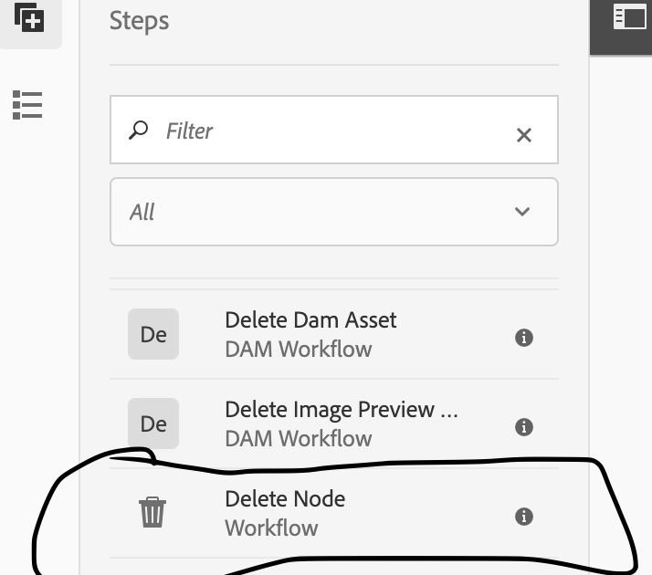

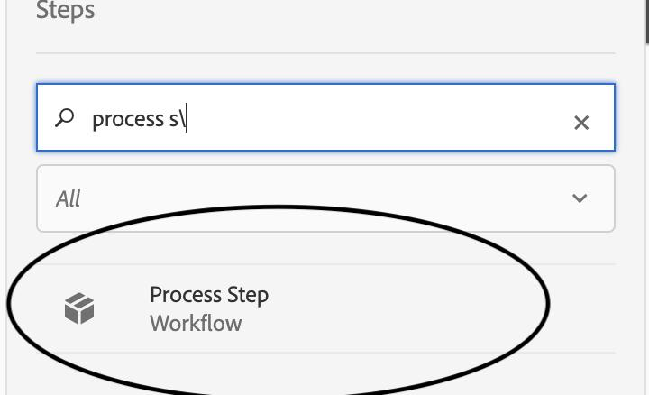

This is how our workflow model looks like

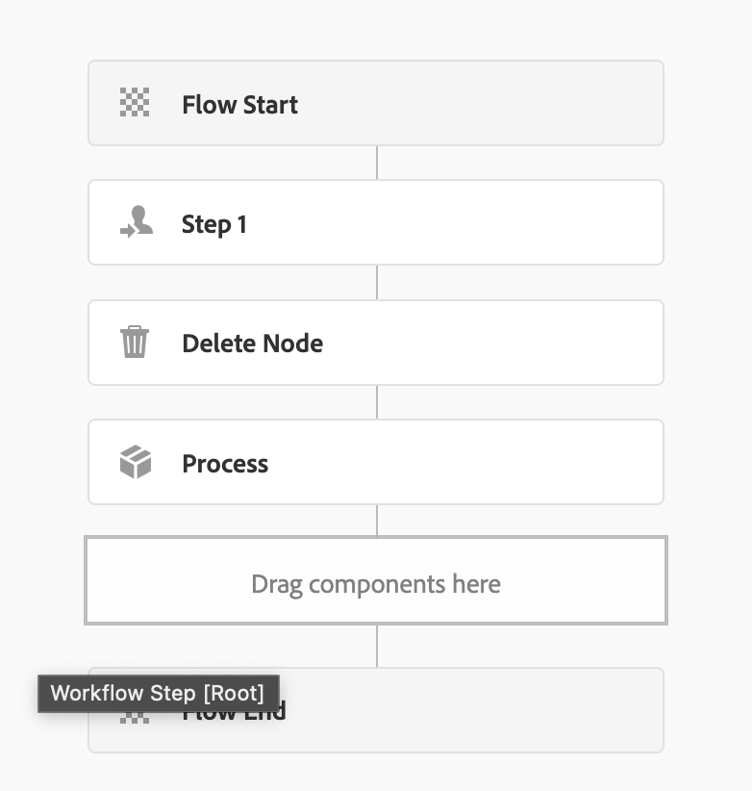

1. Now we have to create backend code which is a class which have code for process step , logging into gmail user for sending mail and reciever email address and details the code is as below :-

package com.adobe.aem.guides.wknd.core.models;  
  
import org.apache.commons.mail.DefaultAuthenticator;  
import org.apache.commons.mail.Email;  
import org.apache.commons.mail.EmailException;  
import org.apache.commons.mail.SimpleEmail;  
import org.apache.sling.api.resource.ResourceResolver;  
import org.osgi.service.component.annotations.Component;  
import org.osgi.service.component.annotations.Reference;  
import org.slf4j.Logger;  
import org.slf4j.LoggerFactory;  
  
import com.adobe.granite.workflow.WorkflowException;  
import com.adobe.granite.workflow.WorkflowSession;  
import com.adobe.granite.workflow.exec.WorkItem;  
import com.adobe.granite.workflow.exec.WorkflowProcess;  
import com.adobe.granite.workflow.metadata.MetaDataMap;  
import com.day.cq.mailer.MessageGateway;  
import com.day.cq.mailer.MessageGatewayService;  
  
@Component(  
 service = WorkflowProcess.class,   
  
 property = {"process.label=Send Email Notification Delete Node"}  
  
)  
public class CustomStepToSendEmailNode implements WorkflowProcess {  
  
 private static final Logger LOG = LoggerFactory.getLogger(CustomStepToSendEmailNode.class);  
  
 @Reference  
 private MessageGatewayService messageGatewayService;  
  
 public void execute(WorkItem item, WorkflowSession wfsession, MetaDataMap args) throws WorkflowException {  
 try {  
 LOG.info("Custom workflow step: Email Notification executed.");  
  
 // Get the resource resolver  
 ResourceResolver resourceResolver = wfsession.adaptTo(ResourceResolver.class);  
  
 if (resourceResolver == null) {  
 LOG.error("ResourceResolver is null. Unable to proceed.");  
 throw new WorkflowException("ResourceResolver is null.");  
 }  
  
 // Set up the Email message  
 Email email = new SimpleEmail();  
  
 // Set the mail values  
 String emailToRecipients = "dileepkandregula4641@gmail.com";  
  
 String emailCcRecipients = ["panchakarlanirbhai@gmail.com";](mailto:\"panchakarlanirbhai@gmail.com\";)

String subject = "Node Deleted Notification";  
 String body = "The Node " + item.getWorkflowData().getPayload().toString() + " has been deleted.";  
  
 email.addTo(emailToRecipients);  
 email.addCc(emailCcRecipients);  
 email.setSubject(subject);  
 email.setMsg(body);  
   
 // Set SMTP server settings

email.setHostName("smtp.gmail.com");  
 email.setSmtpPort(587);  
 email.setStartTLSEnabled(true);  
 email.setAuthenticator(new DefaultAuthenticator("nirbhaipanchakarla1@gmail.com", "fdkyioeocddvaeji"));  
  
  
 // Log the email details  
 LOG.info("Email details:");  
 LOG.info("To: {}", emailToRecipients);  
 LOG.info("Cc: {}", emailCcRecipients);  
 LOG.info("Subject: {}", subject);  
 LOG.info("Body: {}", body);  
  
 // Get the message gateway  
 MessageGateway messageGateway = messageGatewayService.getGateway(SimpleEmail.class);  
  
 if (messageGateway == null) {  
 LOG.error("MessageGateway is null. Unable to proceed.");  
 throw new WorkflowException("MessageGateway is null.");  
 }  
  
 // Send the email  
 LOG.info("Sending email...");  
 messageGateway.send((Email) email);  
 LOG.info("Email notification sent successfully.");  
  
 // Additional workflow logic or actions here  
 // For example, you might update workflow metadata, trigger another workflow step, etc.  
 // ...  
  
 LOG.info("Additional workflow logic executed successfully.");  
 } catch (Exception e) {  
 LOG.error("Error executing custom workflow step: {}", e.getMessage(), e);  
 throw new WorkflowException("Error executing custom workflow step", e);  
 }  
 }  
}

1. We are Sending an email to other user By using SMTP SERVER.   
   This server is typically responsible for sending an email from user to user through AEM.
2. If the sender user needs to send Email from their Respective Gmail accounts we have to follow below steps which will be involving generating passwords and adding it in SMTP server.
3. Now for sending an email from user, the sender needs to generate an app password in Gmail account in order to login, because our mail passwords would be strong and the SMTP sever cant be able to login with our password.

In order to generate app password follow this below steps :-

--> Go to your google account

--> Click on Manage Your Google account

--> Go to security

--> search for apps and passwords

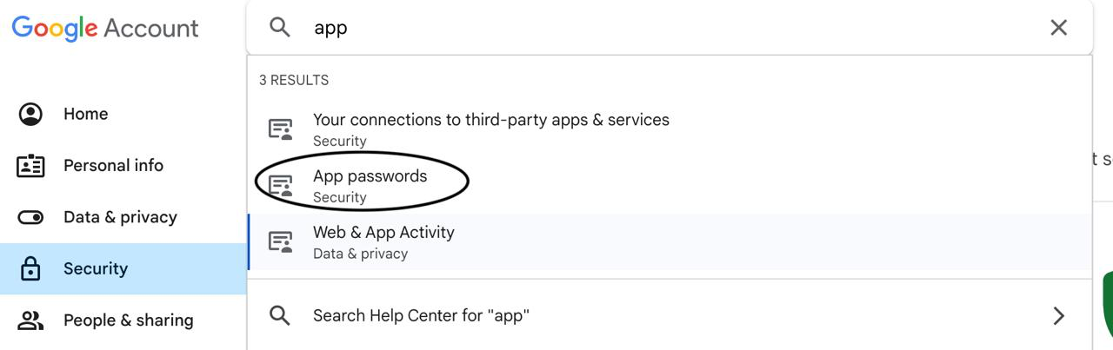

--> Add a new app name as u need and click on create, 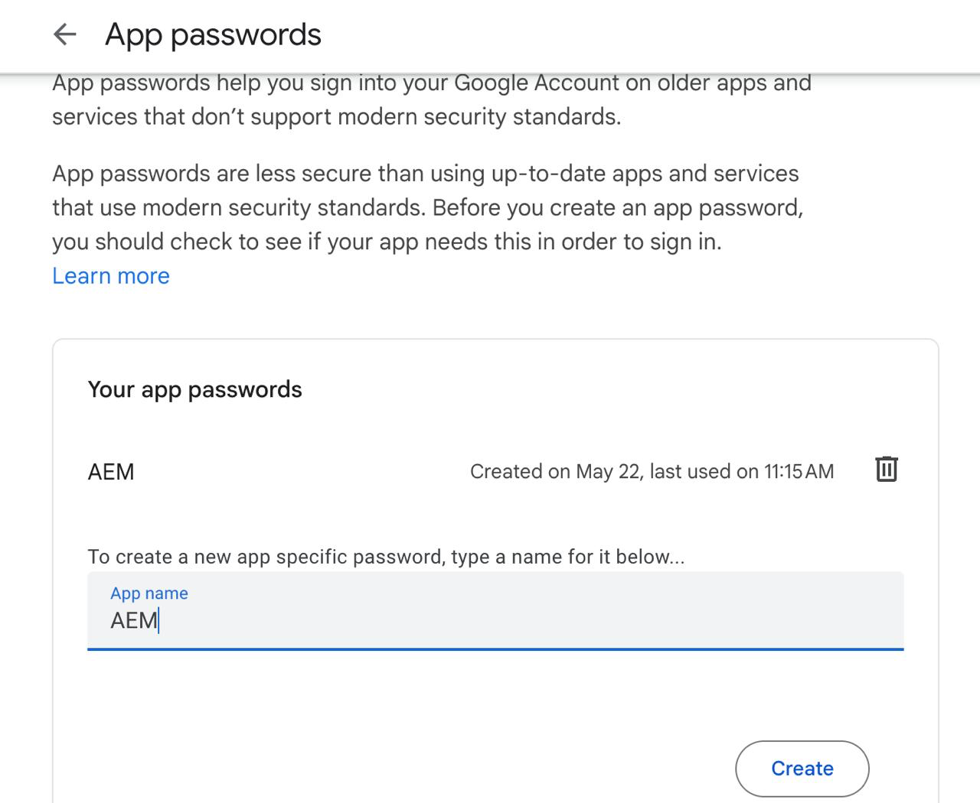

--> it will generate a new password . copy the password and save wherever u need it.

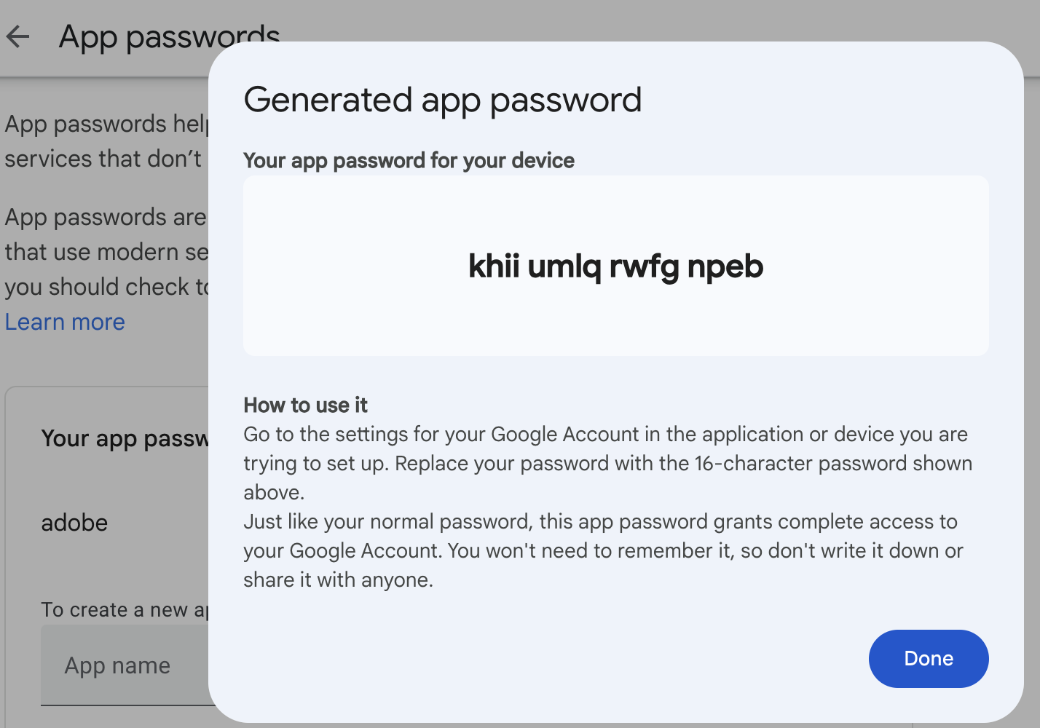

But the Password which is generated will be with spaces in between but You have to remove the spaces and save the password somewhere.  
ex:- khiiumlqrwfgnpeb

1. Now the user have to change the Mail id and generated password in the code in // Set SMTP server settings .  
   The user can change the reciever mail id also as if they required in // Set the mail values   
   in the code
2. Now we have to save and run the code after making this above changes.   
   The same changes are needed to be Configured in SMTP- Day CQ MAIL SERVICE in Adobe Web console. which is explained in below steps
3. Now we have to configure this Mail id and Password and other settings in DayCQ MAIL SERVICE in system web console . follow this below steps

--> Redirect to Adobe Webconsole (System console)

--> In system console click on OSGI-> CONFIG

<http://localhost:4502/system/console/configMgr>

--> Search for “’DAY CQ MAIL SERVICE”.

--> Configure the below setting in day cq mail service as shown as below image

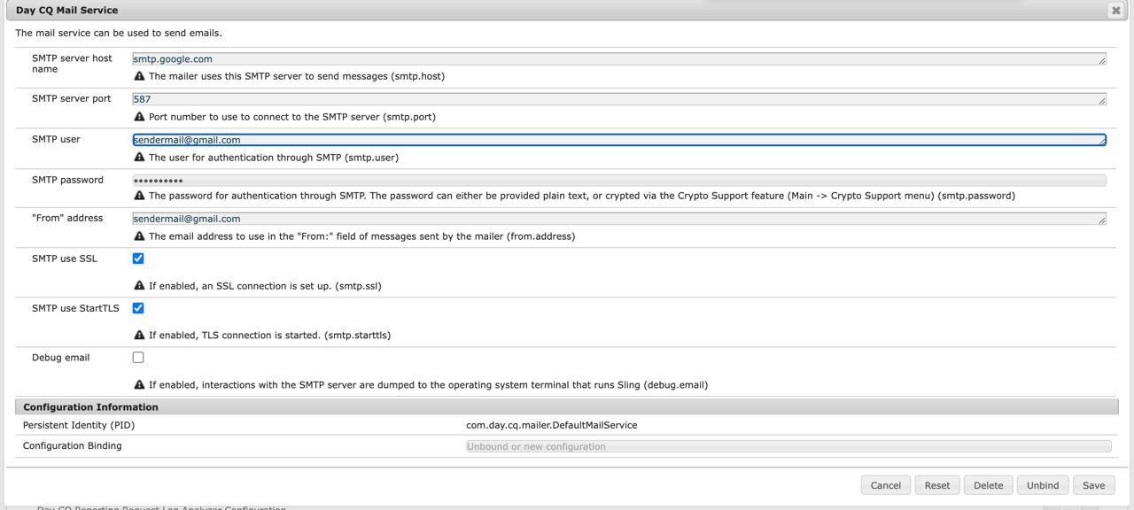

--> // Set SMTP server settings

Now configure the details in Day CQ MAIL SERVICE Based on the SMTP SERVER SETTING which are already configured in Worklow backend code.

* And also enable the SMTP use SSL (tick it) and SMTP use StartTLS(tick it)

now save the settings.

1. Now we have configured all the settings which are required in order to trigger workflow.
2. Now we have to redirect to Workflow model which we created in 2nd step
3. We have to trigger workflow code which is in backend. By using the Process Label Property we can append the backend code to the Workflow Model and trigger it.

In order to Append the Backend Workflow class to this Workflow model now we have to Open Process Step Node and u will able to see as below.

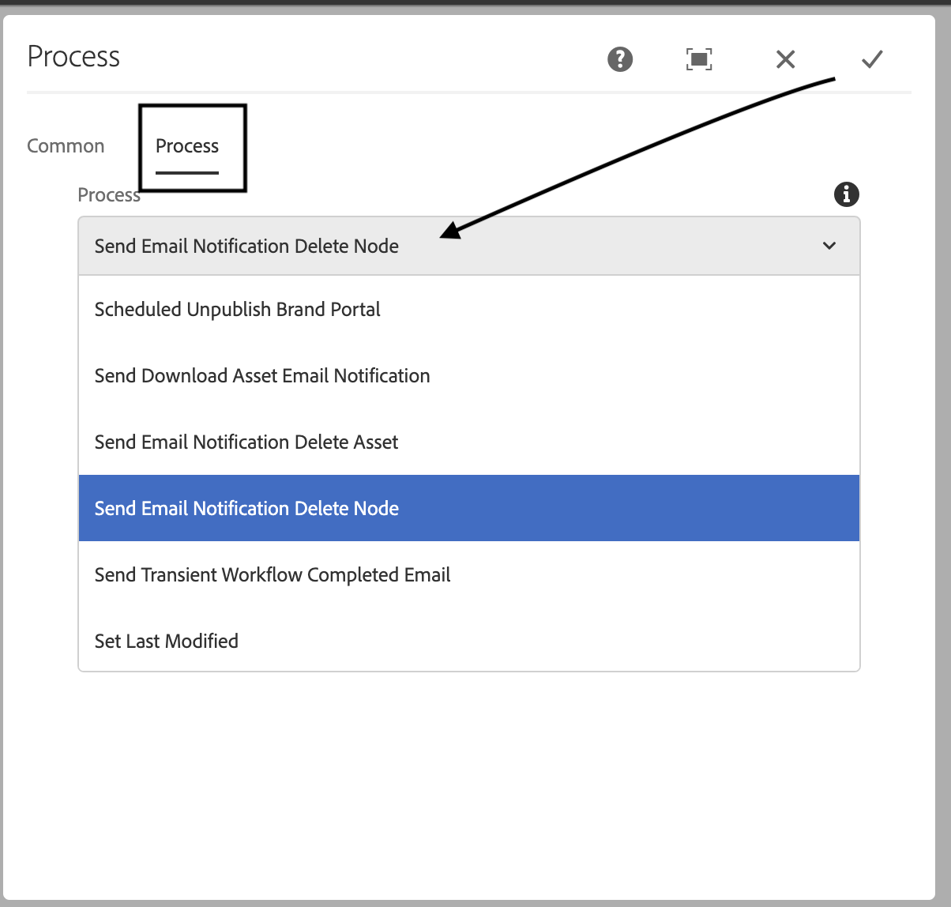

Now Process step u will be able to see “Send Email Notification DeleteNode“

Which is in property (Process Label step ) in backend code. select this and save it.

1. When we have saved the workflow dont forget to click on SYNC on top right corner so that this worflow will be updated in runtime.
2. Now we have to start workflow on a page.  
     
   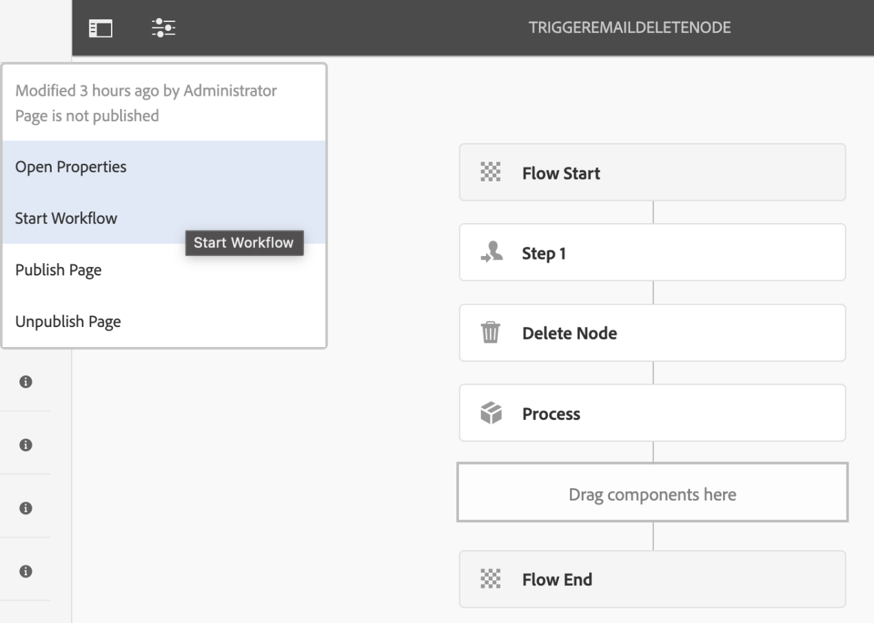  
     
     
   Now after clicking on start flow we have to select payload of the page in which where worlfow has to be started
3. Now select the Payload of the page in your project where workflow has to be started. And Click on RUN.  
     
     
   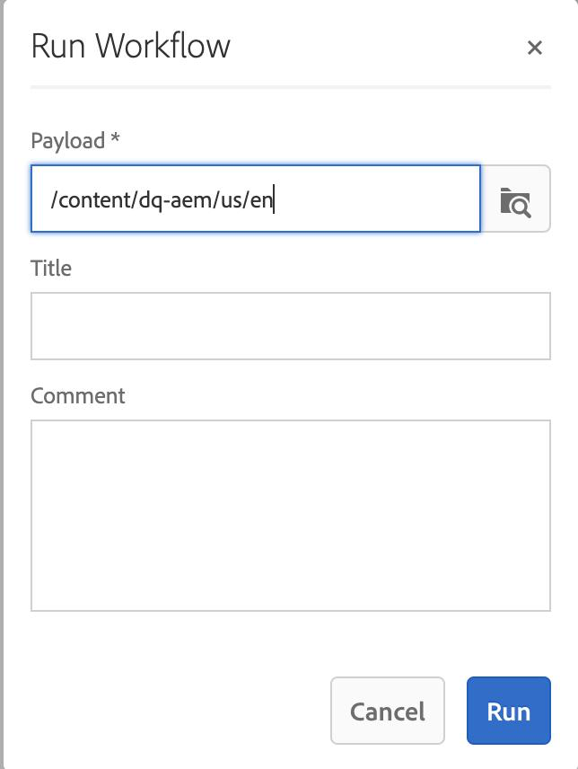f
4. No go to sites , and now Whatever the page u have started the workflow in above step u have to select that Page and click on create Workflow as below   
     
   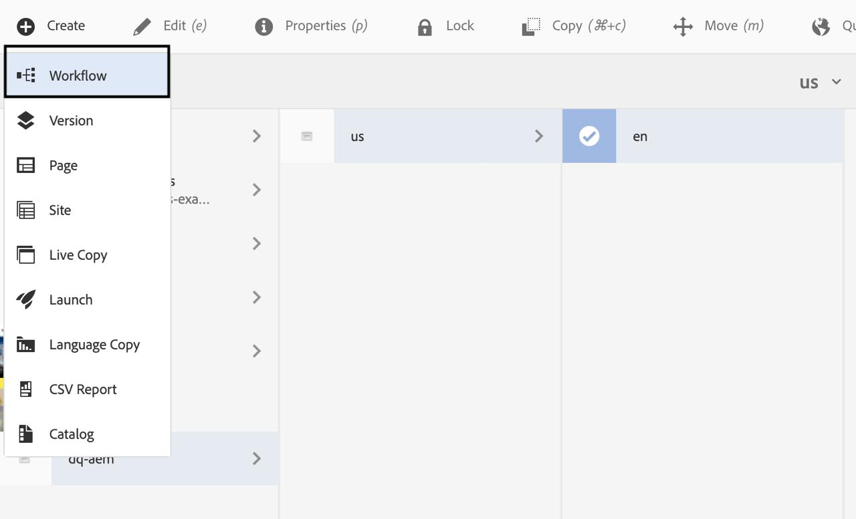
5. And now You have to select the Workflow Model which u have created. and add workflow title and then click on next.  
     
   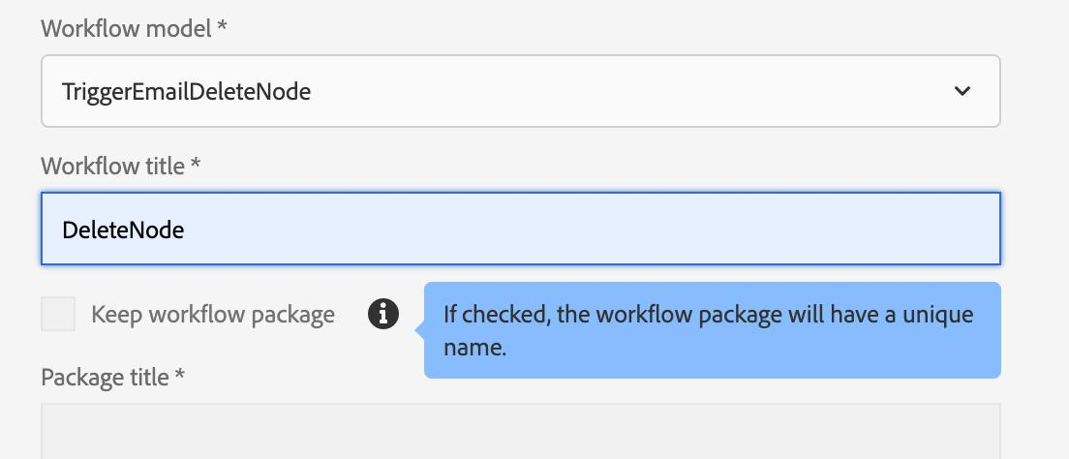
6. After clicking on next now we have to select the ppage and then click on create as below  
     
   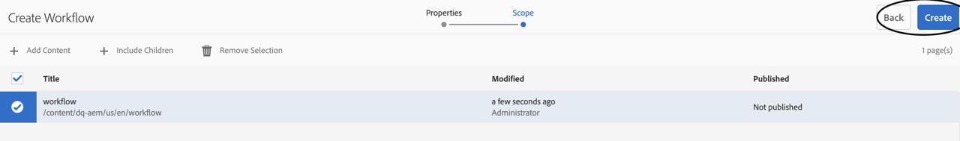
7. Ater clicking on create now we would have got a Notification.   
   Click on Bell icon as shown as below   
     
   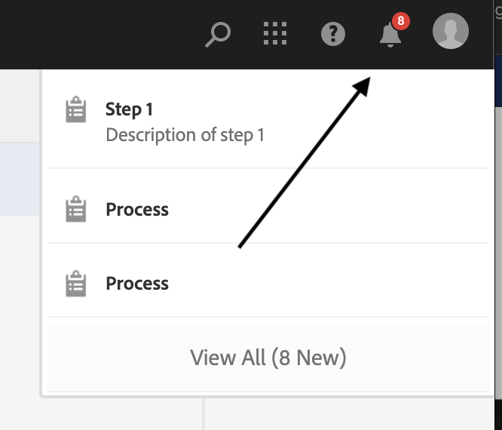
8. Now we have to select the notification which we sent and then click on complete  
   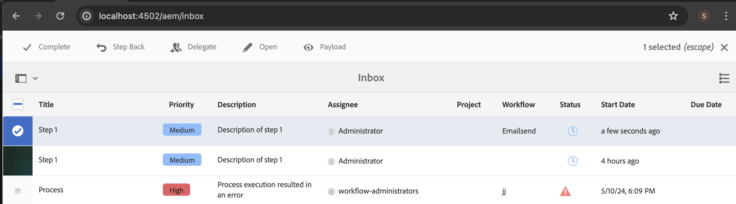
9. After clicking complete it should appear like this as below image. After clicking ok it will send the mail and page will be deleted.

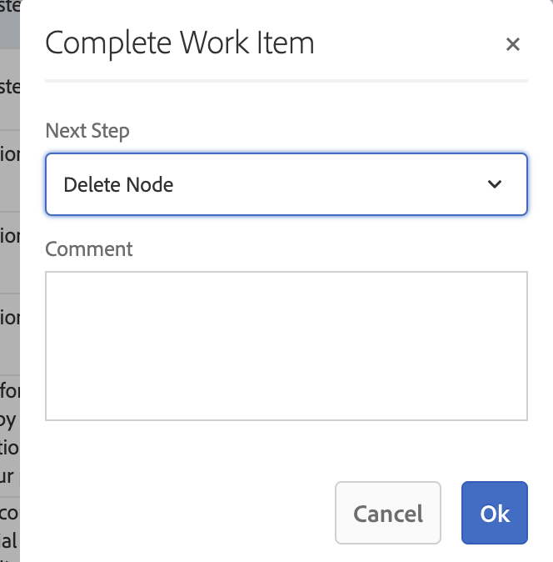

1. Now mail has been sent saying the page has been deleted.  
   We can verify by checking the mail of Reciever Inbox a mail would have been recieved.

OutPut shows like this below image.  
  
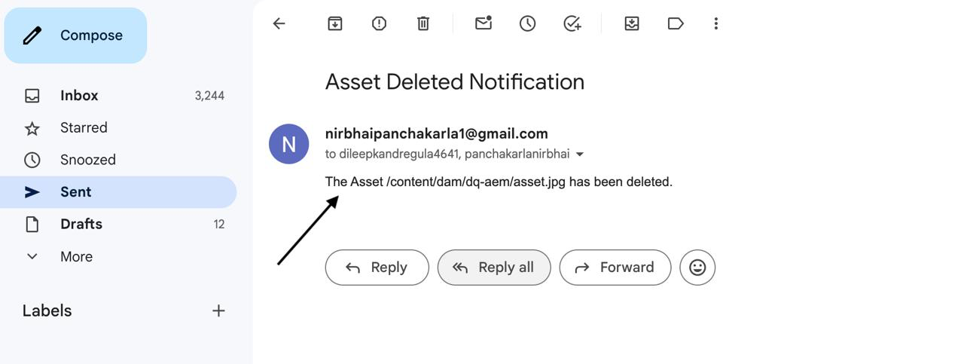

GIT PUSHING PROCESS FOR WORKFLOW MODELS:-

For this workflow task we cannot push as the other tasks because the workflows will store under conf and var.

The workflows Models will store under these two paths Conf and Var.

We have to Store this two folder under “Ui-Content” like below image

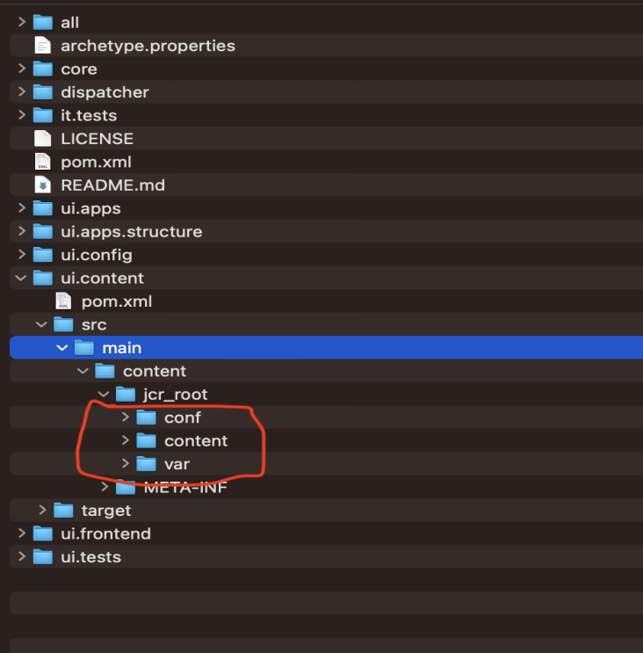

And also we have to add filter to reading the folder we have added, like below image then it will be accepted by this folder

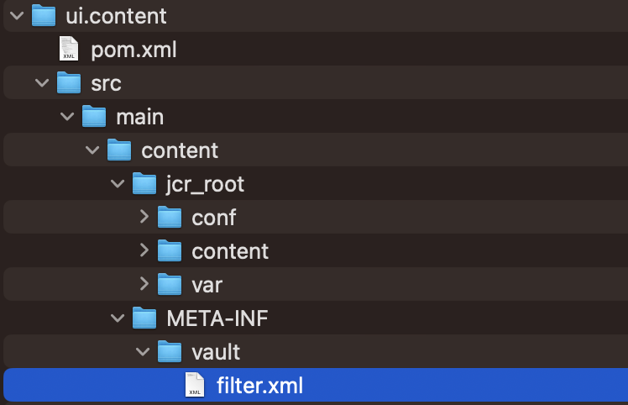

The Added code of the filter as below image

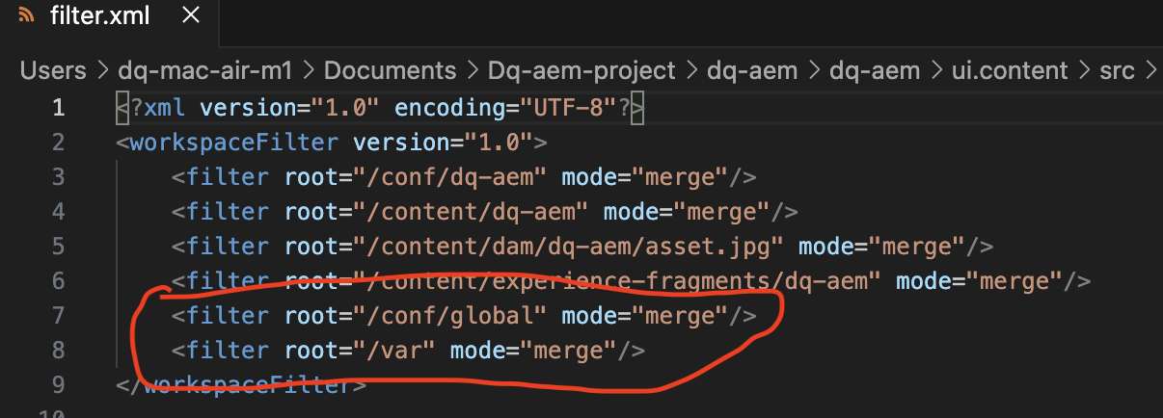

Before adding the filter.xml the conf and var will get error. After adding the filter the error will be resolved becuase before we haven’t added the path that should read.