CREATING A NEW REPOSITORY AND RAISING A PR USING GIT BASH :-
Requirement :
I am having a project in local and I want to push it to a new repository (main branch) and creating branches from it and pull it into our local and now i just want to push a java class which i created in my local (Eclipse) to a specific branch and then merge to main branch.
- Create a new repository in github.(make sure it is public).
- Now create a folder in our local (any location)
- Now open gitbash
- Now go to the folder location which u have created in 2nd point. By following command
cd (drive location) ex:- cd d: (my folder is in d drive)
cd (folder location) ex:- cd cloning (my folder name is cloning)
- Now we have to clone our repository in this folder. Type following command
git clone (repo code url)
ex:- git clone https://github.com/sainavatej/Git-Practise.git
now when u clone it u will get whatever the files which are present in the (main branch) in your folder
- Now we have to go into the cloned repository folder location. As below
cd reponame ex:- cd New-repo (my repository name)
as soon as we go to this location we will get the main branch
- Now we have to copy and paste our project structure or any files you wanted to push into the main branch in this folder. As below
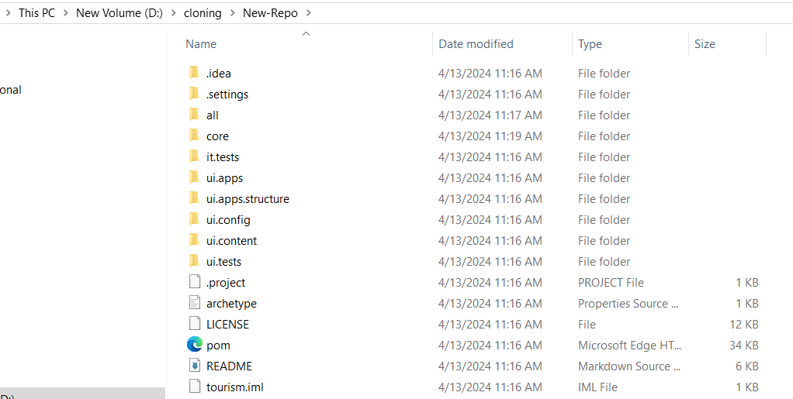
- As soon as we copied and pasted, this changes will be updated in gitbash when u type the following command
git status
- now we have to commit and push this changes into main. So type
git add . (for staging files)
git commit -m “commit message”
(for commiting the files)
- Now we have added and also commited the changes now we have to push the changes to main branch by using following command
git push origin (branchname) ex:- git push origin main
- now u have commited and also pushed the changes to main branch which means the project structure will be updated in the main branch (refresh to get updated)
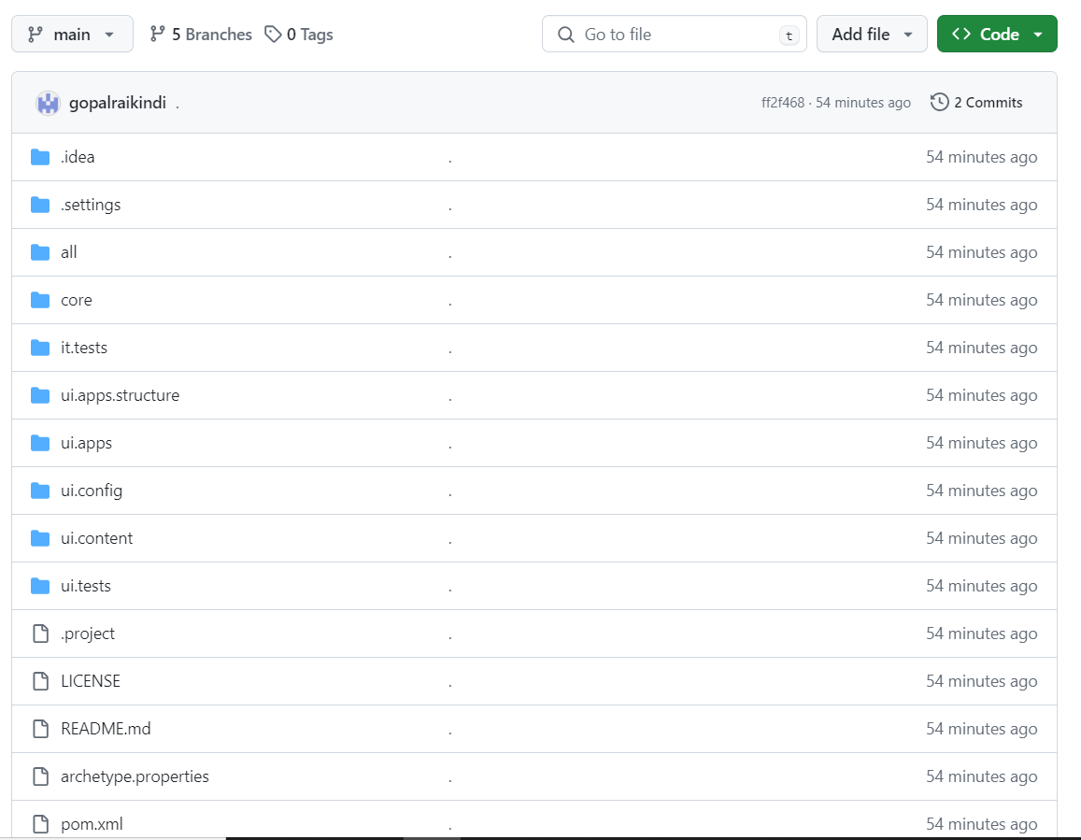

- Now different persons will be working on this project. So we should not be working on the main branch because main branch is the main source code.
So in order to do work we have to create branches on our own from the main branch. So first we will be creating dev branch (because dev is used as a bridge between our branch and main branch). Now again cut a branch from dev branch. Now we have to work on our branch which has been created from dev.
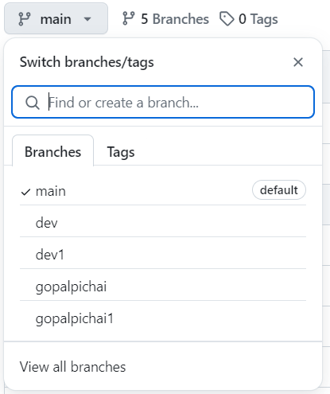
- Now we have to shift to our newly created branch in order to make changes from our branch. In order to do this type
git fetch (it will fetch all the newly created branches in the github repository)
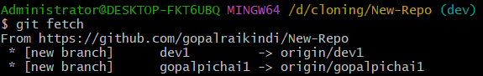
- Now we have to shift to our branch from gitbash in order to do it type as below
git checkout (branchname you wanted to shift) ex:- git checkout gopalpichai1
now when you checkout the new branch name will be updated as in below image
- Now we have to make changes on this branch. So I am importing this project into my eclipse by giving this project location which is present in our local. (refer 7th point).
as soon as we imported the branch name will be updated in the eclipse too(beside project name)

- Now we have to make changes like creating a file(class or interfaces or anything u want).After making changes, This changes will be appeared in gitbush when u type following command
git status (changes are appeared in the red colour as below)
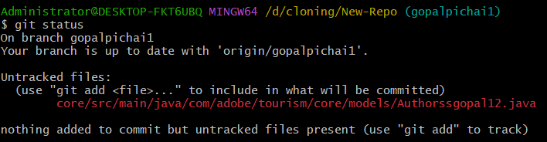
- Now we have add and commit this changes by using following commands
git add . (for adding all the changes at a time)
git add (filename) (for adding a particular change u wanted to commit)
now we have to commit use
git commit -m “commit message” ex:- git commit -m “files changed”
- Now we have added and commited, now we have to puch to our branch. So use
git push
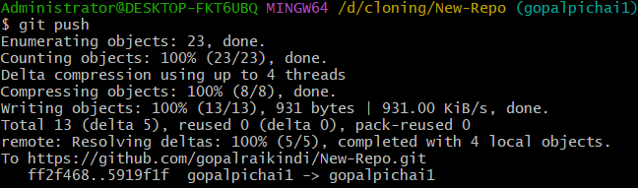
- Now the changes have been pushed to our branch. In order to check this go to github.
- Now we have to raise a pr to dev branch or any upper branch. In order to do this u will see a tab as below in github when u pushed changes in the 18th step.

click on compare and pull request and u will see as below in order to raise a pr. So u can compare the branches and raise a pr to the branch u needed. U will be able to see able to merge when u are eligible to raise a pr from your branch. And add some title and description which are related to the change you made and click on create pullrequest.
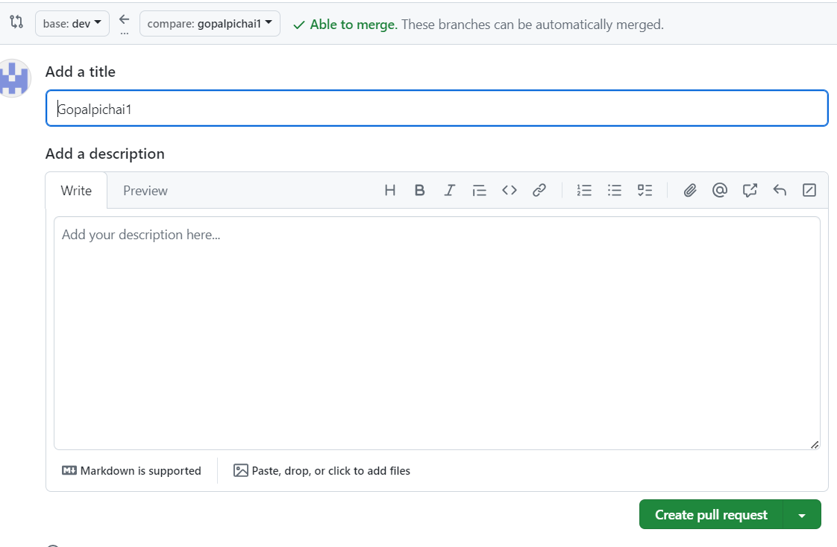
- Now we have raised a pull request.So they will verify the changes we made and then they will merge to dev. So the same changes will be updated in dev branch too.
2)Check whether that repository present in local or not by typing ls -al
3)if that repository is present in our local then we dont need to do anything.
if it is not present in our local then we have to clone that repository to our local by typing following command. (give ur repository url)
git clone https://github.com/sainavatej/aem-files.git
4)

Requirement :
I am having a git repository in my github. And now i just want to push a java class which i created in my local (Eclipse) to a specific branch and then merge to main branch.
1) Open gitbash
2)Check whether that repository present in local or not by typing ls -al
3)if that repository is present in our local then we dont need to do anything.
if it is not present in our local then we have to clone that repository to our local by typing following command. (give ur repository url)
git clone https://github.com/sainavatej/aem-files.git
4)

