Lab1_ANP_C7270_JDBC_Connection_on_MYSQL

Name: M.SaiNavitha

Id:AFO400796

1.

Mike is a software developer in a Marketing company. The business analysts have provided mike a requirement to develop a application which stores the department and employee information. The application should also provide a feature for users to query the records based on employee id.

The following are the information which needs to be stored

Employees information such as employee id, employee name, salary, Employee address, contact number, and the department where he works.

Department information such as of the firm such as department id, department name, department head and number of employees in the department.

Additional Requirement:

1.     Duplicate Employee data should not be stored in the system.

2.     Duplicate department data should not be stored in the system.

3.     Salary should be between 1000 and 30001.

Problem # 1 Creating Tables : Create following tables using My SQL command line Client and DDL’s.

 i.Create Department table

a.     Department_ID – Primary Key - Number

b.     Department_Name -  Varchar

c.     Department_Head – Varchar

d.     Department_Description - Varchar

create table Department(

Department_ID int primary key,

Department_Name varchar(255) not null,

Department_Head varchar(255) not null,

Department_Description varchar(500)

);

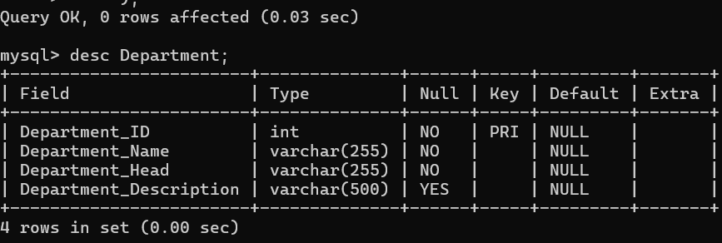

  ii.      Create Employee table

a.     Employee_Id- Primarykey- Number

b.     Employee_Name- Varchar

c.     Employee_Address- Varchar

d.     Employee_Salary- Decimal Number

e.     Employee_Contact_No- Number

f.      Department_Id-  Number (Foreign Key)

create table Employee(

-> Employee_Id int primary key,

-> Employee_Name varchar(255),

-> Employee_Address varchar(255),

-> Employee_Salary decimal(5,2),

-> Employee_Contact_No int,

-> Department_Id int,

-> foreign key (Department_ID) references Department(Department_ID)

-> );

Query OK, 0 rows affected (0.04 sec)

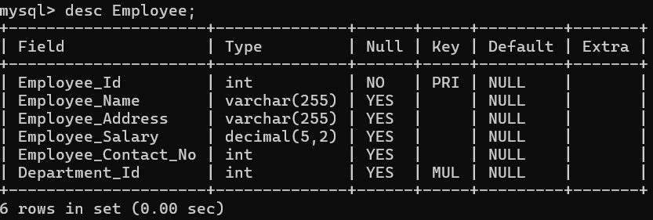

 iii.    Create a constraint on salary to ensure salary between 1000 and 1000000.

mysql> alter table Employee

-> add constraint salary_check

-> check (Employee_Salary between 1000 and 1000000);

Query OK, 0 rows affected (0.10 sec)

