SCREENSHOTS

**Arduino Application Window :**

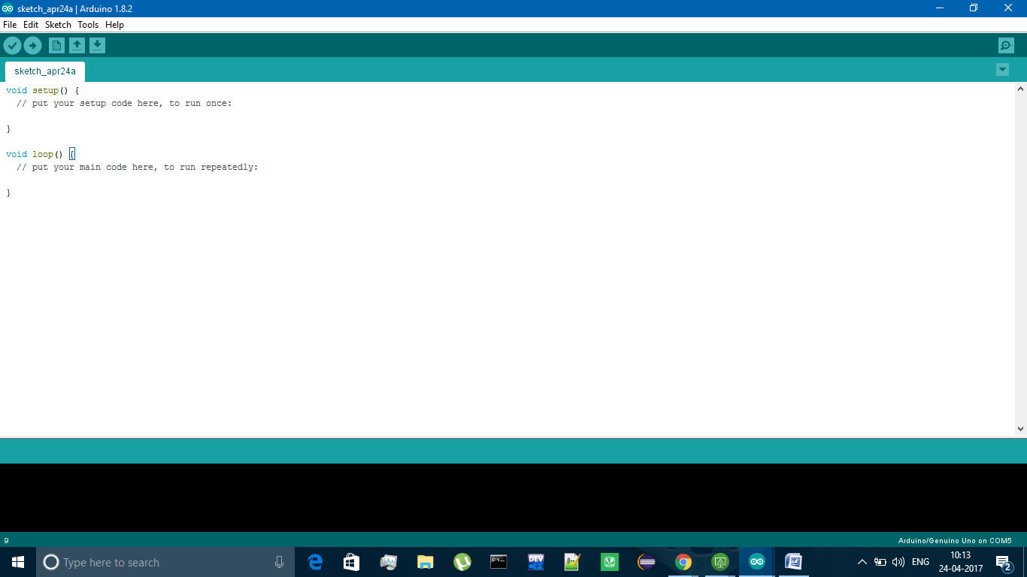

: The above screenshot shows the window after installing the Arduino uno in the pc and we need to type the program is required for the project in this window and execute the program

**Selecting the type of Arduino board :**

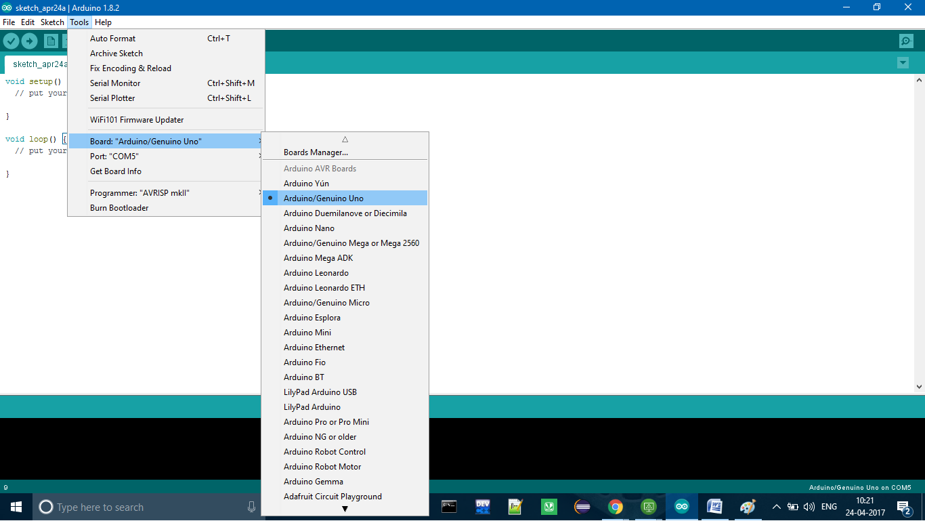

**Description**:

The above screenshot shows the different Arduino’s available and we need to select the Arduino board we are using the project .

Here we are selecting Arduino uno board

**Serial Port :**

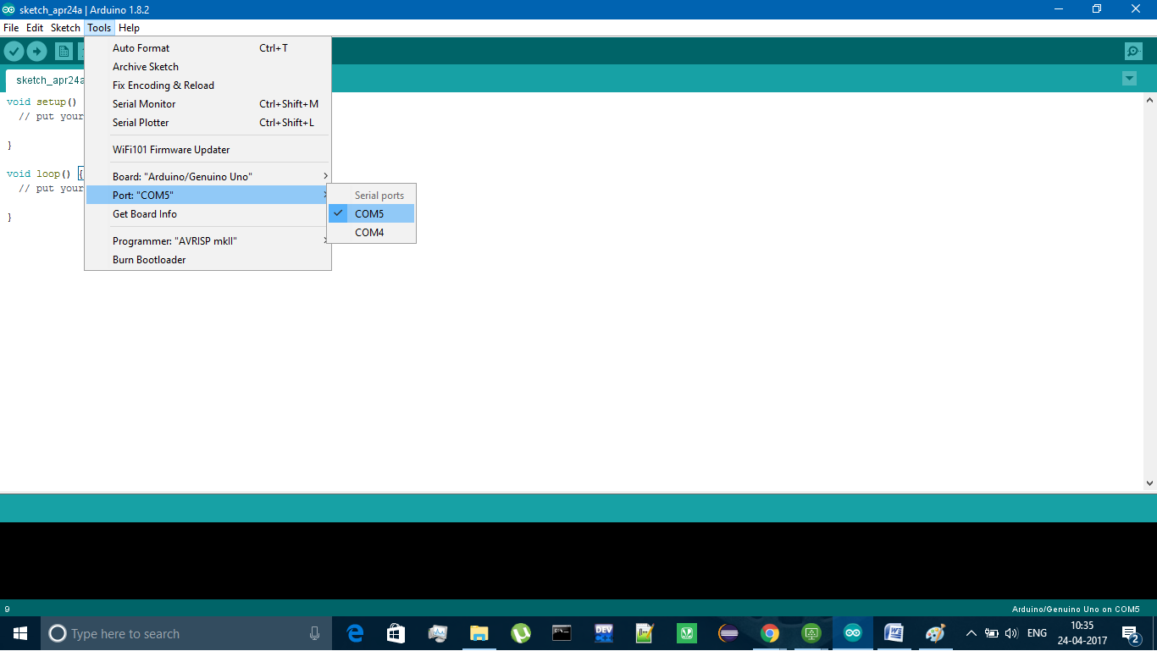

**Description:** the above screen shot shows how the different ports available

Serial is used for communication between the Arduino board and a computer or other devices.

**setup( ):**

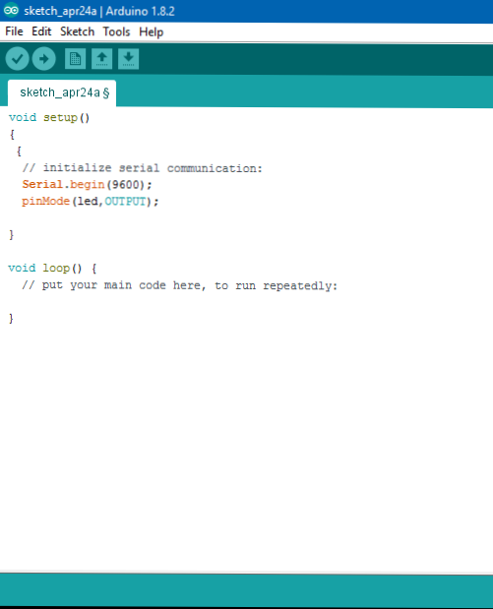

**Description:**

The setup() function is called when a sketch starts. Use it to initialize variables, pin modes, start using libraries, etc. The setup function will only run once, after each powerup or reset of the Arduino board.

**Loop( ) :**

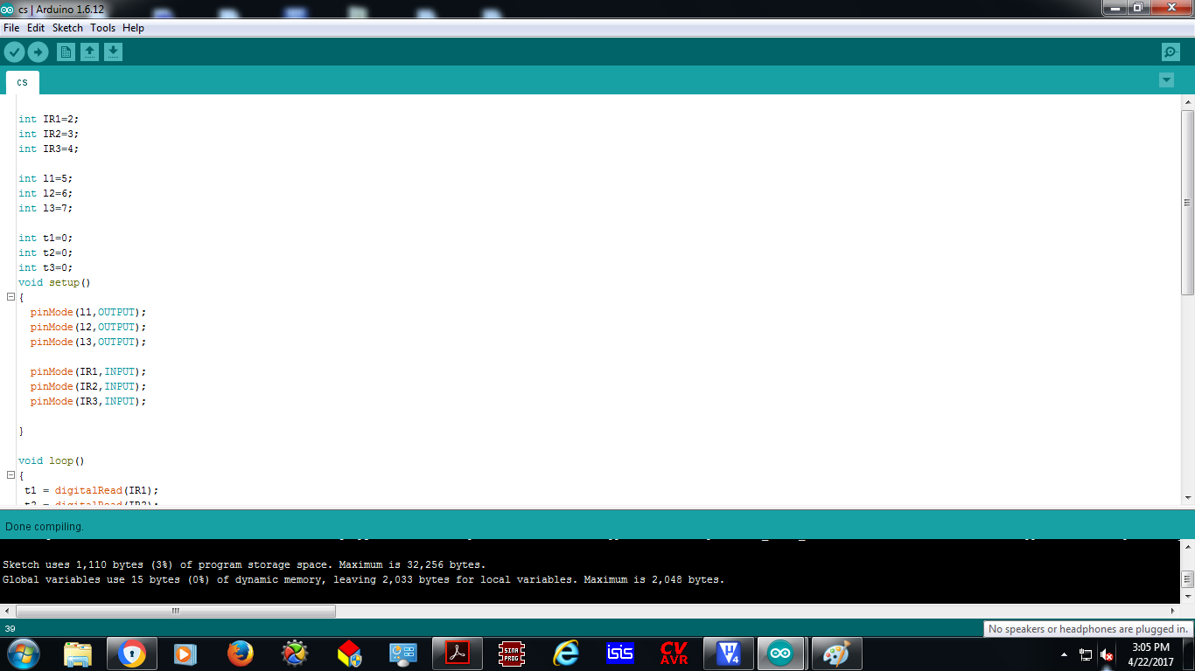

**Description:**

The above screen shot shows after creating a setup() function, which initializes and sets the initial values, the loop() function does precisely what its name suggests, and loops consecutively, allowing your program to change and respond. Use it to actively control the Arduino board.

**Loop( ) continuation :**

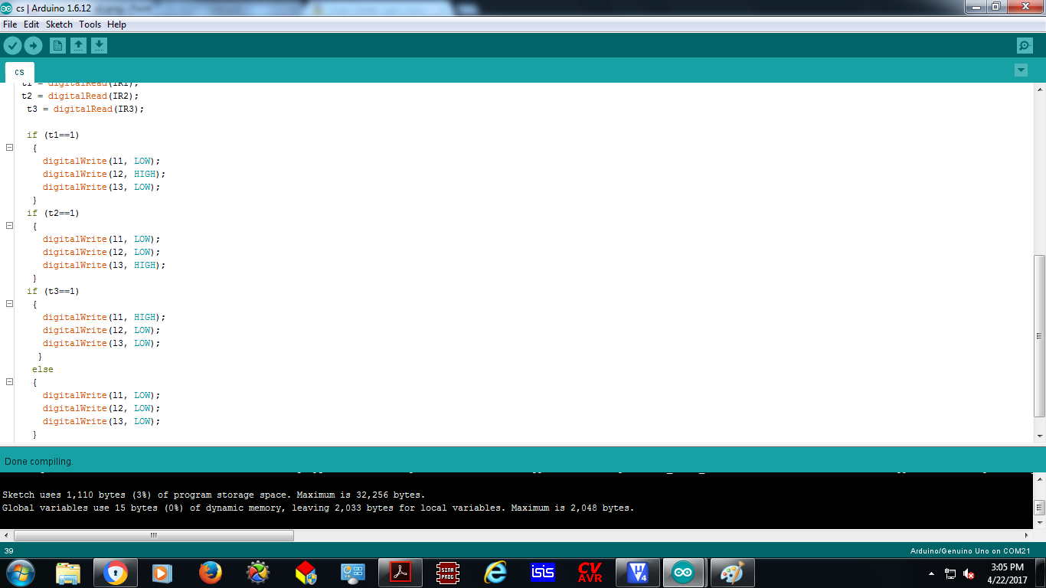

**Description:**

In the above screenshot each led is programmed in a such a way that when one sensor is sensed the respected led glows and other led’s remain stable until and unless it’s sensor senses motion.