Contents

Introduction: 2

Project overview: 3

Scope: 3

Project tasks and scope that we have discussed in the group are: 4

My Tasks: 4

Assessment tasks and due date: 5

Requirements: 5

Functional requirements: 5

Non-functional requirements: 6

Story Card: 7

UML DIAGRAMS: 7

USE CASE DIAGRAM: 8

Architecture Diagram: 10

SEQUENCE DIAGRAM: 11

Deadline Project: 11

PERFORMANCE REQUIREMENTS: 11

MODULES: 12

REUSABLE MODULES: 12

BUSINESS NEEDS: 12

TESTING 13

UNIT TESTING 13

SECURITY TESTING 14

IMPROVEMENTS AND MODIFICATIONS: 14

USER INTERFACE: 15

Website interface: 16

References: 16

# Introduction:

In the past, physical games have been popular, but nowadays computer games take over and have a lot of advantages. Computer games are known to be effective instructional tools if used for the right task and help to enhance motivation and improve the engagement of the user in the task.

Computer games are providing an opportunity for practicing and learning through failure and success, and they also have the ability to create active and engaged societies for learning, communication, problem solving, and group activities. Computer games can provide the learner with a tool to play, explore, experiment and have fun all at the same time (Whitton 2012).

With the rapid growth in gaming technology and changes in the demographics of gamers, the gaming world had created a new breed of gamers who desire new challenges and more in depth experiences in the gaming world.

# Project overview:

For the project our group will have face a high level of complexity because we will cover different software topics and methodology we will work on the process, we need to have well understanding of the IT and functionality requirements. We need to divide the project tasks between our group members to understand the project very well and analysis business organization needs to develop the project requirements.

# Scope:

We selected the Flappy Bird Game because it has a suitable software code that able to practice all the software engineering methodologies that let us to work as a group and individual. The Flappy Bird game based on Java languages and we using GitHub platform for editing the code also, we divided this software into modules, makes improvements, and tests the entire software after integrating the modules.

The project will illustrate the needs of development a friendly webpage interface for the game that can attract the user by changing some features of the game throughout using GitHub for editing Java language code.

## Project tasks and scope that we have discussed in the group are:

* Flappy bird - a game written in JavaScript
* Develop a website
  + Main page
  + Documentation
* Competitive Analysis
* Mobile friendly
* Functionality: Score page (able to enter user ID)
* Modify Interfaces
* Modify Multi Languages
* Methods
  + Scrum (so requirements will be added incrementally)
    - Stories
    - Sprints
    - Backlogs
  + Analysis of Requirements
  + Unit tests
  + Integration testing
  + User Acceptance Tests
  + Burndown chart
  + Gantt Chart
* Configuration Management
  + GitHub

# Tasks:

My tasks for this project is that to build a friendly and accessible home page for the game that can attract the user to play the game more than once. Moreover, I will do some documentation and checklist with the due date of tasks that need it to build the home page. We decided to build a web page for the game to give the user more instruction information about the Game for example how to play the game, information about the game itself and feedback about the game.

In addition, my task is to do user acceptance tests for the game also for the home webpage to identify the threats and the weakness of the game.

Moreover, my last task is to draw Burndown chart to adjust the graphical representation of work left to do versus time, it is useful for predicting when all of the work will be completed.

# Assessment tasks and due date:

|  |  |  |  |  |  |  |  |  |  |  |  |  |  |  |  |  |
| --- | --- | --- | --- | --- | --- | --- | --- | --- | --- | --- | --- | --- | --- | --- | --- | --- |
|  | |  |  |  | | --- | --- | --- | | **Assessment Task** | **Value** | **Due date** | | Project plan (3 - 5 pages) | 10% | W 3, Monday, 1/8/2016 | | Project progress Report- 1500 words | 20% | W 5, Monday, 15/8/2016 | | Presentation and demonstration of software methods (10 minutes) | 30% | W 11, Monday, 26/9/2016 | | Written report - 5000 words | 40% | W 12, Monday 3/10/2016 | |

# Requirements:

Understanding the requirements for the software is very important for the group members to match the business or users’ needs that would use our software to work out what improvements that we want to make to the software.

## Functional requirements:

1. Access the game and play
2. Can play the game on the computer, Smartphone and (Android, iOS)
3. Create individual user account for security
4. Sound provided
5. System functionality
6. Game is located to a local server

## Non-functional requirements:

Some of the example of non-functional requirement are as:

* Performance, Capacity, Reliability and Speeding
* Security, Maintainability, Manageability and Usability
* Efficiency and Effectiveness
* System ha to match IEEE standards and Australian Standards

There are many Core Functionality of Requirement Management Software for Flappy Bird game for example: Feedback, Issues, Specification and Planning

The main requirement management software of the game is:

1. Specification of the game in terms of:

Functionality:

• Detailed requirement management

• Use & Test Case Management

• Accurate Change & Traceability Management

Benefits:

• Single repository

• No duplication of work

• Specification standardization

1. Planning the process of the game:

Functionality:

• Project & requirements planning

• Task & time management

• Full analytics and reporting

Benefits:

• Eliminate overruns and overspends

• Better & more timely decisions

• Effective communication to stakeholders

Our group members are follow the implemented templates in a Requirements Management Software platform for increase efficiency, reduce risk and minimize cost.

There are several different templates derived from the IEEE standard, which are:

* Stakeholder requirements specification template
* System requirements specification template
* Software requirements specification
* Project plan template
* Stakeholder questionnaire template (RequirmentOne, 2016).

# Story Card:

**Story #1**

**TIME:** 3 days

**STORY NAME:** Project option

**AS Client:** Modification of web browser game

**I WANT:** An existing project from the open source website

**THAT:** A group of four students could improve its functions and demands.

**CONDITIONS:** Source code should be at least 10,000 lines.

**Story #2**

**TIME:** 2 weeks

**STORY NAME:** Unit Testing

**AS Client:** Test units in your module

**Want:** nominated testing methods to each requirement

**THAT:** Make sure the units can perform the functions that they are supposed to be doing

**CONDITIONS:** every team member should do unit testing.

POINTS TO BE CONSIDERED: Modules of the game should be divided nicely by the group

Review Status: Accepted Team Status: Planned

# UML DIAGRAMS:

Now we illustrate the flowing of the data from one module to another through data flow diagrams and carrying out system analysis of your software.

[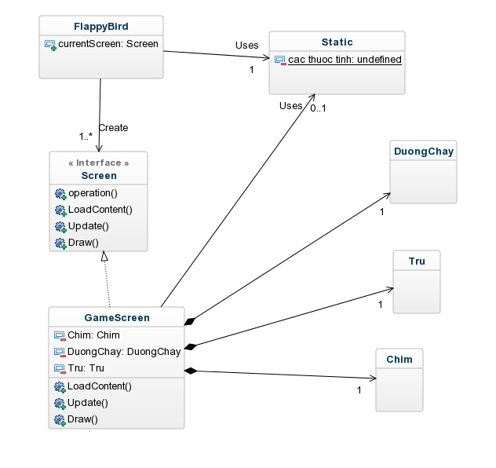](https://www.google.com.au/url?sa=i&rct=j&q=&esrc=s&source=images&cd=&cad=rja&uact=8&ved=0ahUKEwjL7b7_oP_OAhWBPZQKHa3WBlkQjRwIBw&url=https://repository.genmymodel.com/tungnt620/FlappyBird&psig=AFQjCNFJ5smpPoGnFHjKaiJ25qbF79GcMg&ust=1473405008830328)

("Flappy Bird ( Use Case Diagram (UML)) | Creately", 2016)

## USE CASE DIAGRAM:

Player

("Flappy Bird ( Use Case Diagram (UML)) | Creately", 2016)

## Architecture Diagram:

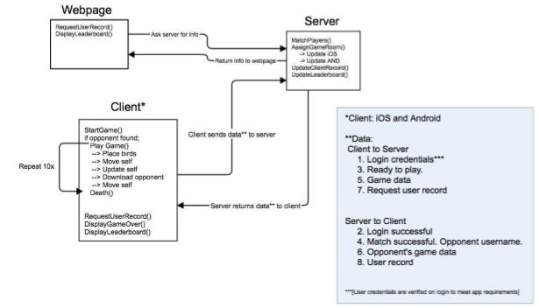

("Flappy Bird ( Use Case Diagram (UML)) | Creately", 2016)

## SEQUENCE DIAGRAM:

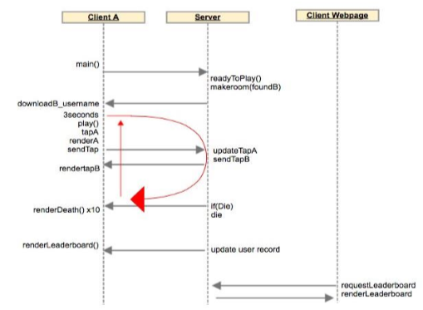

("Flappy Bird ( Use Case Diagram (UML)) | Creately", 2016)

## Deadline Project:

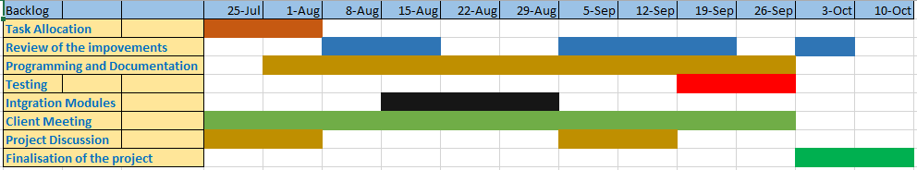

# PERFORMANCE REQUIREMENTS:

Performance of the game is very important to attract the user to play the game more than one time. Therefore, the performance requirements have to mention in all the lifecycle application stages. The most important performance requirements for the game are that:

* Processing Time of loading and playing the game
* Accessibility, Measurable and Scalability

# MODULES:

Modules are generally a different software components or small parts of programs.

Group members are identified the different modules in this particular project. The stages of the development process for the software divided into module and respective testing will be done for each module to improve the efficiency of the application. Once the modules are joined together, integration testing will be done to ensure the efficiency of each joint. Given below are the different modules of this project.

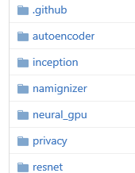

# REUSABLE MODULES:

Reuse modules it can save time due to each phase of the process builds on the previous phase which has already been developed also the cost of development software can be reduced.

Reusable modules can be used repeatedly in the same code. If the functionalities of different parts in code are same. In our project, we are reused modules. ("Definition From Whatis.Com", 2016)

# BUSINESS NEEDS:

The business need is one of the most fundamental aspects of business analysis, the main need of the application is to share the information about particular product among the different section in an organization. In the real world, many technologies are present in the development of different applications. The business needs has to saturate with consumer applications because we’re all consumers in one way or another. By making sure by mapping the specified requirement with the exact working of the application.

By using GitHub for editing the game, it is very easy for the entire development process and makes it easy for the business enterprises for the usage ("The Marketplace Needs More Business Apps", 2016).

# TESTING

The main concept for testing is that planning for various types of testing and make sure you can correct the errors without affecting the overall performance of software.

It is the responsibility of any organization or development team to test the product in different ways before it is made available for the users. Testing of the application helps to reduce the errors also to improve the efficiency of the product. Every area of the application should be tested and corrected before the release. Given below are the different types of tests, which are going to be performed on our application.

* User- Acceptance testing
* Unit testing
* Security testing
* Integration testing
* System testing
* Performance testing
* Functional testing

## UNIT TESTING

Unit testing is a software development process in which test the smallest testable parts of an application by testing unit-by-unit process. Therefore, the main aim of the unit testing is to isolate each part of the program and show that the individual parts are correct.

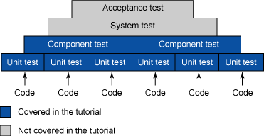

* The unit tests are written in the junit framework.
* The output of each unit test should match 100% to the requirements given
* Each units are dependent to each other
* Fail in any one of the unit means that the application is not working properly.

## SECURITY TESTING

It very important to secure the application because it frequently access form different operating system through website or application so the connection will be from different unspecified security levels of the internet.

The attack can be done many different ways. The after effects of these attacks can be the loss of data, personal information or even the total compromise of the system. To make sure the game is secure so we need to create user name for each user with user name and password. Therefore, it means every user has his own login details.

# IMPROVEMENTS AND MODIFICATIONS:

The current version of the game comes with some specification. There is an option for sharing the information by email also by using text message.

The proposed modifications for the new version of the application are the following.

* To add some backgrounds and change the bird. This will make the application more efficient. More people will be attracted to the application to use it.
* Create a new webpage for the game to be able to play the game and find some different information about the game, it help the user to access the game from anywhere or any device.

**Before After**

**bird.pngbird-1.pngBird:**



**Ground:**

**gameover-4.pnggameover-1.png**

**Game Over:**

## USER INTERFACE:

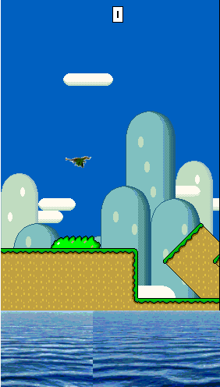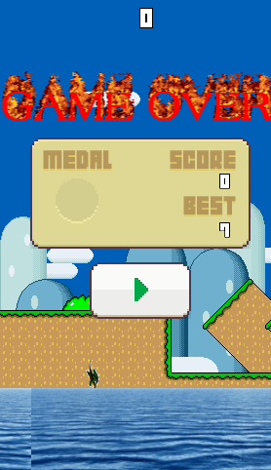

## Website interface:

# References:

1. "Flappy Bird For The Enterprise: The Marketplace Needs More Business Apps". *Salesforce Blog*. N.p., 2016. Web. 10 Sept. 2016 Retrieved from: <https://webcache.googleusercontent.com/search?q=cache:F8ljCNhQhIUJ:https://www.salesforce.com/blog/2014/03/enterprise-app-development-flappy-bird.html+&cd=2&hl=en&ct=clnk&gl=au>
2. "Flappy Bird ( Use Case Diagram (UML)) | Creately". *Creately.com*. N.p., 2016. Web. 10 Sept. 2016. Retrieved from: <http://creately.com/diagram/example/i84opqod2/Flappy%20bird>

1. One, Requirment. "How To Operationalize IEEE Standards". *Google.com.au*. N.p., 2016. Web. 10 Sept. 2016. Retrieved from: <https://www.google.com.au/url?sa=t&rct=j&q=&esrc=s&source=web&cd=1&cad=rja&uact=8&ved=0ahUKEwjgkqCFsoTPAhXCmZQKHZYiD-EQFggdMAA&url=http%3A%2F%2Fwww.requirementone.com%2Fmedia%2F9ff98a46-bbaf-4791-91c4-2c3b9c1383e2%2Fa_9ssg%2Fpdf%2FResource%2FDownloads%2FRequirementONE_IEEE_Whitepaper.pdf&usg=AFQjCNHUGhQelqbZjckVCvXzqUM2_mU1vA&bvm=bv.132479545,d.dG>
2. Whitton, N 2012, ‘The place of game-based learning in an age of austerity’, *Electronic Journal of e-Learning*, Vol. 10, Issue 2, Reviewed on 30 July 2016, available from: <http://www.ejel.org/issue/download.html?idArticle=197>
3. "What Is Reuse-Oriented Model Or Reuse-Oriented Development (ROD) ? - Definition From Whatis.Com". *SearchSoftwareQuality*. N.p., 2016. Web. 10 Sept. 2016 Retrieved from: <http://searchsoftwarequality.techtarget.com/definition/reuse-oriented-model>