WEEK 4 PROJECT PLAN
Comprehensive Data Science Report and Insights Presentation
Final Report and Communication Strategy
Project Type | Final Data Science Report and Presentation Plan
Estimated Time | 32 Hours
Project Theme | Customer Churn Prediction

1. Executive Summary
This report presents a final communication plan for a hypothetical Customer Churn Prediction project. The purpose of the project is to use customer information and behaviour data to identify customers who may be at risk of leaving a subscription service.
The planned analysis would combine data preparation, exploratory analysis and machine learning to understand the main patterns related to churn. For illustration, the expected findings may show that customers with lower activity, shorter tenure, payment problems or frequent support issues have higher churn risk.
The final report will focus on what the results mean for the business rather than presenting technical details alone. The goal is to help decision-makers understand the important findings and decide what actions should be taken next.

2. Project Purpose
- Understand the factors associated with customer churn.
- Summarize the analytical approach in a simple way.
- Present important findings using clear charts and tables.
- Translate technical results into practical business insights.
- Recommend realistic next steps for customer retention.
- Explain limitations and possible future improvements.

3. Methodology Overview
The project would follow a complete Data Science workflow. Customer data would first be collected and checked for quality. Missing values, duplicate records, incorrect values and outliers would be handled carefully.
- Data preparation and quality checking.
- Exploratory Data Analysis to understand distributions and relationships.
- Feature engineering to create useful customer behaviour measures.
- Classification model development for churn prediction.
- Model validation using appropriate evaluation metrics.
- Interpretation of results and identification of useful business patterns.

4. Hypothetical Findings and Insights
Because this is a planning exercise and no real dataset is supplied, the charts and findings in this report are illustrative. They show how the final results could be communicated after real analysis.
- Lower customer activity may be associated with higher churn risk.
- Customers with shorter tenure may require more attention because they have had less time to become loyal to the service.
- Payment problems may be an early warning signal for possible churn.
- Frequent support complaints may indicate dissatisfaction and should be investigated.
- A simple and interpretable model may be preferable if its performance is close to a more complex model.

5. Mock Visualization 1 – Churn by Subscription Plan
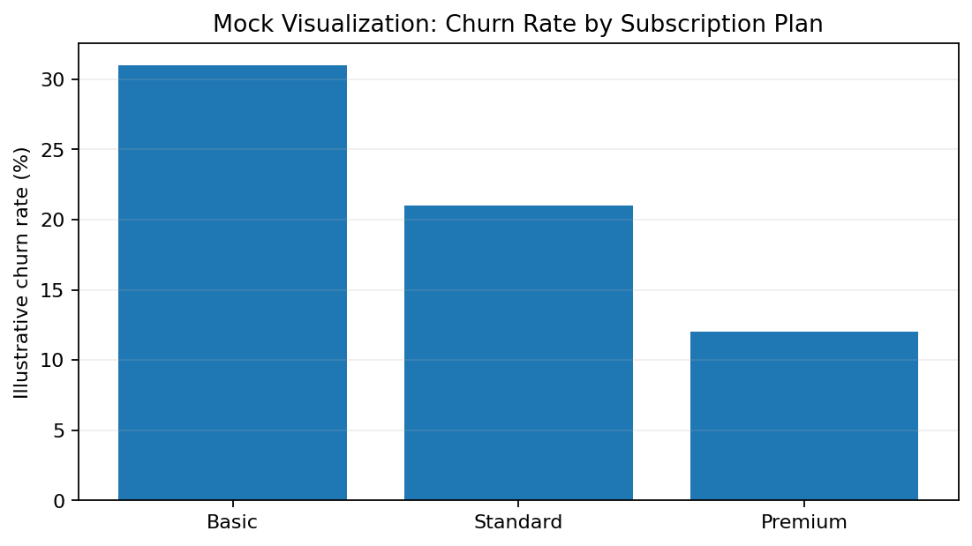
Figure 1: Illustrative chart showing how churn could be compared across plans.
Why this chart? A bar chart makes category comparisons easy for a non-technical audience. If a real dataset showed a higher churn rate for one plan, management could investigate pricing, features, contract terms or customer expectations for that plan.

6. Mock Visualization 2 – Activity and Churn Risk
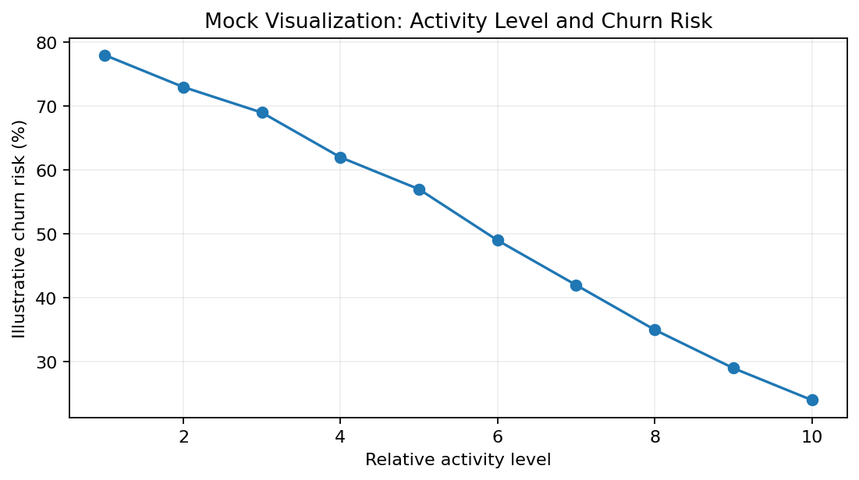
Figure 2: Illustrative relationship between activity level and predicted churn risk.
Why this chart? A line or scatter-style visualization can make a trend easier to understand. If real analysis showed that lower activity was consistently linked with higher risk, the company could consider early engagement messages or support.

7. Other Visualizations Planned
Visualization | What it would show | Reason for using it
Histogram | Distribution of numerical variables | Understand typical values and unusual observations
Box Plot | Spread and outliers | Compare distributions between churn groups
Heatmap | Correlation between numerical variables | Quickly identify relationships
Confusion Matrix | Model prediction errors | Explain correct and incorrect predictions
Feature Importance Chart | Important model features | Show which variables contribute most to predictions
KPI Table | Key business numbers | Give executives a quick summary

8. Turning Analysis into Actionable Insights
An insight is useful only when it can help someone make a better decision. Therefore, each important finding will be connected to a possible business action.
Finding | Possible Meaning | Suggested Action
Low activity and high risk | Customer may be losing interest | Create an early engagement or reminder program
Payment failures | Customer may face billing difficulty | Send timely payment assistance or reminders
High support complaints | Possible dissatisfaction | Review complaint reasons and improve support
High-risk new customers | Early experience may be weak | Improve onboarding and first-month support

9. Presentation Strategy for Non-Technical Audience
The presentation should not start with algorithms or technical formulas. It should start with the business problem and then gradually explain what was found.
- Start with the problem: Why are customers leaving?
- Explain the approach in one simple slide.
- Show only the most important charts.
- Explain each chart in plain language.
- Connect every major finding to a possible action.
- Mention model performance without overwhelming the audience with technical terms.
- Finish with clear recommendations and next steps.

10. Suggested Presentation Story
Slide | Content
Slide 1 | Title and business problem
Slide 2 | Why customer churn matters
Slide 3 | Data and methodology in simple terms
Slide 4 | Main customer behaviour patterns
Slide 5 | Important churn findings
Slide 6 | Model performance and what it means
Slide 7 | Key business insights
Slide 8 | Recommendations
Slide 9 | Limitations and future work
Slide 10 | Final conclusion / discussion

11. Communicating Technical Results Simply
For a non-technical audience, terms such as precision, recall and ROC-AUC should be explained in practical language. For example, instead of saying 'the model has high recall', I would say that 'the model is good at finding customers who are actually at risk of leaving.'
I would also avoid showing too many technical charts. One clear graph with a short explanation is more useful than many graphs with no clear message.

12. Recommendations
- Create an early-warning list of customers with higher predicted churn risk.
- Focus retention efforts on customers showing declining activity.
- Investigate payment-related problems before they lead to cancellation.
- Improve onboarding and support for new customers.
- Review the model regularly as customer behaviour changes.
- Track whether retention actions actually reduce churn instead of assuming that correlation means causation.

13. Future Work
- Collect more recent and representative customer data.
- Test additional machine learning models.
- Use explainability methods to make predictions easier to understand.
- Build a simple dashboard for monitoring churn risk.
- Connect predictions with a controlled retention experiment.
- Monitor model performance and retrain when data patterns change.

14. Limitations
- The project is hypothetical and does not use a real dataset.
- The mock charts contain illustrative values and must not be treated as actual business results.
- A model can identify patterns and risk but cannot guarantee that a customer will churn.
- Business actions should be tested to determine whether they actually improve retention.

15. Week 4 – 32 Hour Timeline
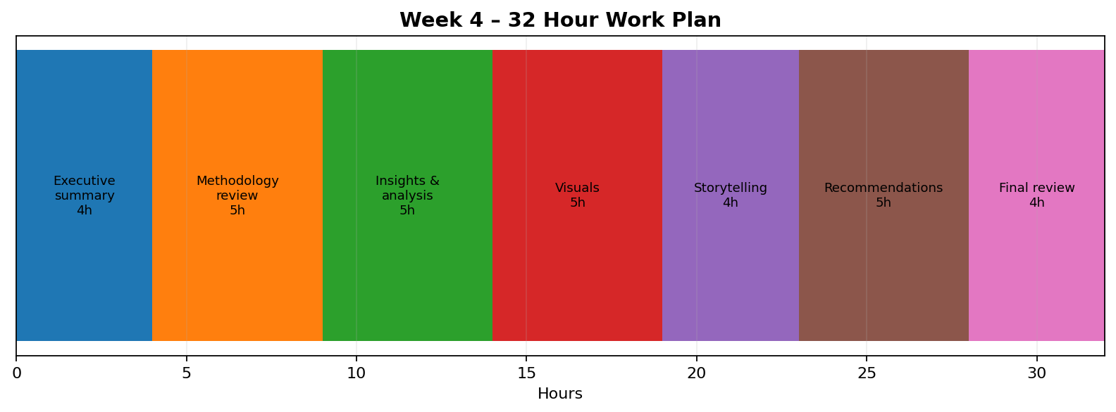
Figure 3: Planned 32-hour work allocation
Activity | Hours | Expected Output
Executive summary | 4 | Final project overview
Methodology review | 5 | Clear explanation of analytical approach
Insights and analysis | 5 | Main findings and interpretation
Visualizations | 5 | Mock charts and tables
Presentation storytelling | 4 | Non-technical communication plan
Recommendations and future work | 5 | Actionable next steps
Final review | 4 | Polished report and presentation plan

16. Evaluation Criteria
- The report should be clear, complete and logically organized.
- Technical work should be translated into understandable business insights.
- Visualizations should directly support the story.
- Recommendations should be connected to findings.
- The presentation should be understandable to a non-technical audience.
- Limitations and future work should be clearly acknowledged.
- The final document should be suitable for an executive-level review.

17. Conclusion
This final report and presentation plan brings the Data Science project together by focusing on communication and decision-making. The main goal is not only to build a model, but also to explain what the analysis means and what should be done next. A clear story, simple visualizations and practical recommendations can help non-technical stakeholders understand the value of Data Science. The planned approach provides a foundation for turning future analytical results into useful business decisions.

