GIT AND GIT HUB

<https://automationstepbystep.com/>

[How to change your git user and email account for per project]

Run the following command:

git config user.name “Saini.ashu90”

git config user.email [Saini.ashu90@gmail.com](mailto:Saini.ashu90@gmail.com)

To verify:

git config –get user.name

git config –get user.email

====================for global config command===========================

git config –global user.email “saini.ashu---@gmail.com”

git config –global user.name “ashusai”

GIT: Git is a version control system [VCS].

* To track changes in files/folders
* To collaborate in teams.
* Free and open source system

GIT != GITHUB

GIT = DVCS

Centralized VCS | Distributed VCS

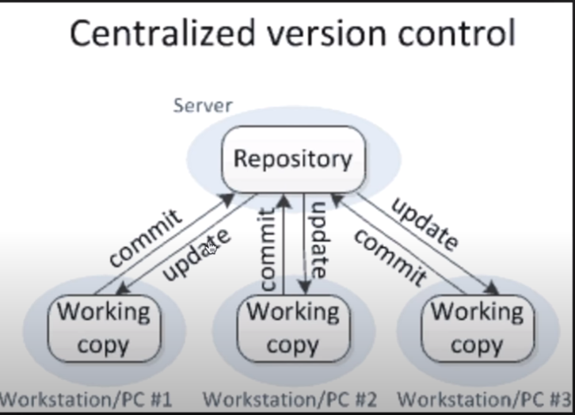

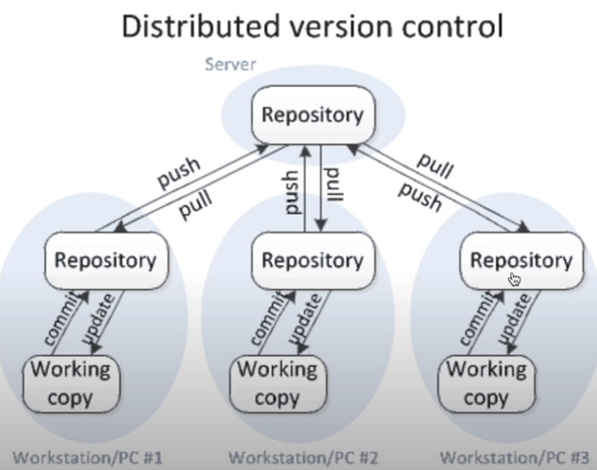

GITHUB: website to upload your repositories online

* Provides a backup
* Provides visual interface to your repo.
* Makes collaboration easier

== T-2 Install Git On Windows =

1. Install Git or verify it is already installed
   1. Go to command line and enter “git –version”

**git version 2.17.0.windows.1**

1. **Download and Installed**

GIT BASH: git bash is a git utility which provide helps to write command and provide autocomplete options

RECOMMENDED OPTION: USE GIT FROM THE WINDOWS COMMAND PROMPT

Click next

Use the default selected option: “Checkout windows-style, commit Unix-style line endingss”

Click next

Select: Use windows default console windows

1. Add your project to git
2. Create folder in your local system: GitHub
3. Open a command prompt and Go to the folder location GitHub “E:\GitHub\”

**GIT COMMAND:**

* git init : is to initiate git repository
* git status: check the status
* git add: add new files/folder in the repository
* git add *.* : it is add all the files related to the wild card
* git add . : it will add everything which is not yet

ADDING TO REMOTE REPOSITORY

1. Go to github website: <https://github.com/>
2. Create a new repository and make it public
3. Copy the new repo. url <https://github.com/sainiashu/git.git>
4. Go to command line and enter the below command

git remote add origin <https://github.com/sainiashu/git.git>

== T-3 BRANCHING AND MERGING=

1. Create a branch
   1. git branch “branch name”
2. checkout new branch
   1. git checkout “branch name”
3. push your changing on origin of your branch
   1. git push -u origin “branch name”
4. Merge new branch in master branch “BEFORE MERGE INTO MASTER BRANCH FIRST YOU NEED TO CHECK OUT MASTER BRANCH ”
   1. git merge “newbranch_1”
   2. git push -u origin master : push your changes into master branch.
5. Delete branch
   1. Git branch -d “branch name” : Delete branch from local system
   2. Git push origin –delete “branch name” : delete branch from remote