**TESTING**

* **Software Testing:**

Here we did the **white box testing**, because what white box testing means is testing done when the testers knows the very internal implementation of what and how things were implemented in the doing section.

Testing is done on each of the features implemented in the model. And following are the outputs:

1. **Work Out:**

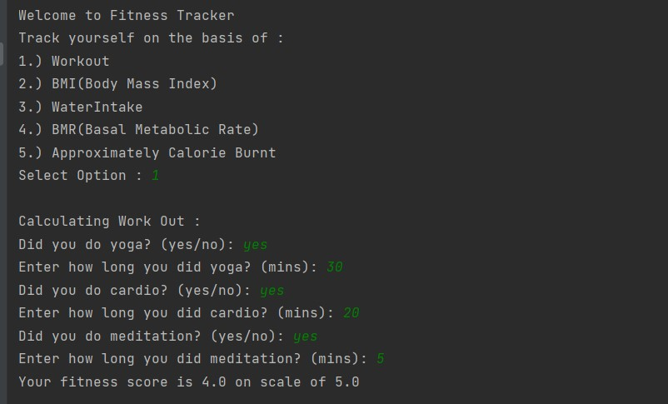

1. **BMI(Body Mass Index):**

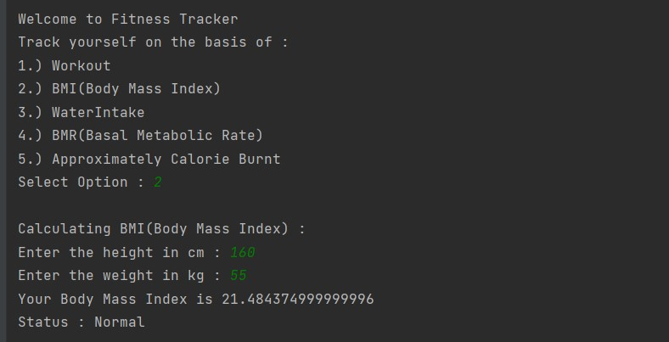

1. **Water Intake:**

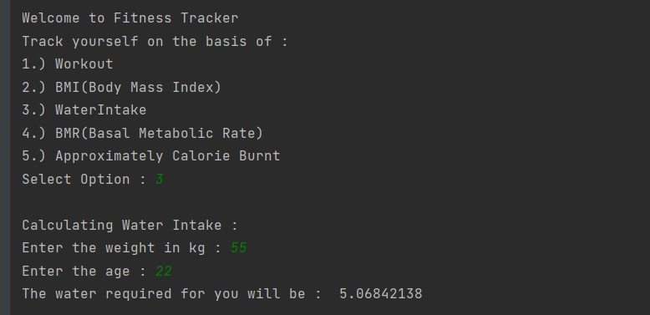

1. **BMR(Basal Metabolic Rate):**

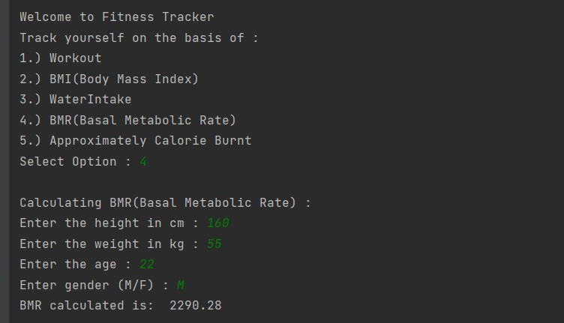

1. **Approximate Calorie Burnt:**

