Exploratory Data Analysis (EDA) & Business Intelligence Report
Internship Task 2 – ApexPlanet Software Pvt. Ltd.
1. Introduction
This report presents an Exploratory Data Analysis (EDA) of the Netflix Movies and TV Shows dataset. The objective of this analysis is to understand the dataset, identify patterns, generate insights, and answer business-related questions using SQL and data visualization techniques.

2. Dataset Overview

Dataset Name: Netflix Movies and TV Shows

Total Records Analyzed: 8,807

Total Columns: 12

Key Attributes:

Show ID
Type
Title
Director
Country
Release Year
Rating
Duration
Genre
Description

3. Descriptive Statistics

Descriptive statistics were calculated for numerical fields.

Key observations:

Mean Release Year: 2014
Earliest Release Year: 1925
Latest Release Year: 2021
Majority of content was released after 2015.

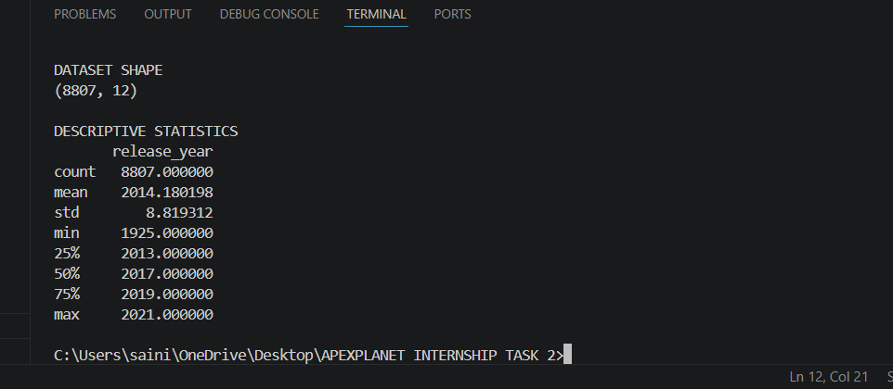

4. Univariate Analysis
Movies vs TV Shows

Analysis revealed:

Movies: 6,131
TV Shows: 2,676

Movies dominate Netflix content.
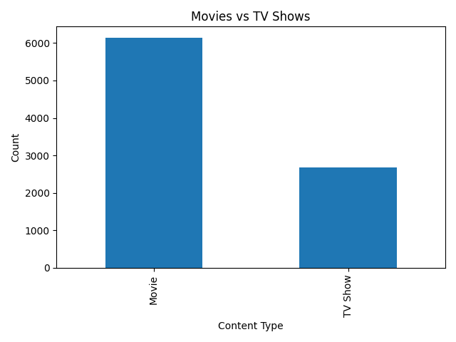

Top Countries

Top content-producing countries include:

United States
India
United Kingdom
Japan
South Korea

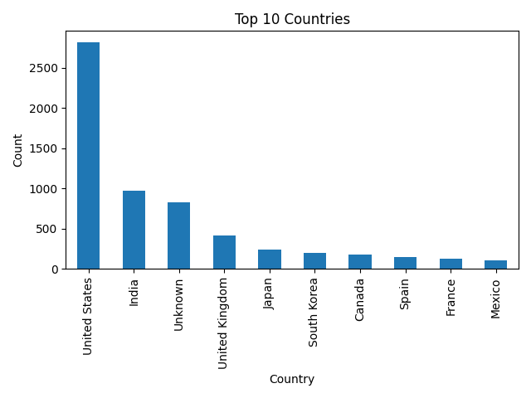

Rating Distribution

Most content falls under:

TV-MA
TV-14
TV-PG
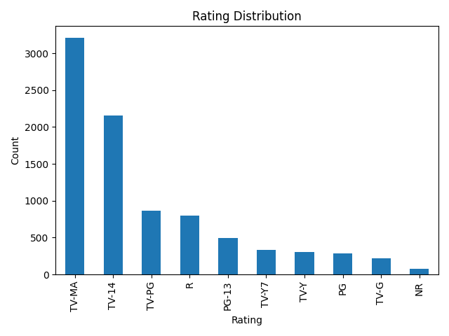

Release Year Distribution

Netflix content production increased significantly after 2015.
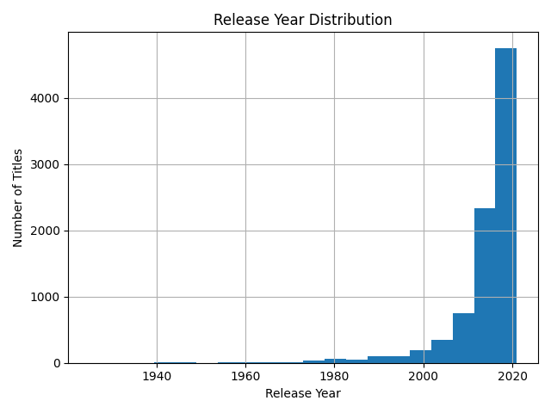

5. SQL Business Questions

Question 1

Which countries contribute the most Netflix content?

Result:
United States ranked highest.

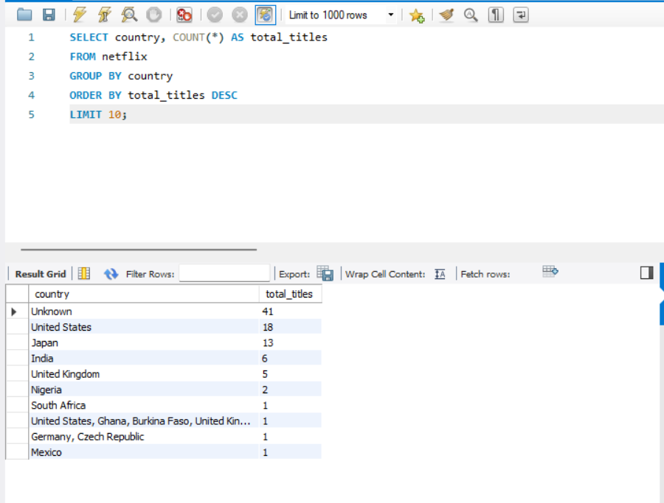

Question 2

How many Movies and TV Shows exist?

Result:
Movies significantly outnumber TV Shows.
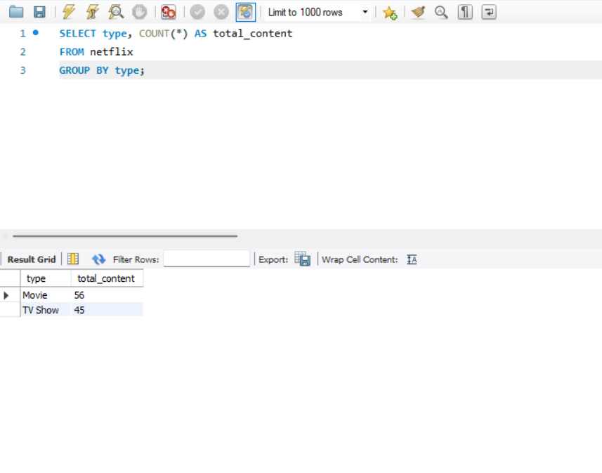

Question 3

What ratings are most common?

Result:
TV-MA is the most common rating.
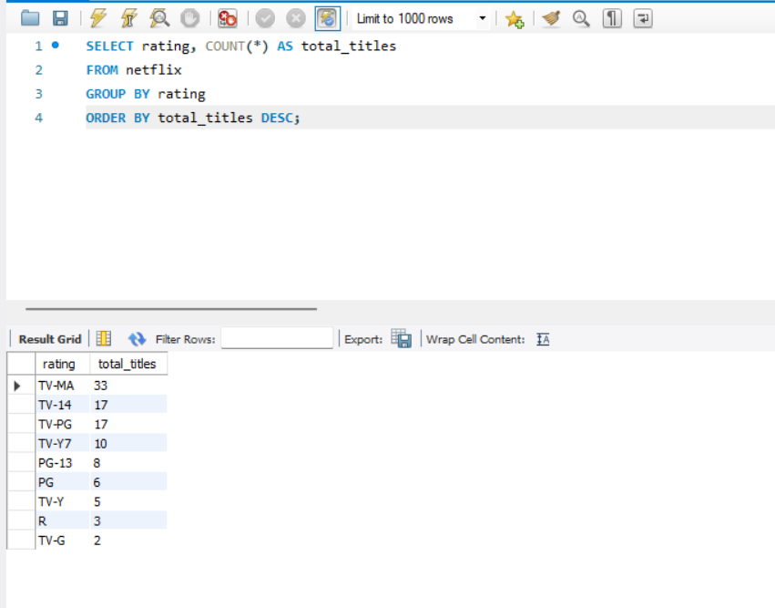

Question 4

Which years have the highest content releases?
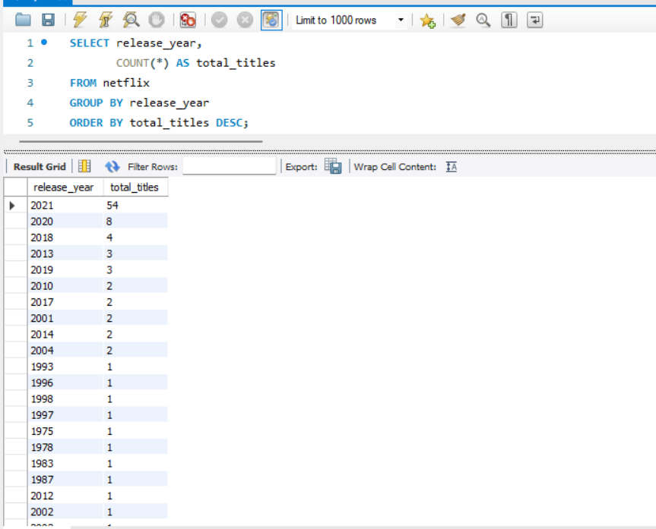

Question 5

Who are the top directors by number of titles?

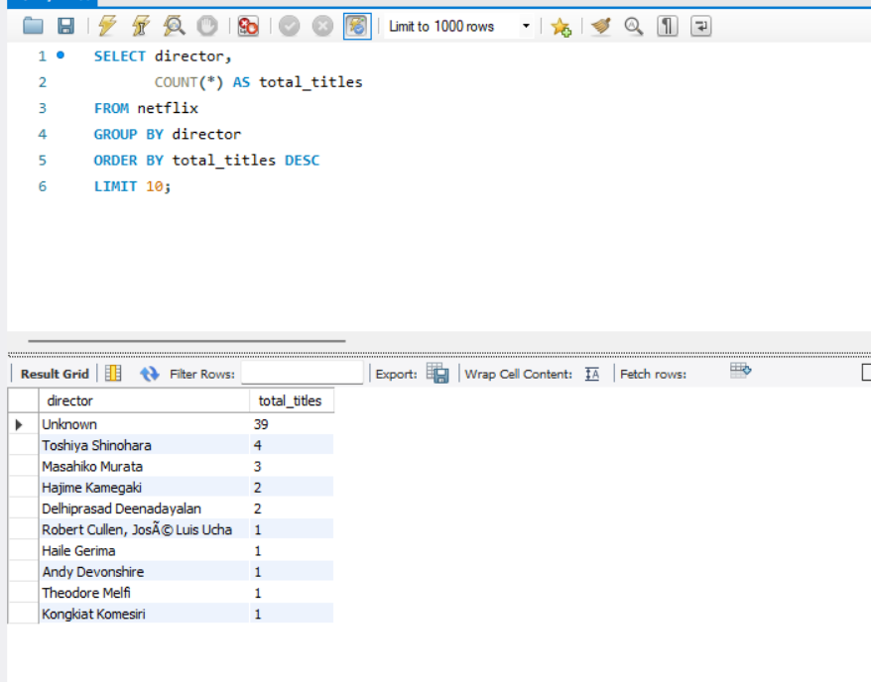

Question 6

Which countries produce the most Movies?

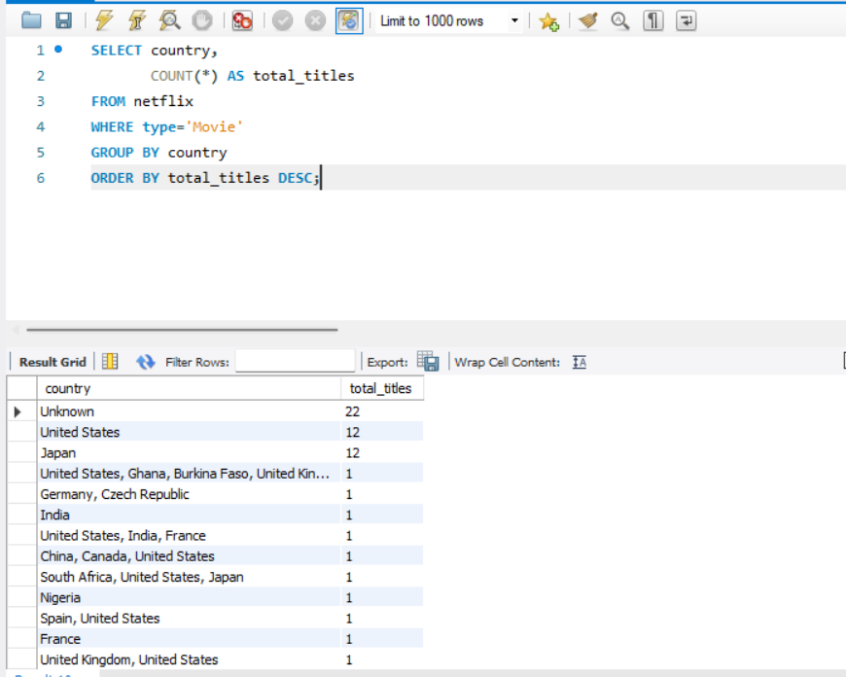

Question 7

What ratings are most common among TV Shows?
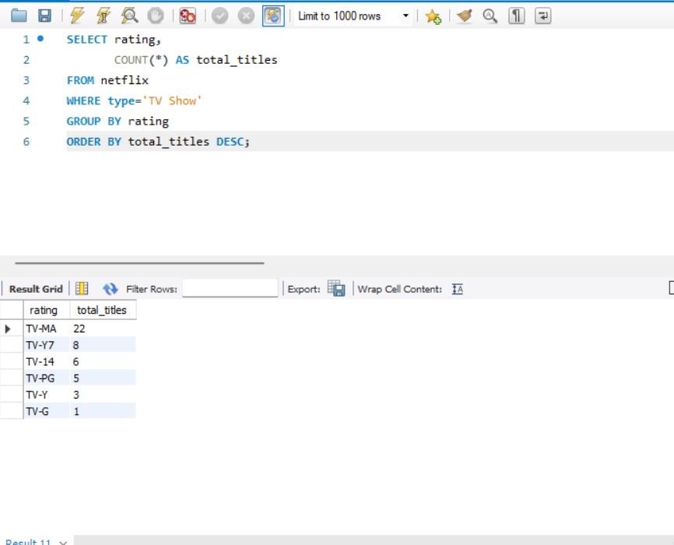

6. Key Insights

Movies dominate Netflix content.
The United States contributes the highest number of titles.
TV-MA is the most common content rating.
Content production increased significantly after 2015.
Netflix has a diverse international catalog.

7. Conclusion

The Netflix dataset provides valuable insights into content trends, production patterns, and audience-targeted ratings. Through EDA, visualization, and SQL-based analysis, important business insights were identified that can support decision-making and strategic planning.

