**Week5-HandsOn**

**CREATING MICROSERVICES FOR ACCOUNT AND LOAN**

In this hands on exercises, we will create two microservices for a bank. One microservice for handing accounts and one for handling loans. Each microservice will be a specific independent Spring RESTful Webservice maven project having it's own pom.xml. The only difference is that, instead of having both account and loan as a single application, it is split into two different applications. These webservices will be a simple service without any backend connectivity. Follow steps below to implement the two microservices: Account Microservice.

* Create folder with employee id in D: drive
* Create folder named 'microservices' in the new folder created in previous step. This folder will contain all the sample projects that we will create for learning microservices.
* Open https://start.spring.io/ in browser
* Enter form field values as specified below: o Group: com.cognizant o Artifact: account
* Select the following modules o Developer Tools > Spring Boot DevTools o Web > Spring Web
* Click generate and download the zip file
* Extract 'account' folder from the zip and place this folder in the 'microservices' folder created earlier
* Open command prompt in account folder and build using mvn clean package command
* Import this project in Eclipse and implement a controller method for getting account details based on account number. Refer specification below: o Method: GET o Endpoint: /accounts/{number} o Sample Response. Just a dummy response without any backend connectivity.
* { number: "00987987973432", type: "savings", balance: 234343 }
* Launch by running the application class and test the service in browser Loan Microservice

**Pom.xml :**

<project xmlns="http://maven.apache.org/POM/4.0.0"

xmlns:xsi="http://www.w3.org/2001/XMLSchema-instance"

xsi:schemaLocation="http://maven.apache.org/POM/4.0.0

http://maven.apache.org/xsd/maven-4.0.0.xsd">

<modelVersion>4.0.0</modelVersion>

<groupId>com.cognizant</groupId>

<artifactId>loan</artifactId>

<version>0.0.1-SNAPSHOT</version>

<packaging>jar</packaging>

<name>loan</name>

<description>Loan Microservice</description>

<parent>

<groupId>org.springframework.boot</groupId>

<artifactId>spring-boot-starter-parent</artifactId>

<version>3.1.0</version>

<relativePath/>

</parent>

<properties>

<java.version>21</java.version>

</properties>

<dependencies>

<dependency>

<groupId>org.springframework.boot</groupId>

<artifactId>spring-boot-starter-web</artifactId>

</dependency>

<dependency>

<groupId>org.springframework.boot</groupId>

<artifactId>spring-boot-devtools</artifactId>

<scope>runtime</scope>

<optional>true</optional>

</dependency>

<dependency>

<groupId>org.springframework.boot</groupId>

<artifactId>spring-boot-starter-test</artifactId>

<scope>test</scope>

</dependency>

</dependencies>

<build>

<plugins>

<plugin>

<groupId>org.springframework.boot</groupId>

<artifactId>spring-boot-maven-plugin</artifactId>

</plugin>

</plugins>

</build>

</project>

**application.properties**

spring.application.name=loan

server.port=8081

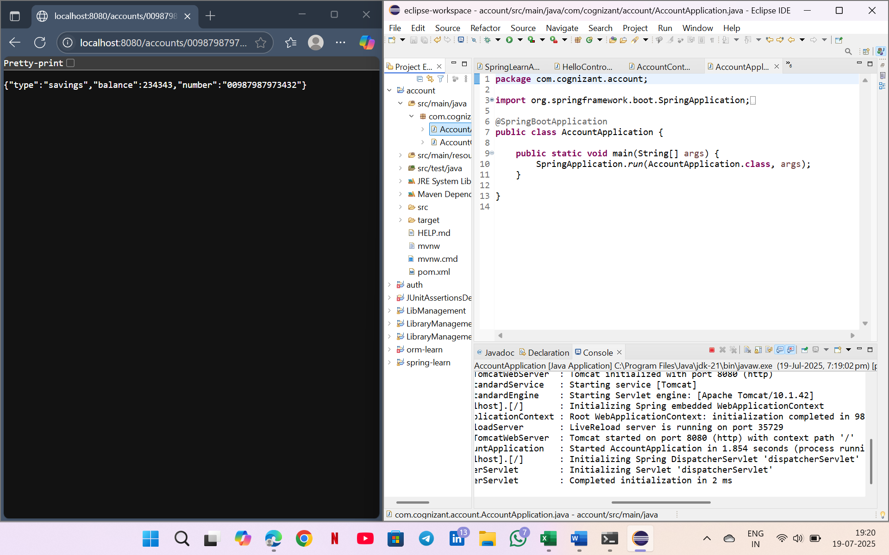

**LoanApplication.java**

package com.cognizant.loan;

import org.springframework.boot.SpringApplication;

import org.springframework.boot.autoconfigure.SpringBootApplication;

@SpringBootApplication

public class LoanApplication {

public static void main(String[] args) {

SpringApplication.run(LoanApplication.class, args);

}

}

**LoanController.java**

package com.cognizant.loan;

import org.springframework.web.bind.annotation.GetMapping;

import org.springframework.web.bind.annotation.RestController;

@RestController

public class LoanController {

@GetMapping("/loan")

public String getLoanInfo() {

return "Loan service is running";

}

}

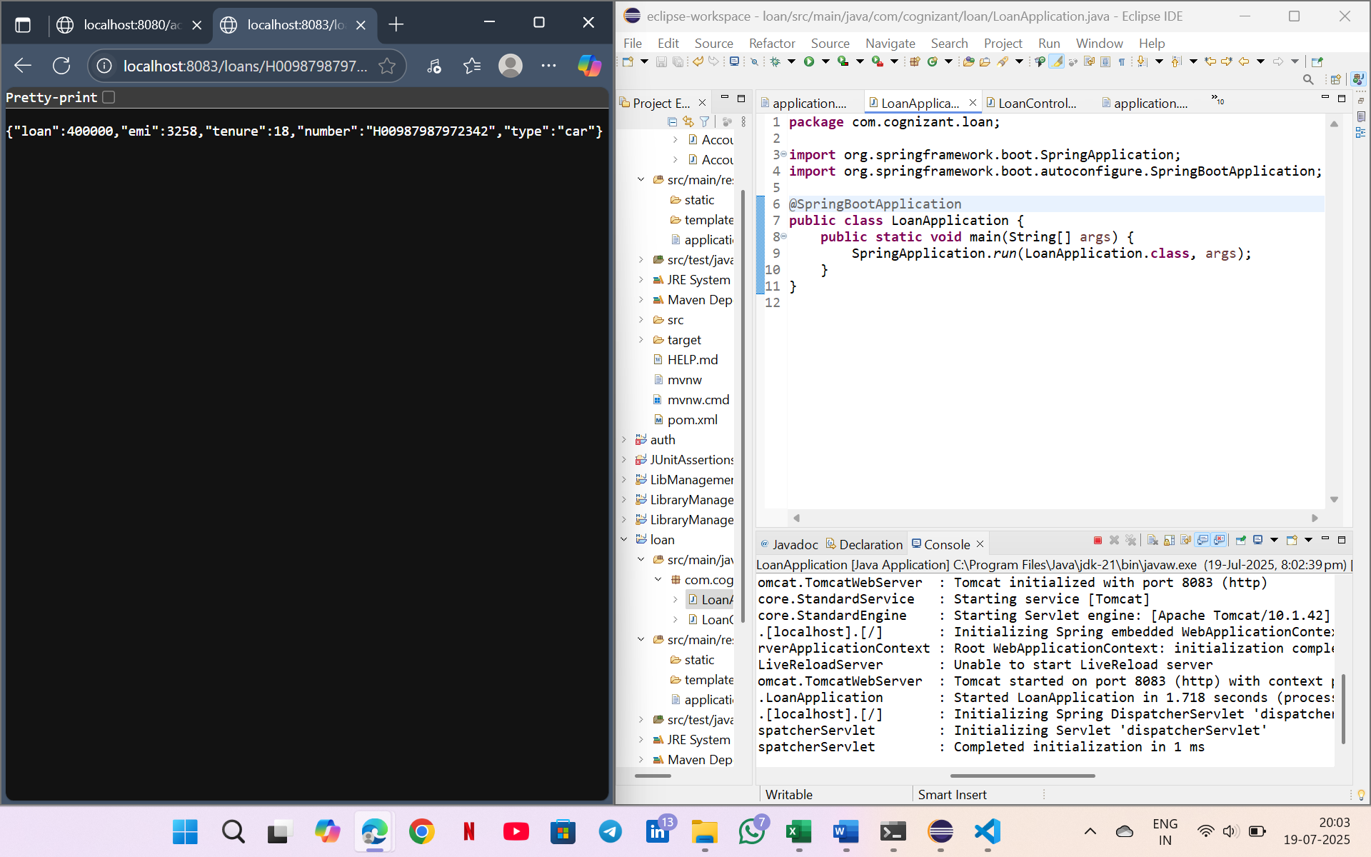

V Sai Nikhitha

[nikhithavalmiki66@gmail.com](mailto:nikhithavalmiki66@gmail.com)

superset ID: 6389288