**JUnit Testing Exercises**

**Exercise 1: Setting Up Junit**

**Code:**

import org.junit.Test;

import static org.junit.Assert.*;

public class HelloWorldTest {

public void testMessage() {

String message = "Hello, JUnit!";

assertEquals("Hello, JUnit!", message);

}

}

**Output:**

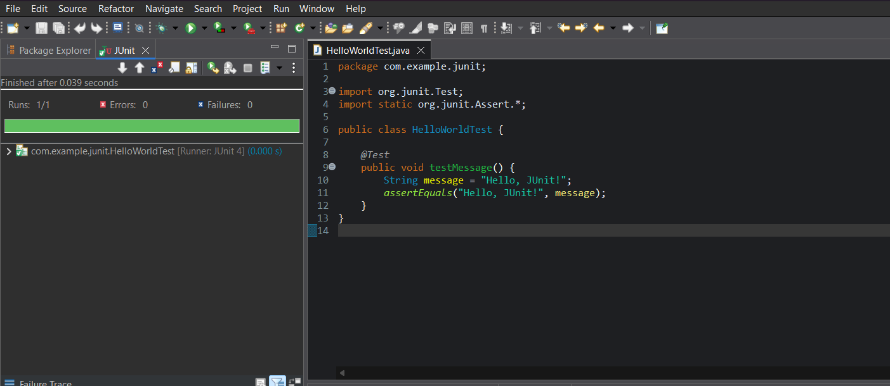

**Exercise 3: Assertions in Junit**

**Code:**

import static org.junit.jupiter.api.Assertions.*;

import org.junit.jupiter.api.Test;

public class AssertionsTest {

public void testAssertions() {

assertEquals(5, 2 + 3);

assertTrue(5 > 3);

assertFalse(5 < 3);

assertNull(null);

assertNotNull(new Object());

}

}

**Output:**

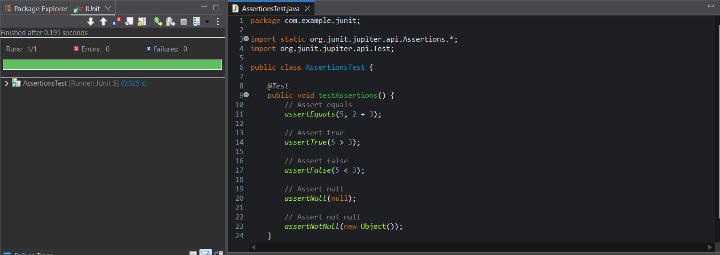

**Exercise 4: Arrange-Act-Assert (AAA) Pattern, Test Fixtures, Setup and Teardown Methods in Junit**

**Code:**

import org.junit.Before;

import org.junit.After;

import org.junit.Test;

import static org.junit.Assert.*;

public class CalculatorTest {

private Calculator calculator;

public void setUp() {

calculator = new Calculator();

System.out.println("Setup: Calculator instance created");

}

public void tearDown() {

calculator = null;

System.out.println("Teardown: Calculator instance cleared");

}

public void testAddition() {

int a = 5;

int b = 3;

int result = calculator.add(a, b);

assertEquals(8, result);

}

public void testSubtraction() {

int a = 10;

int b = 4;

int result = calculator.subtract(a, b);

assertEquals(6, result);

}

}

class Calculator {

public int add(int a, int b) {

return a + b;

}

public int subtract(int a, int b) {

return a - b;

}

**} Output:**

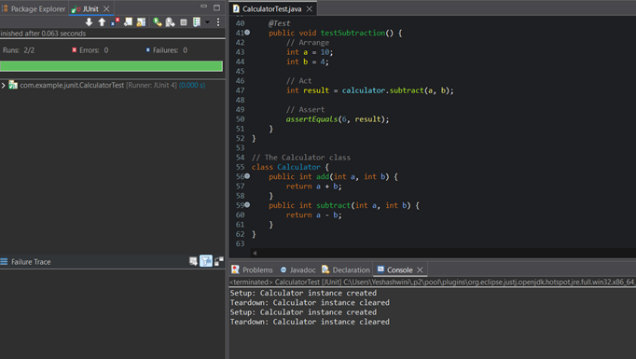

**Mockito Hands-On Exercises**

**Exercise 1: Mocking and Stubbing**

**pom.xml:**

<project xmlns="http://maven.apache.org/POM/4.0.0"

xmlns:xsi="http://www.w3.org/2001/XMLSchema-instance"

xsi:schemaLocation="http://maven.apache.org/POM/4.0.0

http://maven.apache.org/xsd/maven-4.0.0.xsd">

<modelVersion>4.0.0</modelVersion>

<groupId>com.example</groupId>

<artifactId>mockito-demo</artifactId>

<version>1.0-SNAPSHOT</version>

<packaging>jar</packaging>

<properties>

<maven.compiler.source>1.8</maven.compiler.source>

<maven.compiler.target>1.8</maven.compiler.target>

<junit.version>5.10.0</junit.version>

<mockito.version>5.11.0</mockito.version>

</properties>

<dependencies>

<!-- JUnit 5 -->

<dependency>

<groupId>org.junit.jupiter</groupId>

<artifactId>junit-jupiter-api</artifactId>

<version>${junit.version}</version>

<scope>test</scope>

</dependency>

<dependency>

<groupId>org.junit.jupiter</groupId>

<artifactId>junit-jupiter-engine</artifactId>

<version>${junit.version}</version>

<scope>test</scope>

</dependency>

<!-- Mockito -->

<dependency>

<groupId>org.mockito</groupId>

<artifactId>mockito-core</artifactId>

<version>${mockito.version}</version>

<scope>test</scope>

</dependency>

</dependencies>

<build>

<plugins>

<!-- Required to run JUnit 5 tests -->

<plugin>

<groupId>org.apache.maven.plugins</groupId>

<artifactId>maven-surefire-plugin</artifactId>

<version>2.22.2</version>

<configuration>

<includes>

<include>**/*Test.java</include>

</includes>

</configuration>

</plugin>

</plugins>

</build>

</project>

**Code:**

**1.ExternalApi class:**

public interface ExternalApi {

String getData();

}

**2. MyService class:**

public class MyService {

private ExternalApi externalApi;

public MyService(ExternalApi externalApi) {

this.externalApi = externalApi;

}

public String fetchData() {

return externalApi.getData();

}

}

**3. MyServiceTest class:**

import static org.mockito.Mockito.*;

import static org.junit.jupiter.api.Assertions.*;

import org.junit.jupiter.api.Test;

import org.mockito.Mockito;

public class MyServiceTest {

public void testExternalApi() {

ExternalApi mockApi = Mockito.mock(ExternalApi.class);

when(mockApi.getData()).thenReturn("Mock Data");

MyService service = new MyService(mockApi);

String result = service.fetchData();

assertEquals("Mock Data", result);

}

}

**Output:**

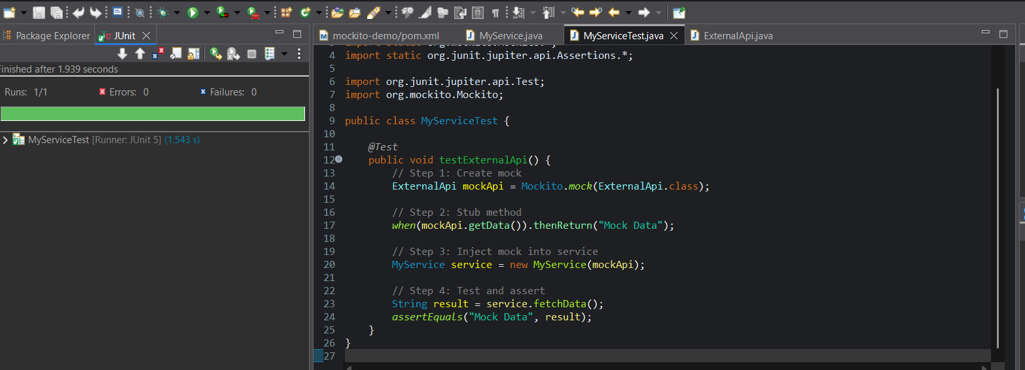

**Exercise 2: Verifying Interactions**

**Pom.xml:**

<project xmlns="http://maven.apache.org/POM/4.0.0"

xmlns:xsi="http://www.w3.org/2001/XMLSchema-instance"

xsi:schemaLocation="http://maven.apache.org/POM/4.0.0

http://maven.apache.org/xsd/maven-4.0.0.xsd">

<modelVersion>4.0.0</modelVersion>

<groupId>com.example</groupId>

<artifactId>mockito-demo</artifactId>

<version>0.0.1-SNAPSHOT</version>

<packaging>jar</packaging>

<properties>

<maven.compiler.source>1.8</maven.compiler.source>

<maven.compiler.target>1.8</maven.compiler.target>

<junit.version>5.10.0</junit.version>

<mockito.version>5.11.0</mockito.version>

</properties>

<dependencies>

<!-- JUnit 5 -->

<dependency>

<groupId>org.junit.jupiter</groupId>

<artifactId>junit-jupiter-api</artifactId>

<version>${junit.version}</version>

<scope>test</scope>

</dependency>

<dependency>

<groupId>org.junit.jupiter</groupId>

<artifactId>junit-jupiter-engine</artifactId>

<version>${junit.version}</version>

<scope>test</scope>

</dependency>

<!-- Mockito -->

<dependency>

<groupId>org.mockito</groupId>

<artifactId>mockito-core</artifactId>

<version>${mockito.version}</version>

<scope>test</scope>

</dependency>

</dependencies>

<build>

<plugins>

<plugin>

<groupId>org.apache.maven.plugins</groupId>

<artifactId>maven-surefire-plugin</artifactId>

<version>2.22.2</version>

<configuration>

<includes>

<include>**/*Test.java</include>

</includes>

</configuration>

</plugin>

</plugins>

</build>

</project>

\

**Code:**

**1.ExternalApi class:**

package com.example;

public interface ExternalApi {

String getData();

}

**2. MyService class:**

package com.example;

public class MyService {

private ExternalApi externalApi;

public MyService(ExternalApi externalApi) {

this.externalApi = externalApi;

}

public String fetchData() {

return externalApi.getData();

}

}

**3. MyServiceTest class:**

package com.example;

import static org.mockito.Mockito.*;

import org.junit.jupiter.api.Test;

import org.mockito.Mockito;

public class MyServiceTest {

public void testVerifyInteraction() {

ExternalApi mockApi = Mockito.mock(ExternalApi.class);

MyService service = new MyService(mockApi);

service.fetchData();

verify(mockApi).getData();

}

}

**Output:**

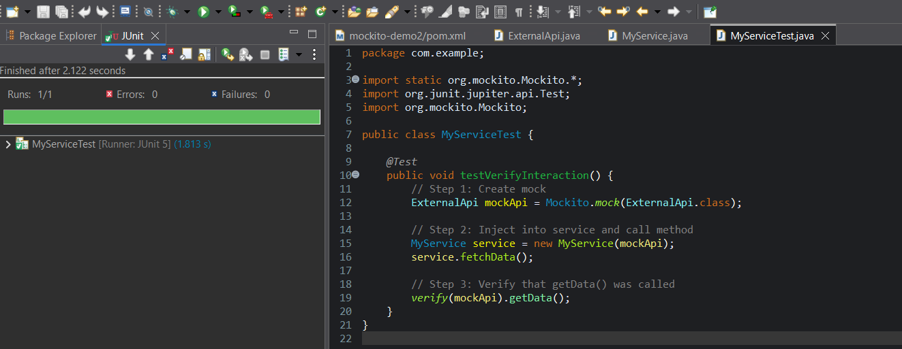

**Logging using SLF4J**

**Exercise 1: Logging Error Messages and Warning Levels**

**Code:**

import org.slf4j.Logger;  
import org.slf4j.LoggerFactory;  
  
public class LoggingExample {  
 private static final Logger *logger* = LoggerFactory.*getLogger*(LoggingExample.class);  
 public static void main(String[] args) {  
 *logger*.error("This is an error message");  
 *logger*.warn("This is a warning message");  
 *logger*.info("This is an info message");  
 *logger*.debug("This is a debug message");  
 }  
}

**pom.xml :**

<?xml version="1.0" encoding="UTF-8"?>  
<project xmlns="http://maven.apache.org/POM/4.0.0"  
 xmlns:xsi="http://www.w3.org/2001/XMLSchema-instance"  
 xsi:schemaLocation="http://maven.apache.org/POM/4.0.0 http://maven.apache.org/xsd/maven-4.0.0.xsd">  
 <modelVersion>4.0.0</modelVersion>  
  
 <groupId>org.example</groupId>  
 <artifactId>LoggingDemo</artifactId>  
 <version>1.0-SNAPSHOT</version>  
 <properties>  
 <maven.compiler.source>24</maven.compiler.source>  
 <maven.compiler.target>24</maven.compiler.target>  
 <project.build.sourceEncoding>UTF-8</project.build.sourceEncoding>  
 </properties>  
 <dependencyManagement>  
 <dependencies>  
 <dependency>  
 <groupId>ch.qos.logback</groupId>  
 <artifactId>logback-core</artifactId>  
 <version>1.4.14</version>  
 </dependency>  
 </dependencies>  
 </dependencyManagement>  
  
 <dependencies>  
 <dependency>  
 <groupId>org.slf4j</groupId>  
 <artifactId>slf4j-api</artifactId>  
 <version>2.0.13</version>  
 </dependency>  
 <dependency>  
 <groupId>ch.qos.logback</groupId>  
 <artifactId>logback-classic</artifactId>  
 <version>1.4.14</version>  
 </dependency>  
 </dependencies>  
</project>

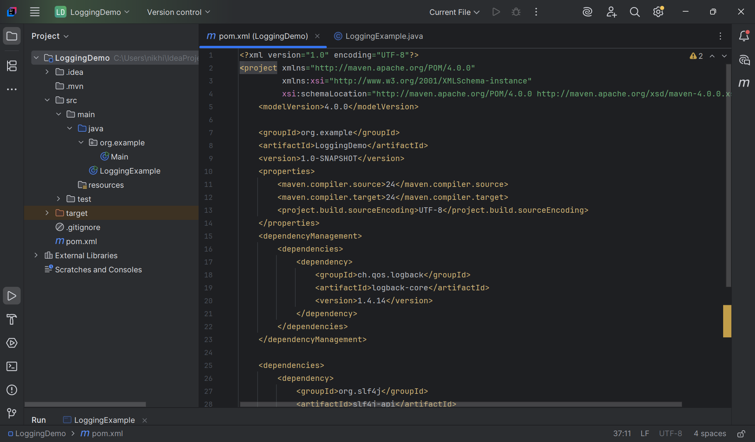

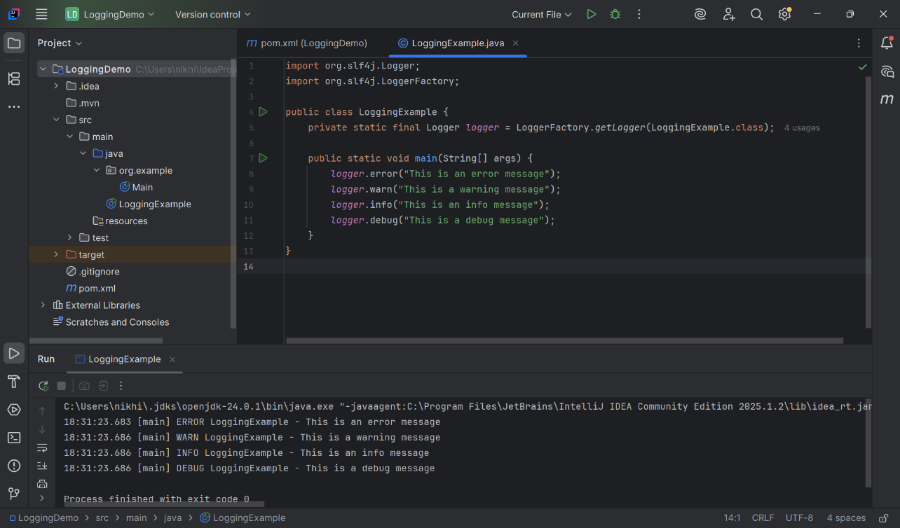

V Sai Nikhitha

nikhithavalmiki6@gmail.com