**Week 2 : PL/SQL Practical Exercises**

**Exercise 1: Exploring Control Structures**

**Creating Tables and Populating Sample Data**

BEGIN  
EXECUTE IMMEDIATE 'DROP TABLE loans';  
EXECUTE IMMEDIATE 'DROP TABLE customers';  
EXCEPTION  
WHEN OTHERS THEN NULL;  
END;  
/

CREATE TABLE customers (  
customer_id NUMBER PRIMARY KEY,  
customer_name VARCHAR2(100),  
age NUMBER,  
balance NUMBER(10,2),  
is_vip VARCHAR2(5) DEFAULT 'FALSE'  
);

CREATE TABLE loans (  
loan_id NUMBER PRIMARY KEY,  
customer_id NUMBER,  
loan_amount NUMBER(10,2),  
interest_rate NUMBER(5,2),  
due_date DATE,  
FOREIGN KEY (customer_id) REFERENCES customers(customer_id)  
);

INSERT INTO customers VALUES (1, 'John Smith', 65, 15000.00, 'FALSE');  
INSERT INTO customers VALUES (2, 'Mary Johnson', 45, 8500.00, 'FALSE');  
INSERT INTO customers VALUES (3, 'Robert Brown', 72, 25000.00, 'FALSE');  
INSERT INTO customers VALUES (4, 'Sarah Davis', 55, 12000.00, 'FALSE');  
INSERT INTO customers VALUES (5, 'Michael Wilson', 68, 7500.00, 'FALSE');

INSERT INTO loans VALUES (1, 1, 50000.00, 5.5, DATE '2025-07-15');  
INSERT INTO loans VALUES (2, 2, 30000.00, 6.0, DATE '2025-07-20');  
INSERT INTO loans VALUES (3, 3, 75000.00, 5.0, DATE '2025-08-10');  
INSERT INTO loans VALUES (4, 4, 40000.00, 5.8, DATE '2025-07-25');  
INSERT INTO loans VALUES (5, 5, 20000.00, 6.2, DATE '2025-07-05');

COMMIT;

**Case 1: Applying Interest Rate Reduction**

BEGIN  
DBMS_OUTPUT.PUT_LINE('Adjusting Interest Rates for Senior Customers');  
FOR rec IN (  
SELECT c.customer_id, c.customer_name, c.age, l.loan_id, l.interest_rate  
FROM customers c  
JOIN loans l ON c.customer_id = l.customer_id  
WHERE c.age > 60  
) LOOP  
UPDATE loans  
SET interest_rate = interest_rate - 1  
WHERE loan_id = rec.loan_id;

END;  
/

**Case 2: Marking Customers as VIP**

BEGIN  
DBMS_OUTPUT.PUT_LINE(CHR(10) || 'Upgrading Customers to VIP (Balance > 10K) ');  
FOR rec IN (SELECT customer_id, customer_name, balance FROM customers WHERE balance > 10000) LOOP  
UPDATE customers SET is_vip = 'TRUE' WHERE customer_id = rec.customer_id;  
DBMS_OUTPUT.PUT_LINE('Customer: ' || rec.customer_name ||  
' promoted to VIP (Balance: $' || TO_CHAR(rec.balance, '999,999.00') || ')');  
END LOOP;  
COMMIT;  
END;  
/

**Case 3: Generating Due Payment Alerts**

BEGIN  
DBMS_OUTPUT.PUT_LINE(CHR(10) || 'Loan Due Alerts (Next 30 Days) ');  
DBMS_OUTPUT.PUT_LINE('Current Date: ' || TO_CHAR(SYSDATE, 'DD-MON-YYYY'));

END;  
/

**OUTPUT :**

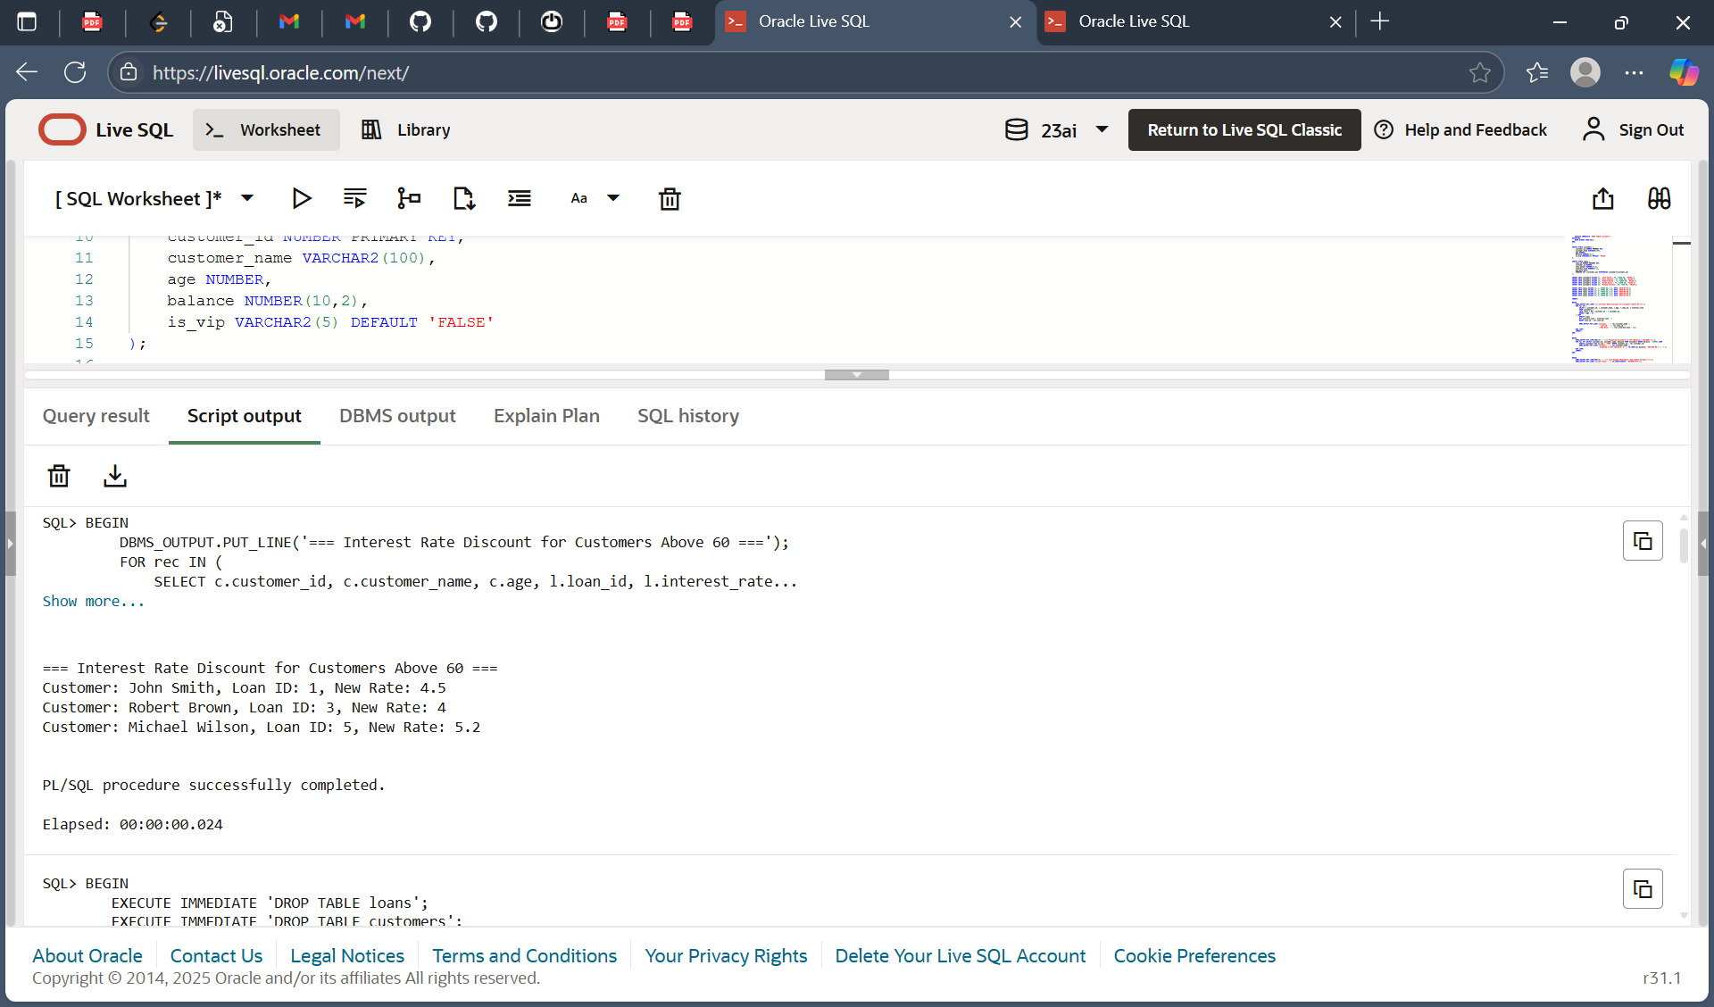

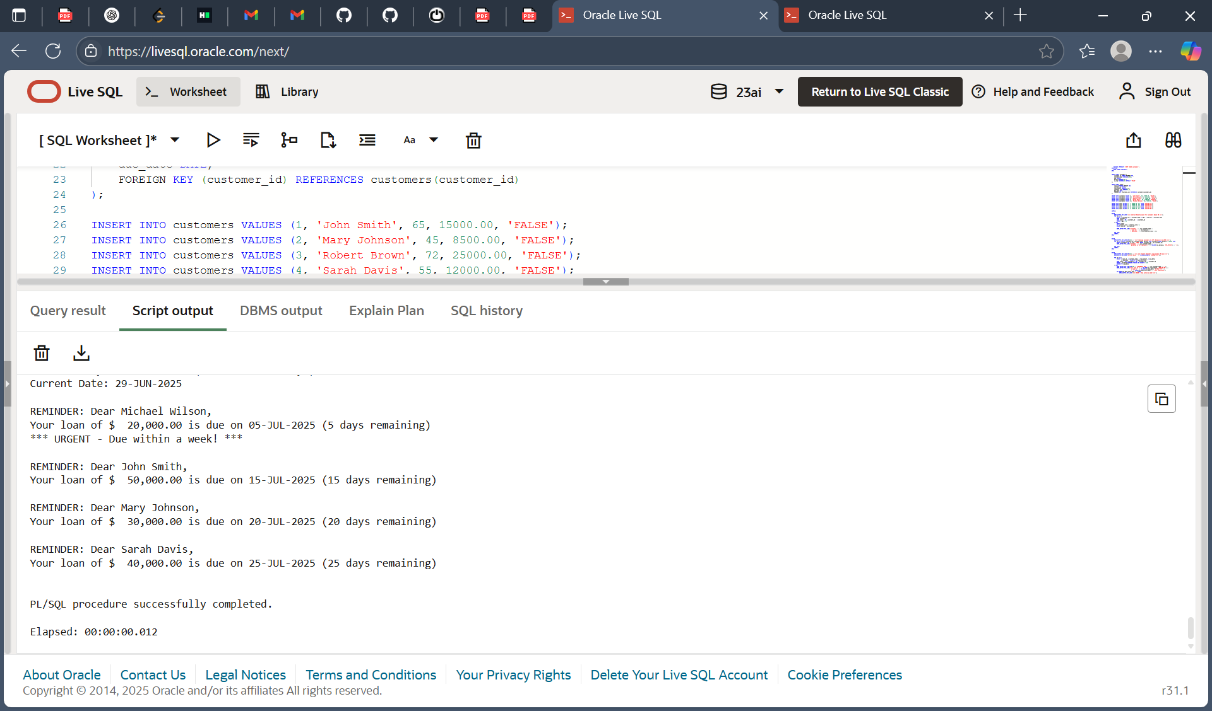

**Exercise 2: Stored Procedure Demonstration**

**Creating Tables and Inserting Data**

CREATE TABLE accounts (  
account_id NUMBER PRIMARY KEY,  
customer_name VARCHAR2(100),  
account_type VARCHAR2(20),  
balance NUMBER(10,2)  
);

CREATE TABLE employees (  
emp_id NUMBER PRIMARY KEY,  
emp_name VARCHAR2(100),  
department VARCHAR2(50),  
salary NUMBER(10,2)  
);

INSERT INTO accounts VALUES (1, 'John Smith', 'Savings', 10000);  
INSERT INTO accounts VALUES (2, 'Mary Johnson', 'Savings', 12000);  
INSERT INTO accounts VALUES (3, 'Robert Brown', 'Current', 8000);  
INSERT INTO accounts VALUES (4, 'Sarah Davis', 'Savings', 15000);

INSERT INTO employees VALUES (101, 'Alice', 'Sales', 50000);  
INSERT INTO employees VALUES (102, 'Bob', 'Sales', 55000);  
INSERT INTO employees VALUES (103, 'Charlie', 'HR', 48000);

COMMIT;

**PL/SQL Programs for Specific Tasks**

**Monthly Interest Addition Procedure**

CREATE OR REPLACE PROCEDURE ProcessMonthlyInterest AS  
BEGIN  
DBMS_OUTPUT.PUT_LINE('Processing Monthly Interest for Savings Accounts ');  
FOR acc IN (SELECT account_id, balance FROM accounts WHERE account_type = 'Savings') LOOP  
UPDATE accounts  
SET balance = balance + (balance * 0.01)  
WHERE account_id = acc.account_id;

END;  
/

**Employee Bonus Calculation Procedure**

CREATE OR REPLACE PROCEDURE UpdateEmployeeBonus (  
dept_name IN VARCHAR2,  
bonus_percent IN NUMBER  
) AS  
BEGIN  
DBMS_OUTPUT.PUT_LINE('Applying Department-Wise Bonus ');  
FOR emp IN (SELECT emp_id FROM employees WHERE department = dept_name) LOOP  
UPDATE employees  
SET salary = salary + (salary * bonus_percent / 100)  
WHERE emp_id = emp.emp_id;

END;  
/

**Procedure to Transfer Funds**

CREATE OR REPLACE PROCEDURE TransferFunds (  
from_acc_id IN NUMBER,  
to_acc_id IN NUMBER,  
amount IN NUMBER  
) AS  
from_balance NUMBER;  
BEGIN  
SELECT balance INTO from_balance FROM accounts WHERE account_id = from_acc_id;

END;  
/

**Executing All Procedures Together**

BEGIN  
DBMS_OUTPUT.PUT_LINE('INITIATING ALL PROCEDURE TESTS ');

END;  
/

**Output :**

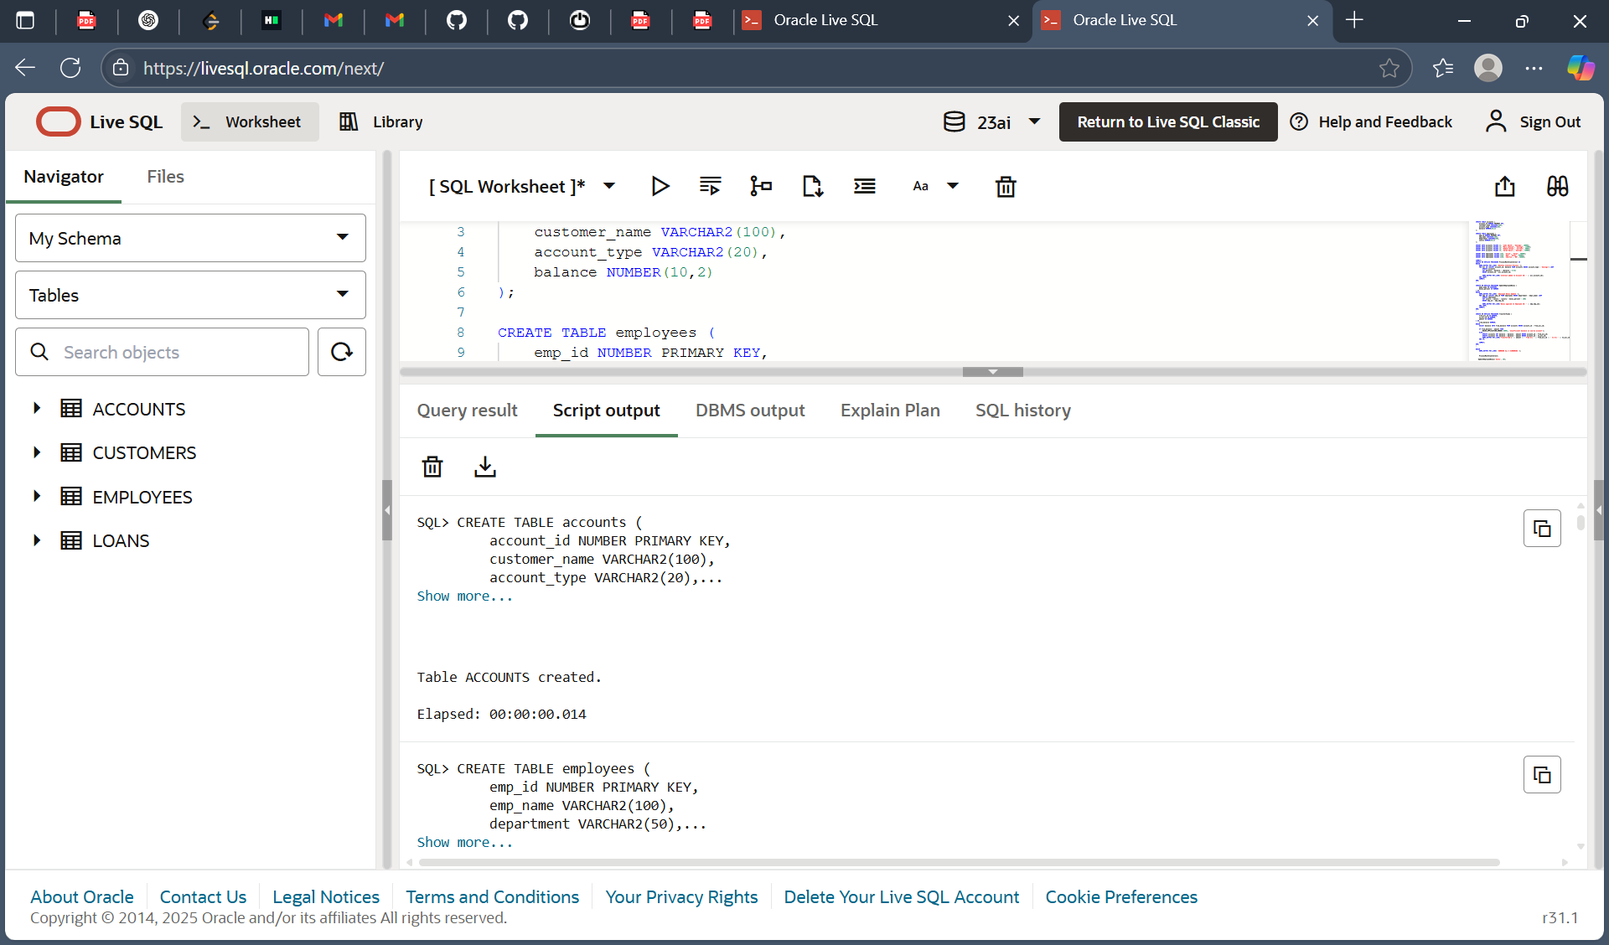

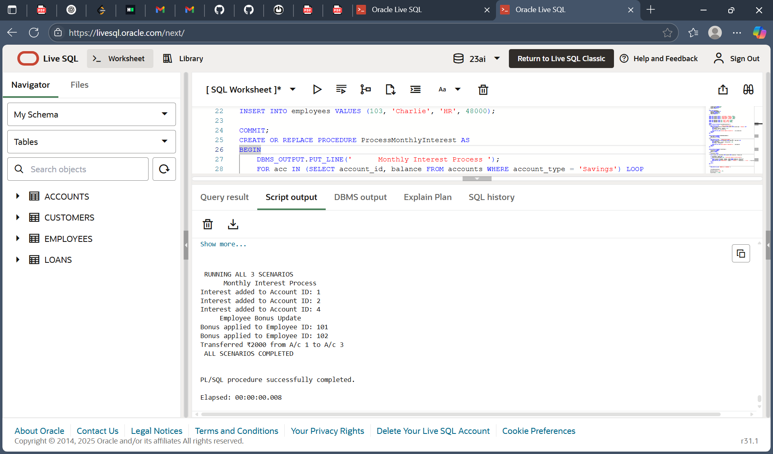

V Sai Nikhitha

nikhithavalmiki6@gmail.com