**Week 3 : 1. spring-data-jpa-handson**

**Hands On 1 : Spring Data JPA - Quick Example**

**Country.java**

package com.cognizant.ormlearn.model;

import javax.persistence.Column;

import javax.persistence.Entity;

import javax.persistence.Id;

import javax.persistence.Table;

@Entity

@Table(name = "country")

public class Country {

@Id

@Column(name = "co_code")

private String code;

@Column(name = "co_name")

private String name;

public String getCode() {

return code;

}

public void setCode(String code) {

this.code = code;

}

public String getName() {

return name;

}

public void setName(String name) {

this.name = name;

}

@Override

public String toString() {

return "Country [code=" + code + ", name=" + name + "]";

}

}

**CountryRepository.java**

package com.cognizant.ormlearn.repository;

import org.springframework.data.jpa.repository.JpaRepository;

import org.springframework.stereotype.Repository;

import com.cognizant.ormlearn.model.Country;

@Repository

public interface CountryRepository extends JpaRepository<Country, String> {

}

**CountryService.java**

package com.cognizant.ormlearn.service;

import java.util.List;

import org.springframework.beans.factory.annotation.Autowired;

import org.springframework.stereotype.Service;

import org.springframework.transaction.annotation.Transactional;

import com.cognizant.ormlearn.model.Country;

import com.cognizant.ormlearn.repository.CountryRepository;

@Service

public class CountryService {

@Autowired

private CountryRepository countryRepository;

@Transactional

public List<Country> getAllCountries() {

return countryRepository.findAll();

}

}

**OrmLearnApplication.java**

package com.cognizant.ormlearn;

import java.util.List;

import com.cognizant.ormlearn.model.Country;

import com.cognizant.ormlearn.service.CountryService;

import org.slf4j.Logger;

import org.slf4j.LoggerFactory;

import org.springframework.boot.SpringApplication;

import org.springframework.boot.autoconfigure.SpringBootApplication;

import org.springframework.context.ApplicationContext;

@SpringBootApplication

public class OrmLearnApplication {

private static final Logger LOGGER = LoggerFactory.getLogger(OrmLearnApplication.class);

private static CountryService countryService;

public static void main(String[] args) {

ApplicationContext context = SpringApplication.run(OrmLearnApplication.class, args);

LOGGER.info("Inside main");

countryService = context.getBean(CountryService.class);

testGetAllCountries();

}

private static void testGetAllCountries() {

LOGGER.info("Start");

List<Country> countries = countryService.getAllCountries();

LOGGER.debug("countries={}", countries);

LOGGER.info("End");

}

}

**application.properties**

logging.level.org.springframework=info

logging.level.com.cognizant=debug

logging.level.org.hibernate.SQL=trace

logging.level.org.hibernate.type.descriptor.sql=trace

logging.pattern.console=%d{dd-MM-yy} %d{HH:mm:ss.SSS} %-20.20thread %5p %-25.25logger{25} %25M %4L %m%n

spring.datasource.driver-class-name=com.mysql.cj.jdbc.Driver

spring.datasource.url=jdbc:mysql://localhost:3306/orm_learn

spring.datasource.username=root

spring.datasource.password=root

spring.jpa.hibernate.ddl-auto=validate

spring.jpa.properties.hibernate.dialect=org.hibernate.dialect.MySQL5Dialect

**MySQL Table Creation**

CREATE TABLE country (

co_code VARCHAR(2) PRIMARY KEY,

co_name VARCHAR(50)

);

INSERT INTO country VALUES ('IN', 'India');

INSERT INTO country VALUES ('US', 'United States of America');

**Output :**

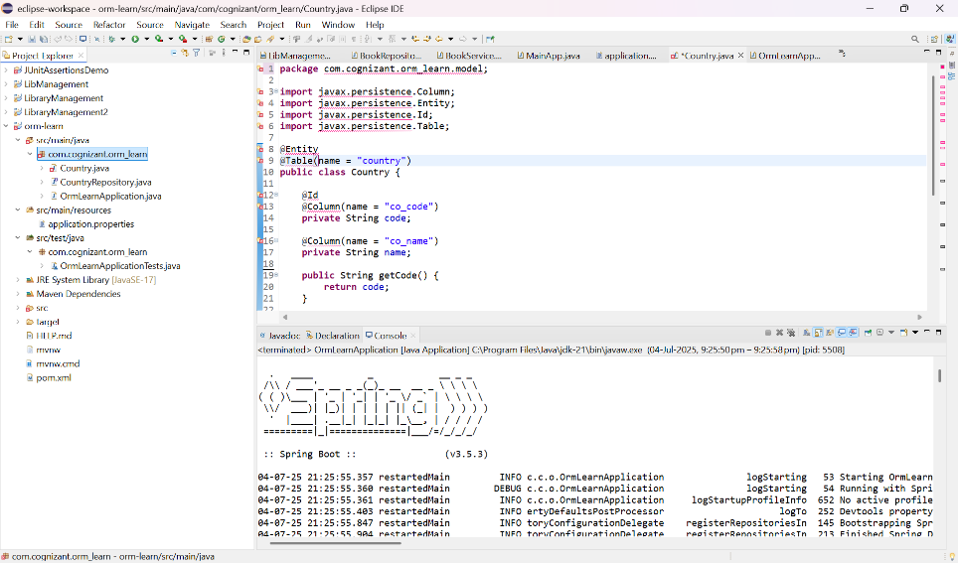

**Hands on 4**

**Difference between JPA, Hibernate and Spring Data JPA**   
  
Java Persistence API (JPA)

* JSR 338 Specification for persisting, reading and managing data from Java objects
* Does not contain concrete implementation of the specification
* Hibernate is one of the implementation of JPA

Hibernate

* ORM Tool that implements JPA

Spring Data JPA

* Does not have JPA implementation, but reduces boiler plate code
* This is another level of abstraction over JPA implementation provider like Hibernate
* Manages transactions

**Refer code snippets below on how the code compares between Hibernate and Spring Data JPA  
Hibernate**

   /* Method to CREATE an employee in the database */

   public Integer addEmployee(Employee employee){

      Session session = factory.openSession();

      Transaction tx = null;

      Integer employeeID = null;

      try {

         tx = session.beginTransaction();

         employeeID = (Integer) session.save(employee);

         tx.commit();

      } catch (HibernateException e) {

         if (tx != null) tx.rollback();

         e.printStackTrace();

      } finally {

         session.close();

      }

      return employeeID;

   }

**Spring Data JPA**  
EmployeeRespository.java

public interface EmployeeRepository extends JpaRepository<Employee, Integer> {

}

EmployeeService.java

@Autowire

  private EmployeeRepository employeeRepository;

@Transactional

public void addEmployee(Employee employee) {

  employeeRepository.save(employee);

  }

​​​​​​​   
  
**Reference Links:**   
<https://dzone.com/articles/what-is-the-difference-between-hibernate-and-sprin-1>   
<https://www.javaworld.com/article/3379043/what-is-jpa-introduction-to-the-java-persistence-api.html>

**Objective**

Retrieve a specific Country entity using its primary key (code) through Spring Data JPA.

1. **Implementation**

**1. Add getCountry(String code) in CountryService**

**File**: src/main/java/com/cognizant/ormlearn/service/CountryService.java

@Transactional

public Country getCountry(String code) {

return countryRepository.findById(code).orElse(null);

}

**2. Add testGetCountry() method in OrmLearnApplication.java**

**File**: src/main/java/com/cognizant/ormlearn/OrmLearnApplication.java

private static void testGetCountry() {

LOGGER.info("Start");

Country country = countryService.getCountry("IN");

LOGGER.debug("Country: {}", country);

LOGGER.info("End");

}

**3. Modify main() method to call testGetCountry()**

Inside the main() method in OrmLearnApplication.java:

public static void main(String[] args) {

ApplicationContext context = SpringApplication.run(OrmLearnApplication.class, args);

LOGGER.info("Inside main");

countryService = context.getBean(CountryService.class);

testGetAllCountries();

testGetCountry(); // added here

}

**B. Output in Console**

Country: Country [code=IN, name=India]

**C. Difference Between Hibernate and Spring Data JPA**

| **Feature** | **Hibernate** | **Spring Data JPA** |
| --- | --- | --- |
| Code Complexity | Requires managing Session, Transaction | Simple interface-based implementation |
| Boilerplate Code | High, must write all queries and configuration manually | Very low, most is auto-generated |
| Querying | Uses HQL or Criteria API | Uses method names like findById(), findAll() |
| Configuration | Needs Hibernate-specific configuration | Integrated with Spring Boot configuration |
| Repository Support | No default repository support | Built-in JpaRepository interface |
| Transaction Management | Manual with Session.beginTransaction() | Automatic with @Transactional |
| Learning Curve | Steeper | Easier for beginners |
| Development Speed | Slower due to more manual steps | Faster with Spring abstractions |

**V Sai Nikhitha**

**nikhithavalmiki66@gmail.com**