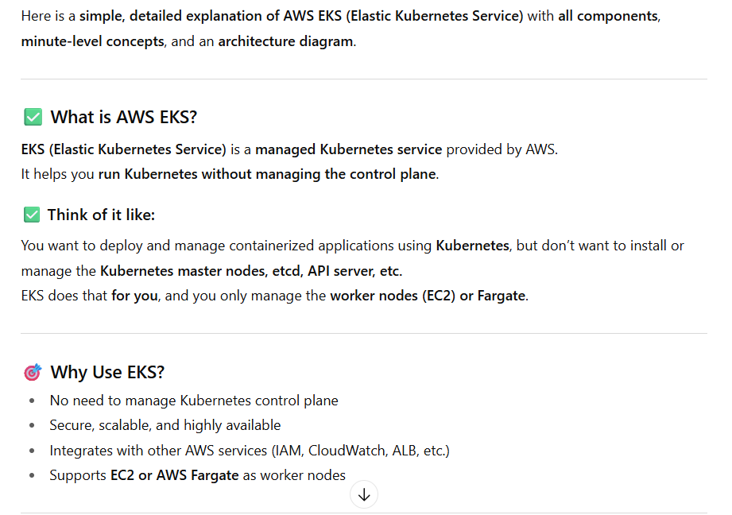

**EKS Architecture Diagram (Text-Based)**

