MOHIT SAINI

CSE 4th sem | 03610102716

Lottery Ticket Generator

DBMS project

**INTRODUCTION**

For my DBMS project I have made a **Lottery Ticket Generator.** This program uses *python* programming language and python’s *MySqlclient* library. The program consists of two python files. Both file work on same database. First file is used to generate lottery numbers and it stores them in database named ‘dbms’. Whereas second file uses database to randomly select winning lottery number.

The program uses python’s tkinter library to generate GUI to display results. Tkinter generates a very minimalistic GUI’s for python programs. Here our GUI contains six windows for random numbers to display and a button which generates a number.

MySqlclient library is used by program to communicate to MySql. It helps program to add queries to selected MySql database.

To generate lottery ticket number we have used python’s NumPy library. NumPy’s random.randint() method is used to generate random numbers.

**WORKING**

Lottery Ticket Generator:

Here first we have imported all required Python libraries. In below screenshot area within red box contains MySql queries. These queries are used to add data to the database named ‘DBMS’. These values are added to the table dbms project. All data of table gets reset to EMPTY every time we execute program.

**NOTE:** All sql related code is highlighted in a red square box.

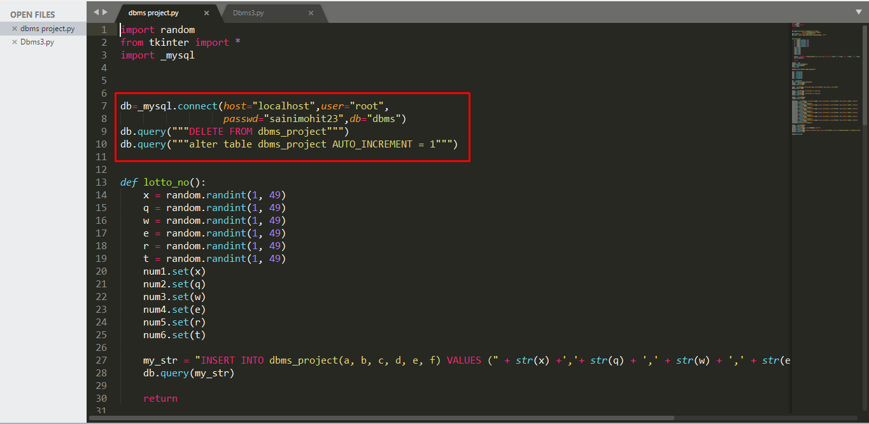

Function *lotto_no()*  is used to generate random lottery numbers. Then through a query it is added to the database.

Below are the screenshots of rest of the code. Rest of the code is about tkinter GUI creation.

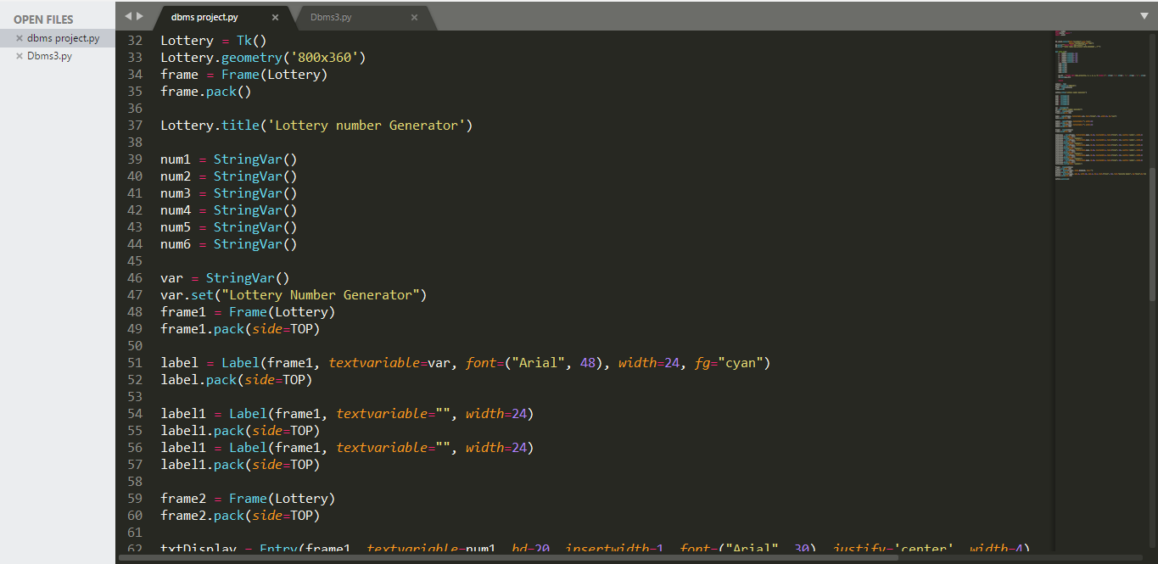

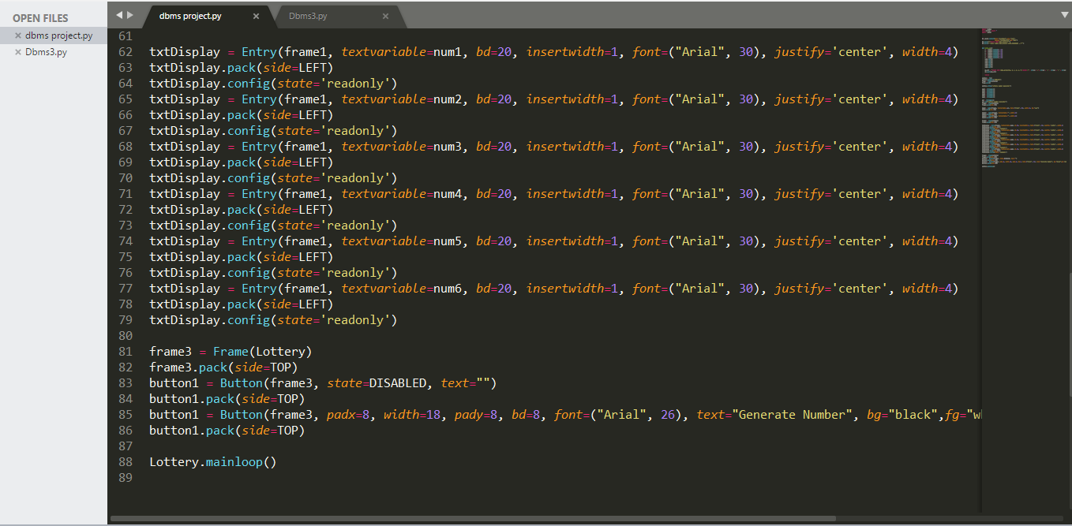

Output of Lottery Ticket Generator:

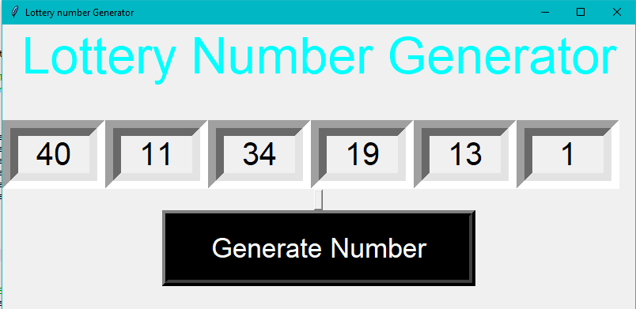

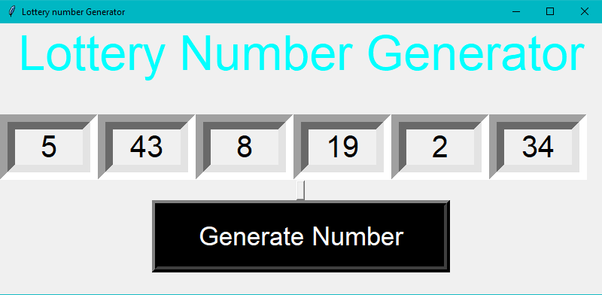

Changes in database:

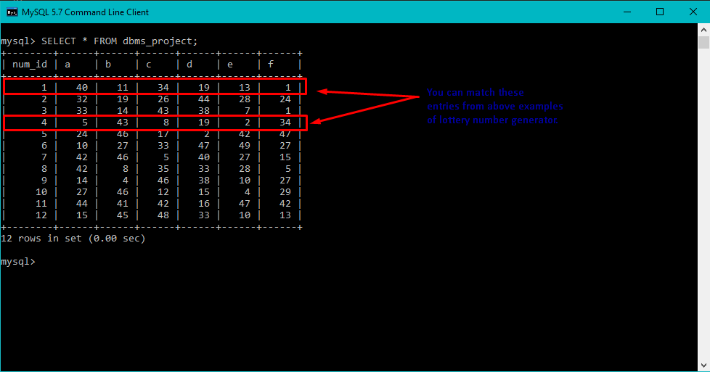

Winning Lottery Number Generator:

Here is the second code which generates winning lottery number. This number is generated randomly and then it is displayed on tkinter GUI.

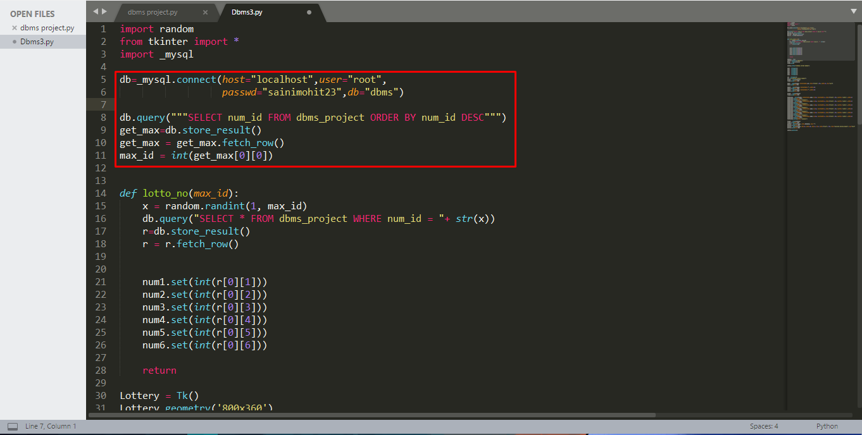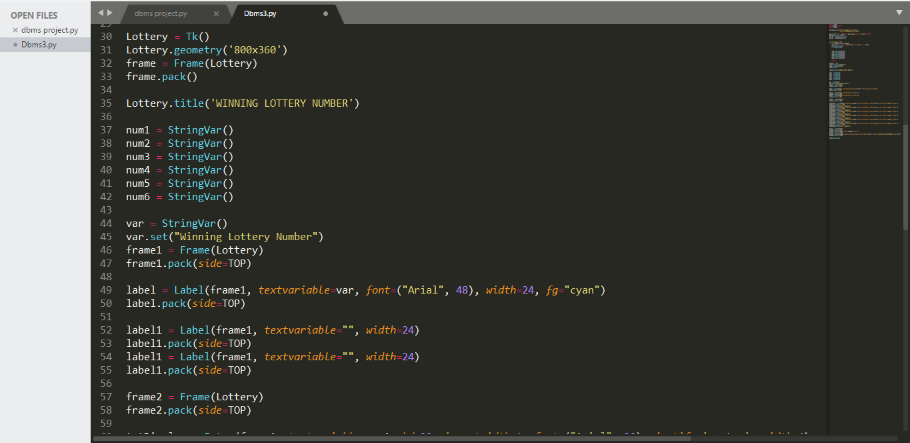

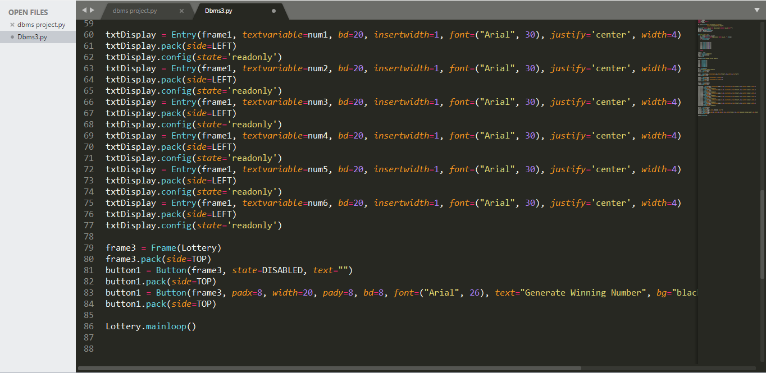

Output of Winning Lottery Ticket Number Generator:

We can match this number from the numbers stored in our database.

