YaleB
PCA 30 56 120 504
kNN 0.8312 0.9089 0.9419 0.8854 (0.9399)
NFS 0.8995 0.9270 0.9396 0.9474
SRC 0.8548 0.9254 0.9584 0.9859
WSRC 0.8807 0.9451 0.9694 0.9851

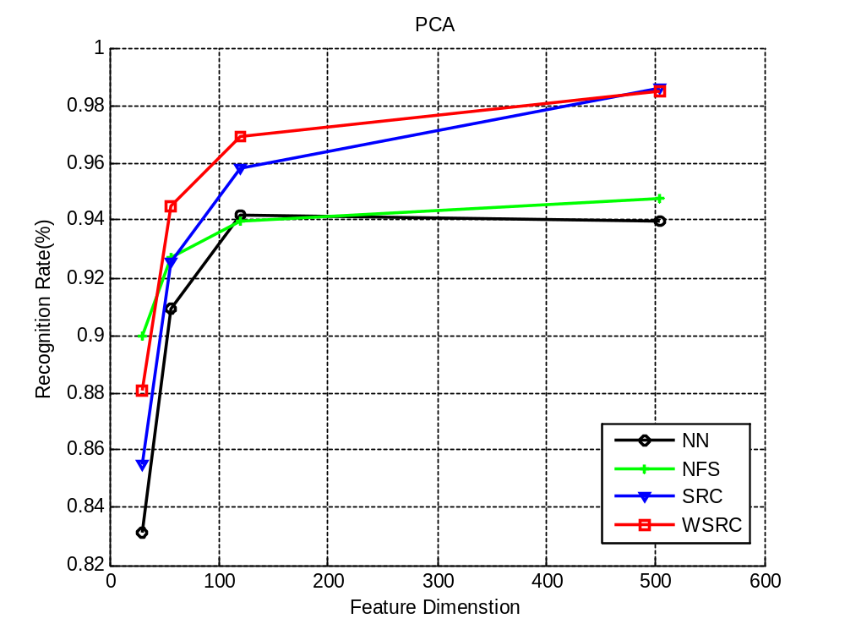

YaleB
Random 30 56 120 504
NN 71.11 74.10 79.98 82.18
NFS 82.42 91.44(91.02) 93.56 94.43
SRC 84.38 90.82 94.82 97.80(97.33)
WSRC 86.26 91.84 95.45 97.65

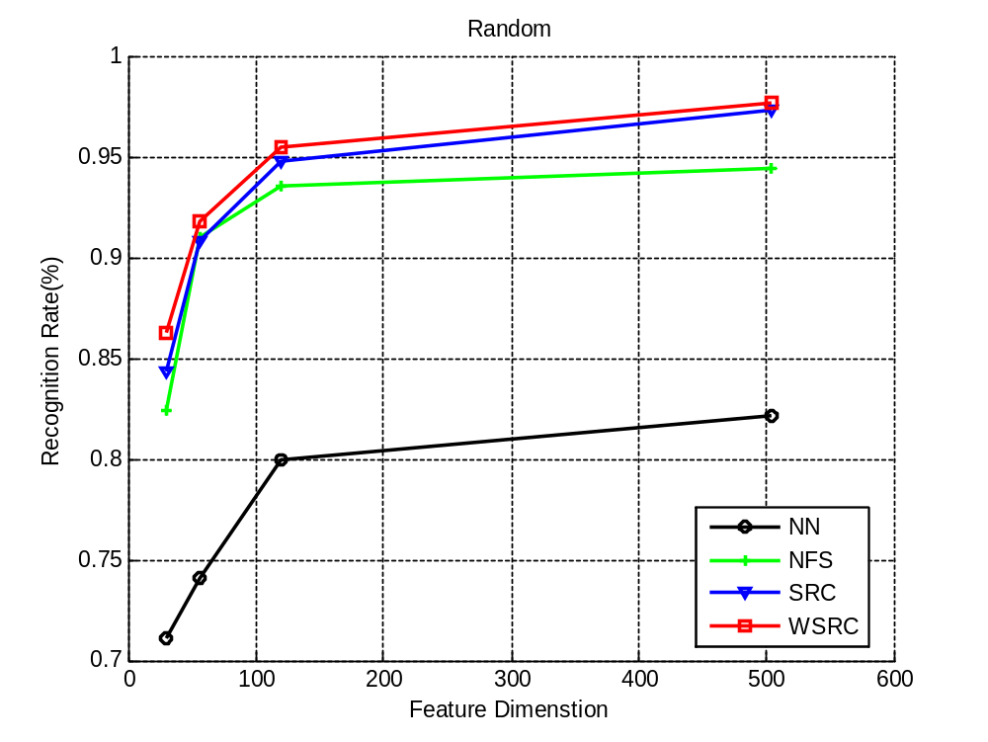
YaleB
LDA 5 10 15 20 25 30 35
NN 55.81 73.16 79.75 82.34 83.83 84.14 86.03
NFS 48.59 69.78 78.65 80.61 82.97 83.44 84.54
SRC 48.04 69.00 77.94 80.93 83.44 84.30 86.34
WSRC 49.14 70.02 78.57 81.16 82.97 84.46 86.50

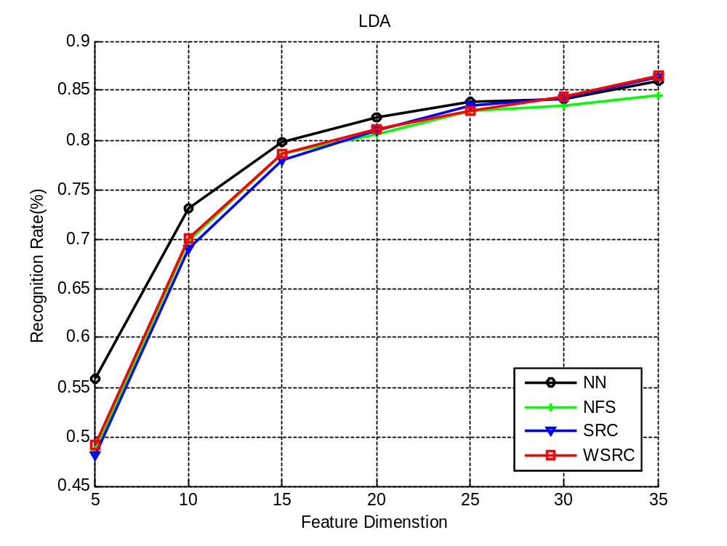
AR
PCA 30 54 130 540
NN 73.29 79.57 80.14 60.86(79.81)
NFS 64.29 72.43 77.00 80.00
SRC 74.29 85.14 91.00 94.29
WSRC 77.14 86.43 91.00(91.86) 94.43

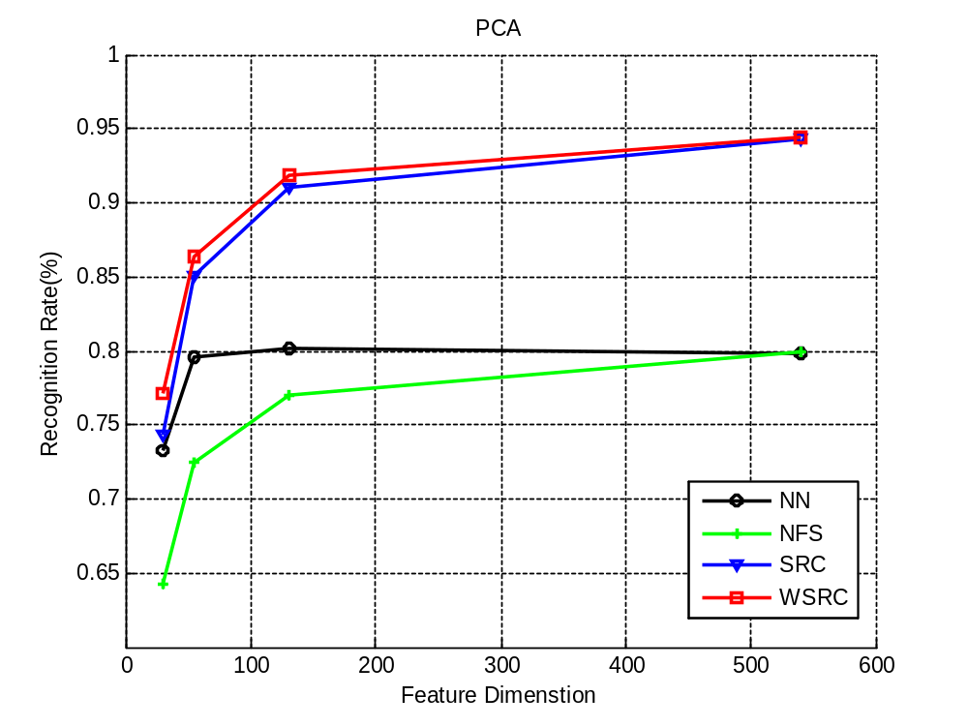
AR
Random 30 54 130 540
NN 57.43 65.00 73.00 77.29
NFS 55.71 66.29 73.29 77.57
SRC 57.00 78.57 87.43 93.14
WSRC 62.57 79.29 86.00(88.20) 92.00(93.33)

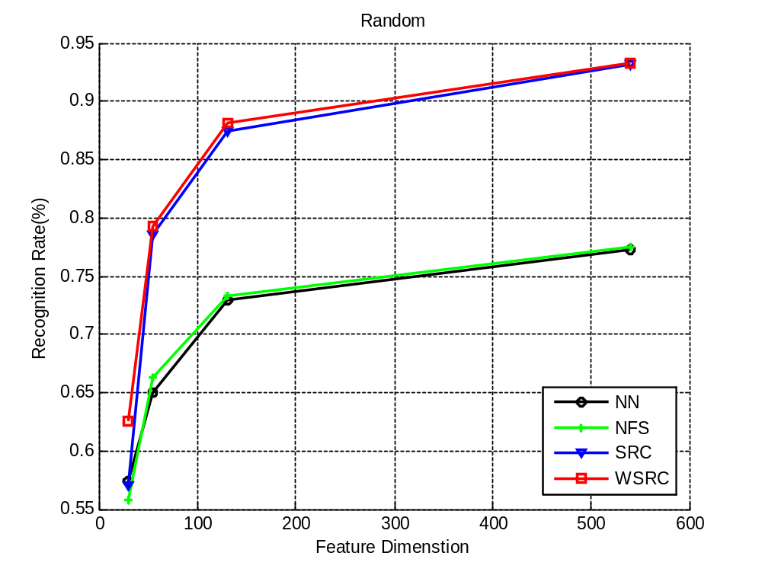
AR
LDA 10 20 30 40 50 60 70 80 90
NN 29.29 47.29 55.14 55.14 57.29 56.00 55.00 85.86 87.71
NFS 27.00 46.86 54.86 56.14 59.71 57.29 56.57 86.14 87.57
SRC 28.29 50.71 65.43 72.00 77.57 81.71 82.43 87.29 88.71
WSRC 28.57(29.29) 50.57(51.29) 66.29 72.57 77.71 81.14 84.29 87.00 88.71

