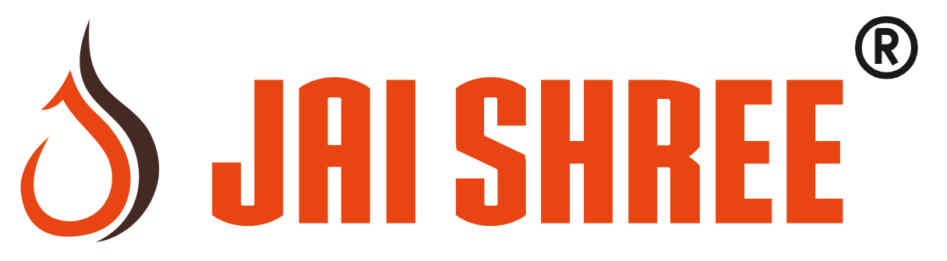
Unit Websites — Your Answers
Please fill in the shaded boxes and send this file back. Short answers are fine; write “OK” where you agree. To tick a box, replace ☐ with ✓.
Updated with your feedback: expanded metal added to Shree Perforators, and Jai Shree Perforator (Palghar) has no laser cutting.
1. Which unit gets which website?
Each unit gets its own website for the product line it is best known for.
Unit | Proposed website | Your answer (OK, or what to change)
Shree Perforators  Talawade, Pune | Perforated sheets and hole patterns, plus expanded metal (added as you asked)
Jai Shree Metal Perforators  Talawade, Pune | Laser cutting and CNC punching job work
Jai Shree Industries  Bhayander, Mumbai | Expanded metal
Jai Shree Perforator  Palghar | Architectural and decorative panels (perforated and expanded metal; we noted there is no laser here). Is this a good fit, or what does Palghar mainly make?
Jai Shree Filtration  Masjid Bunder, Mumbai | Process screens for sugar, rice, grain and mining
Shree Weld Mesh  Talawade, Pune | Precision sheet leveling
2. Which products does each unit make?
Tick every product the unit makes today. This decides what each website shows.
Unit | Perforated sheets | Laser cutting | Expanded metal | Turret punching | Sheet leveling | Custom parts and screens
Shree Perforators  Talawade | ☐ | ☐ | ☐ | ☐ | ☐ | ☐
Jai Shree Metal Perforators  Talawade | ☐ | ☐ | ☐ | ☐ | ☐ | ☐
Jai Shree Industries  Bhayander | ☐ | ☐ | ☐ | ☐ | ☐ | ☐
Jai Shree Perforator  Palghar | ☐ | ☐ | ☐ | ☐ | ☐ | ☐
Jai Shree Filtration  Masjid Bunder | ☐ | ☐ | ☐ | ☐ | ☐ | ☐
Shree Weld Mesh  Talawade | ☐ | ☐ | ☐ | ☐ | ☐ | ☐
3. Two unit names
These names refer to products you no longer make, so we want to avoid confusing buyers.
Unit | Keep the name with a short description? | Or new name
Shree Weld Mesh  Name refers to welded mesh | ☐ Yes, e.g. "Shree Weld Mesh — Precision Sheet Leveling"  ☐ No
Jai Shree Filtration  Name refers to filtration products | ☐ Yes, e.g. "Jai Shree Filtration — Process Screens"  ☐ No
4. Who receives enquiries for each unit?
Each website sends its enquiries here. Please correct anything that is out of date.
Unit | Phone and email we have | Contact person, and any correction
Shree Perforators  Talawade | +91 93706 06017  shreeperforator@gmail.com
Jai Shree Metal Perforators  Talawade | +91 93202 04156  jsmppune@gmail.com
Jai Shree Industries  Bhayander | +91 81818 15592  inderjangid@gmail.com
Jai Shree Perforator  Palghar | +91 93202 04151  inderjangid@gmail.com
Jai Shree Filtration  Masjid Bunder | +91 93202 04151  inderjangid@gmail.com
Shree Weld Mesh  Talawade | +91 90494 56019  balajiwelded@gmail.com
5. A few quick questions
a) Main website address: jaishreegroup.com or jaishreegroup.in?

b) Working days and hours. Is Thursday the weekly holiday at every unit?

c) Anything else you want to add, remove or change?
Approval
Approved by |  | Date

