**Name :Ritika Saini**

**Index**

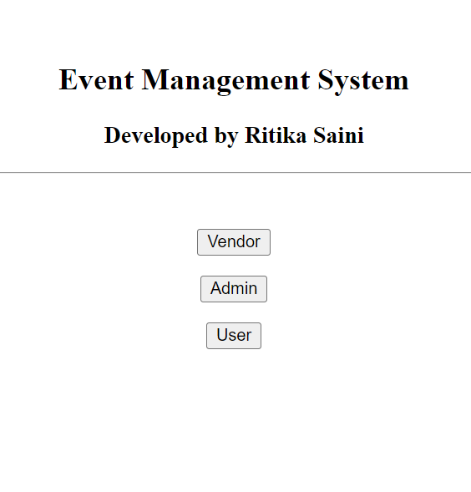

**Admin Signup**

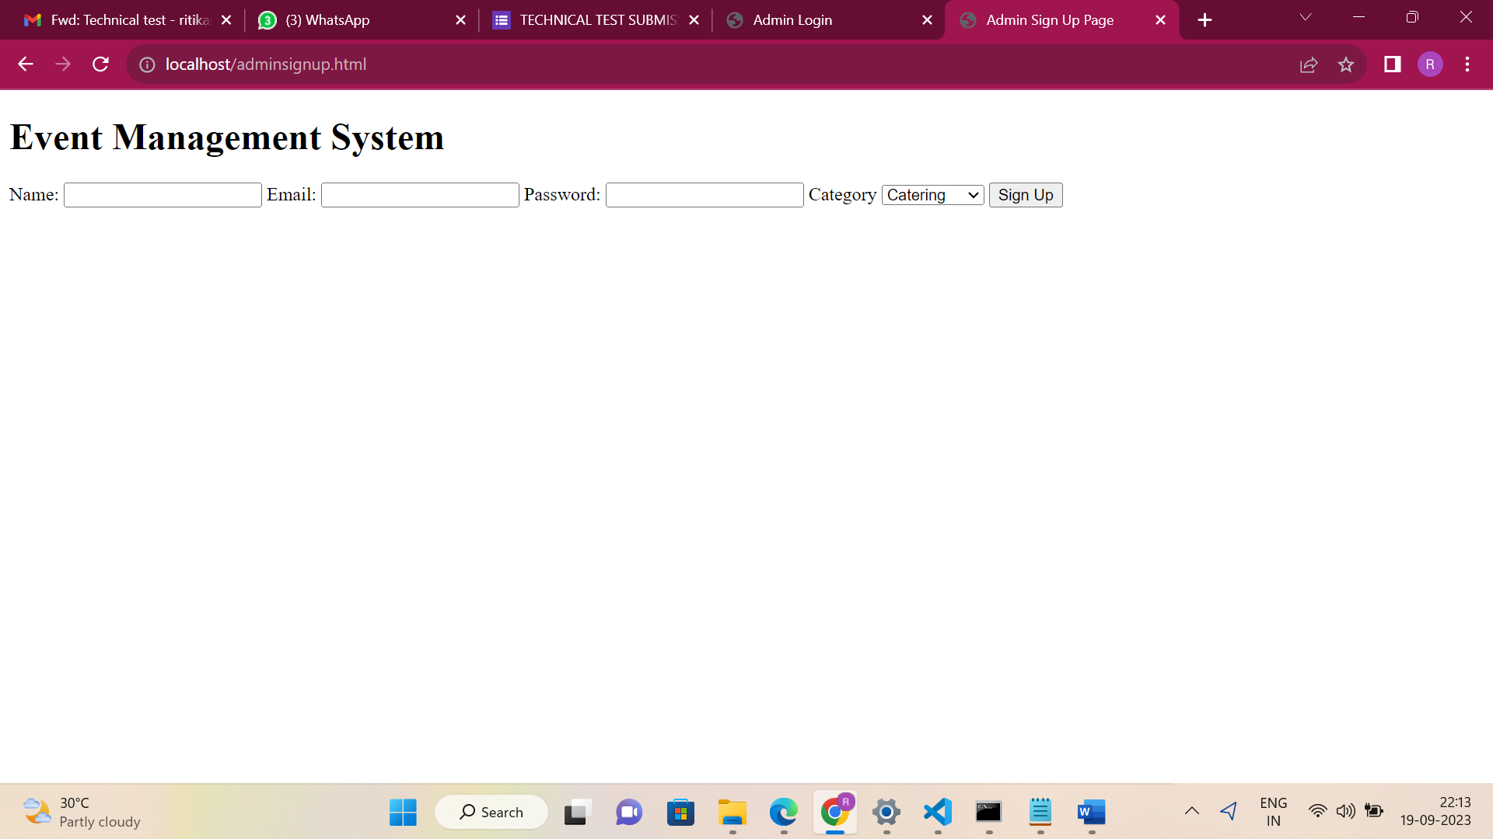

**Admin login**

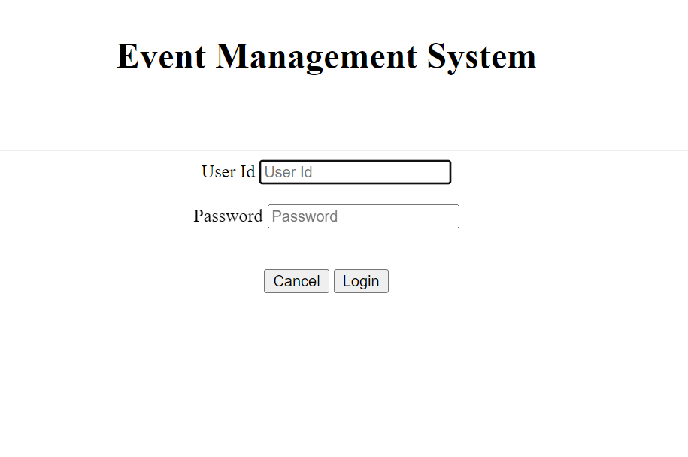

Maintainence menu

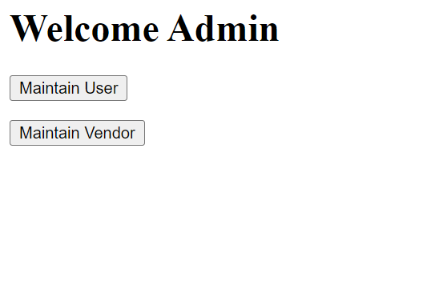

**1 Maintain user**

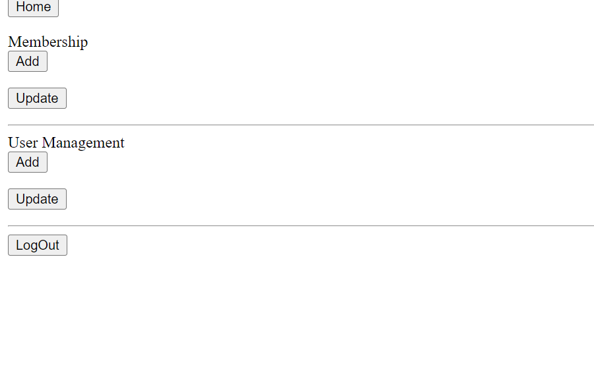

**Update membership**

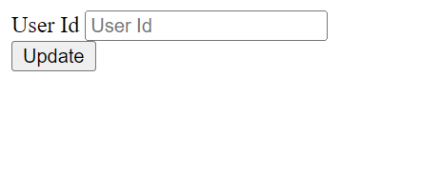

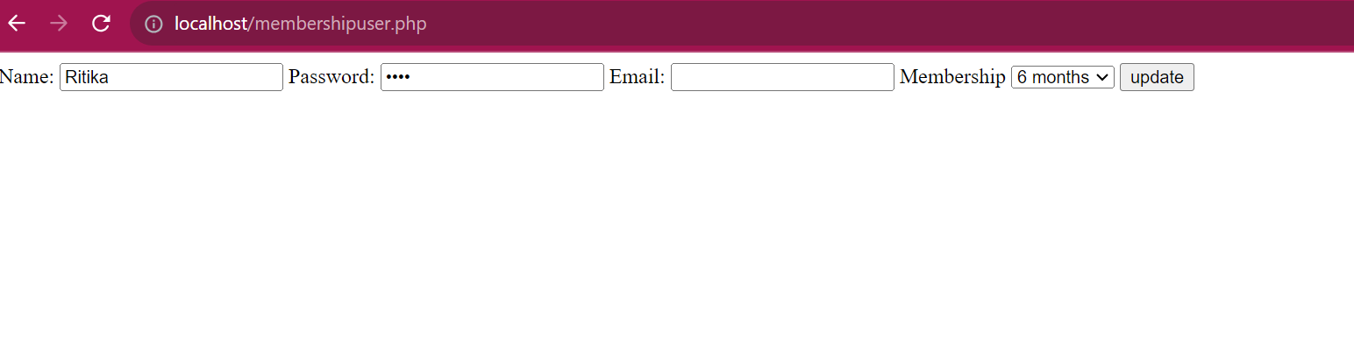

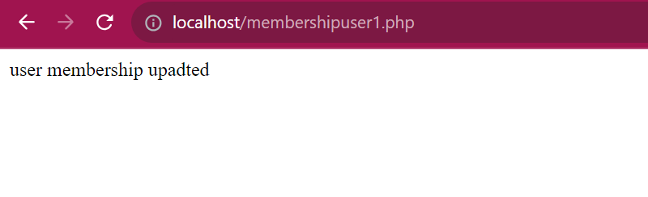

**User Management**

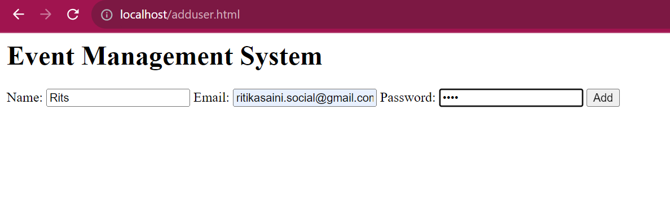

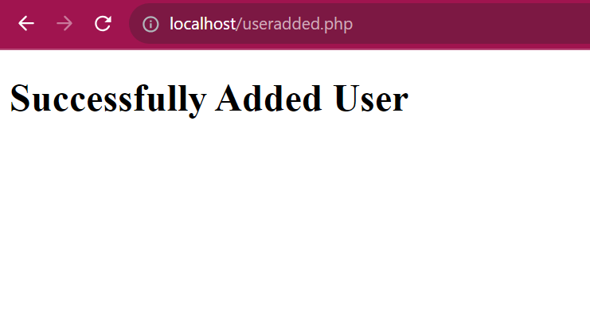

**Update user**

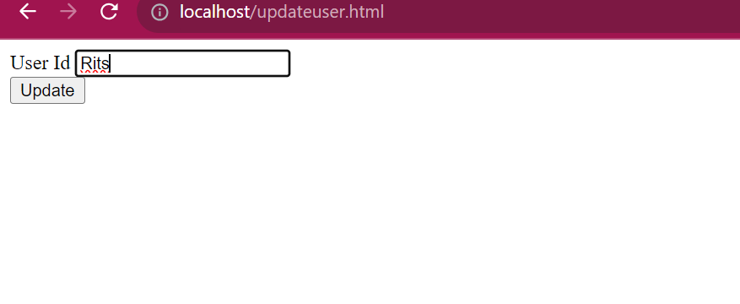

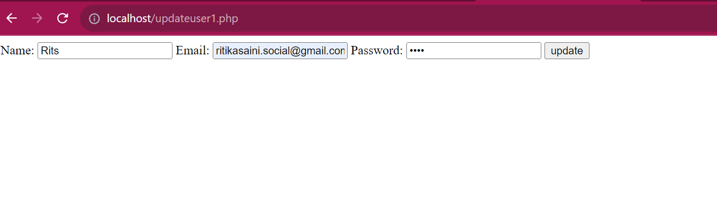

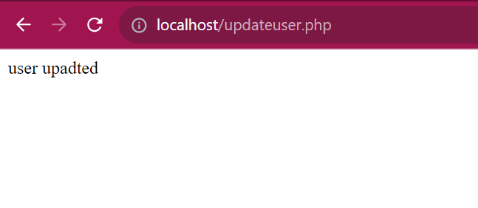

**2 Maintain Vendor**



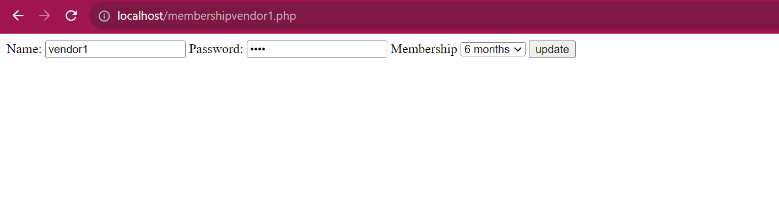

**VENDOR**

**Vendor login**

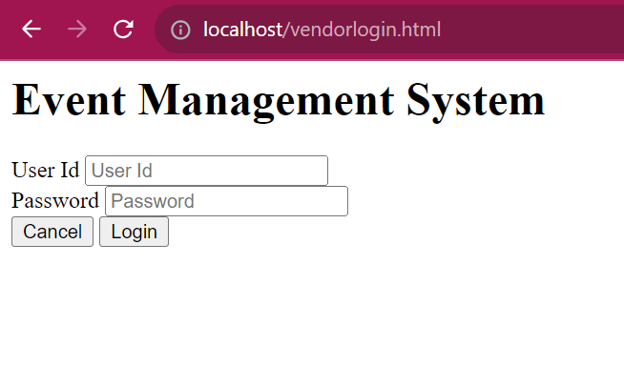

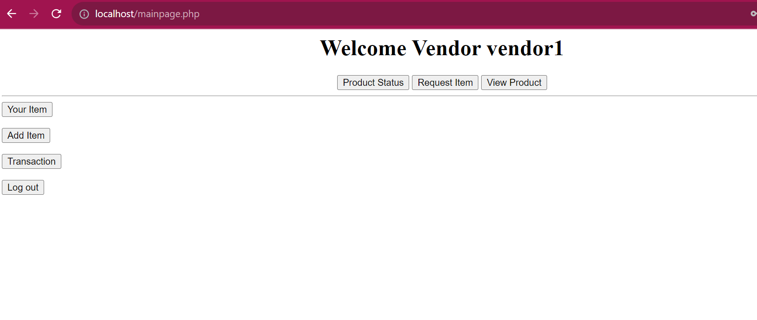

**Vendor Item List**

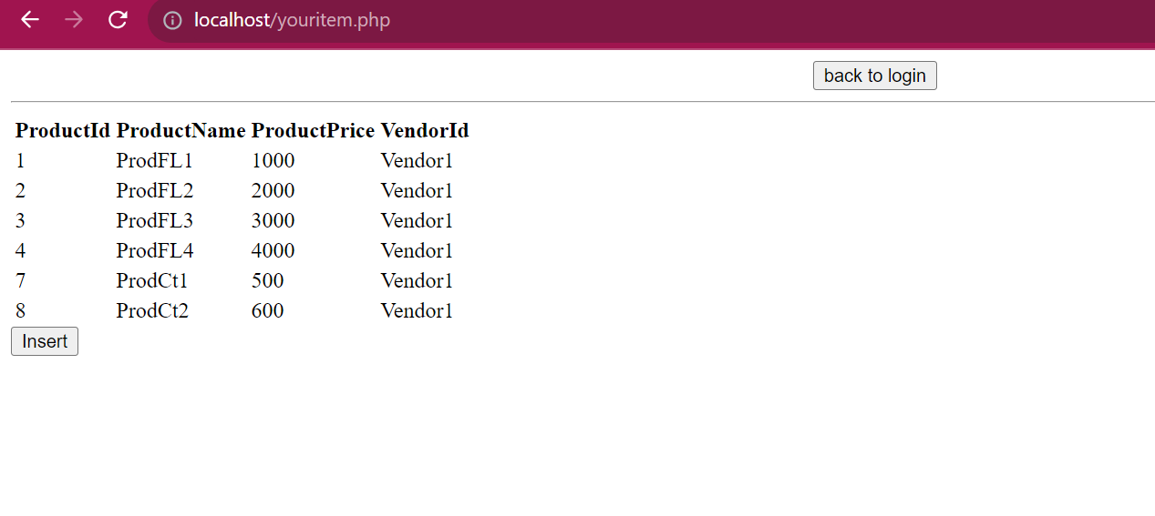**insert product**

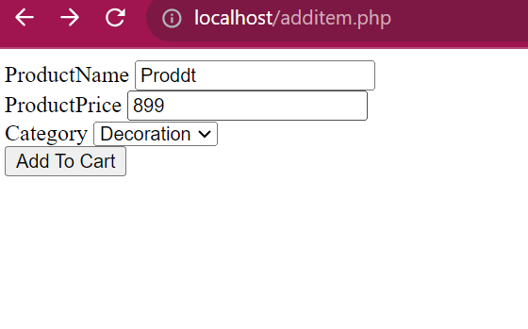

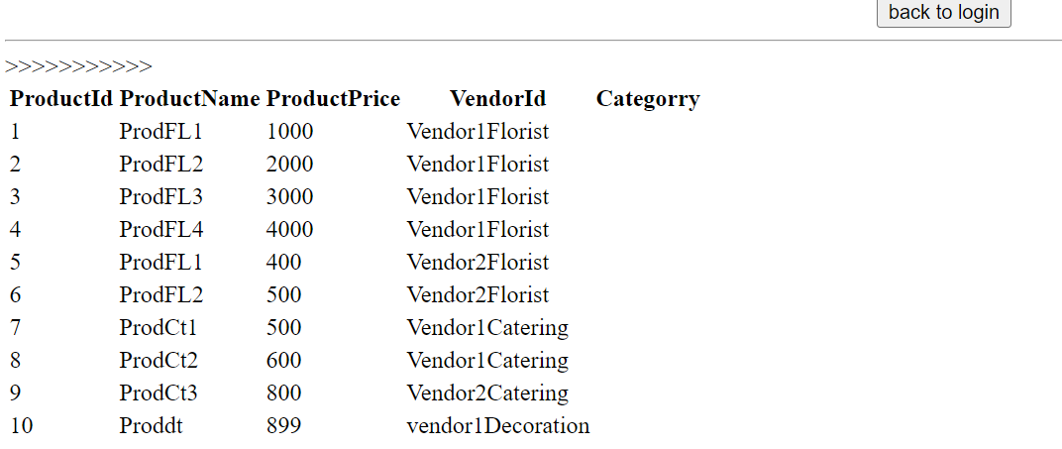

**After USER Login**

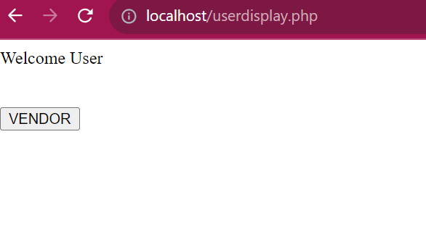

**Vendor list**

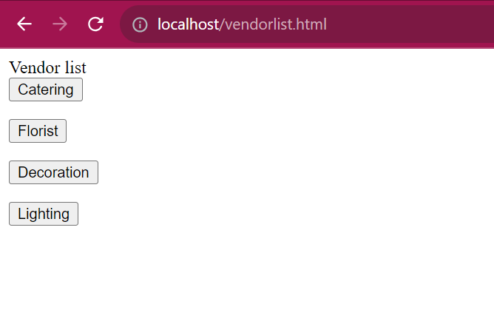

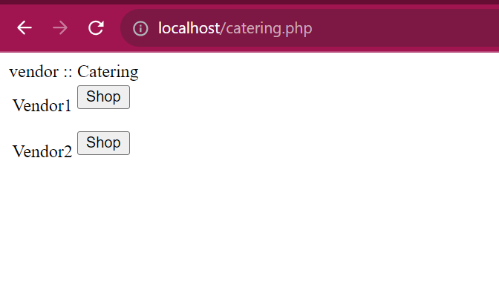

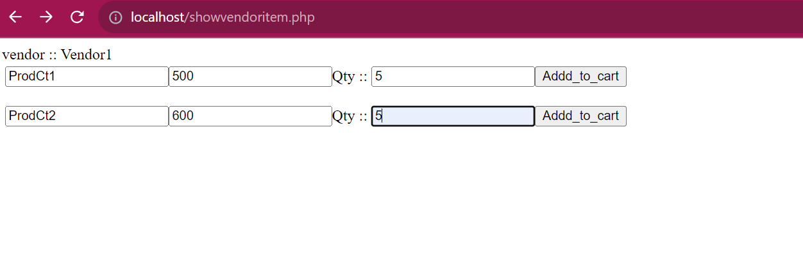

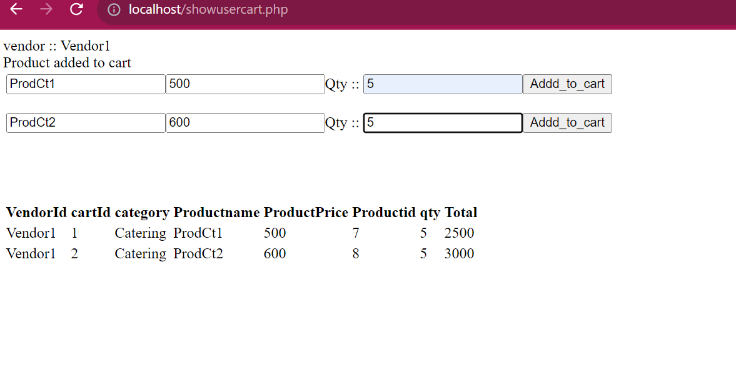

**Database Connection**

**1 creation of cart table**

**create table cart(CartId int PRIMARY KEY AUTO_INCREMENT,VendorId varchar(20),Category varchar(20),ProductId int,ProductName varchar(20),ProductPrice int,Qty int,TotalPrice int);**

**2 creation of Product table**

**create table Products(ProductId int PRIMARY KEY AUTO_INCREMENT,ProductName varchar(20),ProductPrice int,VendorID varchar(20) ,Foreign Key(VendorId) references Vendor(UserId),Category varchar(20));**

**3 creation of users table**

**create table Users(UserId varchar(20) PRIMARY KEY,Password varchar(20),Email varchar(20),Membership varchar(30) default "6 months");**

**4 creation of vendor table**

**create table Vendor(UserId varchar(20) PRIMARY KEY,Password varchar(20),Membership varchar(30) default "6 months");**

**5 creation of Admin Table**

**create table Admin(UserId varchar(20) PRIMARY KEY,Password varchar(20),Email varchar(30),Category varchar(30));**