Untitled
Kavya Kuruvanghat
2026-01-05

R Markdown
This is an R Markdown document. Markdown is a simple formatting syntax for authoring HTML, PDF, and MS Word documents. For more details on using R Markdown see http://rmarkdown.rstudio.com.
When you click the Knit button a document will be generated that includes both content as well as the output of any embedded R code chunks within the document. You can embed an R code chunk like this:
library(dplyr)
##
## Attaching package: 'dplyr'
## The following objects are masked from 'package:stats':
##
## filter, lag
## The following objects are masked from 'package:base':
##
## intersect, setdiff, setequal, union
library(ggplot2)
library(corrplot)
## corrplot 0.95 loaded
behavior <- read.csv("user_behavior_sample.csv")
head(behavior)
## user_id session_id landing_page exit_page pages_viewed time_on_site
## 1 user_1 session_1415 /home /home 4 916
## 2 user_2 session_1463 /home /blog 7 1448
## 3 user_3 session_1179 /home /cart 7 112
## 4 user_4 session_1526 /home /blog 7 493
## 5 user_5 session_1195 /products /products 4 382
## 6 user_6 session_1938 /products /blog 10 1475
## scroll_depth conversion
## 1 0.8391001 0
## 2 0.8685008 0
## 3 0.1131007 0
## 4 0.1341335 0
## 5 0.3689709 0
## 6 0.3940215 0
## page_sequence
## 1 /checkout|/checkout|/product-details|/products|/cart|/contact|/blog|/about
## 2 /cart|/faq
## 3 /contact|/faq|/about|/contact|/about|/blog|/blog
## 4 /product-details|/about|/faq|/product-details|/checkout|/blog
## 5 /cart|/contact
## 6 /contact|/about
engagement_summary <- behavior %>%
summarise(
avg_pages_viewed = mean(pages_viewed, na.rm = TRUE),
avg_time_on_site = mean(time_on_site, na.rm = TRUE),
avg_scroll_depth = mean(scroll_depth, na.rm = TRUE),
conversion_rate = mean(conversion, na.rm = TRUE)
)
engagement_summary
## avg_pages_viewed avg_time_on_site avg_scroll_depth conversion_rate
## 1 5.987 902.022 0.5513711 0.146
landing_page_analysis <- behavior %>%
group_by(landing_page) %>%
summarise(
sessions = n(),
avg_pages = mean(pages_viewed, na.rm = TRUE),
avg_time = mean(time_on_site, na.rm = TRUE),
conversion_rate = mean(conversion, na.rm = TRUE)
)
landing_page_analysis
## # A tibble: 4 × 5
## landing_page sessions avg_pages avg_time conversion_rate
## <chr> <int> <dbl> <dbl> <dbl>
## 1 /about 103 5.99 840. 0.0777
## 2 /blog 199 6.16 913. 0.136
## 3 /home 387 5.88 907. 0.163
## 4 /products 311 6.01 910. 0.154
ggplot(landing_page_analysis, aes(x = landing_page, y = sessions)) +
geom_bar(stat = "identity") +
labs(x = "Landing Page", y = "Sessions")
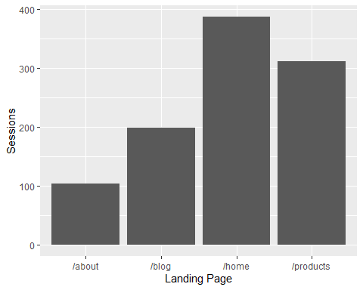
exit_analysis <- behavior %>%
group_by(exit_page) %>%
summarise(
exits = n(),
exit_rate = n() / nrow(behavior)
)
exit_analysis
## # A tibble: 5 × 3
## exit_page exits exit_rate
## <chr> <int> <dbl>
## 1 /blog 289 0.289
## 2 /cart 108 0.108
## 3 /checkout 101 0.101
## 4 /home 210 0.21
## 5 /products 292 0.292
#Conversion Distribution (Pie Chart)
conversion_data <- behavior %>%
count(conversion)
ggplot(conversion_data, aes(x = "", y = n, fill = as.factor(conversion))) +
geom_bar(stat = "identity", width = 1) +
coord_polar("y") +
theme_void()
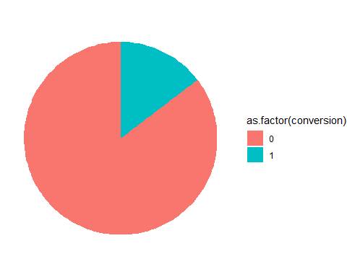
#Time on Site Distribution (Histogram)
ggplot(behavior, aes(x = time_on_site)) +
geom_histogram(bins = 10) +
labs(x = "Time on Site", y = "Frequency")
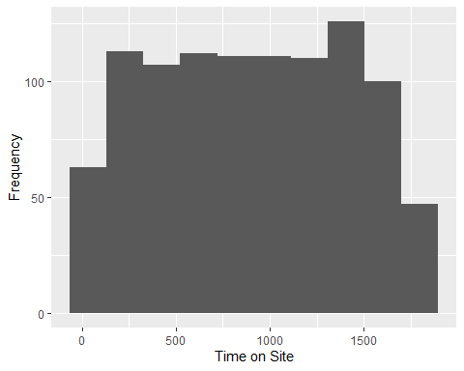
#Pages Viewed vs Conversion (Box Plot)
ggplot(behavior, aes(x = as.factor(conversion), y = pages_viewed)) +
geom_boxplot() +
labs(x = "Conversion Status", y = "Pages Viewed")
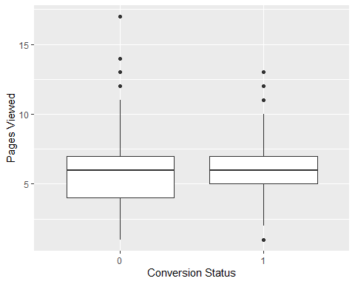
#time on Site vs Pages Viewed (Scatter Plot)
ggplot(behavior, aes(x = time_on_site, y = pages_viewed)) +
geom_point() +
labs(x = "Time on Site", y = "Pages Viewed")
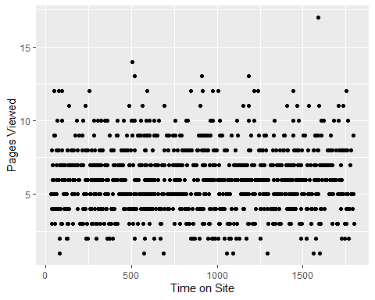
#Correlation Heat map
correlation_matrix <- cor(
behavior[, c("pages_viewed", "time_on_site", "scroll_depth", "conversion")],
use = "complete.obs"
)
corrplot(correlation_matrix, method = "color", type = "upper")
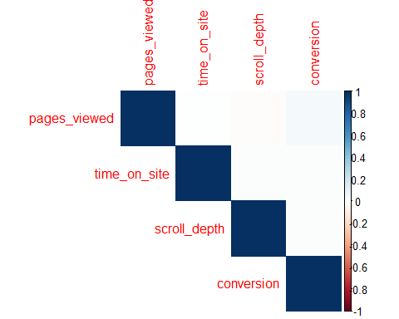
#

Including Plots
You can also embed plots, for example:
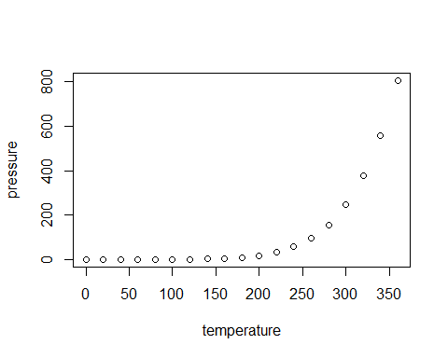
Note that the echo = FALSE parameter was added to the code chunk to prevent printing of the R code that generated the plot.

