| Week| Holiday_Ref |

|----: |:---------------------------------- |

| 6 |SupperBowl Week |

| 36 |LaborDay Week |

| 47 |ThanksGiving Week |

| 52 |Christmas Week |

**Fig. 7.** Holiday Reference for Corresponding Week Numbers

**Figure 8. Weekly sales vs Stores**

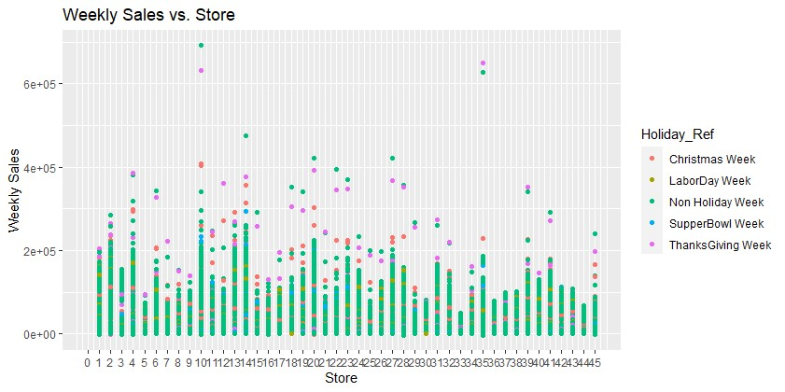

The analysis of weekly sales across various stores reveals a prominent surge in sales during Thanksgiving Week (Week 47), suggesting a notable correlation between this holiday period and heightened purchasing activity. Additionally, a general upward trend in holiday sales is observed across most stores, indicating increased customer spending during these periods. While Thanksgiving Week stands out as a high-sales period, store-specific variations in performance during other holidays highlight opportunities for tailored marketing and strategic promotions. The findings suggest the importance of understanding both overarching trends and individual store dynamics for effective sales strategies.

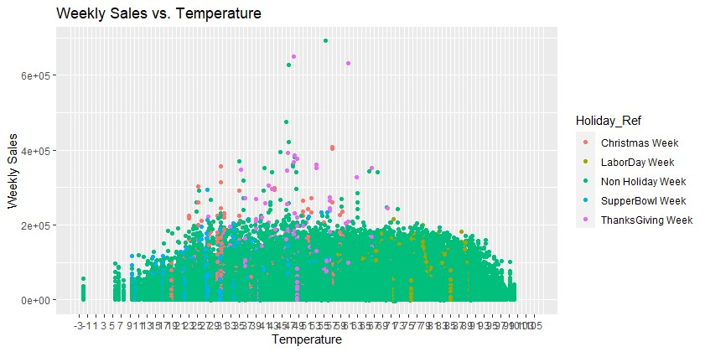

The examination of the weekly sales in relation to temperature patterns revealed noteworthy aspects into consumer behavior. The majority of sales happens within a temperature range of 19 to 79 degrees. This indicate a preference for moderate climatic conditions. Further, holidays such as Christmas, SuperBowl, and ThanksGiving showed distinct temperature-sales correlations which saw Christmas and ThanksGiving having increased sales in the range of 17 to 65 degrees, which aligns with a preference for cooler weather during these festivities. The Labor Day, conversely, shows elevated sales in the warmer range of 55 to 90 degrees. Moreover, ThanksGiving proves to be a pivotal driver of high sales as compared to sales in other holidays, emphasizing the significance of strategic planning and targeted marketing efforts during this holiday. This analysis gives the importance of considering holiday dynamics and temperature variations in crafting effective sales strategies.

Top of Form