NPA Early Detection & AI Explainability System
Comprehensive Technical Architecture, Predictive Modeling, and Governance Specification
DOCUMENT VERSION  2.0 (Production Handoff) | DATA PIPELINE  SAS Viya / Model Studio 2026.02 | ANALYTICS STACK  Python / SQLite / ChromaDB / RAG | AUTHORITY / REGULATION  RBI 90-Day Master NPA Guidelines

1. Executive Overview & Business Case
――――――――――――――――――――――――――――――――――――――――
In commercial and retail banking, credit risk management has historically been reactive. Under Reserve Bank of India (RBI) regulatory guidelines, an account is classified as a Non-Performing Asset (NPA) when principal or interest remains overdue for more than 90 consecutive days (Days Past Due or DPD > 90). By the time an account reaches DPD 91, borrower cash flows have typically collapsed, collateral value may be impaired, and capital recovery rates drop below 25%.
The NPA Early Detection System fundamentally shifts credit risk operations from reactive default recovery to proactive, preventative early intervention. By evaluating leading behavioral, financial, macroeconomic, and cash-flow indicators on currently performing accounts (where DPD is strictly zero), the system predicts the statistical probability of a borrower defaulting over a forward-looking 12-month horizon.
[CORE PARADIGM SHIFT: PREDICTIVE VS. REACTIVE]
Crucial Distinction: The system evaluates borrowers who are 100% current on their payments today (Current DPD = 0). A customer labeled as 'CRITICAL' has not yet missed a payment; rather, their underlying financial indicators reveal a >= 60% probability that they will default within the next 12 months unless preventative action is taken.

2. End-to-End System Architecture & Workflow
――――――――――――――――――――――――――――――――――――――――
The system consists of four seamlessly decoupled operational tiers, illustrated in Figure 1 below. Each tier enforces strict architectural boundaries, ensuring that data generation, statistical machine learning, scoring handoffs, and web-based AI explainability operate with total data lineage and zero lookahead leakage.

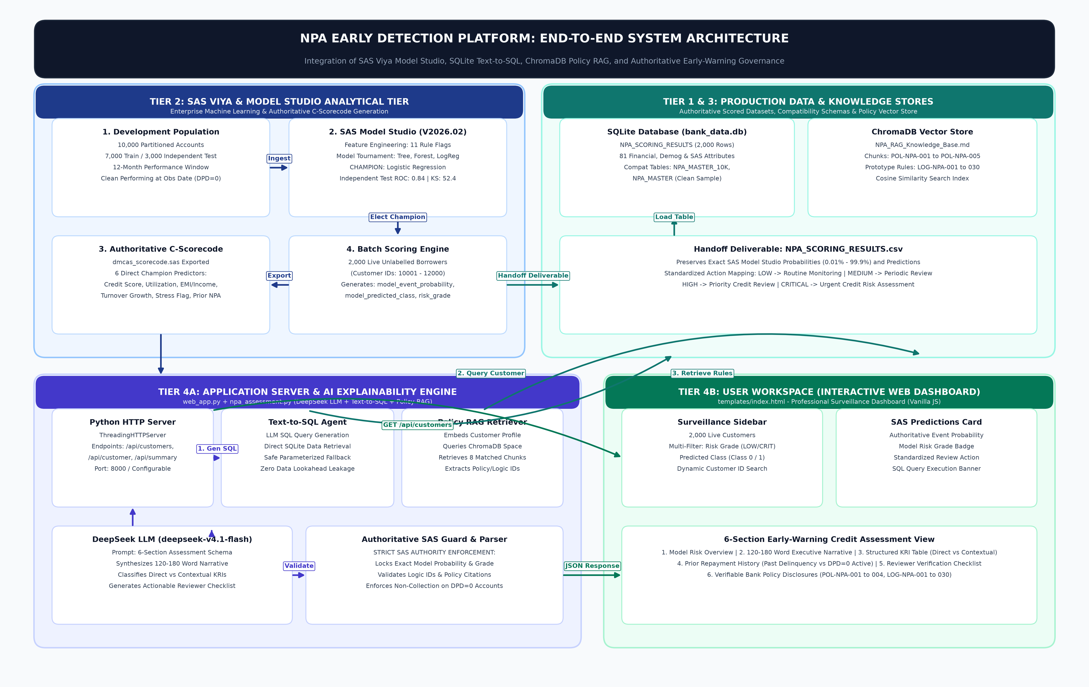
Figure 1: End-to-End System Architecture — Integrating Tier 2 SAS Viya Model Studio, Production Data Stores, Text-to-SQL Agent, ChromaDB Policy RAG, and Authoritative Early-Warning Governance.

Tier 1: Synthetic Data Engine (Python & SQLite)
Generates 12,000 realistic, economically calibrated borrower records spanning demographics, loan contracts, 12-month repayment history (clean performing), transaction activity, bureau exposure, employer corporate health, and 12-month forward repayment simulations. Staged in SQLite (npa_project.sqlite) and standardized CSV files.
Tier 2: SAS Viya Machine Learning (Model Studio)
Ingests the partitioned 10,000 development customers (7,000 Train / 3,000 Test). Engineers analytical ratios and trains machine learning models (Logistic Regression, Decision Trees, Forest). Elects the Champion Model and exports authoritative C-scorecode (dmcas_scorecode.sas).
Tier 3: Automated Scoring & Contract Handoff
Executes the champion model against 2,000 live, unlabelled scoring customers (IDs 10,001–12,000) who possess zero target data. Enforces output file schemas and outputs NPA_SCORING_RESULTS.csv with model event probabilities, predicted classes, and risk grades.
Tier 4: Web Application Dashboard & RAG Engine
A lightweight, high-performance web server (web_app.py) serving an interactive banking dashboard (index.html). An integrated Text-to-SQL agent dynamically writes and executes parameterized queries to fetch live customer profiles directly from SQLite (bank_data.db). The vector RAG engine semantic-searches official bank policies (POL-NPA-001 to 005) and SAS prototype rules (LOG-NPA-001 to 030) in ChromaDB. DeepSeek LLM synthesizes an authoritative 6-section evidence-based assessment with explicit separation between direct champion model predictors and contextual indicators, locked by a strict SAS Model Studio guard that prohibits altering model event probabilities, predicted classes, or standardized review actions.

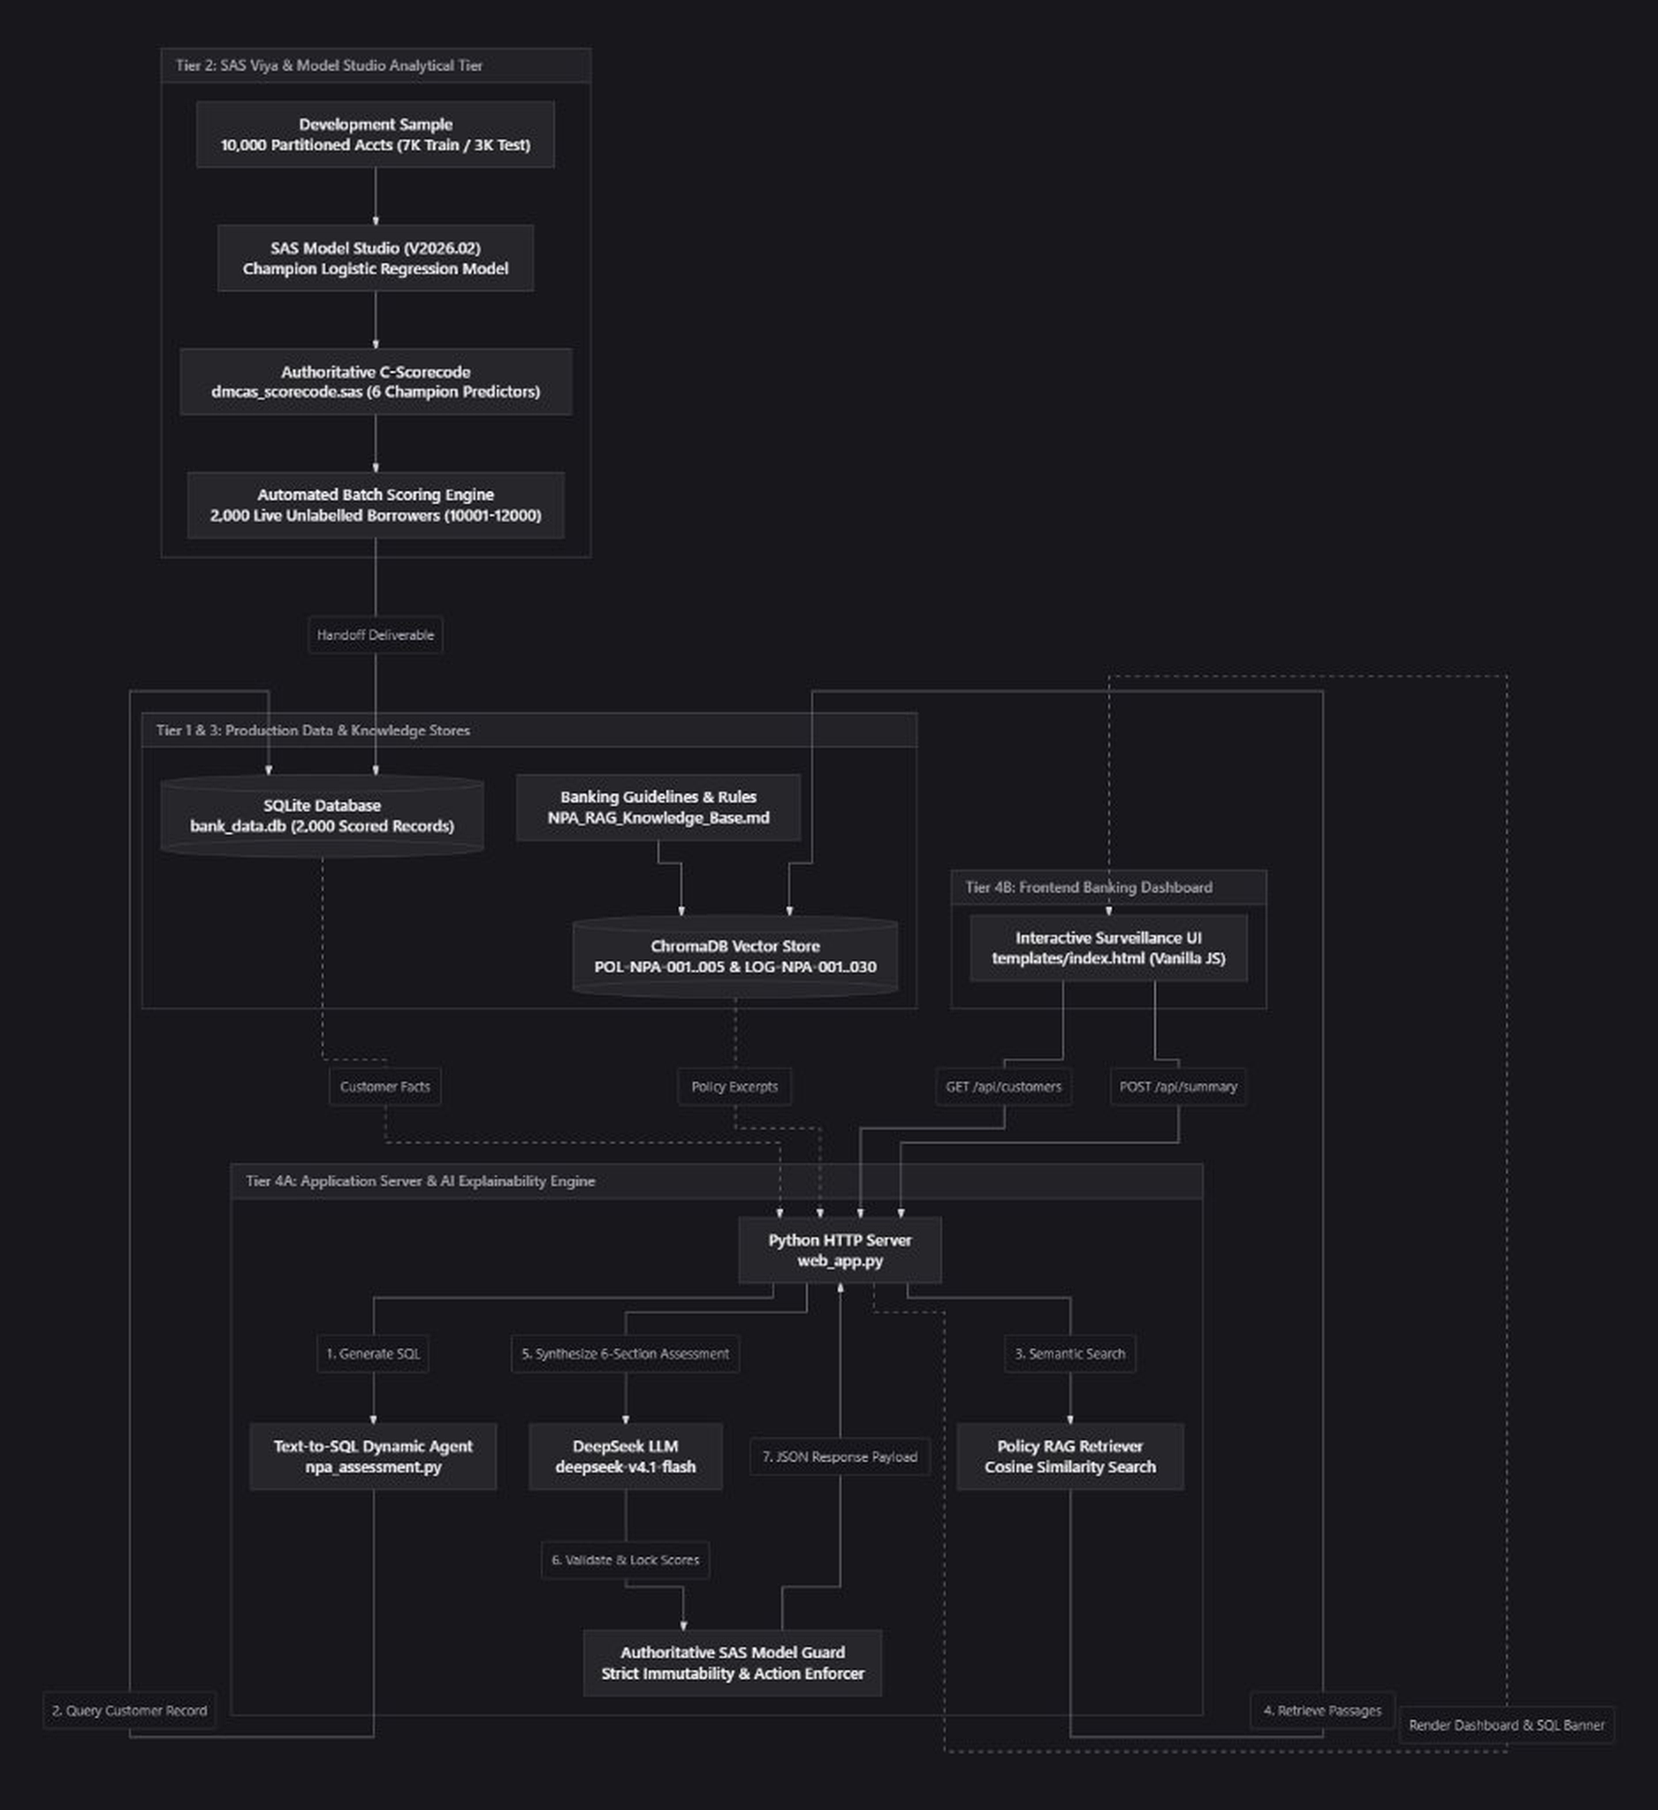
3. Population Structure & Dataset Specifications
――――――――――――――――――――――――――――――――――――――――
To guarantee reproducible model training and prevent data snooping, the 12,000 generated customers are partitioned into three mutually disjoint populations at the customer ID level:
Population Group | Customer Count | Customer ID Range | Target (npa_flag) | Operational Purpose
Training Population | 7,000 | 1 to 10,000 (70% Stratified) | Available (Simulated) | Model parameter estimation & training in SAS
Independent Test Set | 3,000 | 1 to 10,000 (30% Stratified) | Available (Simulated) | Independent evaluation, ROC, F1, & confusion matrix
Live Scoring Population | 2,000 | 10,001 to 12,000 (Disjoint) | NOT Available (Strictly Null) | Live bank dashboard scoring & loan officer review

Domain Data Entities & Raw CSV Schema
Each borrower profile is constructed across nine normalized tables reflecting realistic commercial banking operations:
Table Name | Granularity | Core Attributes | Business Definition & Integrity Rules
customer_master.csv | 1 row / customer | customer_id, age, gender, occupation, monthly_income, employment_years, city_type | Demographic and employment profile. Correlated income tiers by occupation.
loan_account.csv | 1 active loan / customer | loan_id, loan_type, sanctioned_amount, outstanding_amount, emi_amount, interest_rate, collateral_value, loan_age_months, remaining_tenure | Active loan facility. Principal amortized over at least 12 months. Plausible LTV.
emi_history.csv | 12 rows / customer | customer_id, month_no, emi_due, emi_paid, days_past_due, npa_indicator | Current loan payment discipline. Strict rule: emi_paid = emi_due, DPD = 0, npa_indicator = 0.
payment_history.csv | 12 rows / customer | customer_id, month_no, payment_mode, payment_status, receipt_id, transaction_timestamp | Payment settlement channel. Validated modes: NACH auto-debit, NetBanking, UPI, Cheque.
credit_bureau.csv | 1 row / customer | credit_score, total_credit_limit, total_credit_balance, active_credit_accounts, recent_enquiries | External credit bureau file (CIBIL equivalent). Range: 300 to 900.
transaction_history.csv | 12 rows / customer | credit_transaction, debit_transaction, transaction_count, cash_withdrawal | Monthly checking account cash flows, debit/credit burn rate, and ATM cash usage.
customer_company_details.csv | 1 row / customer | annual_turnover, turnover_growth_pct, profit_margin_pct, debt_to_equity, current_ratio, credit_rating, financial_stress_flag_synthetic | Employer/business corporate balance sheet health. Tracks negative growth and liquidity stress.
npa_history_customer_summary.csv | 1 row / customer | previous_npa_flag, prior_missed_payment_count, prior_avg_dpd, prior_max_dpd, max_consecutive_missed_months | Historical repayment behavior on CLOSED or past loans from prior years.
future_outcome.csv | 1 row / customer (Dev only) | npa_flag, event_month, peak_future_dpd, final_repayment_status | The ground truth 12-month future simulation target. npa_flag = 1 if peak future DPD > 90.

4. Feature Engineering, Financial KPIs & Internal Risk Flags
――――――――――――――――――――――――――――――――――――――――
To translate raw banking tables into predictive power, the SAS Viya feature pipeline computes standardized financial ratios and 11 transparent, rule-based prototype risk flags before feeding data into the machine learning engine:
Analytical Ratio (KPI) | Mathematical Formulation | Threshold Trigger | Banking Rationale
EMI-to-Income Ratio | emi_amount / max(1, monthly_income) | > 0.40 (40%) | Measures monthly installment burden relative to borrower net disposable income.
Debt-to-Income Ratio (DTI) | (emi_amount + (annual_debits / 12)) / max(1, monthly_income) | > 0.50 (50%) | Aggregates living expenses and loan service vs. earnings. Trigger for affordability stress.
Credit Card Utilization | total_credit_balance / max(1, total_credit_limit) | > 0.75 (75%) | Indicates reliance on expensive revolving debt to subsidize cash flow shortfalls.
Outstanding Principal Ratio | outstanding_amount / max(1, sanctioned_amount) | > 0.85 (85%) | Reflects unamortized exposure. High ratios limit equity cushion and recovery salvage.
Cash Withdrawal Ratio | total_cash_withdrawal / max(1, total_debit_transaction) | > 0.35 (35%) | High cash burn obscures traceable banking transactions and correlates with liquidity distress.
Unstable Cash Flow | total_debit_transaction > total_credit_transaction * 0.90 | Flag = 1 | Account debits consume > 90% of credits; borrower operates with zero liquidity buffer.

The 11 Prototype Internal Rule Risk Flags
The 11 boolean flags provide immediate, rule-based triage. The sum of active flags forms the internal_risk_flag_count:
Flag Column Name | Trigger Logic / Condition | Risk Indicator Domain
flag_high_emi_burden | emi_income_ratio > 0.40 | Affordability / Debt Service
flag_high_credit_utilization | credit_utilization > 0.75 | Revolving Exposure
flag_low_credit_score | credit_score < 650 | External Bureau Assessment
flag_high_outstanding_ratio | outstanding_ratio > 0.85 | Principal Exposure
flag_previous_npa | previous_npa_flag == 1 | Historical Delinquency Track Record
flag_prior_missed_streak | max_consecutive_missed_months >= 3 | Historical Delinquency Severity
flag_company_financial_stress | financial_stress_flag_synthetic == 1 | Employer Balance Sheet Health
flag_negative_turnover_growth | turnover_growth_pct < -5.0% | Corporate Revenue Contraction
flag_low_current_ratio | current_ratio < 1.0 (Business accounts) | Operating Working Capital Liquidity
unstable_cash_flow | total_debit_transaction > 0.90 * total_credit | Account Cash Flow Strain
flag_history_unavailable | history_available == 0 | Thin Credit File / Information Asymmetry

5. SAS Viya Predictive Modeling & Scoring Engine
――――――――――――――――――――――――――――――――――――――――
In SAS Model Studio (Visual Data Mining and Machine Learning release V2026.02), competitive machine learning models were evaluated on the 7,000-customer training population. A rigorously penalized Logistic Regression algorithm was selected as the champion model based on validation KS, ROC-AUC, and regulatory explainability.
Authoritative Scoring Formula (dmcas_scorecode.sas)
The model computes the linear predictor (log-odds) using the following estimated coefficients:
Linear Predictor (_linp_) = 12.819139
- 0.025313 * credit_score
+ 5.697614 * credit_utilization
+ 29.190010 * emi_income_ratio
+ (-3.279568 if financial_stress_flag_synthetic == 0 else 0.0)
+ (-1.019847 if flag_negative_turnover_growth == 0 else 0.0)
+ (-6.601533 if flag_previous_npa == 0 else 0.0)
The predicted probability of default is then bounded via the sigmoid activation function:
model_event_probability = 1 / (1 + exp(-_linp_))
Probability Stratification & Operational Decision Contract
Every borrower is mapped into a discrete risk grade and prescribed a mandatory bank operational protocol:
Model Event Probability Band | Model Risk Grade | Predicted Class (Cutoff = 0.30) | Prescribed Operational Bank Action
0.00% to 9.99% | LOW | Class 0 (Performing) | NORMAL MONITORING: Retain standard automated portfolio surveillance.
10.00% to 29.99% | MEDIUM | Class 0 (Performing) | REMINDER: Dispatch automated soft reminder (SMS/email) prior to EMI debit.
30.00% to 59.99% | HIGH | Class 1 (NPA Risk) | COLLECTION CALL: Dedicated loan officer outreach to verify cash flows.
60.00% to 100.00% | CRITICAL | Class 1 (NPA Risk) | RECOVERY TEAM: Initiate loan restructuring, tenure extension, or workout.

Independent Test Set Performance Metrics (3,000 Customers)
The champion model was evaluated against the unseen 3,000-customer independent test set (NPA_MODEL_METRICS.csv):
Metric Name | Metric Value | Technical Description
Test Population Size | 3,000 | Total independent test customer count
Actual Positive Defaults | 365 (12.17%) | Actual simulated future NPA events (DPD > 90)
Overall Accuracy | 94.10% | Proportion of total correct classifications
Sensitivity / Recall | 67.12% | Proportion of true future NPA cases captured before default
Specificity | 97.84% | Proportion of true performing accounts correctly identified
Precision | 81.13% | Proportion of predicted positive accounts that truly defaulted
F1-Score | 0.7346 | Harmonic mean of precision and recall

6. Explainable AI & RAG Knowledge Base Architecture
――――――――――――――――――――――――――――――――――――――――
Under banking regulations, model probability alone cannot justify adverse action or credit intervention. The system integrates a Retrieval-Augmented Generation (RAG) engine connecting ChromaDB with an official bank policy repository (NPA_RAG_Knowledge_Base.md).
When a loan officer opens a customer profile, the system extracts borrower metrics, vectorizes the query, and retrieves matching policy chunks based on cosine distance. The RAG engine cites specific Logic IDs and Policy IDs:
Policy ID & Name | Logic IDs Indexed | Core Regulatory & Operational Mandate
POL-NPA-001: Repayment Performance & DPD | LOG-NPA-007  LOG-NPA-008 | Auditable repayment histories, progressive DPD tracking, and verification of posting disputes.
POL-NPA-002: Bounces & Repayment Capacity | LOG-NPA-016  LOG-NPA-017  LOG-NPA-018 | Evaluation of payment bounce counts, debt-to-income limits (50%), and cash-flow sustainability.
POL-NPA-003: Credit Exposure & Collateral | LOG-NPA-026  LOG-NPA-027  LOG-NPA-030 | External bureau score benchmarks (650), revolving credit limits (75%), and loan-to-value margins.
POL-NPA-004: Escalation & Protection | LOG-NPA-028  LOG-NPA-029 | Fair practices code, customer protection, notice protocols, and separation of model predictions from legal status.

7. LLM Summary Generation & Governance Guardrails
――――――――――――――――――――――――――――――――――――――――
The application leverages deepseek-v4.1-flash via an OpenAI-compatible interface to produce structured JSON audit summaries. Strict governance guardrails prevent artificial intelligence hallucinations:
Strict SAS Authority Enforcement
The LLM is strictly prohibited from recalculating, overriding, or adjusting the SAS model event probability, predicted class, risk grade, or recommended action. In web_app.py, these fields are programmatically injected and locked after generation.
Strict Reason Slot Alignment
The system requires LLM outputs to respect the exact priority order of SAS explanation conditions: primary_reasons maps to risk_reason_1, secondary_reasons maps to risk_reason_2, and additional_reasons maps to risk_reason_3. If a slot reports a stable baseline (e.g., 'Secondary risk indicators within acceptable range.'), the array must remain empty.
Non-Hallucination Identifier Validation
The response validator inspects every cited Logic ID and Policy ID. If an ID does not exist in the retrieved ChromaDB chunks, the response is rejected and regenerated. Customer personal data is strictly barred from being cited as knowledge-base sources.
8. Interactive Web Dashboard & UI Walkthrough
――――――――――――――――――――――――――――――――――――――――
The user interface (web_app.py and templates/index.html) presents an integrated loan officer workspace designed for fast, transparent portfolio surveillance:
1. Live Customer Sidebar & Dynamic Filters
Displays all 2,000 live scored customers. Officers can instantly filter by Risk Grade (CRITICAL, HIGH, MEDIUM, LOW) or Prediction Class (Predicted NPA Class 1 vs. Performing Class 0), or search by customer ID. Badges display color-coded risk.
2. Customer Financial & Loan Profile Card
Summarizes the borrower's comprehensive financial profile: Demographics (Age, Income, Occupation), Loan Contract (Sanctioned, Outstanding, EMI, Tenure, Interest), Bureau Score, Credit Card Utilization, and DTI ratio.
3. Active Internal Risk Flags & Pre-Score Triggers
Renders prominent pill tags for every active rule flag (e.g., [High EMI Burden], [High Credit Utilization], [Employer Financial Stress]). Displays the composite rule-based risk grade alongside stored SAS explanation reasons.
4. SAS Model Studio Predictions Card
Authoritatively displays Predicted NPA (Yes/No), Model Event Probability (e.g., 66.20%), Model Risk Grade (CRITICAL), and Recommended Action (RECOVERY TEAM) with explicit notes clarifying that current payments are performing.
5. Structured Evidence-Based AI Assessment
Provides a human-readable executive summary, primary/secondary/additional risk factor tables with observed vs. threshold values, repayment history analysis, applicable bank policy disclosures, and expandable source citations with exact text excerpts.
9. Complete Data Dictionary & Column Reference
――――――――――――――――――――――――――――――――――――――――
The production handoff deliverable (NPA_SCORING_RESULTS.csv) contains 82 standardized attributes for each scored borrower. The table below details key representative columns across all domains:
Attribute Name | Data Type | Domain / Source | Technical Definition & Valid Value Range
customer_id | Integer | customer_master | Unique borrower identifier. Range: 10001 to 12000 for live scoring.
monthly_income | Float | customer_master | Net monthly disposable earnings in INR.
loan_id | String | loan_account | Unique active loan account identifier.
outstanding_amount | Float | loan_account | Current unamortized principal balance.
emi_amount | Float | loan_account | Contractual monthly installment due.
credit_score | Integer | credit_bureau | External bureau score (300 to 900). Scores < 650 trigger warning flags.
total_credit_balance | Float | credit_bureau | Total revolving credit balance drawn across cards and credit lines.
total_debit_transaction | Float | transaction_history | Sum of account debit withdrawals and spending over past 12 months.
financial_stress_flag_synthetic | Binary (0/1) | customer_company_details | Simulated corporate stress flag indicating employer financial distress.
turnover_growth_pct | Float | customer_company_details | Year-over-year revenue growth rate of the employer/business.
emi_income_ratio | Float | Engineered KPI | Monthly EMI / Monthly Income. Flagged if > 0.40.
credit_utilization | Float | Engineered KPI | Total credit balance / Total credit limit. Flagged if > 0.75.
debt_to_income | Float | Engineered KPI | Total monthly living and debt expenses / Monthly Income. Flagged if > 0.50.
unstable_cash_flow | Binary (0/1) | Engineered KPI | Flagged if annual debits exceed 90% of annual account deposits.
internal_risk_flag_count | Integer | Internal Rule Engine | Sum of all active prototype warning flags (0 to 11).
internal_rule_risk_grade | String | Internal Rule Engine | Prototype rule-based risk triage: LOW (0-1), MEDIUM (2-3), HIGH (4-5), CRITICAL (>5).
model_event_probability | Float | SAS Model Studio | Authoritative continuous probability of 90 DPD default over 12 months (0.0 to 1.0).
model_predicted_class | Binary (0/1) | SAS Model Studio | Binary classification at 0.30 decision cutoff (1 = NPA Risk, 0 = Performing).
model_risk_grade | String | SAS Model Studio | Authoritative SAS risk tier: LOW (<10%), MEDIUM (10-30%), HIGH (30-60%), CRITICAL (>=60%).
recommended_action | String | SAS Model Studio | Operational action: NORMAL MONITORING, REMINDER, COLLECTION CALL, RECOVERY TEAM.
risk_reason_1 | String | SAS Explainability | Primary explanation condition matching Knowledge Base Logic IDs (e.g., LOG-NPA-016).
risk_reason_2 | String | SAS Explainability | Secondary explanation condition matching Knowledge Base Logic IDs (e.g., LOG-NPA-008).
risk_reason_3 | String | SAS Explainability | Additional explanation condition matching Knowledge Base Logic IDs (e.g., LOG-NPA-030).

