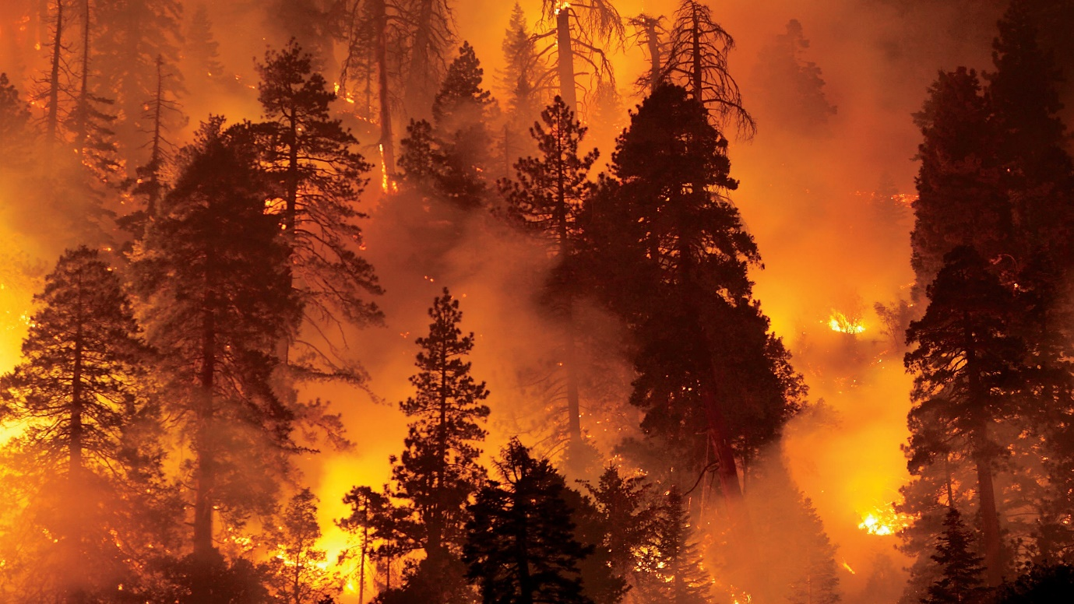

**Objective**

Forest fires help in the natural cycle of woods' growth and replenishment. They Clear dead trees, leaves, and competing vegetation from the forest floor, so new plants can grow. Remove weak or disease-ridden trees, leaving more space and nutrients for stronger trees.

But when fires burn too hot and uncontrollable or when they’re in the “wildland-urban interface” (the places where woodlands and homes or other developed areas meet), they can be damaging and life threatning.

In this kernel, our aim is to predict the burned area (area) of forest fires, in the northeast region of Portugal. Based on the the spatial, temporal, and weather variables where the fire is spotted.

This prediction can be used for calculating the forces sent to the incident and deciding the urgency of the situation.

For Further Info, Read: [MyLandPlan](https://mylandplan.org/content/good-and-bad-forest-fires)

target = 'area'

**RMSE**

RMSE is the most popular evaluation metric used in regression problems. It follows an assumption that error are unbiased and follow a normal distribution.

Further Read: [Analytics Vidhya](https://www.analyticsvidhya.com/blog/2019/08/11-important-model-evaluation-error-metrics/)