Login
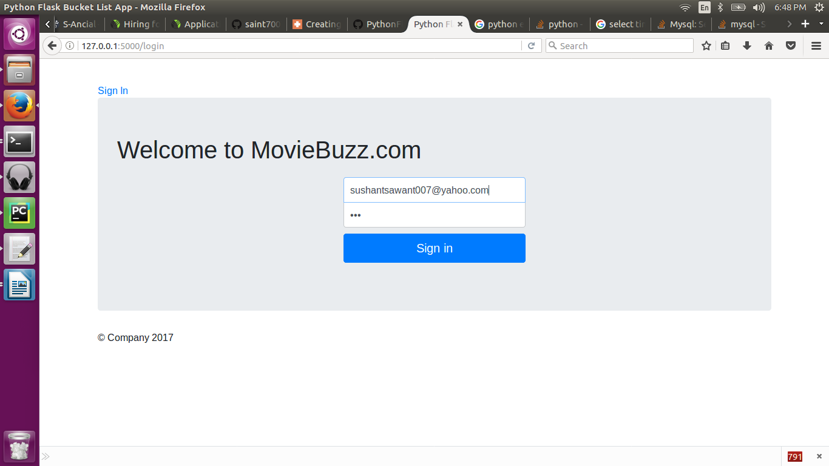
http://127.0.0.1:5000/login
http://127.0.0.1:5000/showDashboard

No movies currently. Next we gonna add Click on Add Movie
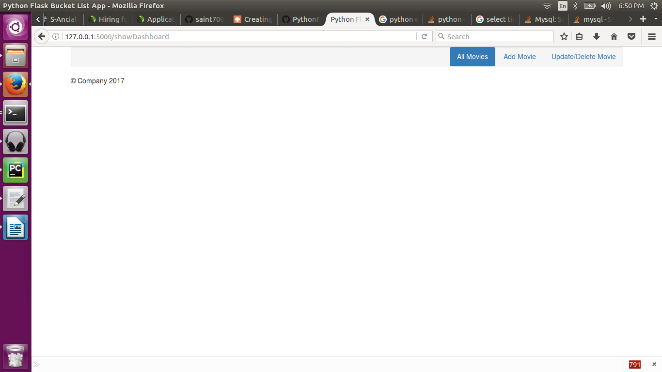
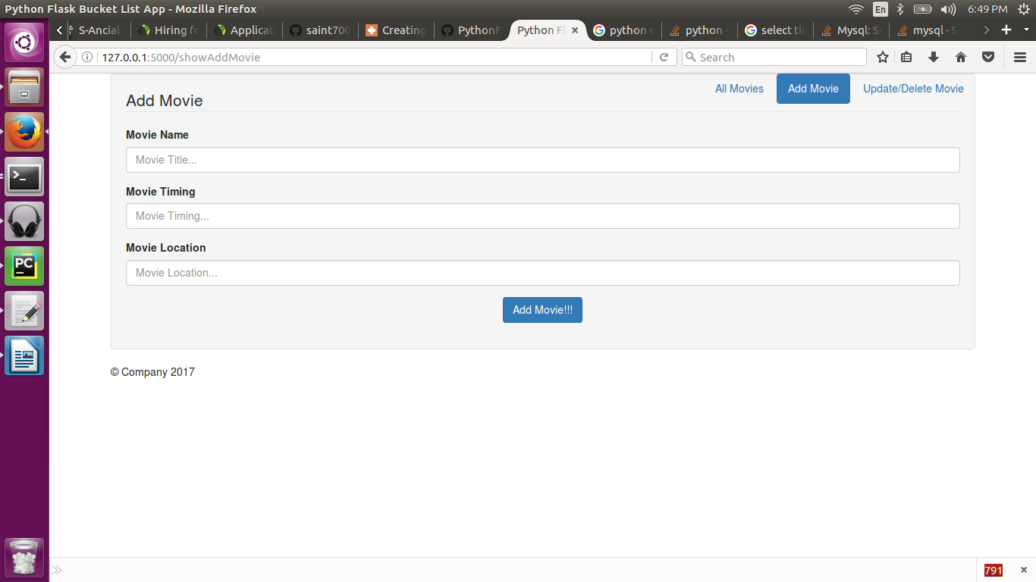
http://127.0.0.1:5000/showAddMovieAdd movie page

after adding movie
Current have not adding date picker. For movie timing
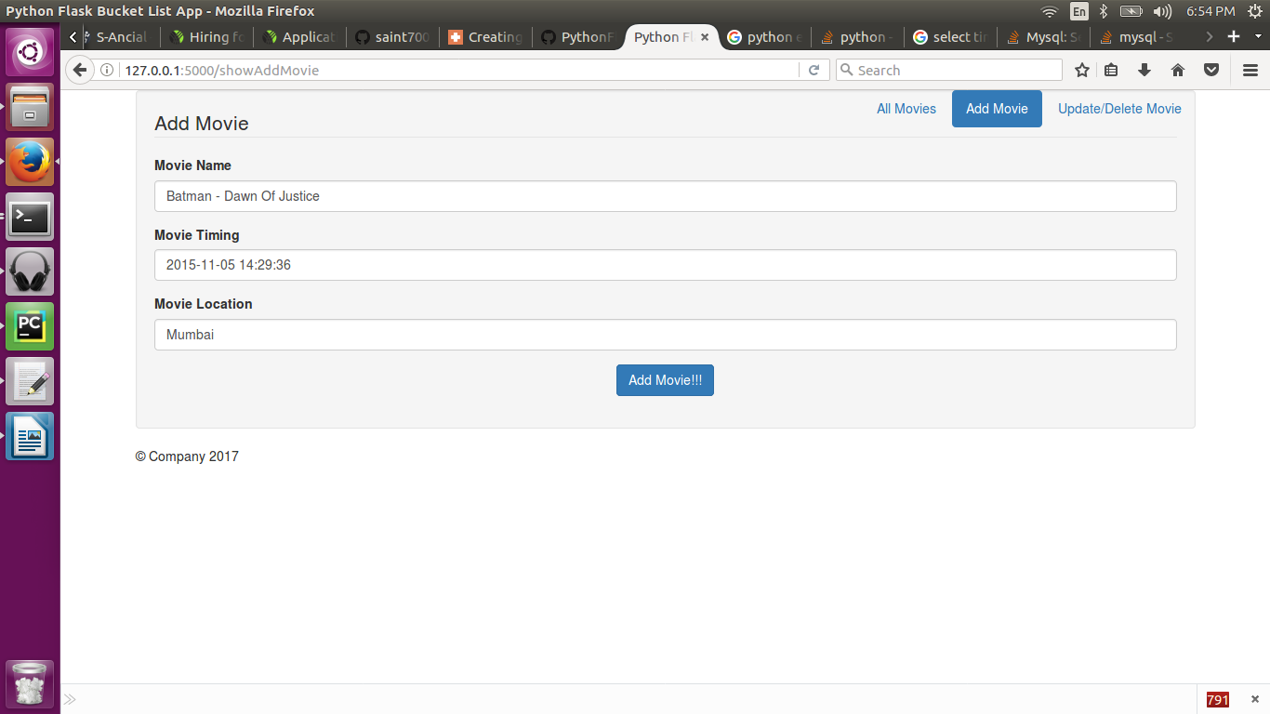

After Clicking on Add Movie!!!
Need bit ui improvement but works!

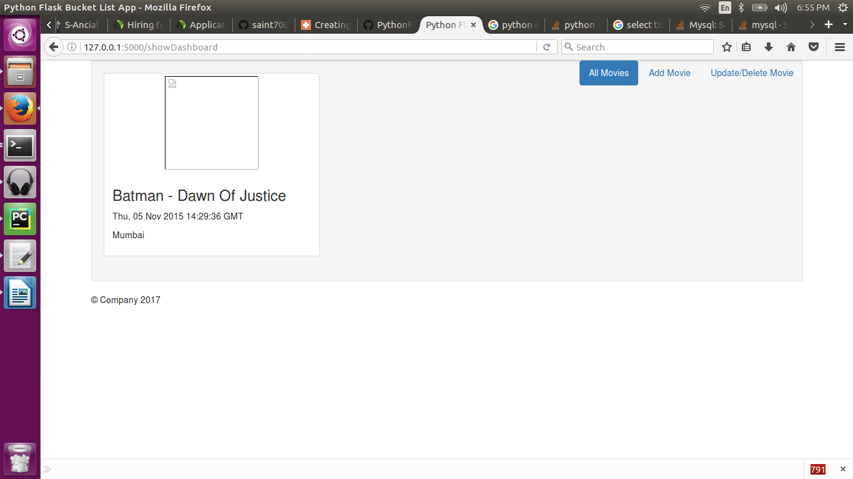
MySQL entry

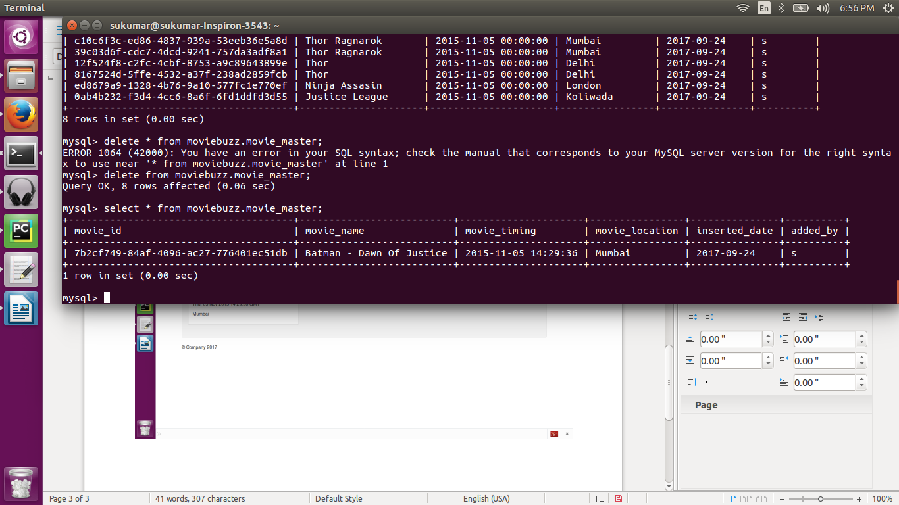

Adding few more
Justice League…..

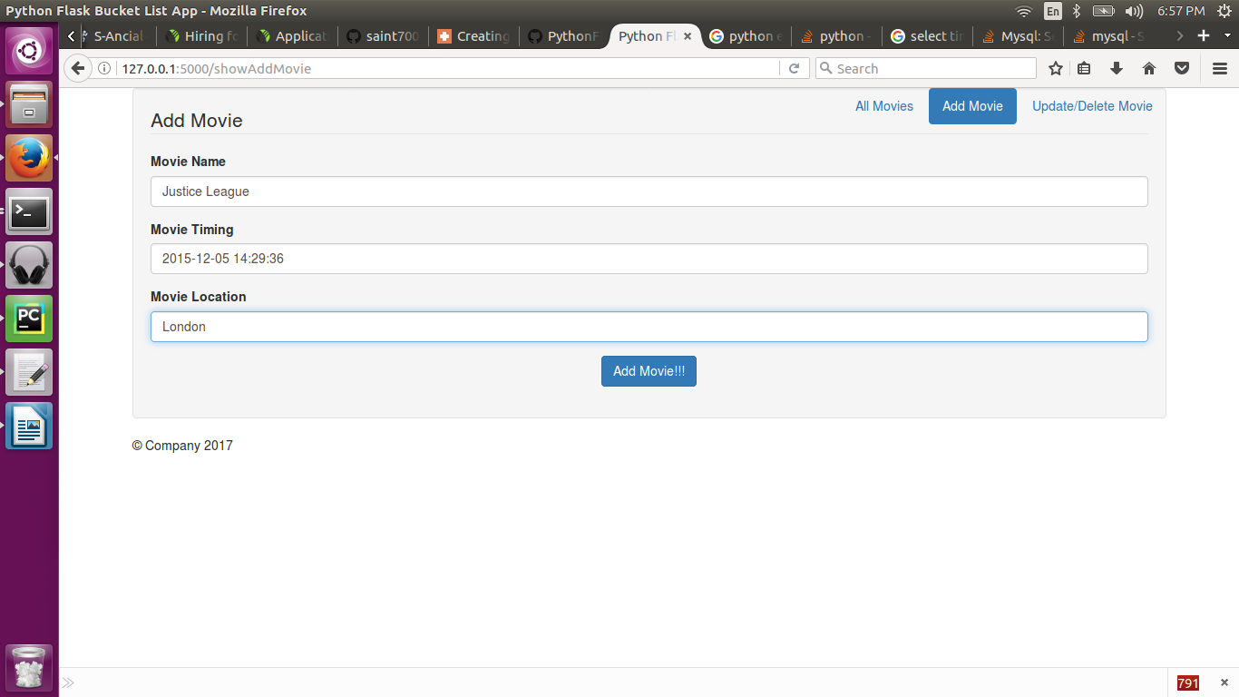

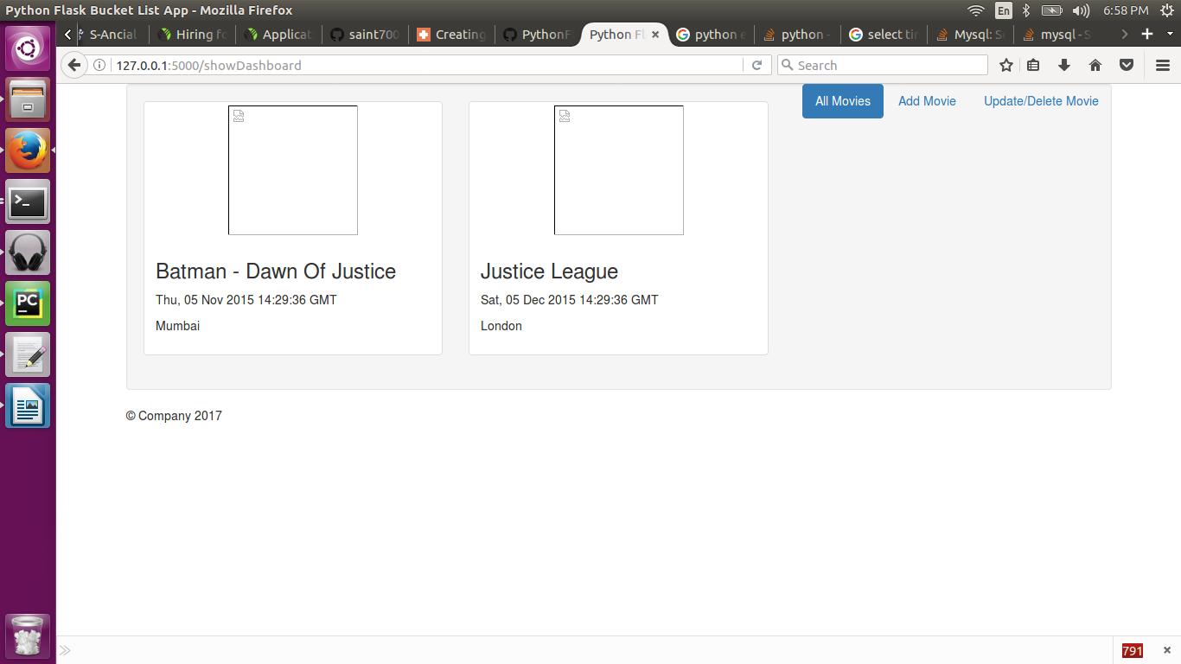

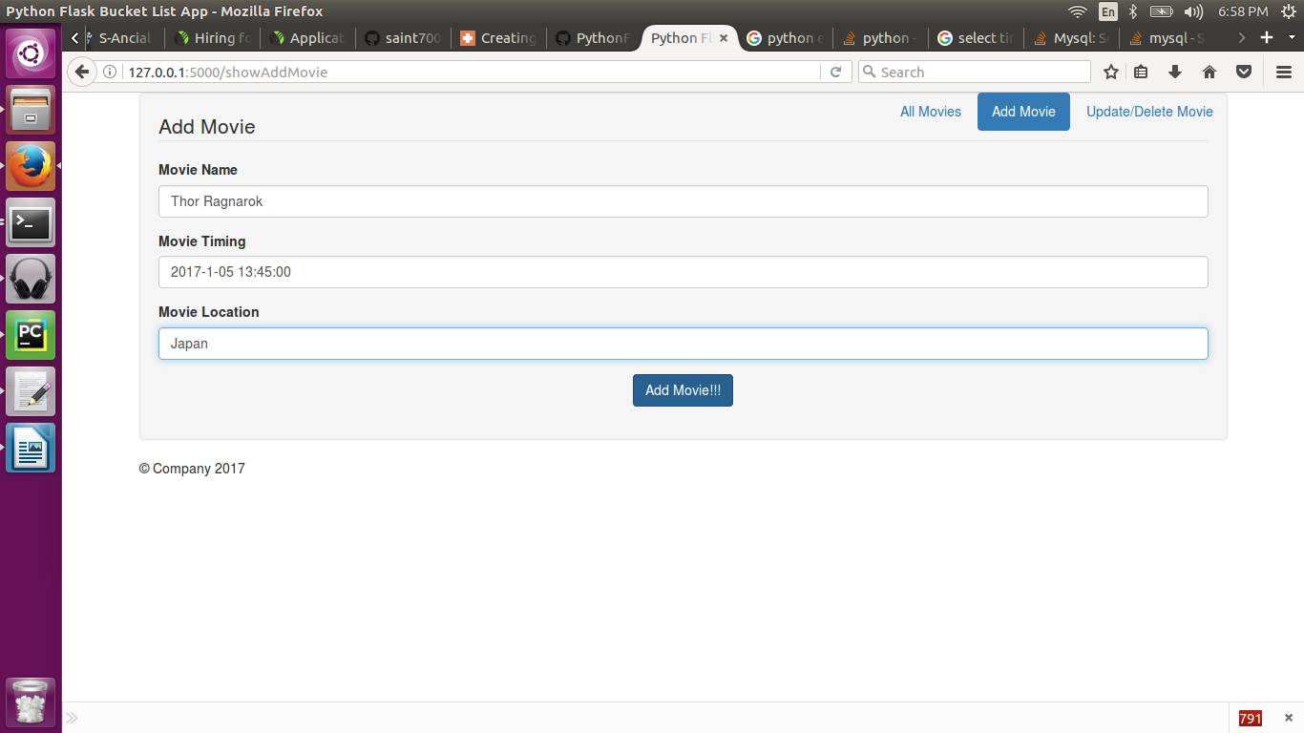
Added Thor Ragnarok ….

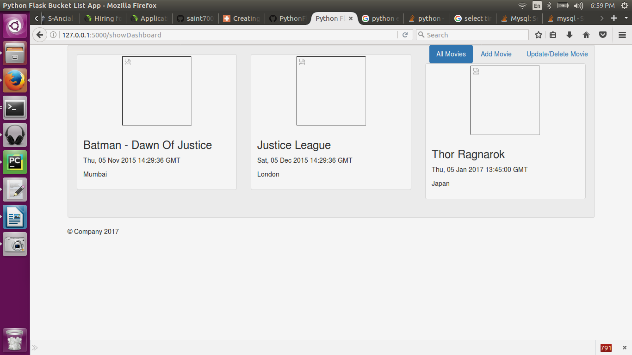

Now updating, After clicking on Update/Delete Movie.
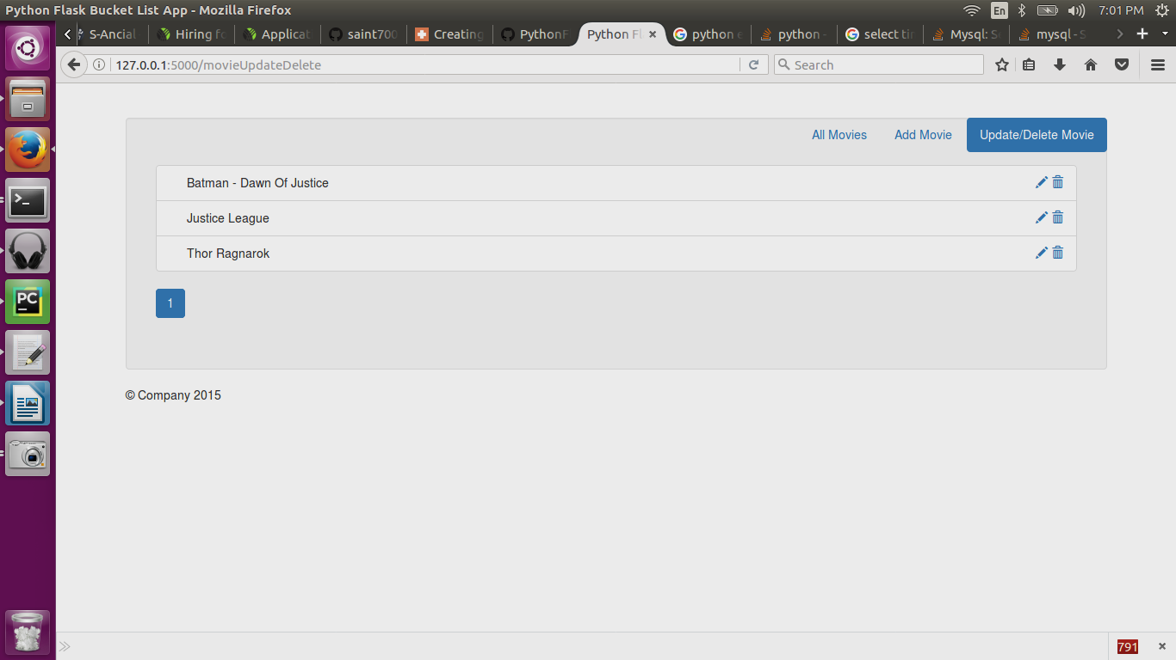

Let say Thor Ragnarok,
Location, Japan to Mumbai

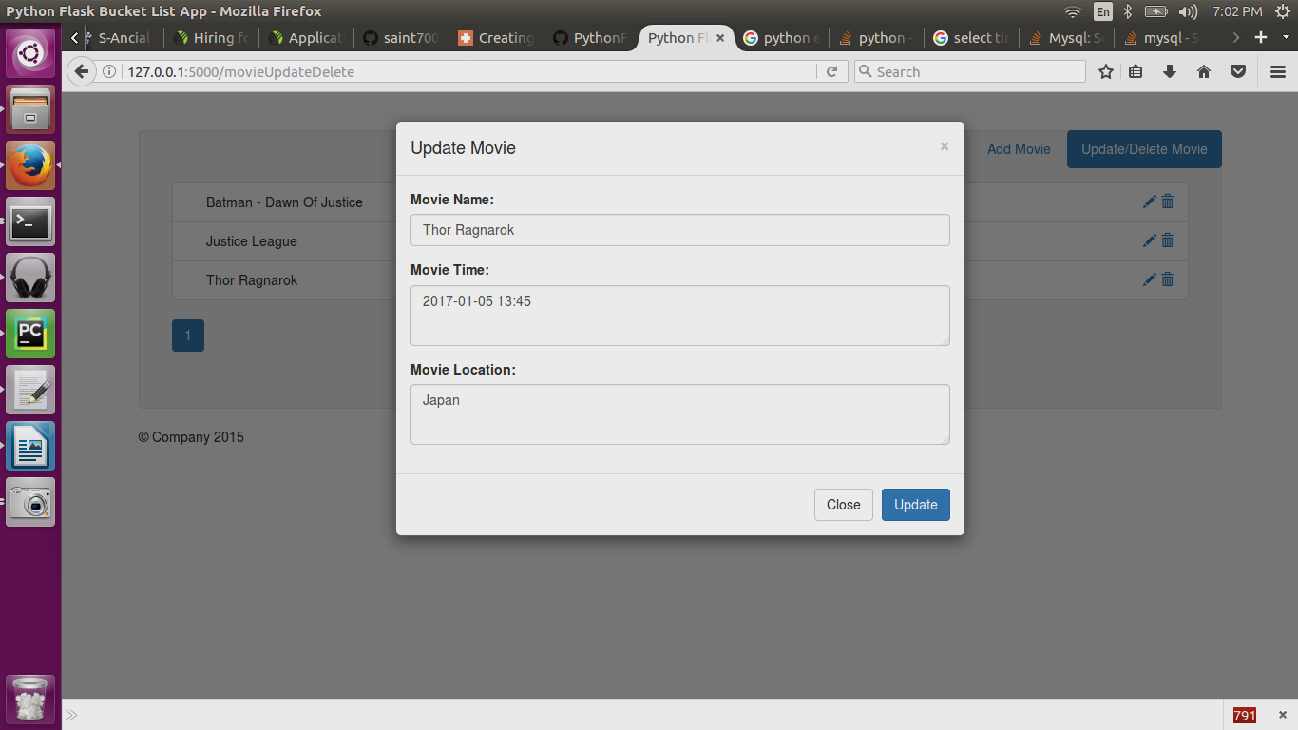

Changed Movie Location to Mumbai and Movie Name
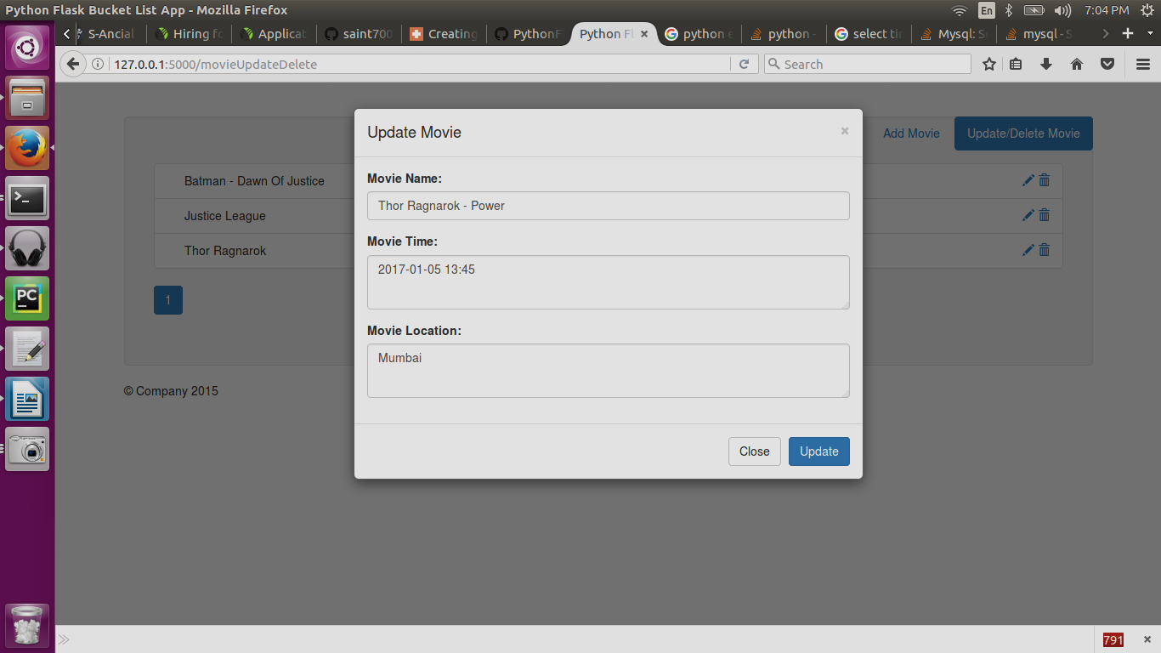
We can see, Thor Ragnarok to Thor Ragnarok -Power

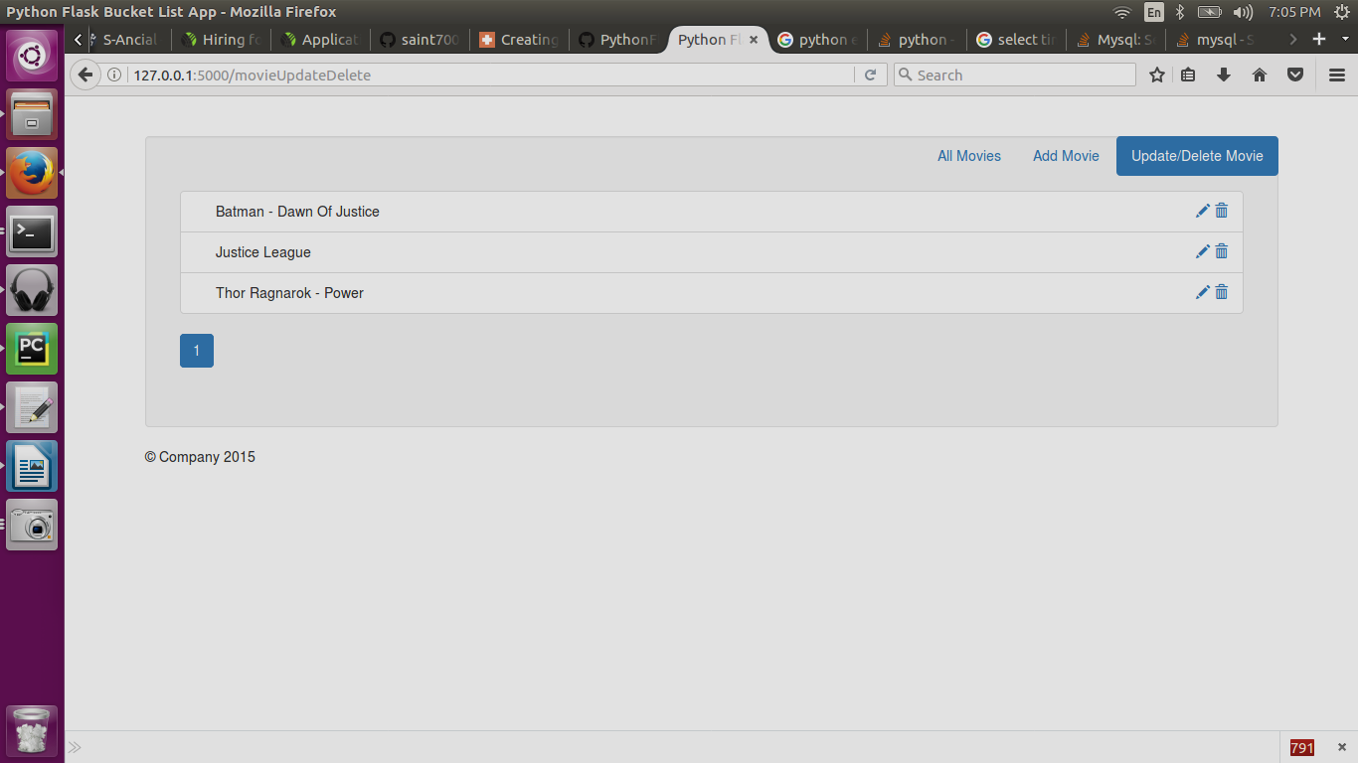

Further to check location is changed or not, clicking on All movies tab.
Location changed from Japan to Mumbai

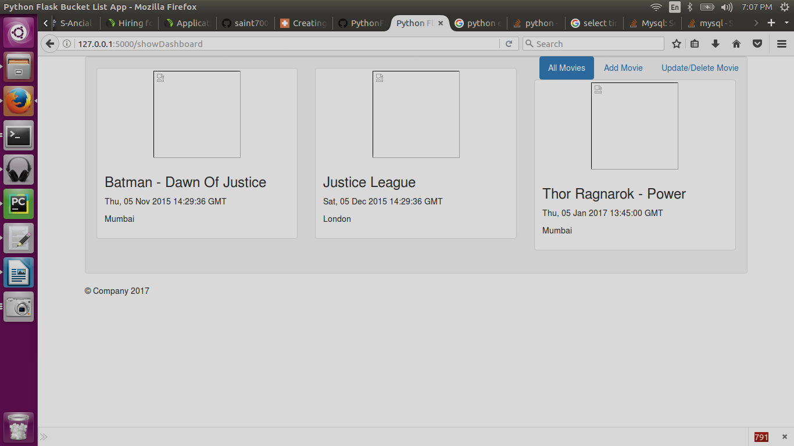
Deleting Batman vs Superman

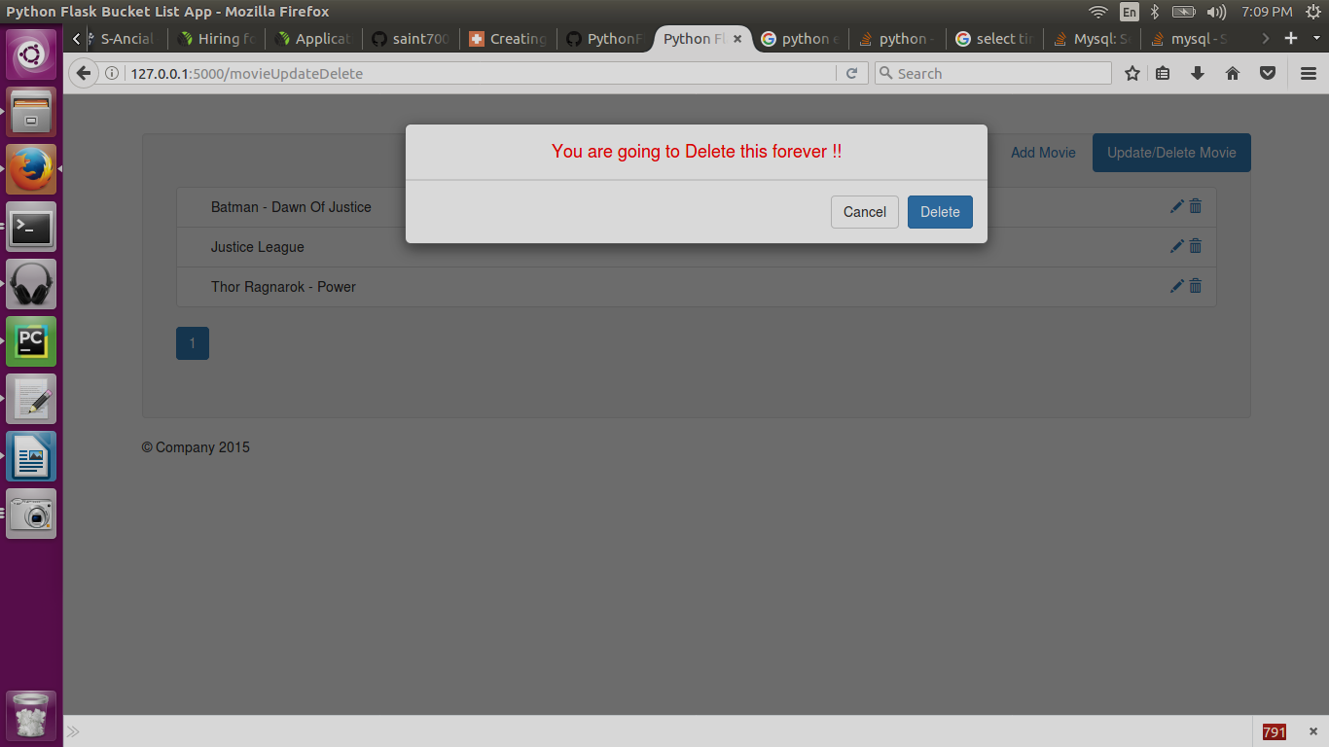

Post Deletion

