|  |  |  |  |  |  |
| --- | --- | --- | --- | --- | --- |
| FWH Number | Pressure Ratio For FWH | Pressure Ratio For Drain | Calculated Mass Flow Rate(Tones/hr) | Published Mass Flow Rate(Tones/hr) | Relative Error(%) |
| FWH1 | 0.906 | 0.17 | 10.37 | 10.32 | 0.45 |
| FWH2 | 0.906 | 0.47 | 20.63 | 20.52 | 0.54 |
| FWH3 | 0.906 | 1 | 13.52 | 13.45 | 0.52 |
| FWH4 | 0.906 | 0.52 | 21.34 | 21.15 | 0.89 |
| FWH5 | 0.99 | 0.63 | 17.44 | 17.6 | 0.91 |
| FWH6 | 0.906 | 1 | 18.14 | 18.22 | 0.44 |

Table 1. mass flow rate of steam extracted

Notes: For FWH1, the extract steam is actually saturated, it is a mixture of liquid and vapor, but if we use the published value of T and P to find out h, XSteam will take the steam as superheated steam, which will cause the internal energy of steam to be larger than it actually is, so we should use the value of given h as the internal energy of the extracted steam.

Rankine engine circuit of the Ivanpah SEGS：

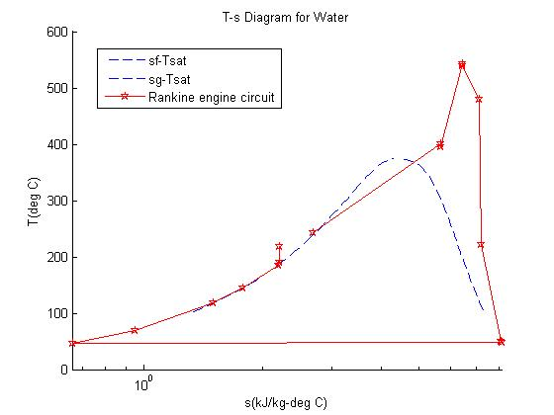

Figure 1. Rankine engine circuit on T-s diagram

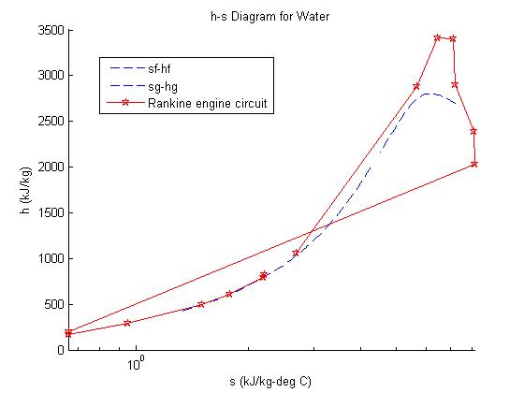

Figure 2. Rankine engine circuit on h-s diagram