**Rapids Whitewater Rafting**

Branding

Logo



Style Guide

Color Schema

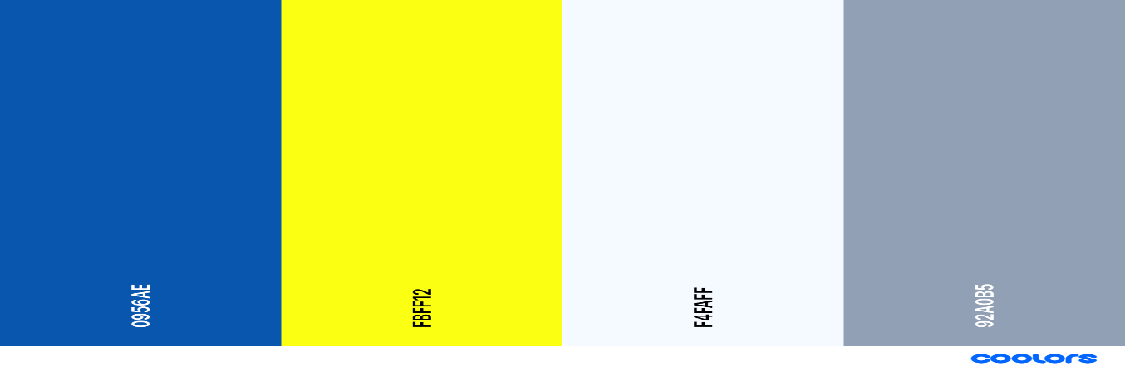

* primary-color: #0956AE
* secondary-color: #FBFF12
* accent1-color: #F4FAFF
* accent2-color: #92A0B5

Fonts

heading-font: Oswald

text-font: Lato

Color palette: <https://coolors.co/0956ae-fbff12-f4faff-92a0b5>