Big-Bank Data Platform
Project Report
An end-to-end retail-bank data platform — explained as a story
DataStage · SQL · Greenplum · Python · PySpark · Databricks · GCS · dbt · CI/CD

Contents

1. Executive summary
This project builds the entire data platform a retail bank runs — the kind of system a senior data engineer owns. It takes raw data from the bank's systems, cleans and organizes it, catches fraud in real time, checks it against strict quality rules, and turns it into trusted numbers for executives, analysts, and regulators — wired together so it runs on a schedule and nothing broken ever ships.
It combines the real enterprise stack — DataStage, SQL, Greenplum, Python, PySpark, Databricks, GCS, dbt, data contracts, and CI/CD — across both batch and streaming data. It runs end to end on a laptop with one command (python run.py), using faithful local stand-ins where the real tools are cloud or proprietary, and documents how each piece maps to production.
In one sentence: we turn messy raw bank data into one reconciled, governed “golden source” of trusted numbers — handling fraud in real time and regulators at night — with quality and controls enforced automatically.

2. The scenario — a day at “Meridian Bank”
Picture a mid-sized retail bank, Meridian. Two very different things must happen with its data every day:
- 9:02 a.m. — a card is swiped abroad for $4,300. Is it fraud? Meridian has seconds to approve or block it. This needs real-time data.
- 11:00 p.m. — the books must close. Finance needs the day reconciled to the penny; risk needs exposure by region; regulators need reports they can trust under inspection. This needs trustworthy, complete batch data.
These are opposite needs — fast vs complete-and-correct — so the platform runs two paths that meet in one governed place. That two-path design is a Lambda architecture, exactly what big banks use. The villain throughout is untrusted data: if three reports disagree, or a bad row reaches a regulatory return, the bank fails an audit. So a second theme runs through everything: controls — quality checks, contracts, reconciliation, and an audit trail — so the data is trustworthy by design.

3. The big picture (architecture)
Two paths — a batch path and a real-time (speed) path — meet in a governed warehouse, are served to people through a semantic layer, and are wrapped in automation (orchestration + CI/CD).
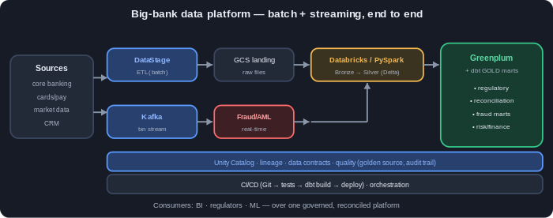

4. The journey of one transaction (end to end)
The best way to feel what the platform does is to follow a single card payment through it:
- It's born. A customer pays $4,300 abroad. The card system emits an event onto a stream (Kafka) and writes it to the day's transaction file.
- The fast lane (seconds). A Spark Structured Streaming job scores it instantly: large amount + high-risk country → fraud alert. The bank can block it now.
- The slow lane (that night). A DataStage ETL job extracts the day's files, standardizes them, rejects malformed rows into a separate pile, and lands clean raw in GCS as the bronze layer.
- It gets trustworthy. A PySpark / Databricks job turns bronze into silver: removes duplicates, fixes types, flags reversals, links account and customer, and runs a quality check. Silver is the single source of truth.
- It passes the gate. A data contract checks silver against agreed rules; if it fails, the whole run stops — bad data cannot move forward.
- It becomes a business number. Silver loads into Greenplum, where dbt builds the gold marts (reconciliation, regulatory exposure, fraud) and tests them.
- It reaches a human. A semantic layer defines each metric once, and a BI dashboard (Power BI / Looker / Tableau) shows the same trusted numbers.
- It's all automatic. The chain runs as an Airflow / Databricks Workflows DAG with retries and the contract gate as a stop-sign, and CI/CD ensures nothing ships unless tests, the contract, and dbt all pass.

5. Stage by stage — what, how, why
Stage | What & why | How (local) → real tool
Sources | The bank's systems; messy, multi-system data to integrate | generate_data.py → core banking / cards / CRM
DataStage ETL → bronze | Standardize, reject bad rows, land replayable raw | datastage_etl.py → IBM DataStage
GCS landing | Cheap durable landing zone | local folder → GCS bucket (MinIO)
PySpark → silver | Dedupe, type, SCD2 dim, quality — single source of truth | spark_medallion.py (real PySpark) → Databricks/Delta
Streaming fraud/AML | Score card txns in real time | streaming_fraud.py → Kafka
Data contracts | Block bad data before consumers (the gate) | contracts.py → datacontract-cli in CI
Greenplum + dbt → gold | Business marts in SQL with tests | DuckDB + dbt → Greenplum (MPP)
Semantic + BI | Define metrics once; consistent dashboards | serve_dashboard.py → Power BI/Looker
Orchestration + CI/CD | Wire stages with retries + gate; gate every change | Airflow + Databricks job + GitHub Actions

6. The data model
The platform uses the medallion model — refine data in layers, each more trustworthy:
- Bronze — raw, as it arrived, append-only + metadata. Immutable and replayable.
- Silver — cleaned, deduped, typed, conformed; the single source of truth. Includes an SCD2 dim_customer keyed by a surrogate key, and a transaction fact linked to accounts/customers.
- Gold — business marts: a transaction fact, a daily reconciliation control mart, a regulatory exposure mart, and a fraud summary.
Key decisions: surrogate keys (so SCD2 history works and joins are fast), conformed dimensions (one customer definition reused across marts), and denormalized gold marts (fast BI reads).

7. Real-world complexity it handles
Problem | Where it's handled
Bad / unparseable values | DataStage reject link
Duplicate deliveries | dedupe by txn_id (proven by a dbt unique test)
Reversals (negative amounts) | flagged is_reversal in silver
Orphan accounts (broken FKs) | referential-integrity check → surfaces as UNKNOWN
Customer attributes change over time | SCD2 dim_customer with change-hash
Real-time fraud / AML | streaming scoring
Bad data reaching consumers | data-contract gate fails the run / CI
Books must reconcile | gold_daily_reconciliation control totals
Regulatory reporting | gold_regulatory_exposure from the golden source
Different teams, different numbers | semantic layer defines metrics once

8. Why these decisions (trade-offs)
- Lambda (batch + streaming) — fraud needs speed; regulatory needs completeness; one path can't do both, so we run both and reconcile.
- Medallion — refine in layers; keep raw bronze so we can reprocess when logic changes.
- Surrogate keys + SCD2 — report attributes as they were at the time; keep joins fast and stable.
- Data contracts as a gate — cheaper to fail a build than to explain a bad regulatory return.
- Greenplum (MPP) → cloud-ready — same dbt SQL migrates to Snowflake/Databricks later.
- Semantic layer — one trusted number for executives and regulators.

Orchestration & CI/CD
The stages run as a DAG with retries, alerts, and the contract gate as a fail-stop, in Airflow or Databricks Workflows; CI/CD gates every code change.
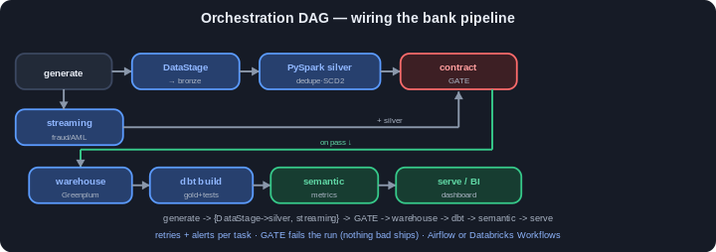

9. How to run it
pip install -r requirements.txt (needs Java 11+ for PySpark)
python run.py (full pipeline end to end)
docker compose up -d (optional real Greenplum + Kafka + MinIO)
Verified locally: PySpark medallion + streaming run, the contract gate passes, dbt build is green (PASS=19, including the metrics model), and the dashboard renders.

10. Results
- A reconciliation mart with the day's control totals (posted, reversals, net movement).
- A fraud summary: high-risk geographies flagged at a high rate, normal traffic ~0.
- A regulatory exposure mart by region/segment (data-quality issues honestly surface as UNKNOWN).
- An executive dashboard (out/dashboard.html) served from the governed metrics layer.
- A green CI run: tests + contract gate + dbt build all passing.

11. How to present this as your work
- Set the scene — Meridian's two needs (real-time fraud, nightly reconciliation/regulatory).
- Show the architecture diagram — two paths meeting in a governed golden source.
- Run python run.py live — narrate each stage.
- Open the proof points — reject pile, SCD2 dim, fraud alerts, contract gate, marts, dashboard, CI workflow.
- Explain the mapping — DuckDB↔Greenplum, file↔Kafka, Parquet↔Delta, Python↔DataStage.
- Close with trade-offs — why Lambda, why medallion, why contracts. That signals senior.

12. Glossary (plain English)
Term | Meaning
DataStage | IBM's visual, parallel ETL tool common in banks
GCS | Google Cloud Storage; cheap durable file storage (a landing zone)
Lakehouse / medallion | Cheap storage + warehouse reliability, refined bronze→silver→gold
PySpark / Databricks | Distributed data processing; Databricks is the managed platform
Delta / Parquet | Table/file formats; Delta adds transactions + time travel
Streaming / Kafka | Processing events continuously in real time
SCD2 | Slowly Changing Dimension Type 2 — keeps history of changes
Surrogate key | A meaningless integer key (enables SCD2 + fast joins)
Data contract | Agreed schema/quality rules, enforced automatically (the gate)
Greenplum / MPP | A massively parallel SQL warehouse (data across nodes)
dbt | Builds and tests SQL models (the gold marts)
Semantic / metrics layer | Defines each metric once so every tool agrees
Reconciliation | Proving numbers match the source (control totals)
CI/CD | Automation that tests and ships code safely

