
Assignment on
CONTEXT-AWARE E-COMMERCE CHATBOT INTENT CLASSIFICATION AND RESPONSE GENERATION

Assignment Report submitted in partial fulfilment of the requirements for the Course of

DSA0308 – Natural Language Processing
to the award of the degree of
BACHELOR OF Technology
IN
ARTIFICIAL INTELLIGENCE AND Machine Learning
Submitted by
L Sai Pavan (192472129)
Under the Supervision of
Kumaragurubaran T
SIMATS ENGINEERING
Saveetha Institute of Medical and Technical Sciences
Chennai – 602105
SEPTEMBER 2026
CONTEXT-AWARE E-COMMERCE CHATBOT INTENT CLASSIFICATION AND RESPONSE GENERATION
1. Problem Statement and Problem Formulation
Problem Statement
E-commerce websites receive a wide variety of customer queries concerning orders, deliveries, cancellations, refunds, payments, products, accounts, and complaints. A chatbot that identifies intent only by searching for individual keywords can easily misunderstand a customer's actual requirement.
For example, in the conversation:
“I ordered a laptop three days ago, but it still hasn't arrived. Can you check where it is?”
the customer's intention is clearly related to tracking the order. However, in the following statement:
“I don't want to cancel it. I just want to know when it will arrive.”
the word cancel could incorrectly cause a keyword-based system to predict Order Cancellation.
Therefore, the problem is formulated as the design of a context-aware NLP chatbot that determines customer intent using multiple linguistic levels instead of relying on individual keywords. The proposed system considers morphology, n-grams, POS information, syntax, negation, semantics, word senses, references, discourse and entities before making the final classification. This directly addresses the assignment requirement for an integrated NLP pipeline.

Problem Formulation
Input:
A sequence of customer messages belonging to an e-commerce conversation.
Output:
- Detected intent
- Identified entities
- Relevant references
- Intent score
- Confidence level
- Retrieved information
- Generated chatbot response
- Tamil translation of the response
Possible intents include:
- Order Tracking
- Order Cancellation
- Product Information
- Return Request
- Refund Request
- Payment Problem
- Delivery Information
- Account Problem
- Complaint
- General Inquiry
These categories are specified in the assignment case.

2. Objective and Expected Outcomes
Objectives
The main objective is to develop a chatbot capable of understanding the meaning of a customer's complete conversation.
Specific objectives are:
- Preprocess customer messages using standard NLP techniques.
- Perform morphological analysis and stemming.
- Generate unigram, bigram and trigram features.
- Identify grammatical information using POS tagging.
- Analyze sentence structure using CFG rules.
- Detect negation and its scope.
- Represent important statements semantically using FOPC.
- Resolve ambiguous word senses.
- Extract important e-commerce entities.
- Resolve references such as it, this and that.
- Analyze discourse markers such as but, still and just.
- Combine these signals through an interpretable scoring mechanism.
- Retrieve information related to the predicted intent.
- Generate a suitable response.
- Translate the response into Tamil.
These objectives correspond closely with the functional requirements given in the assignment.
Expected Outcomes
The expected system should correctly identify:
Final Intent: Order Tracking / Delivery Information
Reason: The customer is asking about the arrival status of an existing order and explicitly rejects cancellation.
The system should therefore produce a response requesting or using the order number instead of providing cancellation instructions.

3. Requirements, Constraints and Assumptions
Requirements
Functional Requirements
The system requires:
- Customer conversation as input
- Text preprocessing
- Morphological analysis
- N-gram generation
- POS tagging
- CFG parsing
- Negation detection
- Semantic analysis
- WSD
- Entity extraction
- Reference resolution
- Discourse analysis
- Intent scoring
- Information retrieval
- Response generation
- Tamil translation
The assignment specifically requires intermediate outputs to support the final classification.
Technical Requirements
Requirement | Proposed Tool
Programming | Python
Regular Expressions | re
Tokenization | NLTK
Stemming | PorterStemmer
POS Tagging | NLTK
N-grams | NLTK / Python
CFG Parsing | NLTK
Classification | Rule-based scoring
Information Retrieval | Python dictionary / retrieval module
Translation | Suitable translation library/API

The assignment permits Python, NLTK, spaCy, regular expressions and Scikit-learn among other tools.

Constraints
The system must not make its decision using keyword frequency alone.
It must:
- explicitly handle negation;
- retain conversational context;
- resolve references;
- distinguish entities from intents;
- expose intermediate NLP results;
- prevent contradictory responses;
- justify the final classification using linguistic evidence.
These constraints are explicitly stated in the assignment.
Assumptions
- Customer messages are available as text.
- The conversation occurs in sequential turns.
- The system maintains recent conversational context.
- A predefined set of e-commerce intents is available.
- Important entities can be identified from the conversation.
- The chatbot has access to a small knowledge/retrieval store.
- Translation is performed after English response generation.

4. Application of Relevant Course Knowledge / Concepts
The proposed solution integrates concepts from all five NLP units.
Unit I – Morphology
The input is tokenized and morphological variations are reduced using stemming.
For example:
Original Word | Stem
ordered | order
arrived | arriv
cancelling | cancel
delivered | deliv

This allows related word forms to contribute similar evidence.
Regular expressions are also used to identify patterns such as order numbers, dates and special expressions.

Unit II – N-Grams and POS
Unigrams identify individual terms while bigrams and trigrams preserve local relationships.
For example:
Unigrams
ordered
laptop
three
days
arrived

Bigrams
ordered laptop
three days
still arrived

Trigrams
three days ago
still hasn't arrived
want to know
The phrase “hasn't arrived” provides much stronger delivery-related evidence than considering arrived alone.
POS tagging further distinguishes nouns, verbs, adjectives and other word classes.

Unit III – CFG and Negation
A simplified CFG can represent the structure:
S → NP VP
VP → V NP
VP → V AdvP
NP → Det N
AdvP → Adv VP
The system also identifies negation.
For:
“I don't want to cancel it.”
the negation modifies the cancellation action.
Therefore:
cancel → detected
negation(cancel) → TRUE
Consequently, cancellation should not become the final intent.

Unit IV – Semantic Analysis
A simplified FOPC representation can be constructed:
Ordered(Customer, Laptop)
Occurred(Order, ThreeDaysAgo)
NotArrived(Order)
Wants(Customer, ArrivalInformation)
NotWants(Customer, Cancellation)
This representation captures the underlying meaning rather than merely storing words.
WSD can also distinguish meanings of ambiguous words depending on their context.
For example, order in an e-commerce conversation is interpreted as a purchase transaction rather than a command.

Unit V – Discourse and Language Generation
The conversation contains important discourse relations.

Expression | Function
but | Contrast
still | Continuing unresolved state
just | Restriction/emphasis
it | Context-dependent reference

The pronoun “it” is resolved using the previous context and refers to the existing order.
The final intent is then passed to response generation and translation.

5. Design / Proposed Solution / Methodology
The proposed architecture is a multi-stage linguistic scoring system.
Customer Conversation
↓
Text Preprocessing
↓
Regular Expression Analysis
↓
Morphological Processing
↓
N-gram Generation
↓
POS Tagging
↓
CFG Parsing
↓
Negation Detection
↓
Semantic Representation
↓
WSD
↓
Reference Resolution
↓
Discourse Analysis
↓
Entity Identification
↓
Intent Scoring
↓
Context-based Decision
↓
Information Retrieval
↓
Response Generation
↓
Tamil Translation

This follows the general pipeline prescribed by the assignment.
Intent Scoring Approach
Instead of simply counting keywords, the system assigns weighted evidence.
For example:
Final Score =
0.20 × N-gram Evidence
+ 0.15 × POS/Syntax Evidence
+ 0.20 × Semantic Evidence
+ 0.15 × Entity Evidence
+ 0.15 × Discourse Evidence
+ 0.15 × Context Evidence
A separate negative score is applied when an intent is explicitly negated.
For cancellation:
Cancellation Evidence = cancel + cancellation-related patterns
Cancellation Penalty = explicit negation
Therefore:
“I don't want to cancel it”
does not increase the final cancellation score; instead, it suppresses that candidate.

6. Algorithm / Pseudocode

BEGIN

Input conversation

Initialize conversation_state
Initialize intent_scores

FOR each message in conversation:

Normalize text

tokens ← tokenize(message)

regex_features ← detect_patterns(message)

stems ← perform_stemming(tokens)

ngrams ← generate_unigrams_bigrams_trigrams(tokens)

pos_tags ← perform_POS_tagging(tokens)

parse_tree ← CFG_parse(message)

negations ← detect_negation(message)

semantic_form ← generate_FOPC(message)

senses ← perform_WSD(tokens, context)

entities ← extract_ecommerce_entities(message)

references ← resolve_references(message, conversation_state)

discourse_features ← analyze_discourse(message)

update conversation_state

END FOR

FOR each possible intent:

calculate ngram_score
calculate syntactic_score
calculate semantic_score
calculate entity_score
calculate discourse_score
calculate context_score

IF intent is contradicted by negation:
apply penalty

final_score ← weighted combination

END FOR

selected_intent ← intent with maximum valid score

retrieved_information ← retrieve_information(
selected_intent,
entities)

response ← generate_response(
selected_intent,
retrieved_information)

tamil_response ← translate(response)

Display intermediate NLP results
Display selected intent
Display score
Display confidence
Display response
Display Tamil response

END

7. Implementation / Source Code and Environment / Tools Used
Environment
Component | Selection
Language | Python
NLP Library | NLTK
Regex | Python re
Operating Environment | Python development environment
Parser | NLTK CFG
Data Representation | Python dictionaries/lists
Translation | Suitable translation API/library

The implementation can be divided into modules:
preprocess()
morphological_analysis()
generate_ngrams()
pos_analysis()
cfg_parse()
detect_negation()
semantic_analysis()
resolve_reference()
analyze_discourse()
extract_entities()
calculate_intent_scores()
retrieve_information()
generate_response()
translate_response()

A dictionary-based knowledge base can store responses for each intent.
Example:
Order Tracking:
"Please provide your order number so I can check its current status."
Order Cancellation:
"Please provide your order number to proceed with cancellation."
Return Request:
"Please provide the order details for the return process."
The actual implementation output should be inserted into the report along with screenshots, as the assignment requires evidence such as program output, intermediate representations and final classification.

8. Test Cases and Expected / Actual Results
Test Case | Input | Expected Intent
TC1 | “Where is my order?” | Order Tracking
TC2 | “I want to cancel my order.” | Order Cancellation
TC3 | “My payment failed.” | Payment Problem
TC4 | “Can I return this product?” | Return Request
TC5 | “I ordered a laptop but it hasn't arrived.” | Order Tracking
TC6 | “I don't want to cancel it. When will it arrive?” | Order Tracking
TC7 | “Tell me more about this phone.” | Product Information

Critical Test Case
Input:
“I ordered a laptop three days ago, but it still hasn't arrived. Can you check where it is? I don't want to cancel it. I just want to know when it will arrive.”
Expected:
Intent: Order Tracking
Reference: it → existing order
Entity: laptop
Delivery Status: not arrived
Cancellation: explicitly rejected

9. Execution Screenshots / Outputs
The implementation should capture screenshots showing:
Screenshot 1
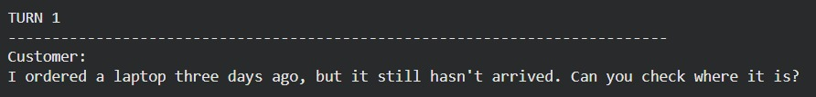
Input conversation entered into the chatbot.
Screenshot 2
Tokenization and stemming output.
Screenshot 3
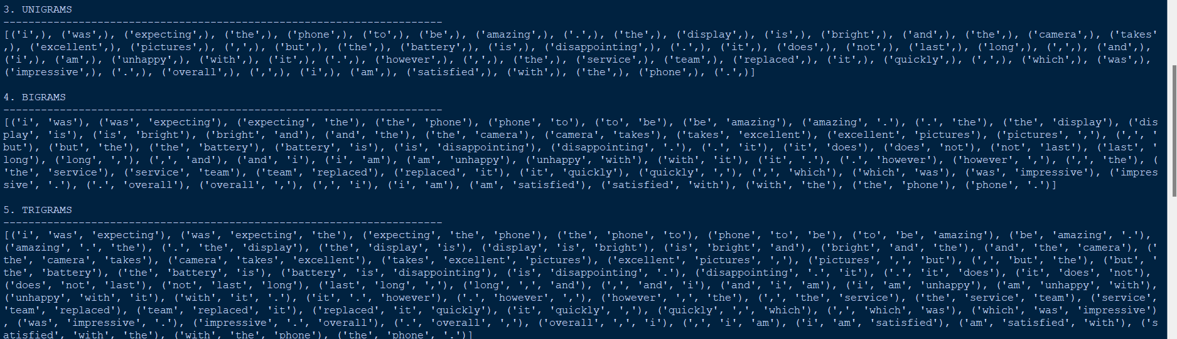
N-gram and POS analysis.
Screenshot 4
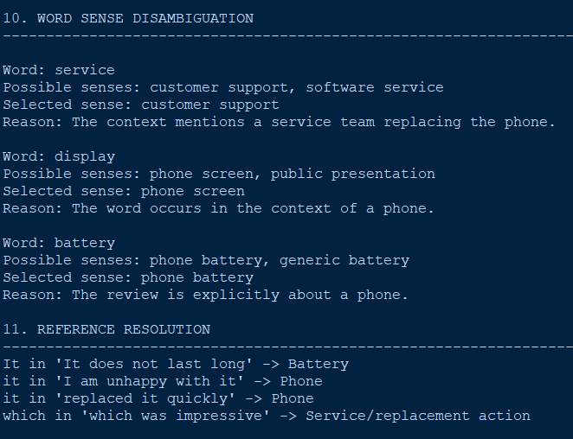
Negation and reference-resolution output.
Screenshot 5
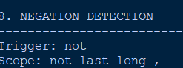
Final intent score.
Generated English and Tamil responses.
A suitable final console/UI output would be:
Detected Product : Laptop
Order Status : Not Arrived
Time Reference : Three Days
Negated Intent : Order Cancellation
Reference "it" : Existing Order
Discourse Marker : but / still / just

Final Intent : Order Tracking
Intent Score : [actual implementation value]
Confidence : [actual implementation value]

Response:
Please provide your order number so I can check the
current delivery status of your laptop.
Tamil Response:
10. Results and Validation
The assignment requires validation against morphological variation, n-grams, POS, negation, ambiguity, references, context, classification and response generation.
Morphological Output
Word | Processed Form
ordered | order
arrived | arriv
cancel | cancel
provide | provid
delivery | deliver

Intent and Entity Analysis
Component | Result | Evidence
Product | Laptop | “ordered a laptop”
Order | Existing order | “I ordered...”
Time | Three days | “three days ago”
Delivery | Delayed/not arrived | “hasn't arrived”
Negation | Cancellation rejected | “don't want to cancel”
Reference | “it” → order | Previous context
Intent | Order Tracking | Wants arrival information

Final Classification
Intent: Order Tracking / Delivery Information
Entities: Laptop, Order, Delivery
Reference Resolution: “it” → customer's existing order
Reason: The customer is concerned about the delivery status and explicitly states that cancellation is not desired.
Generated Response:
Please provide your order number so I can check the current delivery status.
The assignment specifically identifies Order Tracking / Delivery Information as the expected final decision for this case.

11. Analysis, Comparison, Trade-offs and Justification
A keyword-only chatbot might observe the word “cancel” and classify the final message as Order Cancellation. This is incorrect.
The proposed linguistic approach examines the complete interaction.
Effect of “but”
The word but introduces a contrast. The first sentence establishes the delivery problem, while the subsequent information clarifies the customer's actual request.
Effect of “still”
Still indicates that the expected delivery has not occurred despite the passage of time.
Effect of “just”
Just narrows the customer's requirement:
“I just want to know when it will arrive.”
Therefore, the customer is requesting information rather than cancellation.
Effect of “hasn't arrived”
This creates strong delivery-status evidence.
Effect of “it”
The reference cannot be interpreted independently. From the previous sentence, it refers to the customer's existing order.
Effect of negation
The phrase:
“I don't want to cancel it”
contains the cancellation vocabulary but explicitly rejects the cancellation action.
Thus:
Keyword evidence:
cancel → Cancellation
Contextual evidence:
don't want to cancel → NOT Cancellation
want to know when it will arrive → Order Tracking
The contextual evidence dominates.

Advantages
- More interpretable than a black-box prediction.
- Explicit handling of negation.
- Maintains conversational context.
- Provides intermediate linguistic evidence.
- Better suited for the assignment's five-unit NLP integration.
Trade-offs
Approach | Advantage | Limitation
Keyword matching | Very simple | Poor contextual understanding
Pure ML | Learns patterns from data | Less interpretable
Proposed linguistic scoring | Explainable and context-sensitive | Requires manually designed rules
Large language model | Strong language understanding | Higher computational cost and less deterministic
The proposed method therefore provides a reasonable balance between linguistic interpretability, contextual understanding and implementation simplicity.

12. Broader Considerations / SDG Relevance
The assignment maps the work to SDG 9 – Industry, Innovation and Infrastructure.
An intelligent customer-service chatbot contributes to digital infrastructure by automating repetitive support interactions and improving access to information.
Ethical Considerations
Customer conversations may contain personal information such as order numbers, addresses and payment-related details. Such information should be protected.
Bias
The system may perform differently for unusual expressions, spelling variations or different linguistic styles. The intent rules should therefore be tested using diverse examples.
Incorrect Classification
A wrong classification could result in an inappropriate action, such as suggesting cancellation when the customer only wants delivery information. Hence, high-risk actions should require confirmation.
Accessibility
Tamil translation allows the system to serve users who are more comfortable communicating in Tamil.
Responsible AI
The chatbot should provide understandable responses and avoid claiming that an action has been completed when it has only generated a recommendation.

13. Conclusion, Limitations and Possible Improvements
Conclusion
A context-aware e-commerce chatbot was designed using a multi-level NLP pipeline. Unlike a basic keyword system, the proposed approach considers morphological forms, n-grams, POS information, syntactic structure, negation, semantic information, word senses, entities, references and discourse.
For the given conversation, the system identifies Order Tracking / Delivery Information as the appropriate intent. The presence of the word cancel does not result in a cancellation prediction because the cancellation action is explicitly negated and the customer states that the actual requirement is to know the expected arrival time.
The solution therefore satisfies the central requirement of determining intent from the complete conversational and linguistic context.
Limitations
- Rule weights require manual tuning.
- CFG rules may not cover every natural-language construction.
- WSD can be difficult for highly ambiguous expressions.
- Reference resolution becomes harder in long conversations.
- Translation quality depends on the selected translation system.
- A larger intent set would require additional rules and training data.
Possible Improvements
Future versions could incorporate:
- Transformer-based intent classification
- Larger multilingual datasets
- More advanced coreference resolution
- Context-aware embeddings
- Confidence-based human escalation
- Real-time e-commerce API integration
- Improved Tamil NLP and translation

14. Individual Contribution of Group Members
Member | Contribution
Nirmal Kasi  (192424248) | Text preprocessing, tokenization, regular expression analysis, morphological analysis, stemming, and N-gram generation.
Megha Harsha (192424389) | POS tagging, CFG parsing, and syntactic analysis.
B V Chaitanya (192425376) | Negation detection, semantic analysis, word sense disambiguation, and discourse analysis.
K Yeshwanth (192425393) | Module 3: Entity extraction, reference resolution, intent scoring, and context-based intent classification.
Lokeshwara H (192325120) | Module 4: Information retrieval, response generation, knowledge-base management, and Tamil translation.
L Sai Pavan  ( 192472129) | Main Module: Integration of all modules, user input handling, intermediate-result display, final output, testing, debugging, and validation.

15. References
The final report should include the actual sources used. The assignment specifically asks students to cite textbooks, research papers, NLP libraries, datasets, software/tools, websites and AI-assisted tools where applicable.
Suggested categories:
- NLP course textbook/reference material.
- NLTK documentation.
- Python documentation.
- Relevant research papers on chatbot intent classification.
- Documentation for the selected translation library/API.
- Any dataset used for intent classification.
- Any AI-assisted tools used during development.

16. One-Page Individual Reflection
Individual Reflection
This assignment helped me understand how different NLP modules can be integrated into a single working chatbot system. As a member responsible for the main module, I worked mainly on integrating the individual modules, handling user input, displaying intermediate NLP results, testing, debugging, and validating the final output. I learned that developing a complete NLP application requires not only implementing individual techniques but also ensuring that all components communicate correctly.
One of the important parts of my contribution was integrating the four NLP modules into the main program. The main module receives the customer's conversation and passes it through preprocessing, linguistic analysis, intent classification, and response generation. This helped me understand how the outputs of one stage become inputs for the next stage in an NLP pipeline.
I also worked on handling user input and displaying intermediate results. The system displays information such as tokens, stems, N-grams, POS tags, negation, semantic representation, references, discourse markers, entities, intent scores, and confidence. These intermediate outputs make the system easier to understand and help demonstrate how the final intent is obtained.
Testing and debugging were another important part of my contribution. I tested different customer queries, including order tracking, cancellation, product information, returns, refunds, and payment problems. The critical test case was particularly useful because it contained the word “cancel” while explicitly rejecting cancellation. Testing this case helped verify that the complete system considered context and negation before selecting the final intent.
I also learned the importance of validating the interaction between modules. Even when individual modules work correctly, problems can occur when their outputs are passed between different stages. Debugging these issues helped me understand the practical challenges involved in integrating multiple NLP techniques into one application.
Working on the main module gave me a broader understanding of the entire chatbot architecture. I could see how preprocessing, linguistic analysis, entity extraction, intent scoring, information retrieval, and response generation work together to produce the final response. This helped connect the theoretical concepts from the NLP course with their practical implementation.
If I had more time, I would improve the integration by adding better error handling, more extensive test cases, and a graphical user interface for easier interaction. I would also explore connecting the chatbot to a real e-commerce database and evaluating its performance using a larger dataset.
Overall, this assignment improved my understanding of NLP pipeline integration, testing, debugging, and system validation. It also helped me develop practical skills in Python, software integration, problem solving, and evaluating how multiple NLP components work together to create a complete context-aware chatbot.

